m

Standard Operating Procedure
Sensors Division

Title: Electro-Static Discharge (ESD) Compliance

Scope: This policy applies to all handling, transport, storage, & production
assembly of all electronic components.

List Of Attachments: None

Other References & Resources Required:

IPC-A-610D
Preventive Maintenance System database

Revision Notes: Replaces ESD Control Policy dated 1/4/93
Rev. B defines devices to be controlled by this procedure.
Rev. C updates to modified current conditions
Rev. D revises para. 5.6 to state that if visitors or employees enter the manufacturing floor & stay in the walkway (no contact with ESD devices), then foot grounding apparartus is not required.
Rev. E Updated to changed preferred, alternative methods, and current processes.
Rev. F Update alternative methods of ESD control.
Rev. G Remove alternate grounding method, establish verification process
Rev. H Add PM documentation with 409.668F
Rev. I Add new table format with more specific referenced guidelines for ESD & PPE
Rev. J Removed requirement for wearing ESD jackets

Reviewed & Approved By:

Owner(s): ________________ ________________ ________________

Other(s): ________________ ________________ ________________

________________ ________________ ________________

- Purpose

To protect all ESD-sensitive electronic components from deterioration or early failure due to electrostatic discharges.

2) Audience/Application

All employees, visitors, and contractors

3) Definition Of Terms

ESD - Electrostatic Discharge
ESD-sensitive - Any component or assembled device that contains a semiconductor or other specified device.
PCB – Printed circuit board

4) Responsibilities

See procedure.

- ESD Controlled Areas

Typically ESD areas are established where electronics are assembled or exposed, i.e. SE’s, Connector assemblies, Microelectronics and Semiconductors.

Manufacturing Engineers working with Production Supervisors are responsible for determining areas that require ESD control.

ESD-Controlled Areas are defined as “an area where grounding (i.e. wrist strap) is required when electronic circuitry is contained in the product being processed”. These areas shall be delineated on manufacturing floor using yellow and black ESD-Control marking tape. This indicates where all ESD Control protocols (defined in this procedure) shall be followed.

- ESD Wrist Strap Requirements

Within MTS Sensors, wrist strap and ground are the first line of defense to safely and effectively remove static charges. To function properly, the wrist strap needs to make secure contact with the skin. A dirty or loose wrist stap may inhibit removal of static charges.
MTS uses workstation continuous monitors to ensure that ESD sensitive products manufactured in an ESD controlled environment. Snap the cord to the wristband, and fit it snugly onto your wrist. This Connect the end of the wrist strap into the continuous monitor. This should silence the audible alarm and cause the OPERATOR GROUND LED to switch from red to green. If the alarm sounds and red LED lights, examine the wrist cord for continuity or damage and your wrist band to ensure that it is securely fit. If you have dry skin, apply an approved dissipative hand lotion. Replace wrist straps when strap becomes frayed or fails to pass with continuous monitor.

Note: All continuous monitors are tested at minimum annually. All surface testing described in this section is conducted using a Desco 19635 Megohmmeter, or equivalent.

- Workstation Requirements

1. Static dissipative work surfaces are utilized as an integral part of the ESD protective workstation. Workstation ESD dissipative mats are properly grounded to earth or equipment ground. It is important that the work surface is kept clean. Workstation mat to ground is also connected to continuous monitors. Workstations are uniquely identified and mats are to be tested and recorded annually by QA to meet the required resistance value in ANSI/ESD S20.20.

Paper work, insulators (routers, assembly procedures, etc.) are not to be placed on any ESD sensitive items (PCB). Where insulator proximity to ESD sensitive items is required, separate the insulator from the ESD item by a distance of greater than 30 cm (12 inches);

Approved ESD cleaner must be used to clean work mats and benchtops. It is recommended that all ESD control wor k surfaces be cleaned daily.

Non essential static generating materials must be kept off ESD work mats and benches (e.g. plastic bottles, plastic bags, paper products, etc.).

Note: All workstation surfaces are tested at minimum annually. All surface testing described in this section is conducted using a Desco 19635 Megohmmeter, or equivalent.

- ESD Control Guidelines

No. | Category | Picture | ESD Comment
 | Floor Markings | 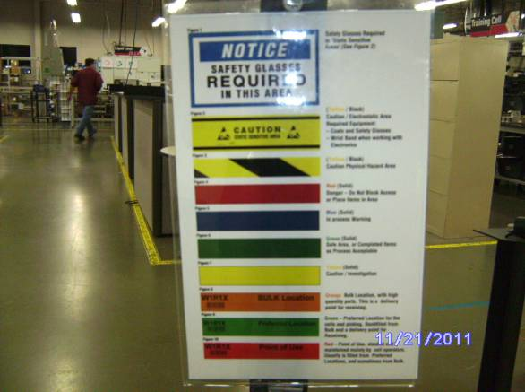 | All areas marked for various equipment and protocol; ESD marking tape identification is yellow with black border. Area inside the tape is deemed as ESD-controlled area.
 | Chairs | 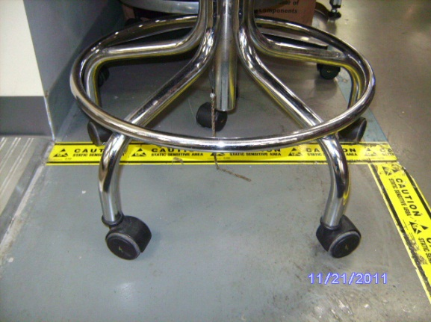 | Chairs are specified as ESD-safe and they can be grounded as an option for each critical area designated.
 | Testers | 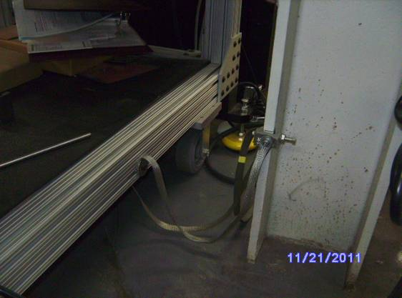 | Heavy duty ground straps used on all testers. R&D department controls this designed aspect of the tester equipment.
 | Drinks | 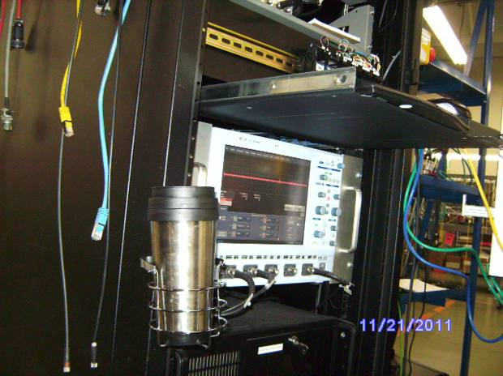 | Only beverage in approved metal closed drink container.
 | Food | n/a | Snacks and similar food are to be stored outside of production area in lockers provided.
 | Tables | 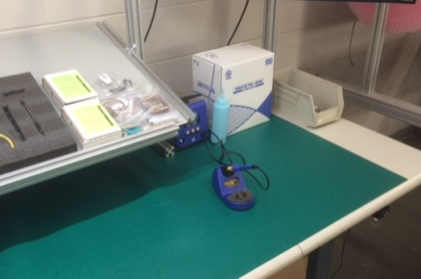 | ESD mats where needed and connected to ground.
 | Circuit board and electronics handling | 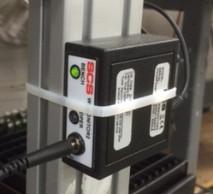 | Plug into continuous (active) ESD monitors; double monitors connected to table mats also as required.
 | Extra Ground Connections | 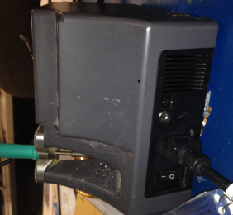 | Some soldering irons have an acceptable electrical ground connection for use.
 | Inbound receiving | n/a | ESD wrist strap and monitor required if handling open PCBs or ASICs. Safety glasses or prescription eyewear with side shields required.
 | Quality Inspection | 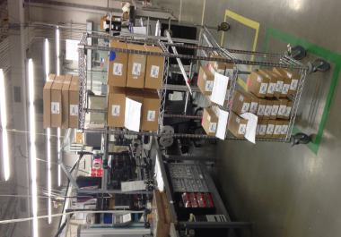 | Inspection of exposed electronics require ESD ground device use. Safety glasses or prescription eyewear required while doing inspections in or out of the area except when using microscopes.
 | Outbound shipping | 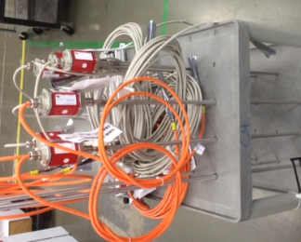 | Non-ESD area but safety glasses or prescription eyewear with side shields required; no sensors allowed to be in area without shipping cap/wire protection.
 | Lotion for ESD strap Connection |  | Special type for ESD use only. Use in cases by employees to improve ground strap connection. Typically not required.
 | General Grounding | 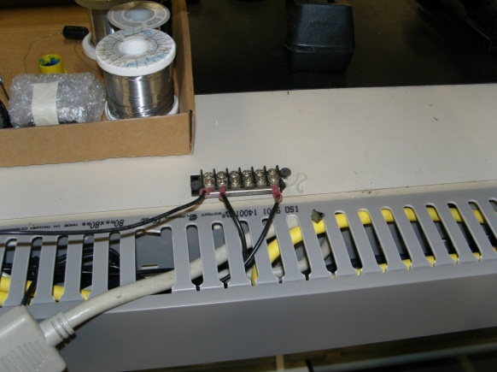 | ESD monitors use electrical ground; earth ground circuit added to all benches and mats shown here; a central copper wire runs throughout building to earth ground.
 | Incoming Material for electronics – Purchasing Guideline | 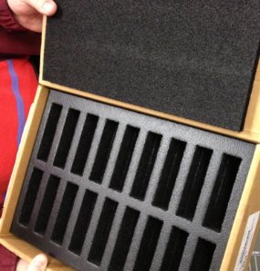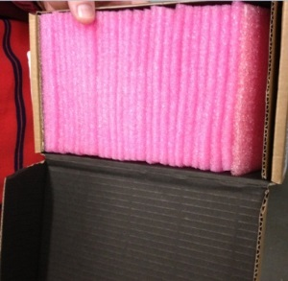 | Dense black conductive PCB storage preferred over antistatic foam type. Box identification, labeling, and ESD seal requirements to be communicated at time of contract or ordering steps.Special electronic component foil wraps or transport protection is of top importance. Special shipment trials or design reviews should always take place for new or improvement supply chain projects.
 | Routing sheet protection | 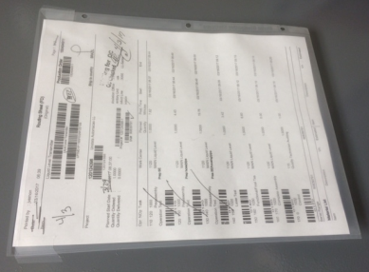 | Router sheets shall be enclosed in antistatic sleeves when mingled with in process electronic products.
 | In Process Electronics storage and transport | 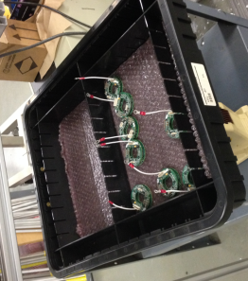 | In process electronic products with an open path to circuits shall be contained within black conductive plastic or fiberboard bins. Bins are to be stored on grounded surfaces.
 | ESD Bags and Packaging | 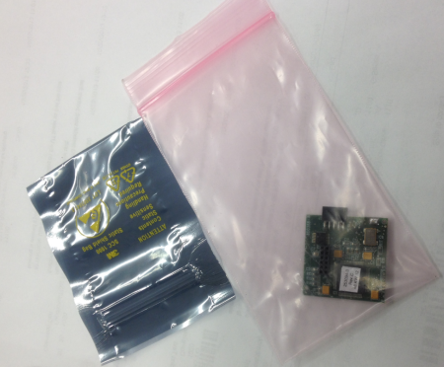 | Foil shielded bags are to be used for outgoing product cable terminations and connectors. Antistatic bags are to be used to provide in process protection of circuit boards.
 | ESD Test Stations for compliance | 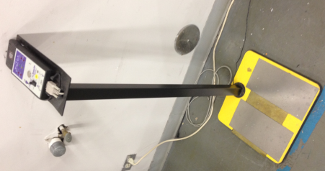 | Associates and supervision have full access to a test station for checking wrist strap function and use in the event the wrist strap or workstation monitoring systems are suspect. Consult QA for assistance.
 | Visitors |  | Vistors are to follow the floor markings and information provided by their tour guide relative to ESD requirements. Generally, visitors will be contained to areas of non-ESD unless for specific visits and audits.

- ESD Training & System Maintenance

Buyer/Planner
- System Maintenance:
  - All electronic devices will be packaged in either the preferred or
alternate method described below when being transported from the
vendor. Reference above guideline section.

A. Preferred: Cardboard cartons with die-cut anti-static foam panels.
B. Alternate: Individual anti-static bags with foam protection for all pins.
Operations/QA

- Training:
  - ESD training is a required component of new hire orientation and yearly refresher training for all operations employees. ESD training is administered by MTS QA.
  - Suppliers should be trained on ESD control, and/or contractually required to train their personnel.

Incoming Insp.
- System Maintenance;
  - Observance of PCB box condition during incoming PCB inspection and alert purchasing of replacement as required
- Training:
  - As required for new products and for hiring orientation

Inventory
- System Maintenance;
  - Observance of PCB box condition at return shipment and alert purchasing of replacement as required
- Training:
  - As required for new products and for hiring orientation

Functional Supv.
- System Maintenance;
  - Monitoring of all ESD requirements for corrective action, use, and requested changes
- Training:
  - As required for new products and for hiring orientation

Facilities Coord. & Quality Management
- System Maintenance;
  - Monitoring of all ESD requirements for corrective action, use, and requested changes
  - Maintain procedures and training requirements of all employees
  - Upgrades system devices as required by internal MTS product needs and national standards for electronic manufacturing methods
- Training:
  - As required for new products and for hiring orientation. Special ESD overview classes to be scheduled as required in conjunction with quality group

All Employees
& Visitors
- System Maintenance;
  - Maintain procedures and training requirements of visitors on an as-needed basis depending on requirements by facilities manager
- Training:
  - As required for visitors and the MTS host

