Contents

1 Purpose 1

2 Scope – applies to where & when the Procedure is used 1

3 Definitions and Acronyms (if needed) 1

4 Graphic (if needed) 2

5 Responsibilities 2

6 Procedure 3

7 Associated Quality Records – as stated in the Quality Records List 11

8 Reference Forms / Templates / Documents 13

9 Current Revision Training Requirements 13

10 Revision History & Approval 14

*Click within the Table of Contents, select* **Update Table > update page numbers**

# Purpose

## Thisprocedure identifies the steps and roles for submitting and managing a Management of Change using the Management of Change data base..

# Scope – applies to where & when the Procedure is used

## This procedure applies to management of change as referenced within the scope of the Management of Change Procedure (EHS-200-132).

# Definitions and Acronyms (if needed)

N/A

# Graphic



# Responsibilities

## **Initiator/Owner**

### Supervisors and/or Managers who recognize changes within their responsibility that meet the scope defined in the Management of Change Procedure (EHS-200-132) and use the Management of Change Database for those situations

## **Contributor**

### Designated subject matter experts for specific types of changes as defined within the Database who are responsible for assisting the owner by reviewing, adding, and acting based on the nature of the change

## **EHS**

### Care and maintenance of the Database to assure its availability and functionality of all users

### Review, approval and closure of MOC Database records

# Procedure

## **Initiator** - Navigate to the Management of Change Database

### Go to the “Quality Management System”

### Click on the “Environmental Health and Safety (EHS)” tab

### Click on the “Risk Assessment-Management of Change” section

### Click on the “Form, Templates and Tools” tab

### Click on the “Management of Change (MOC) Database (electronic replacement for form EHS-500-101)” section

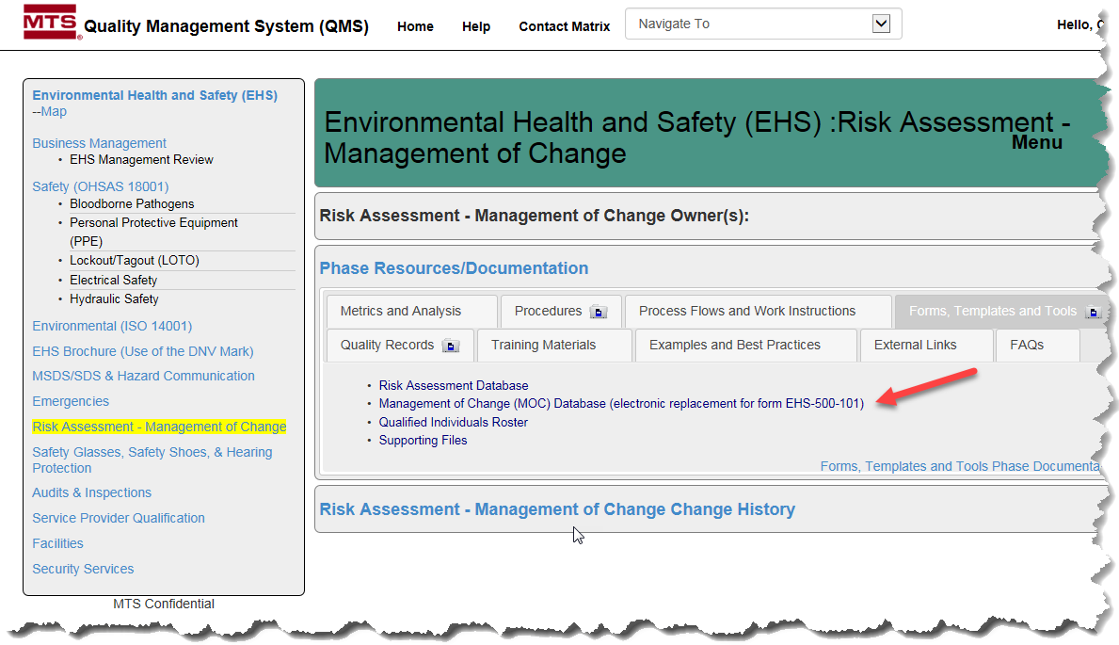

## **Initiator** - Creating a new MOC request

### Click the “Create New” button at the top of the Data Base

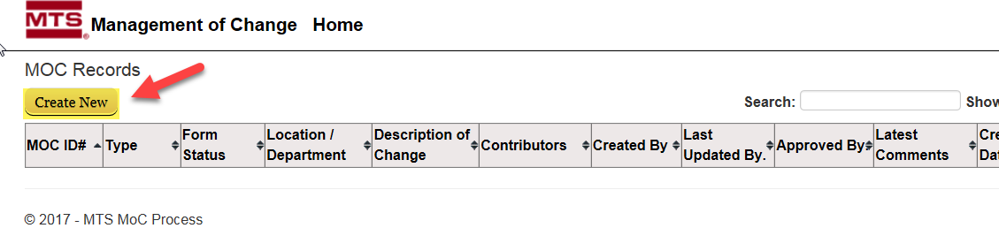

## **Initiator** - Fill in all fields of request form

### Choose the type of request from the drop down list

### Choose all applicable areas

### Fill in chemical Names and CAS Numbers if bringing in any chemicals

### Click Create to Submit MOC request

***Choose the type of***

***request from the drop down list***

## **Initiator** - After the MOC has been created, you will be taken back to the MOC home page. Your MOC entry will be assigned a unique ID# and appear on the MOC Records List.

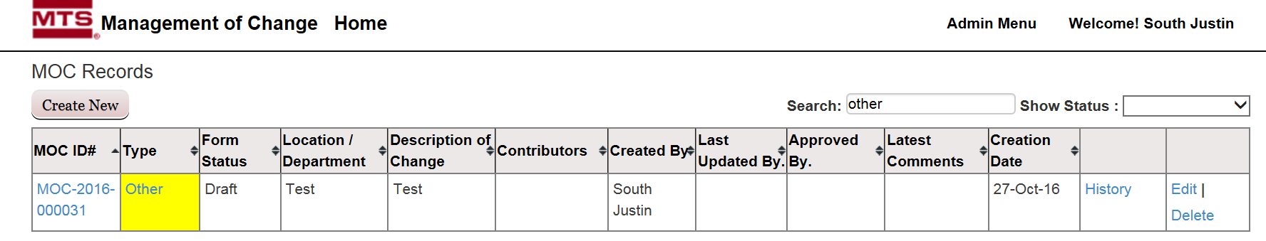

## **All** - An email is generated upon MOC submission and is sent to the MOC originator, MOC database administrators, and the contributors as selected in the MOC

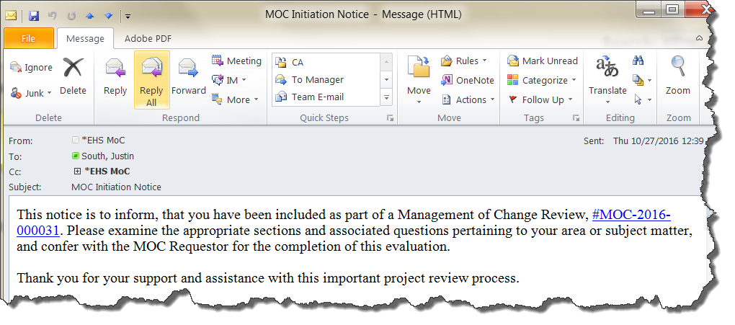

## **Owners** - Owner fills out any additional information needed and saves changes

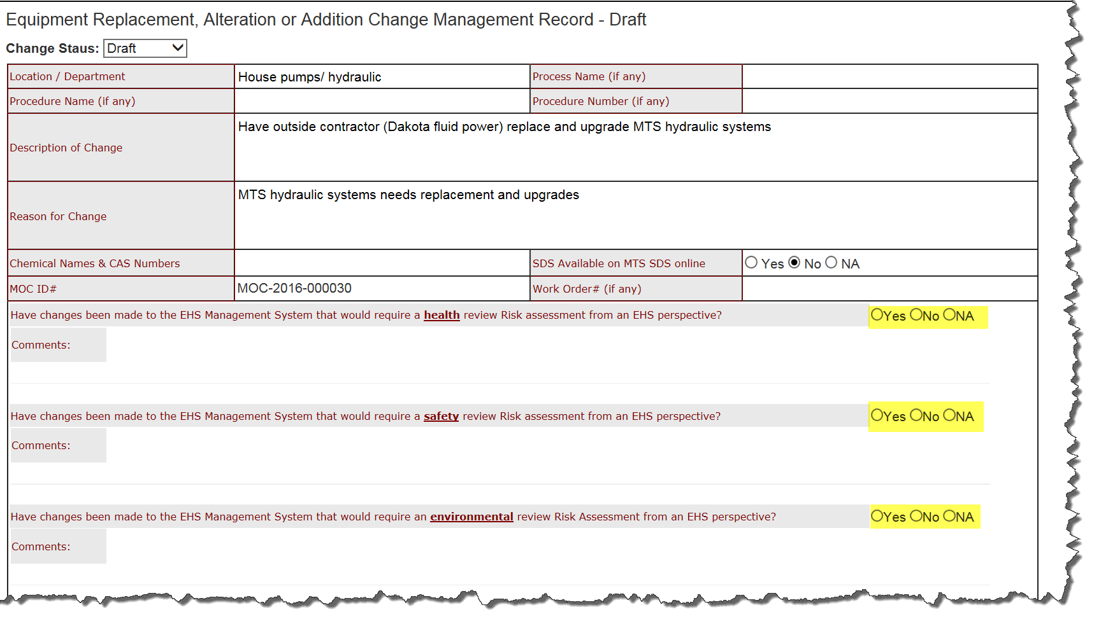

## **Contributors** - Follow the instructions as listed in the initiation notice email, the appropriate sections and associated questions pertaining to the individual’s area or subject matter must be completed as part of the MOC approval process.

### Click the link in the email to go to the draft screen of the MOC

## 

## **Owner** - changes status of the MOC from Draft to Submitted

### An additional window will appear for the owner to provide any direction or necessary information to EHS Review team prior to closure review

### C:\Users\southj\AppData\Local\Temp\SNAGHTML28876f79.PNGClick save to submit

## 

## **All** - an email will be generated and sent out to the MOC Originator, MOC database administrators, and the contributors.

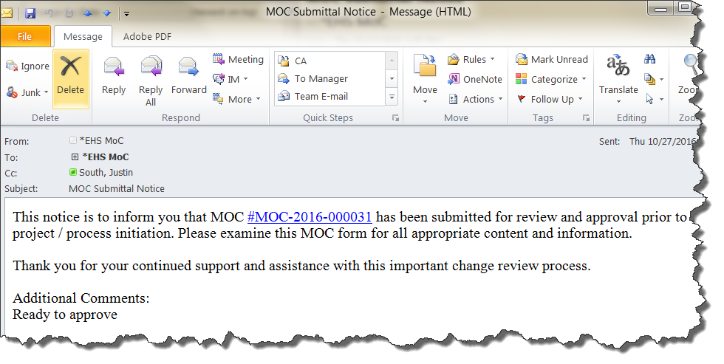

## **All** - Once approved the actions can be implemented. The MOC database entry will be updated to reflect the completion.

## **Owner** - Verifies that all actions have evidence to support their completion

## **Owner** – changes the status from approved to Closure review

### The owner updates the comments field with the appropriate information for the EHS Review team and clicks save

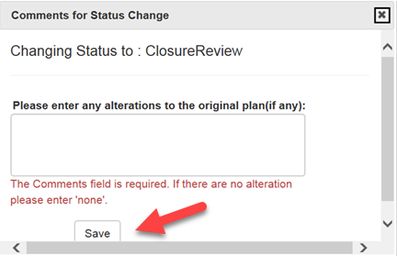

## **All** - an email will be generated and sent out to the MOC Originator, MOC database administrators, and the contributors by the MOC system.

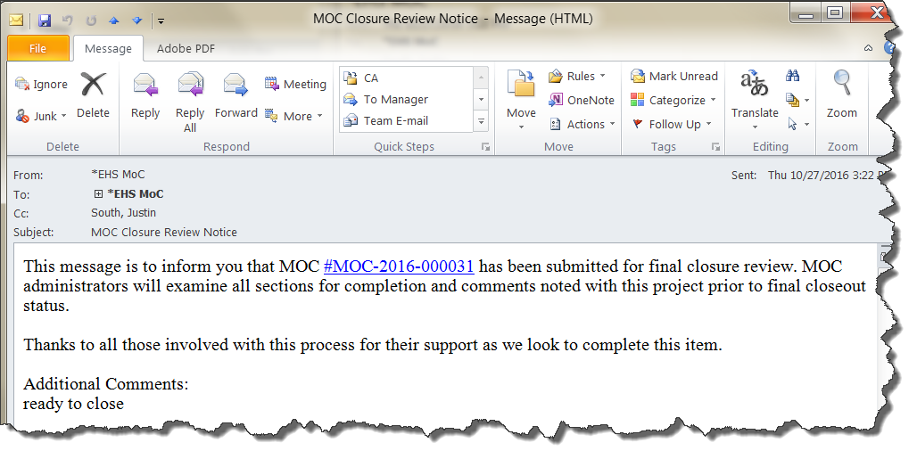

## **EHS** - reviews MOC. Upon approval the MOC is closed.

## **All** - An email is sent to all responsible people indicating that the MOC has been closed

# Associated Quality Records – as stated in the Quality Records List

*Enter resulting document or record to be kept on the QMS records list.*

|  |  |
| --- | --- |
| **Required Record** | **QMS Web Location** |
| MOC Unique ID | MOC Database |
|  |  |
|  |  |

# Reference Forms / Templates / Documents

|  |  |
| --- | --- |
| **Form / Template / Document Title** | **QMS Web Location** |
| Management of Change | EHS Web |
|  |  |
|  |  |
|  |  |

# Current Revision Training Requirements

Training requirements are determined by the document owner.

1. List required LMS Course Number.
2. Checkmark which type of training.
3. List the functions or groups that require the training.

|  |  |  |  |  |
| --- | --- | --- | --- | --- |
| **LMS Course Number** | **Read & Acknowledge** | **Read &**  **Test** | **Instructor Evidence** | **Functions or groups that require this training** |
|  |  | X |  | Manufacturing managers and supervisors, Engineering managers and supervisors, facilities, material handling, logistics and EHS |
|  |  |  |  |  |
|  |  |  |  |  |

# Revision History & Approval

|  |  |  |  |
| --- | --- | --- | --- |
| **Revision History** | | | |
| **Rev** | **Description of Change** | **Author** | **Effective Date** |
| A | Initial Release | Caitlin O’Leary | 10/10/2017 |
|  |  |  |  |
|  |  |  |  |

|  |  |  |
| --- | --- | --- |
| **Required Approvers for Current Revision** | | |
| **Name** | **Function** | **SharePoint Approval** |
| Steven Harrison | President Vehicles & Structures Test Systems |  |
| William Becker | President Materials Test Systems |  |
| Stephen Jordheim | QMS-EHS Systems Manager |  |

*Approvers must include the managers of the functions listed within the Responsibility Section*

*The Quality Management Representative shall approve Test-wide procedures*