Document Control Bill of Manufacturing Responsibilities

1.0 INTRODUCTION

This work instruction describes the processes and responsibilities of the Document Control clerk for entering parts into the Business System Database (BSD) - Bill of Manufacturing.

2.0 DESCRIPTION

This work instruction details the responsibilities of the Document Control clerk in creating parts in the Business System Database (BSD) - Bill of Manufacturing.

3.0 Definitions

Bill of Manufacturing – The list of all parts, quantities and times needed to build the item.
Bill of Materials – The list of all materials and quantities needed for the Bill of Manufacturing.

4.0 LIMITATIONS

This process is limited to the duties of the Document Control Clerk or a designated representative.

5.0 MATERIALS, TOOLS, & EQUIPMENT

Computer
Business System Database (BSD)

- PROCEDURE

6.1 Creating a new Bill of Manufacturing

- An Engineer is the only one who can request that a Bill of Manufacturing (BOM) be created.
- The Engineer will give Document Control an Item Creation form that lists the part number and all relevant information for the BOM to be created. The part will need to be entered into the BSD before a BOM can be created (see D0001.4029).
- In the BSD from the Items (Filter in Place) Tab, search for, and open the item that needs a new BOM.
Enter the Item number in the Item field.
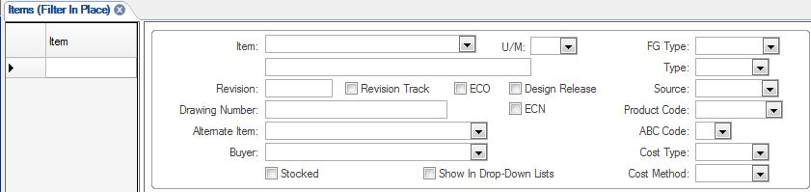

- Click the Filter in Place icon in the toolbar at the top of the page:

- This will open the item’s page in the BSD. The item number will appear at the top of the page:
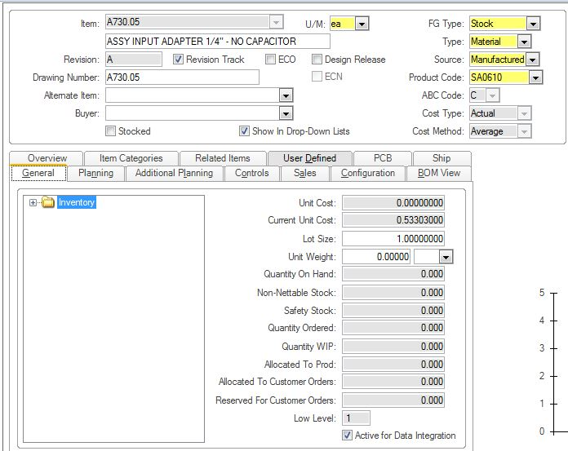
- Make sure the Revision Track box is unchecked. If the box is checked, you will not be able to create a BOM:
- Then open the Current Operations and Current Materials sub-tabs by clicking the buttons to the right of the screen:

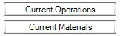

- In the Current Operations sub-tab, the item will appear at the top of the page:
Click the asterisk to the left of the page to add a new operation to the BOM.

The Operations section will be below the grey item information section:

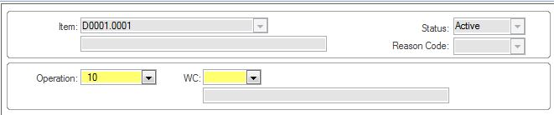

Enter the operation number provided by the Engineer. All operations lists begin with “10”.

Click the WC drop-down menu to select the correct operation. Most
operation lists will start with UT100 Kitting-Logistics:

Click the “Save” icon in the toolbar once the operations have been entered.

- Once all of the operations have been added, go to the Current Materials sub-tab, the item will appear at the top of the page:

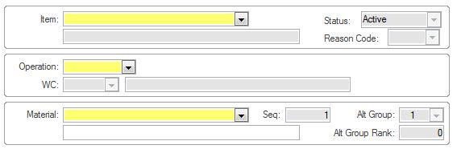
Click the asterisk to the left of the page to add a new material to the BOM.

Select the operation number from the Operation drop-down menu.

Enter the item number in the Material field. The item description will appear in the grey field to the right.

Enter the quantity of the item required in the Quantity field. It will default to 1.00000.

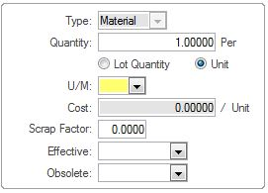

Click the “Save” icon in the toolbar once the operations have been entered.

  - Modifying an existing Bill of Manufacturing

- If a BOM needs to be modified, Operational steps and Materials will be added the same as in section 6.1. To delete Operational steps or Materials you will click on the “Delete” icon instead of the asterisk.

6.3 Copying a BOM from an existing part

- From the main menu in the BSD, click the Open Form icon to open the Copy Routing BOM form.

- Find the form by using the Filter field at the bottom of the pop-up window. Enter “Copy” in the field, and click the “Filter” button. This will bring up all forms that have “Copy” in their title.

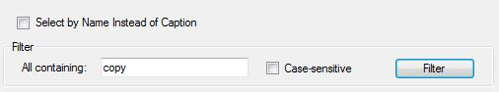

The list will appear at the top of the window. Select “Copy Routing BOM” from the list, and click “OK” at the bottom of the window.

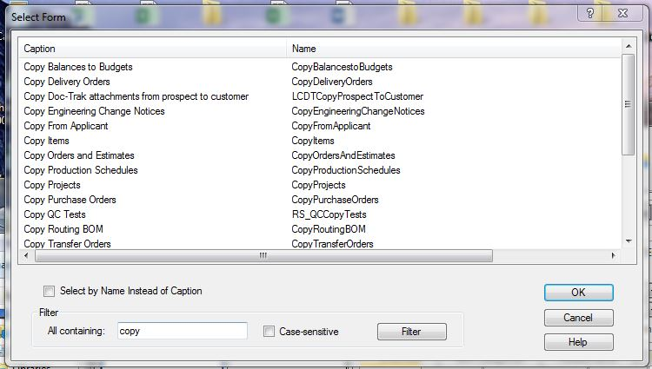

The Copy Routing BOM form will open.

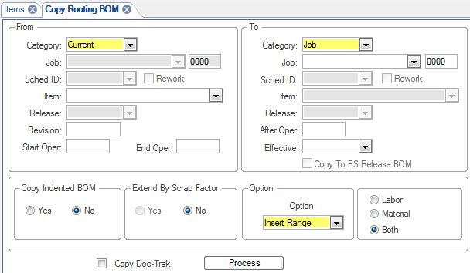
- Fill in the following information:
- In the “From” column, “Category” field, select “Current” from the drop-down menu.

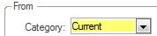

- In the “Item” field, enter the item whose BOM you wish to copy

- The “Revision Field” can be left blank. This is filled in automatically from the Item Master

- The “Start Oper” field will auto-populate with information from the Item’s Operations list. The starting operation should be 10 for every item.

- The “End Oper” field will auto-populate with information from the Item’s Operations list. The ending operation should be 998 for every item.

- In the “To” column, “Category” field, select “Current” from the drop-down menu, and enter the new item number in the “Item” field.

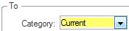

- The “Effective” field will default to today’s date

- “Copy Indented BOM” will be “No.” This cannot be changed.

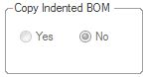
- The “Extend by Scrap Factor” button should be left at its default of “No.”

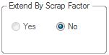

- In the “Option” field, select “Insert Range” from the drop-down menu.

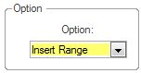

- In the “Labor, Material, or Both” section, click the “Both” button should default to “Both.”

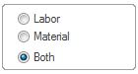

- Click the “Process” button to copy the BOM

- After you have copied the BOM, be sure to go to the new BOM that you created, and make any necessary modifications.

7.0 EVALUATION

N/A

8.0 RECORDS

9.0 REVISION HISTORY

DCO # | REV | DATE | INITIALS | CHANGES MADE
 | A | 11/7/01 | SW | Initial Release
DCO391 | B | 3/7/02 | SW | Add how to verify if drawing revision updates on BOM
446 | C | 7/25/02 | SW | Add how to reset and implode costs
461 | D | 9/6/02 | MB | Clarified how to reset and implode costs
802 | E | 8/25/04 | SLB | Made the work instruction flow more smoothly
1022 | F | 7/2/07 | HKB | Updated to new BSD
1913 | G | 3/17/20 | LAB | Updated to new BSD and procedures

