Document Control Filing Responsibilities

1. **INTRODUCTION**

This work instruction documents where to file controlled documents in Document Control.

**2.0 DESCRIPTION**

This work instruction documents where to file controlled documents in Document Control.

1. **DEFINITIONS**

BSD – Business System Database.

Controlled Documents – Digital or hard-copy documents—ie. policies, procedures, drawings, work instructions, etc.—that are required by the quality management system to be managed by the document control procedure (see D0001.1017 Document Control System).

Document Control – Department and system to maintain and secure controlled documents.

1. **LIMITATIONS**

This is limited to the Document Control Clerk or assigned individual(s).

1. **MATERIALS, TOOLS, & EQUIPMENT**

Computer

File Cabinets

Book Shelves

1. **PROCEDURE**

No documents should be filed in Document Control without proper authorization. All drawings, documents, etc., require approval before they can be filed to Document Control. The only exceptions are documents of external origin (i.e. standards, manuals for non-LD products, etc.), which can be filed and without written approval.

**6.1 Filing Locations**

1. Drawings – only electronic versions are filed in Document Control. For a drawing to be filed, one of the following qualifications must be met:

* It is an unreleased drawing (there is a “^” in the BSD description field)
* There is an ECO that is making the drawing valid (for current drawings)
* Documents will only be stored and filed in an electronic format, unless it is not feasible. Reasons why it would not be feasible are:

*Document is an external product manual

*Document is grandfathered

* 1. **Current Drawings**

Only the newest revision of a drawing will be located in the current drawings folder, located at R:\Provo\Engineering\Docs\ENG\Drawings\Current Drawings\ correct product folder. Add all drawings to DocTrak in the BSD when the drawing has been filed in the correct folder.

* 1. **Old Drawings**

Old revisions are placed in the Old Drawings folder when a new version is released. The folder is located at R:\Provo\Engineering\Docs\ENG\Drawings\Old Drawings\ correct product folder.

* 1. **Unreleased Drawings**

Unreleased drawings should not be distributed without approval from the Engineer who created it. This is usually done during the ECO review and approval process. Unreleased drawings are located at R:\Provo\Engineering\Unreleased Drawings\ correct product folder.

* 1. **Obsolete Drawings**

Obsolete Drawings are maintained in case the drawing is needed in the future. They are located at R:\Provo\Engineering\Docs\ENG\Drawings\Obsolete Product Drawings.

1. Other Documentation
   1. **Completed Engineering Change Orders (ECO)**

All ECOs are stored electronically in the DCO’s & ECO’s folder located at R:\Provo\Engineering\ENG\DCO's & ECO's\Completed\. There are folders to divide the ECOs and DCOs by thousands (ie. ECO'S #1000). The ECO will be found in the appropriate folder.

Once an ECO is complete, the old revision of the document or drawing will need to be moved into its corresponding Old/Obsolete folder. The new revision will be moved from the corresponding Unreleased folder to the Current folder.

The Document Control Clerk must add the ECO and the document or drawing to DocTrak in the BSD.

* 1. **Completed Document Change Orders (DCO)**

All DCOs are stored electronically in the DCO’s & ECO’s folder located at R:\Provo\Engineering\Docs\ENG\DCO’s & ECO’s\Completed\. There are folders to divide the ECOs and DCOs by thousands (ie. DCO’S #1000). The DCO will be found in the appropriate folder.

Once a DCO is complete, the old revision of the document will need to be moved into its corresponding Old/Obsolete folder. The new revision will be moved from the corresponding Unreleased folder to the Current folder.

The Document Control Clerk must add the DCO and the document to DocTrak in the BSD.

c. **Product Obsolescence Forms (SM026)**

The SM026 forms are stored electronically in two places on the R:\ Drive. The first is in R:\Engineering\Obsolete SM026 Records and the second is in R:\Provo\Engineering\Docs\ENG\Obsolete SM026 Records. The first location allows PCB to access the records, and the second location allows local users to access the files without having to search for them.

The Document Control Clerk must add the SM026 to DocTrak in the BSD for each item listed on the Obsolete form.

d. **Item Creations**

All Item Creation forms are stored electronically in the Item Creation folder located at R:\Provo\Engineering\Docs\ENG\Item Creations\ correct numbered folder. There are folders to divide the Item Creation forms by number, or letter for items that are added to the BSD.

The Document Control Clerk must add the Item Creation form to DocTrak in the BSD for the item listed on the form.

e. **Standards**

Most current standards are stored electronically in the Standards folder located at R:\Provo\Engineering\Docs\ENG\Standards\. There are folders to divide the standards by organization (ie. ACGIH, IEC, IEEE, MSHA, etc.). Some of the ISO Standards are monitored by the Quality Manager and are stored in R:\Provo\Quality\ISO Standards\. There are folders to divide the ISO Standards by type (ie. ISO 9001, ISO 17025, etc.).

All old standards are stored in the Old or Archive Standards folder located in each Standard’s folder.

Each time a new standard is provided to Document Control by Quality Assurance, Sales or Engineering, the Document Control Clerk needs to update the Standards Ledger (D0001.4003-1 Standards Ledger) located at R:\Provo\Engineering\Docs\ENG\Standards\D0001.4003-1(A) Standards Ledger.xls.

* If the Standard is replacing an older version of the Standard, place the old version in the Old tab on the Standards Ledger.
* If the Standard is new, enter the relevant information on the Current tab.

A Standards Review Meeting should be held every two years to determine which Standards need to be updated. The Document Control Clerk will need to set up this meeting.

f. **External Equipment Manuals**

Equipment operator manuals are maintained by Document Control   
 and are located in the shelves near the rear of the South Building.

g. **Engineering Specifications**

All Engineering Specifications are saved electronically in the following   
 location: R:\Provo\Engineering\Docs\Engineering Specifications\   
 product appropriate folder.

h.  **Manuals**

LD’s product manuals are stored electronically in   
 R:\Provo\Engineering\Docs\LD Datasheets, Manuals, & Price   
 Lists\Manuals\Current Manuals\ and the appropriate product folder.

The Document Control Clerk must add the Manual to DocTrak in the   
 BSD for the item listed on the form.

i. **Waivers**

Waivers are stored electronically in R:\Provo\Engineering\Docs\ENG\   
 Waivers

The Document Control Clerk must add the Waiver to DocTrak in the   
 BSD for the item listed on the form.

k. **Design Files**

Design Files are stored electronically in R:\Provo\Engineering\Docs\  
 ENG\Design Files\ appropriate product folder.

*The following are instructions for linking files, such as Item Creation forms, ECOs, DCOs, SM026 forms, documents and drawings, to the Items forms in the BSD DocTrak. This makes it easier for all users to find the documents at a later date.

Open the BSD and go to the Items Form. Search for the Item number by entering it in the Item Field, and click the Filter in Place icon in the tool bar.

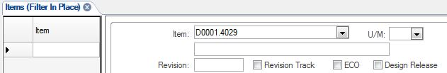

Search Magnify Glass

This will open the Items Form for the Item.

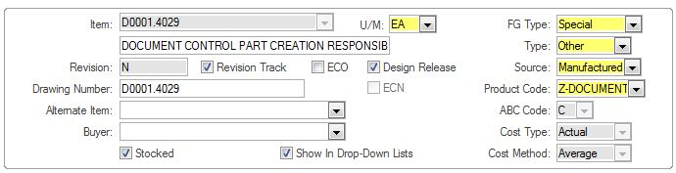

Click the DocTrak Icon in the tool bar to open the DocTrak page.

Items doc trak icon

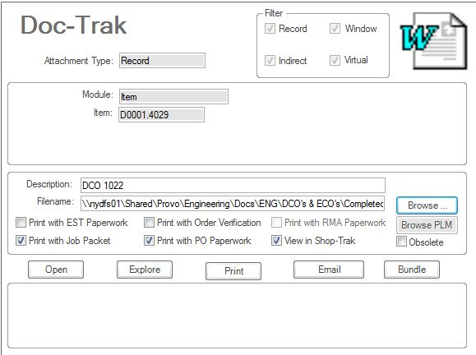

Click the New icon (Asterisk) to the left of the page to create a new record.

asterisk

Enter the drawing’s or document’s title in the Description field and use the Browse button to search for and attach the file to the BSD.

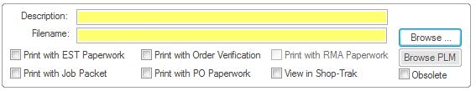

Click the Save icon in the tool bar, and return to the Items form. Close the BSD.

Save

**6.2 Electronic Naming Convention**

**1. Drawings – Electronic Drawings**

A Drawing’s electronic file name consists of three parts:

(1) Drawing Number, (2) Revision and (3) Description.

Example: A730.01-IS(D) Schematic.PDF.

**2. Documents – Electronic Documents**

A Document’s electronic file name consists of three parts:

(1) Document Number, (2) Revision, and (3) Description.

Example: D0001.4003(L) Document Control Filing Responsibilities.

There are two types of documents in Document Control – Policies and   
 Procedures and Work Instructions. These are located in   
 R:\Provo\Quality\Quality Management System\Policies and Procedures and   
 R:\Provo\Quality\Quality Management System\Work Instructions.

**6.3 Sending Electronic Files**

Document Control should not distribute any document within its control to any party outside of direct PCB Piezotronics employees. This restriction includes distributors and sales representatives. Distribution to outside parties will be controlled by other departments such as Sales, Manufacturing, Purchasing and Engineering.

**7.0 EVALUATION**

Not applicable

**8.0 RECORDS**

No records are generated by this procedure. The details of this instruction indicate where documents and other records may be stored in Document Control.

**9.0 REVISION HISTORY**

|  |  |  |  |  |
| --- | --- | --- | --- | --- |
| **DCO #** | **REV** | **DATE** | **INITIALS** | **CHANGES MADE** |
| 449 | A | 8/1/02 | SW | Initial Release |
| 546 | B | 5/29/03 | MB | Strengthening locations and instructions for storage of controlled documents, updated location of vendor emails. |
| 598 | C | 8/13/03 | SLB | Rewrite of the procedure |
| 640 | D | 10/1/03 | SLB | Updated paths |
| 665 | E | 11/3/03 | SLB | Gave ledgers numbers and included minutes from meeting section |
| 669 | F | 11/26/03 | SLB | Added the media cabinet section |
| 708 | G | 2/17/04 | SLB | Modified the paths of the work instructions |
| 803 | H | 8/25/04 | SLB | Added more to standards area and did all around modification |
| 824 | I | 12/20/04 | SLB | Added section about USB Product ID |
| 1031 | J | 8/8/07 | HKB | Updated where the current drawing files are stored on the network. Removed references to Visual. |
| 1266 | K | 9/23/09 | WJM | Updated to file electronically & Doc-Trak instructions. |
| 1947 | L | 10/1/20 | LAB | Complete rewrite to update to current procedures and BSD. |