Document Control Product Obsolescence Responsibilities

**1.0 INTRODUCTION**

This work instruction documents the responsibilities of the Document Control Clerk for processing and tracking the "Product Obsolescence" process.

**2.0 DESCRIPTION**

Procedures to follow when a product is made obsolete, and will no longer be sold or serviced. The Document Control Clerk has the responsibility to receive and track Obsolete Product requests from Sales and/or Management, and to verify that all approvals have been received prior to making the product obsolete in the BSD.

**3.0 DEFINITIONS**

SM026 – Obsolete Products Form and Procedure

Corrective-Preventative Action Request (QC/Quality Concern) – Documented method that encompasses corrective, preventive actions, root cause investigation, resolution and customer satisfaction. The request is used for communicating customer and employee concerns about processes, procedures or products that may affect the quality and reliability of the finished product or service.

Obsolete – A product or material that is no longer manufactured or used in the manufacturing of new commodities.

End of Life – A date after which a product will no longer be supported, serviced, or calibrated.

**4.0 LIMITATIONS**

This process is limited to the duties of the Document Control Clerk or designated representative as outlined here and through the procedures listed below.

D0001.1015 Product Obsolescence Procedure

D0001.1020 Corrective-Preventive Action

SM026 Obsolete Products Form and Procedure found in TCS

**5.0 MATERIALS, TOOLS, & EQUIPMENT**

Computer

SM026 Form

Email Software

Business System Database (BSD)

1. **PROCEDURE**
   1. **SM026 Form**

Any employee may make a request for a product to be made obsolete. This request needs to be made by filling out the SM026 Obsolete Products Form. This should be done prior to the request being submitted to the Document Control Clerk. The form should have the requesting employee’s name, request date and reason(s) for obsoleting the product.

The Document Control Clerk may receive the SM026 Form in one of two ways, Paper or Email.

When submitted in paper form, the paper copy will be signed by the requesting employee, and by a representative from Sales/Marketing. If these signatures are not present, the Document Control Clerk will need to have the individuals sign the form.

When submitted via email, there should be a pdf scan of the SM026 form. If the form is signed by the requesting employee and by Sales/Marketing, then the form can be processed. If not, send an email to each of those who need to sign the form and have them sign it, either digitally or by hand, and return the form to Document Control.

Once the form is properly filled out and signed, scan a copy and save it to be stored in one of two places.

Finished good items need to be sent to PCB so they can obsolete them in the PCB side of the BSD. These will be saved in the following location: R:\Engineering\Obsolete SM026 Records.

Non-finished good items are not saved in the PCB side of the BSD so they do not need to be sent to PCB. They will be saved in the following location: R:\Provo\Engineering\Docs\ENG\Obsolete SM026 Records.

* 1. **Making a Product Obsolete in the BSD**

Open the BSD and go to the Items Form. Search for the Item number by entering it in the Item Field, and click the Filter in Place icon in the tool bar.

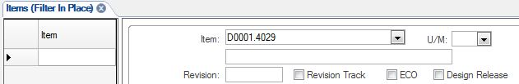

Search Magnify Glass

This will open the Items Form for the Item.

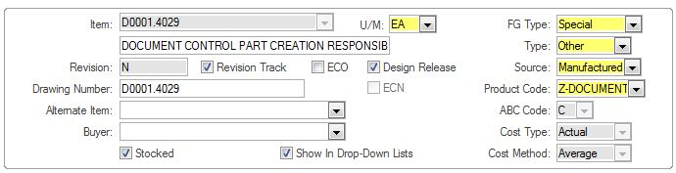

Add “-OBSOLETE” or “-OBS” to the description field if there is space – some descriptions are long and this cannot be done. If there is not enough space, skip this step.

obsolete description field

Click the “Controls” tab in the lower portion of the page. This will open the Controls section of the BSD.

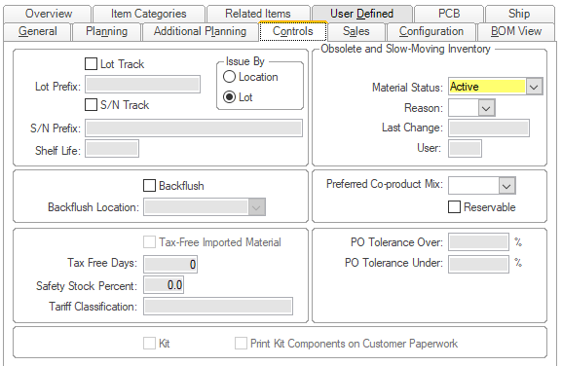

The Obsolete and Slow-Moving Inventory section will be to the right of the Controls section.

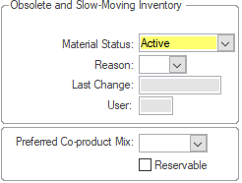

Select “Obsolete” in the Material Status drop-down menu, and “OBS” in the Reason drop-down menu. The BSD will not allow the Item Form to be saved if both the Material Status and Reason drop-down menus are incomplete.

The Last Change and User fields will auto-populate with the date the part is made Obsolete and Document Control Clerk’s initials.

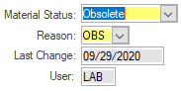

Click the Save icon in the tool bar to save the changes made on the Items Form.

Save

Click the Notes icon in the tool bar to add a note stating that the Item is now obsolete.

notes icon

The Subject field needs to be completed. The note will not save if the field is left blank. If there are no current notes, and the field is blank, choose “General” from the drop-down menu. Enter a note stating that the Item is obsolete, and why.

Refer to the following example for a note idea:

OBSOLETE PER REQUEST FROM LOGISTICS AND SM026 FORM – 09/29/2020.

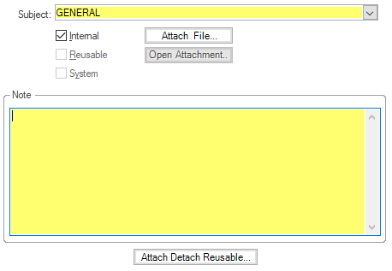

Click the Save icon to save the Notes, and then return to the main Items page when all notes have been entered.

Save

Click the DocTrak Icon in the tool bar to open the DocTrak page.

Items doc trak icon

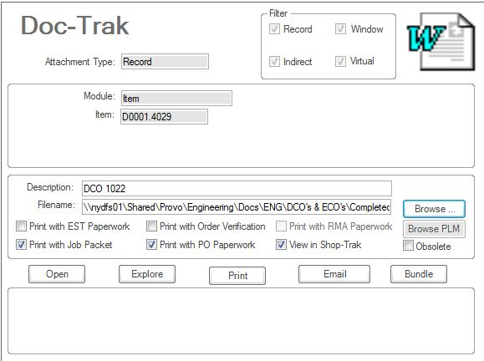

Click the New icon (Asterisk) to the left of the page to create a new record.

asterisk

Enter SM026 OBSOLETE FORM in the Description field and use the Browse button to search for and attach the SM026 form to the BSD.

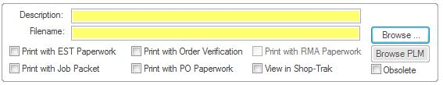

Click the Save icon in the tool bar, and return to the Items form. Close the BSD.

Save

**7.0 EVALUATION**

N/A

**8.0 RECORDS**

Electronic copies of the SM026 Forms are saved on the R:\ Drive in R:\Engineering\Obsolete SM026 Records and R:\Provo\Engineering\Docs\ENG\Obsolete SM026 Records. These forms are saved indefinitely. No additional records are generated or maintained as a result of this instruction.

**9.0 REVISION HISTORY**

|  |  |  |  |  |
| --- | --- | --- | --- | --- |
| **DCO #** | **REV** | **DATE** | **INITIALS** | **CHANGES MADE** |
|  | A | 9/30/02 | MB | Initial Release |
| 638 | B | 10/1/03 | SLB | Updated paths and added Product Obsolescence Ledger as a referenced document |
| 708 | C | 2/17/04 | SLB | Updated paths |
| 2000 | D | 9/29/20 | LAB | Complete rewrite to update to current procedures and current BSD. |
|  |  |  |  |  |
|  |  |  |  |  |