DOCUMENT CONTROL PROCESSING OF ECOs

**1.0 INTRODUCTION**

This work instruction describes the processes and responsibilities of the Document Control Clerk for completing an Engineering Change Order (ECO).

**2.0 DESCRIPTION**

Engineering Change Orders (ECOs) are used to document and communicate changes to released parts, products, and assemblies. The ECOs are submitted to the Document Control Clerk, or a designated representative, for processing.

**3.0 DEFINITIONS**

BOM – Bill of Materials/Bill of Manufacturing

BSD – Business System Database

Document Control – Department and System to maintain and secure controlled documents

ECO – Engineering Change Order

**4.0 LIMITATIONS**

This process is limited to the duties of the Document Control Clerk or designated representative.

**5.0 MATERIALS, TOOLS, & EQUIPMENT**

Computer

ECO Form

Email Software

Business System Database (BSD)

**6.0 PROCEDURE**

# 6.1 Distributing an ECO for Approval

* Only Engineers are authorized to submit ECOs
* All ECOs received in Document Control are to be sent out for approval within 24 hours
* If an ECO requires changes to drawings or files, Document Control is required to have the updated files to process the ECO.

1. ECOs are submitted to Document Control via email. Open the ECO email and save the ECO (Word document) with the file name “ECO number - Name.docx” (example ECO 5032 – S730.03-IS Design Update.docx) in a new folder in the following location: R:\Provo\Engineering\Docs\ENG\DCO's & ECO's\InProcess. The ECO number is provided by the Engineer. The Engineer will get a number from the ECO Numbering Ledger. The Ledger is found in a folder on the wall near Document Control. If the ECO does not have a number, look up the next available number in the ECO Numbering Ledger and assign the next number, being sure to fill in the submitting Engineer’s name and ECO title in the space available, and return the Ledger to the folder.
2. Check the ECO form to make sure it is filled out correctly, (see D0001.1022). Verify that the files referenced in the ECO are in the locations provided in the ECO Form. If they are not in the correct locations, contact the originating Engineer and ask to have the files added to the correct locations.
3. If the new ECO is a revision of a previous ECO, move the previous ECO folder to the Rejected folder.
4. Go to R:\Provo\Engineering\Docs\ENG\DCO's & ECO's\InProcess and move the rejected ECO to R:\Provo\Engineering\Docs\ENG\DCO’s & ECO’s\Rejected
5. Move any emails associated with the rejected ECO out of the inbox, and into an email folder for ECOs, or delete the emails.
6. Create a new email in the email server and complete the following items on the new email:
7. To – Add all employees listed on the ECO page. These are the individuals who will approve the ECO.

U:\FY2020 Goal Tracking\Document Control Rewrites\Graphics\ECO To field.PNG

1. Subject – Add the ECO number, Document title and “For Approval” and the date.

U:\FY2020 Goal Tracking\Document Control Rewrites\Graphics\eco subject.PNG

1. Body – State what the email is regarding, and include any links provided by the Engineer for any files, drawings or documents. The following example clearly states what the email is regarding, the links to the files, and that there are attachments included with the email.

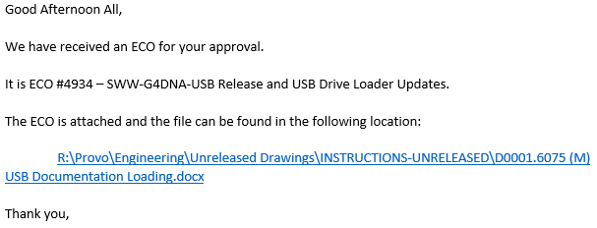

1. Adding Attachments – Click the “Attach File” button in the email, and browse to the file’s location. Highlight the file, and click “Insert” to attach the file. Do this with all files needed for the ECO approval.

email attach file

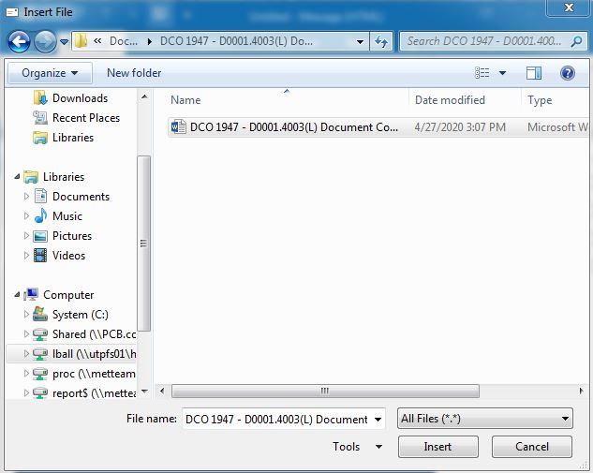

1. Adding Hyperlinks – A link to the document is required if the document being modified is too large to send through an email. Go to the body of the email, and hold press Ctrl K on the keyboard. This will open a browse window. Find the file, and click “OK”. The link will be added to the email. Check the link to verify that it works.
2. Adding Voting Buttons – Click the “Options” tab at the top of the email. Click the “Use Voting Buttons” button and select “Approve; Reject” from the drop-down menu.

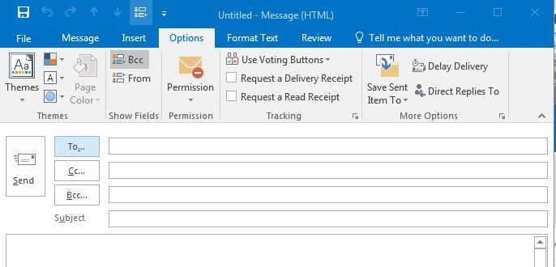

1. Delivery Options – Click the tiny square with an arrow to open the Message Options window. Click the checkbox by “Have replies sent to” and make sure the Document Control Clerk’s name shows in the field. Make sure that “Save copy of sent message” is selected. Then click the “Close” button.

email open options

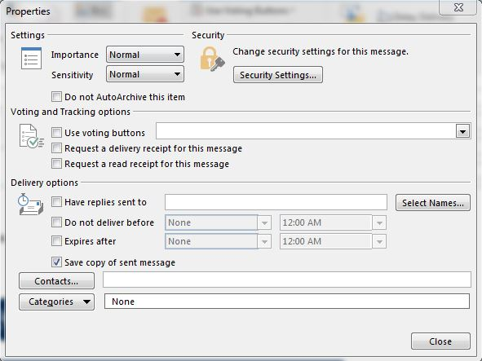

1. Click the “Send” button to send the email to the selected individuals.

email send

# 6.2 Processing an Approved ECO

1. Use the following steps to check the approval status of the pending ECOs.
2. Go to the email server and enter the ECO number in the search field.
3. The emails related to the ECO will appear in the list.
4. Open one of the reply emails to see who has voted on the ECO. Either “Approve” or “Reject” will be in the Subject line..
5. The body of the email will say, “The sender responded: Approve.” Or “The sender responded: Reject.” Click the body to open the Voting Responses. All of the responses, including the date and time they were submitted will appear in the email.

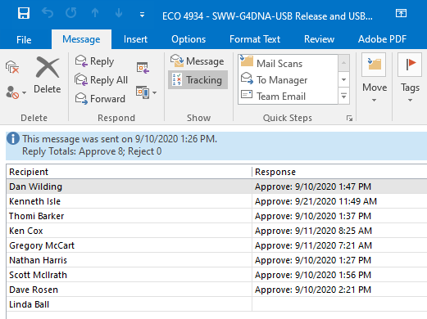

* Open the ECO form and enter the date that each person responded to the ECO. If the ECO is marked as “rejected” by any responder, send an email to the group to let them know that the ECO was rejected, and that a new revision will be sent around for approval once it is available. If the person who rejected the ECO gave a reason, include it in the email.
* Close the ECO if there are missing responses. These will be added to the form as the responses become available.
* Print the completed Approval List email as a PDF, and save it in the InProcess folder if all of the responses are in. Use the following example to name the PDF file: ECO 4937 – SWW-G4DNA-USB Release and USB Drive Loader Updates – Approval List – 09.10.2020.
* If all of the responders voted “Approve,” the Document Control Clerk should make sure all of the responded dates are correct on the ECO form, and enter their name in the space provided at the bottom of the form. Then mark the checkboxes beside additional items in red to the right of the page. Then mark all of the checkboxes on the Items pages through the rest of the ECO. Print the ECO form as a PDF and save it in the ECO folder in the InProcess folder in the R:\ Drive.

1. Open Acrobat Distiller and use the Combine Files Tool to merge all of the PDF files associated with the ECO, and save the merged document in the InProcess folder in the R:\ Drive. Use the following example to title the completed PDF: ECO 4937 – SWW-G4DNA-USB Release and USB Drive Loader Updates with Approval List – 09.10.2020.
2. Save a copy of the completed ECO PDF file in the appropriate Completed DCO’s & ECO’s folder in the R:\ drive. R:\Provo\Engineering\Docs\ENG\DCO’s & ECO’s\Completed and then the appropriately numbered DCO’s folder.

*Review the ECO form, starting with the “L/D Item #” on page 3 of the form. Each item will have its own page. The “L/D Item #” field tells the Document Control Clerk where to begin processing the ECO in the BSD. The “Disposition of Old Revision Item” section will tell Production and Logistics what needs to happen with current stock. Document Control does not need to do anything with this. Simply verify that under the drop-down menus have been filled out. The “Affects/Changes” section will show the Document Control Clerk the Old Revision and the New Revision of the item being updated. Mark the “Done” check box and enter the date that the ECO is being processed. The “Instructions” section will give all of instructions provided by the originating Engineer to process the ECO.

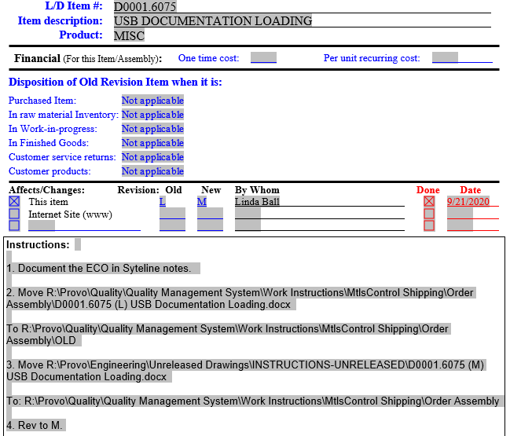

* If there are Drawing, Document or Software files that need to be moved from their “Current” folders to the “Old” folders, these will be listed in the “Instructions” section of the ECO form. Open the Current, Old and Unreleased folders on the R:\ Drive and move the correct items from the Current folder to the Old folder, and from the Unreleased folder to the current folder. Do this for each item page on the ECO.

1. Process the BSD work required by the ECO.
2. Open the BSD and go to the Items Form. Search for the Item number by entering it in the Item field, and click the Filter in Place icon in the tool bar.

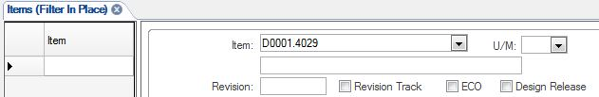

Search Magnify Glass

This will open the Items Form for the Item.

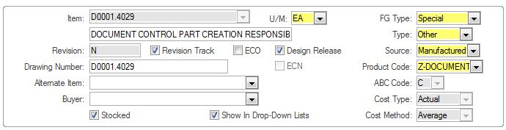

1. Click the Revision Track box to uncheck the box. This will allow editing on the form.

Rev Track open

1. Update the Revision number in the Revision field and click the Revision Track box. Click the Save icon in the tool bar to save the changes made on the Items Form.

Please Note: Many manufactured parts have a Bill of Manufacturing or Bill of Materials. If the item has a BOM, do not check the Revision Track box until after the BOM has been updated.

dco revision updated and rev track clicked

Save

1. Many manufactured parts have a BOM. If the ECO is creating or changing a BOM, make the BOM changes by following the procedures in D0001.4001.
2. Drawing Revisions: When changing a drawing revision, change the revision in the Items Form. If a drawing revision is not being updated, remember to double check the BSD and drawing to make sure that the drawing’s revision.
3. Software and Firmware: When changing the revision for software or firmware, make sure that the correct revision is entered in the Revision field in the BSD Items Form and that the correct version of the firmware or software is saved in the correct folder on the R:\ Drive.
4. Prototype Items: If the ECO is releasing a new product or a prototype item, the Document Control Clerk will need to delete the Prototype carat “^” from the Item Description field for all of the items being released. This should be noted on each Item page of the ECO. If it is not, contact the originating Engineer for clarification or correction.
5. Click the Notes icon in the tool bar to open the Object Notes form. The Subject field needs to be completed. The note will not save if the field is left blank. If there are no current notes, and the field is blank, choose “General” from the drop-down menu. Enter the ECO revision note in the Note field. Click the Save icon to save the Notes, and then return to the main Items page when all notes have been entered.

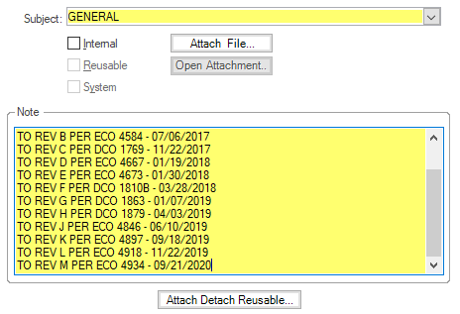

Save

1. Click the DocTrak Icon in the tool bar to open the DocTrak page.

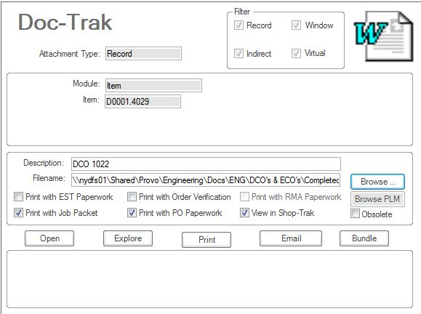

Click the New icon (Asterisk) to the left of the page to create a new record.

asterisk

Enter the ECO number in the Description field (example: ECO 4934) and use the Browse button to search for and attach the ECO to the BSD.

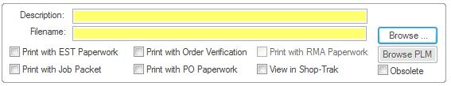

Find the updated drawings, software/firmware or other files that were updated by the ECO by using the Records to the left of the page, and update its link in the Filename field by using the Browse button.

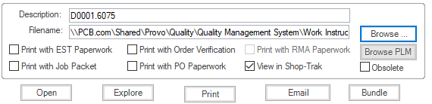

Click the Save icon in the tool bar, and return to the Items form. Close the BSD.

Save

**6.3 Setting ECO Tasks**

*Once the changes are made in the BSD, review the ECO form and see which individuals are also responsible for completing tasks. These will be listed in the Affects/Changes and Instructions sections of the ECO form.

1. “Affects/Changes” Section
   1. In this section, the people specified by the author of the ECO are responsible for making changes. Usually this will only be Document Control, however, there will be times when Purchasing or MetCal is listed.
2. “Instructions” Section
   1. In this section, there will often be a note toward the bottom of the instructions stating that special instructions will need to be carried out by someone other than Document Control. This will often be Logistics, Sales, Purchasing, Production or MetCal.

*Send a task email around to the individual(s) responsible for completing tasks. The task emails must be sent individually so they can be tracked through Outlook.

* In Outlook click “New Items” on the toolbar. Scroll down to “Task”. Once the task window opens, click the “Assign Task” button to assign the task to the correct person. Enter their email address in the “To” field. Complete each item as follows:
  1. Subject – ECO # Task (example ECO 4934 Task)
  2. Start Date/Due Date – Enter the Start Date as the day the task was sent, and the Due Date as a few days later. Most tasks must be completed within a few days of the ECO’s completion.
  3. Body – Provide the instructions from the ECO form so that the person completing the Task fully understands what they need to do.
  4. Click the Send button.

Check the Task status in Outlook frequently until the Task is marked complete. To check it, open Outlook and click the Tasks icon. All Tasks will be listed. If there is a check mark in the far-right column, the Task is complete. If there is a red flag, the Task is still outstanding.

# 6.3 Distributing an Approved ECO

1. Send an email to all of the ECO’s responders, plus the General Manager/Director of Operations, Engineering Manager, Logistics Manager, Logistics Supervisor, Purchasing Buyer, Production Manager, Production Assembly Supervisor and Lead Technician, letting everyone that the ECO has been approved and completed. Include the ECO number, name and date, as well as attaching the completed ECO PDF file and a link to any Drawings, Software/Firmware, Work Instructions, etc., new location(s) on the R:\ Drive.

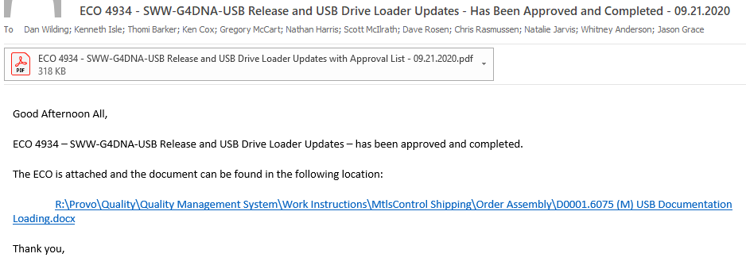

1. Move the ECO folder from R:\Provo\Engineering\Docs\ENG\DCO's & ECO's\InProcess to R:\Provo\Engineering\Docs\ENG\DCO's & ECO's\InProcess\Done.

**7.0 EVALUATION**

N/A

**8.0 RECORDS**

* The ECO Ledger is located in a folder near Document Control.
* Electronic copies of the ECOs are located in R:\Provo\Engineering\Docs\ENG\DCO's & ECO's\Completed\Appropriately Numbered Folder, and are stored by the backup system indefinitely, or as determined by the Engineering Manager.

**9.0 REVISION HISTORY**

|  |  |  |  |  |
| --- | --- | --- | --- | --- |
| **DCO #** | **REV** | **DATE** | **INITIALS** | **CHANGES MADE** |
|  |  | 7/19/01 | LC | Initial Release |
| 373 | B | 12/20/01 | SW | Changed description to match that in ECO procedure (D0001.1022). Removed QA Manager from distribution list, per Jan. Grammatical changes also made. |
| 461 | C | 9/6/02 | MB | Added section on what to do if the ECO is a revision of a previous and added detail to section 5.2, 2 on completing all visual work. |
| 464 | D | 9/25/02 | MB | Changed instruction for changing the drawing revision and added instruction on creating a revision of a BOM |
| 508 | E | 3/20/03 | MB | Changed distribution instructions to match new ECO form, eliminated distribution to Website Manager. |
| 562 | F | 6/25/03 | SLB | Many changes made to parts of ECO instructions |
| 588 | G | 8/4/03 | SLB | Rewrite of the ledger part of the instructions for tracking purposes |
| 595 | H | 8/15/03 | SLB | Rewrite of the drawing revision updating in visual |
| 634A | I | 9/30/03 | SLB | Add Doc Control role to releasing products and updated paths. Also added ECO ledger number |
| 698 | J | 1/20/04 | SLB | Modified Inventory area to talk about old revision parts |
| 708 | K | 2/17/04 | SLB | Modified paths |
| 800 | L | 8/25/04 | SLB | Updated the whole procedure. |
| 889 | M | 9/20/05 | HKH | Updated e-mail processing procedure. |
| 1022 | N | 7/2/07 | HKB | Updated to new BSD |
| 1267 | O | 9/28/09 | WJO | Updated to electronically file and print forms |
| 1999 | P | 9/28/20 | LAB | Rewritten to update to new BSD and procedures. |
|  |  |  |  |  |
|  |  |  |  |  |