DOCUMENT CONTROL PROCESSING OF DCOs

1.0 INTRODUCTION

This work instruction describes the processes and responsibilities of the Document Control Clerk for completing a Document Change Order (DCO).

2.0 DESCRIPTION

Document Change Orders (DCOs) are used to document and communicate changes to processes, procedures, policies, work instructions, manuals, specifications and other literature. DCOs are submitted to the Document Control Clerk, or a designated representative, for processing.

3.0 DEFINITIONS

BSD – Business System Database
DCO – Document Change Order
Document Control – Department and System to maintain and secure controlled documents

4.0 LIMITATIONS

This process is limited to the duties of the Document Control Clerk or designated representative.

5.0 MATERIALS, TOOLS, & EQUIPMENT

Computer
DCO Form
Email Software
Business System Database (BSD)

6.0 PROCEDURE

6.1 Distributing a DCO for Approval

- All DCOs received in Document Control are to be sent out for approval within 24 hours.

- Anyone can submit a DCO for approval. The originator should contact the Document Control Clerk to get a DCO number. Assign the next DCO number from the DCO Ledger (D00001.1021-2). The originator will send an email to Document Control with a completed DCO form and the document that is being released or updated. If the document is too large to email, it may be saved in an “Unreleased” folder on the R:\ Drive. The originator should provide a link to the document’s location.

- Open the DCO email and open the DCO Form and document(s). Create a folder for the DCO in R:\Provo\Engineering\Docs\Eng\DCO’s & ECO’s\InProcess using the following example as a folder name: DCO 1977 – D0001.4029(N) Document Control Item Creation Responsibilities. Save the DCO (Word document) with a filename that is patterned after the following example: DCO 1977 – D0001.4029(N) Document Control Item Creation Responsibilities.docx. The filename should include the DCO number and document title and new rev level.

Save the document that is being updated with the correct numbering format “document number(rev) and title.docx” (example D0001.4029(N) Document Control Item Creation Responsibilities.docx) in the DCO folder in R:\Provo\Engineering\Docs\Eng\DCO’s & ECO’s\InProcess.

- Check the DCO form to make sure it is filled out correctly, (see D0001.1021). Check the document’s Word file to make sure it has Track Changes activated so that all changes are redlined, and visible. If Track Changes is not active, send it back to the originator and ask for a redlined copy. If the DCO is releasing a new document, Track Changes will not be necessary.

- If the new DCO is a revision of a previous DCO, move the previous DCO folder to the Rejected folder.
- Go to R:\Provo\Engineering\Docs\ENG\DCO's & ECO's\InProcess and move the rejected DCO to
R:\Provo\Engineering\Docs\ENG\DCO's & ECO's\Rejected.
- Move any emails associated with the rejected DCO out of the inbox, and into an email folder for DCOs, or delete the emails.
- Change the status of the rejected DCO in the DCO ledger (D0001.1021-2) in R:\Provo\Engineering\Docs\ENG\DCO's & ECO's\D0001.1021-2 DCO Ledger.xls by inserting “rejected” in the status column of the DCO.

- Create a new email in the email server and complete the following items on the new email:
- To – Add all employees listed on the DCO page. These are the individuals who will approve the DCO.

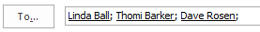

- Subject – Add the DCO number, Document title and “For Approval” and the date.

- Body – State what the email is regarding, and include any links needed if the document is too large to email. The following example clearly states what the email is regarding, and that there are attachments included with the email.

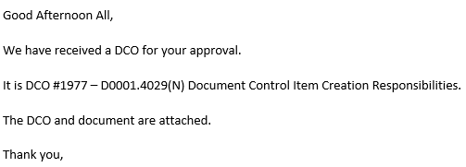

- Adding Attachments – Click the “Attach File” button in the email, and browse to the file’s location. Highlight the file, and click “Insert” to attach the file. Do this with all files needed for the DCO approval.

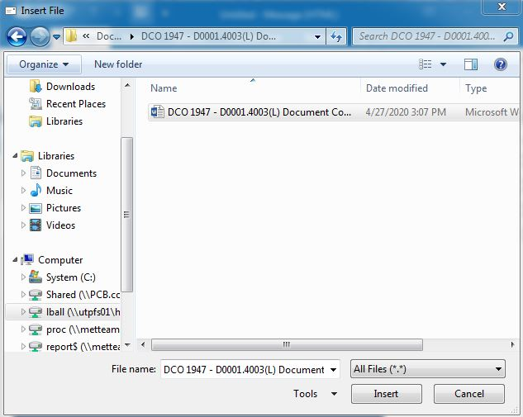

- Adding Hyperlinks – A link to the document is required if the document being modified is too large to send through an email. Go to the body of the email, and hold press Ctrl K on the keyboard. This will open a browse window. Find the file, and click “OK”. The link will be added to the email. Check the link to verify that it works.
- Adding Voting Buttons – Click the “Options” tab at the top of the email. Click the “Use Voting Buttons” button and select “Approve; Reject” from the drop-down menu.

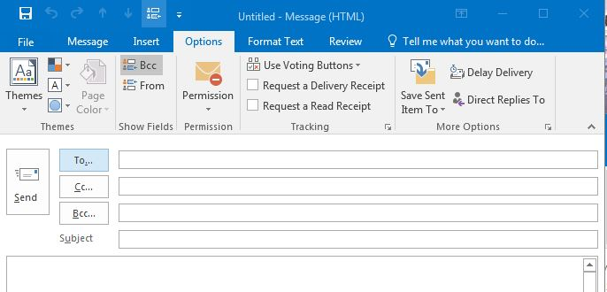

- Delivery Options – Click the tiny square with an arrow to open the Message Options window. Click the checkbox by “Have replies sent to” and make sure the Document Control Clerk’s name shows in the field. Make sure that “Save copy of sent message” is selected. Then click the “Close” button.

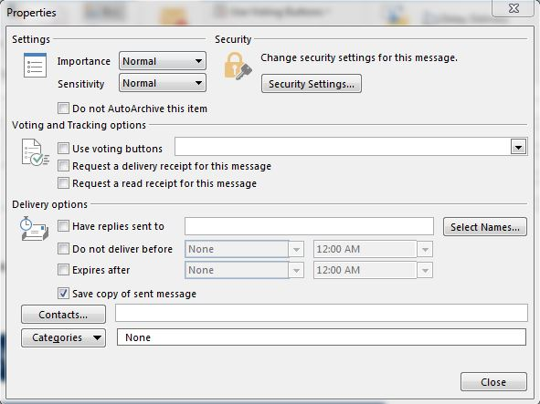

- Click the “Send” button to send the email to the selected individuals.

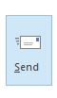

- Update the status of the DCO in the DCO ledger
- Open the “DCO ledger.xls” spreadsheet in R:\Provo\Engineering\Docs\ENG\DCO's & ECO's\D0001.1021-2 DCO Ledger.xls
- When the spreadsheet opens, go to the current DCO number’s line and fill in the information from the DCO form.
- Enter the assigned DCO number in the first cell in the next blank row.
- Fill in the originator’s name in the “Owner” column.
- Insert the dates completed in the “Received” and “E-mail Out” columns.
- Fill in the “Days sent out” column with the number of days between the day that the DCO email was received and the day that the email went out, (i.e. If it was received and sent out on the same day, put a 0 in the cell.)
- Save the spreadsheet, and close Excel.

6.2 Processing an Approved DCO

- Use the following steps to check the approval status of all pending DCOs.
- Go to the email server and enter the DCO number in the Search field.
- The emails related to the DCO will appear in the list.
- Open one of the reply emails to see who has voted on the DCO. Either “Approve” or “Reject” will be in the Subject line.
- The body of the email will say, “The sender responded: Approve.” Or “The sender responded: Reject.” Click the body to open the Voting Responses. All of the responses, including the date and time they were submitted will appear in the email.

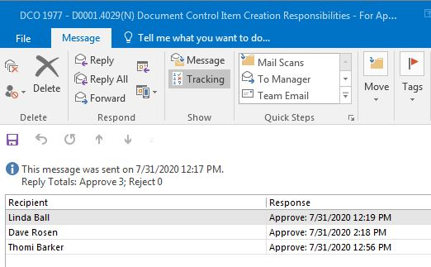

- Open the DCO form and enter the date that each person responded to the DCO. If the DCO is marked as “rejected” by any responder, send an email to the group to let them know that the DCO was rejected, and that a new revision will be sent around for approval once it is available. If the person who rejected the DCO gave a reason, include this in the email.
- Close the DCO if there are missing responses. These will come in as the responders are available.
- Print the completed Approval List email as a PDF, and save it in the InProcess folder if all of the responses are in. Use the following example to name the PDF file: DCO 1977 – D0001.4029(N) Document Control Item Creation Responsibilities – Approval List – 08.31.2020.
- If all of the responders voted “Approve,” the Document Control Clerk should make sure all of the responded dates are correct on the DCO form, and enter their name in the space provided at the bottom of the form. Then mark the checkboxes beside additional items in red to the right of the page. Print the DCO form as a PDF and save it in the DCO folder in the InProcess folder in the R:\ Drive.
- If the DCO is approved, open the document being changed, accept all changes using the Review Tab, Accept tool in Word. If the document has been “Protected,” make sure the protection is off, or it will not be possible to accept the changes. Save the file and print a PDF copy of the document in the InProcess folder in the R:\ Drive.
- Open Acrobat Distiller and use the Combine Files Tool to merge all of the PDF files associated with the DCO, and save the merged document in the InProcess folder in the R:\ Drive. Use the following example to title the completed PDF: DCO 1977 – D0001.4029(N) Document Control Item Creation Responsibilities with Approval List – 08.31.2020.

- Save a copy of the completed DCO PDF file into the appropriate Completed DCO’s & ECO’s folder in the R:\ Drive. This is located at R:\Provo\Engineering\Docs\ENG\DCO’s & ECO’s\Completed and then the appropriately numbered DCO’s folder.

- Save the final version (all changes accepted) of the updated document, into the appropriate folder in the R:\ Drive. This location depends on the type of document. It could be a Work Instruction, a Policy and Procedure, a Certificate or another type of document. The DCO’s originator should provide a location where the file is to be saved. If no location is provided, do a search. Ask the originator where to save the document if the document is not easy to find.

- Move the old version of the document into the Old Versions or Obsolete folder that is located in the same directory. DO NOT DELETE old versions.
- Process the BSD work required by the DCO.
- Open the BSD and go to the Items Form. Search for the document number by entering it in the Item field, and click the Filter in Place icon in the tool bar.

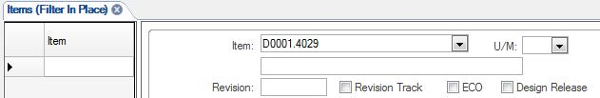

This will open the Items Form for the document.

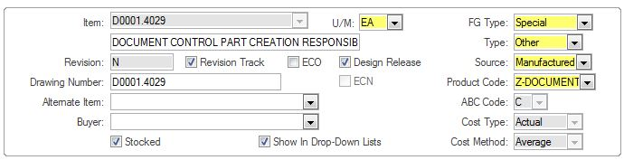

- Click the Revision Track box to uncheck the box. This will allow editing on the form.

- Update the Revision number in the Revision field and click the Revision Track box. Click the Save icon in the tool bar to save the changes made on the Items Form.

- Click the Notes icon in the tool bar to open the Object Notes form. The Subject field needs to be completed. The note will not save if the field is left blank. If there are no current notes, and the field is blank, choose “General” from the drop-down menu. Enter the DCO revision note in the Note field. Click the Save icon to save the Notes, and then return to the main Items page when all notes have been entered.

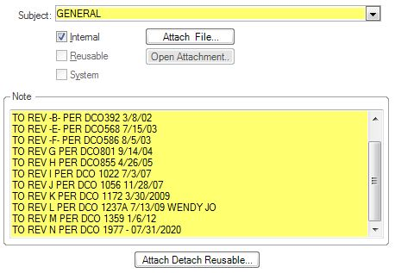

- Click the DocTrak icon in the tool bar to open the DocTrak page.

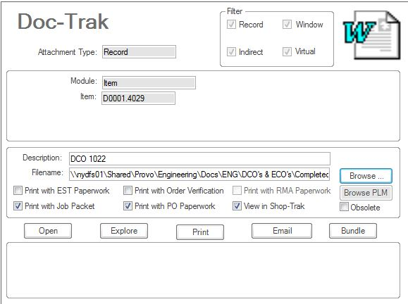

Click the New icon (Asterisk) to the left of the page to create a new record.

Enter the DCO number in the Description field (example: DCO 1977) and use the Browse button to search for and attach the DCO to the BSD.

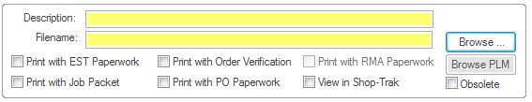

Find the document that was updated using the Records to the left of the page, and update its link in the Filename field by using the Browse button.

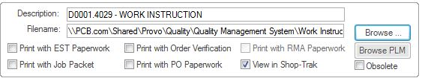

Click the Save icon in the tool bar, and return to the Items form. Close the BSD.

- If the document is a Policy or Procedure, or a Work Instruction, the Document Control Clerk will need to update the Index for Work Instructions or Policies and Procedures. If the document is a new release, add the document to the appropriate index. The Indexes are located in the following locations:

Policies and Procedures – update the revision level and the date of revision – R:\Provo\Quality\Quality Management System\Policies and Procedures\ Procedure Index and Revision Level.xls

Work Instructions – update the revision level – R:\Provo\Quality\Quality Management System\Work Instructions\Work Instruction Index.xls

- Update the DCO’s status in the DCO ledger (D0001.1021-2) once all of the previous steps are complete.
- Open the “DCO ledger.xls” spreadsheet in R:\Provo\Engineering\Docs\ENG\DCO's & ECO's\D0001.1021-2 DCO Ledger.xls. When the spreadsheet opens, go to the current DCO number’s line and fill in the following information.
- Enter the date approved in the “Approved” column.
- Fill in the “Days to approval” column with the number of days between the day the original email was sent out and the day it was approved. If it is longer than the goal for DCO approval (5 days), write the name(s) of the employees who were late to approve the DCO.
- Enter the date completed in the “BSD entry” column.
- Fill in the “Days BSD entered” column with the number of day between the day the DCO was approved and the day it was typed into the BSD.
- Save the spreadsheet and close Excel.

6.3 Distributing an Approved DCO

- Send an email to all of the DCO’s responders, plus the General Manager/Director of Operations, Engineering Manager, Logistics Manager, Logistics Supervisor, Purchasing Buyer, Production Manager, Production Assembly Supervisor and Lead Technician, letting everyone that the DCO has been approved and completed. Include the DCO number, name and date, as well as attaching the completed DCO PDF file and a link to the document’s new location on the R:\ Drive.

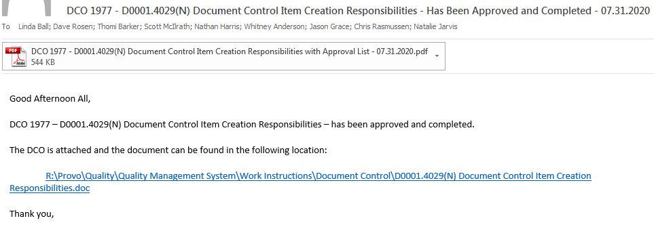

- Update the DCO’s status in the DCO ledger (D0001.1021-2) once all of the previous steps are complete.
- Open the “DCO ledger.xls” spreadsheet in R:\Provo\Engineering\Docs\ENG\DCO's & ECO's\D0001.1021-2 DCO Ledger.xls. When the spreadsheet opens, go to the current DCO number’s line and fill in the following information.
- Enter the current date in the “DCO finished” and “Final copies” columns.
- Fill in the “Days completed” column with the number of days between the day that the DCO was finished and the day that the final copies were distributed.
- Save the spreadsheet and close Excel.

- Move the DCO folder from R:\Provo\Engineering\Docs\ENG\DCO's & ECO's\InProcess to R:\Provo\Engineering\Docs\ENG\DCO's & ECO's\InProcess\Done.

7.0 EVALUATION

N/A

8.0 RECORDS

DCO Ledger located in R:\Provo\Engineering\Docs\ENG\DCO's & ECO's\D0001.1021-2 DCO Ledger.xls is stored by the backup system indefinitely, or as directed by the Engineering Manager.

Electronic copies of the DCOs are located in R:\Provo\Engineering\Docs\ENG\DCO's & ECO's\Completed\Appropriately numbered folder, and are stored by the backup system indefinitely, or as directed by the Engineering Manager.

The Documents that are updated by the DCO are kept in the current folders until the next revision is released. Once the next revision is released, the document is moved to the Old Revisions folders. They are stored by the backup system indefinitely, or as directed by the Engineering Manager.

9.0 REVISION HISTORY

DCO # | REV | DATE | INITIALS | CHANGES MADE
 |  | 7/19/01 | LC | Initial Release
372 | B | 12/20/01 | SW | Made changes in description to match those in Document Change Order (D0001.1021).
447 | C | 7/29/02 | SW | Clarified where to get DCO number and how to file modified document.
472 | D | 10/23/02 | MB | Added section on what to do if it is a revision of a DCO.
545 | E | 5/29/03 | MB | Changed Section concerning saving the information in the ledger, Changed where it calls to use Adobe Photoshop and substituted Microsoft Word.
563 | F | 6/24/03 | SLB | Rewrite of the instructions including changes to the ECO ledger and additional notes
587 | G | 8/4/03 | SLB | Rewrite of the ledger part of the instructions for tracking purposes
594 | H | 8/15/03 | SLB | Added a section that talked about what to do with old documents
636 | I | 10/1/03 | SLB | Updated paths in work instructions
666 | J | 11/3/03 | SLB | Updated adding changes to index during DCO process
708 | K | 2/17/04 | SLB | Updated paths
799 | L | 8/26/04 | SLB | Added manuals section. Updated procedure.
890 | M | 9/20/05 | HKH | Updated e-mail processing procedure.
1022 | N | 7/2/07 | HKB | Updated to new BSD
1269 | O | 10/08/09 | WJO | Updated to file electronically
1981 | P | 8/12/20 | LAB | Complete rewrite to update to current procedures and BSD.

