DOCUMENT CONTROL ITEM CREATION RESPONSIBILITIES

1.0 INTRODUCTION

This work instruction describes the processes and responsibilities of the Document Control Clerk for entering items into the Business System Database (BSD) Items Form.

2.0 DESCRIPTION

This work instruction details the responsibilities of the Document Control Clerk in creating items in the Business System Database (BSD) Items Form

3.0 DEFINITIONS

BSD – Business System Database.
Item Creation Form – Form provided by Engineering, Purchasing or Sales with required information for adding an item to the BSD.
Document Control – Department and system to maintain and secure controlled documents.

4.0 LIMITATIONS

This process is limited to the duties of the Document Control Clerk or designated representative.

5.0 MATERIALS, TOOLS, & EQUIPMENT

Computer
Business System Database (BSD)
Item Creation Form

6.0 PROCEDURE

6.1 Creating items in the BSD

- The Engineers are the only employees who are authorized to request that an item is to be added to the BSD, unless it is a PCB item that Purchasing or Sales needs to add. Purchasing and Sales can do this without an Engineer’s approval. The requestor will email the Item Creation Form to the Document Control Clerk.

- Verify that the Item Creation Form has been filled out correctly. (See D0001.1024 Item Creation Procedure). If there are errors, or an item needs clarification, send it back to the originator for assistance. Once the Item Creation Form is ready, move to step 3.

- Open the BSD, and open the Items form. The BSD system will automatically open to the form with the “General” tab showing. Fill in the required fields in the top portion of the Items form. The following information is listed in order of how it should be entered into the BSD. It does not correspond with the order on the Item Creation Form.

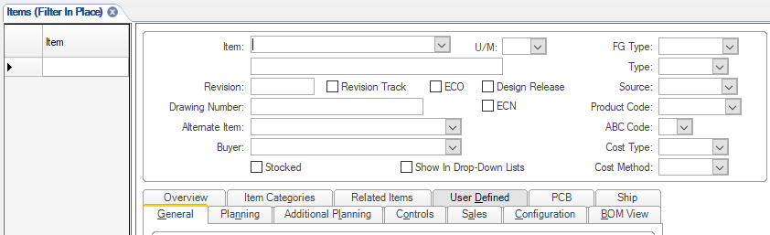

- Item Number (verify that the item number follows the numbering section in D0001.1017). Copy the item number from the form and paste it into the BSD Item Field.

- Item Description – This field does not have a title. Make sure that the description is entered accurately on the Item Creation Form. Copy the description and paste it into the field.

- Prototype – If the Prototype “Yes” box is checked on the Item Creation Form, a caret (^) must be placed at the beginning of the description in the Description field. This flags the item so that changes can be made to it without an ECO. Once the caret has been removed, the item is released and can only be updated through the ECO process.

- U/M – This field is for the Unit of Measure (U/M). Select the correct U/M from the drop-down menu. It is very important that it is entered correctly. The U/M cannot be changed once a transaction is completed for the item. Most items will use “ea” for “each”, or “FT” for “Feet.”

- Revision – If the Item Creation Form lists a Drawing and Revision number, enter the Revision number in the Revision field.

- Drawing Number – If the Item Creation Form lists a Drawing and Revision number, enter the Drawing number in the drawing number field.

- FG Type – This is the Finished Good Type. Select the correct code from the drop-down menu. “Stock” is for an item that is from inventory stock and can be shipped immediately. “Standard” is for an item that is not stocked in inventory, but can be ready, and shipped, within two weeks from order date. “Special” is for an item that is not stocked, and is for special orders. Most items entered into the BSD will be Stock or Standard.

- Type – This is the item Type. Select the correct Type from the drop-down menu. “Material” is for an item that can be sold to a customer, either on its own or as part of a system. “Tool” is for an item that is used by a machine operator to perform an operation, and may be consumed in the manufacturing process. “Fixture” is for an item that supports materials or tools during the manufacturing process, and are not usually consumed in the manufacturing process. “Other” is for an item that does not fall into the previous categories. This includes internal documentation, manufacturing process descriptions and prototypes.

- Source – This is where the company gets the item. Select the correct Source from the drop-down menu. “Purchased” is for an item that is bought from an outside vendor. “Manufactured” is for an item that is made by the company. “Transferred” is for an item that is provided by PCB or another company division.

- Product Code – This is the item’s general category where it will be used within the company. The Item Creation form shows two drop down menus. The first shows if the item is a “Finished Good,” “Raw Material” or “Subassembly.” The second drop-down menu shows the Product Codes. The second selection is what will be entered into the BSD. Select the correct Product Code from the drop-down menu in the BSD.
Please Note: The item cannot be created if the originator of the Item Creation form has not entered a Product Code. If there is not a Product Code listed, send it back to the originator with a request for a Product Code.

If the item becomes obsolete through the SM026 Obsolete process, the item retains its original product code. All quantities are issued from inventory and the item will have “OBSOLETE” or “OBS” added to the Description field.

- ABC Code – This field is defaulted to “C” and cannot be changed.

- Cost Type – This field is defaulted to “Actual” and cannot be changed.

- Cost Method – This field is defaulted to “Average” and cannot be changed.

Next open the PCB tab in the lower half of the Items form.

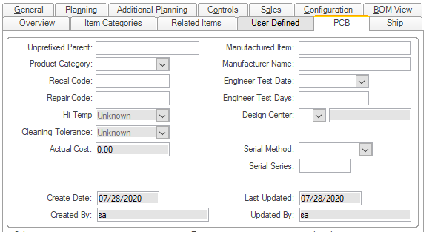

- Hi Temp – This is where the item can be marked as a high temperature tolerance item. This allows the item to withstand temperatures at least 260°C. Choose “Yes” or “No” from the drop-down menu. It is defaulted to “Unknown.” Do not leave it as “Unknown.”

- Cleaning Tolerance – This is where the item can be marked as a high temperature cleaning tolerance item. This means the item is an electrical component that can be cleaned with the Kyzen, or other, cleaning process. Choose “Yes” or “No” from the drop-down menu. It is defaulted to “Unknown.” Do not leave it as “Unknown.”

- Manufactured Item and Manufacturer Name – If the part is provided by an outside vendor, the Engineer will provide a Manufacturer’s Name and Manufacturer’s Part Number on the Item Creation Form. If there are multiple item numbers and manufacturers, then the additional information will need to be added to the Item Notes. This will be discussed later. Add the first Manufacturer and Item Number in the Manufactured Item and Manufacturer Name fields in the BSD.

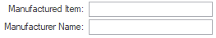

- Design Center – This is where the company’s location can be entered. Choose “L” from the drop-down menu to select “Larson Davis.” If this is not marked, certain items, such as RoHS status, in the BSD cannot be edited by anyone at LD.

- Serialized Product Tracked in LD Database? – If the item is a Finished Good, then the Engineer and Sales need to determine if this is an item that needs a serial number. If the checkbox is marked “Yes,” select “Serial” from the Serial Method drop-down menu. Serial Series will be completed later.

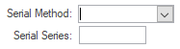

Next scroll down to the Sales, Engineering and Legal sections in the lower half of the PCB tab. If any of the following items are checked on the Item Creation Form, click the check boxes in this section.

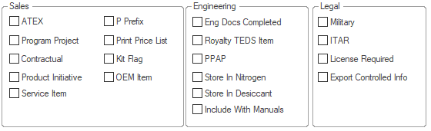

- Hazardous or Controlled Material – This is not listed in the BSD, but it is on the Item Creation Form. If the checkbox is marked “Yes,” let the Safety Manager or Safety Committee know that the item is considered hazardous or has a regulatory or unique requirements for handling and storage.
- MSDS – This is not listed in the BSD, but it is on the Item Creation Form. If the checkbox is marked “Yes,” let the Safety Manager or Safety Committee know that the item has a Safety Data Sheet (SDS). A copy of the SDS will need to be added to the SDS folders on the R:\ Drive.
- ATEX – This is where the Engineer will mark if the item is ATEX approved. If the checkbox is marked “Yes,” click the checkbox in the BSD.
- Print Price List – This is where the Engineer or Sales will state if the item should be placed on the pricelist. This is only for Finished Goods. Component parts are rarely sold without the complete system. If the Place on Pricelist “Yes” checkbox is marked, click the Print Price List checkbox in the BSD.
- Kit Flag – Logistics determines if the Kit Flag should be marked. If the checkbox is marked “Yes,” click the checkbox in the BSD.
- Military Use– If the item is specifically designed for the Military, this will be marked on the Item Creation Form. If the checkbox is marked “Yes,” click the checkbox in the BSD.

Next open the Ship tab in the lower half of the Items form.

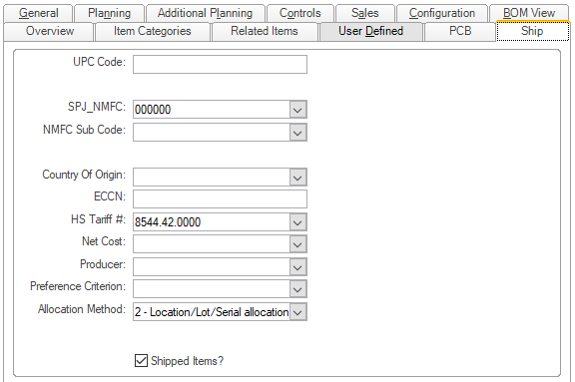

- Schedule B # / HS Tariff Code - All finished goods need to have a Schedule B number. This is the HS Tariff Number for import/exports. Choose the correct Tariff Number from the drop-down menu. All Item Creation Forms with a tariff code will need to be emailed to Legal for Import/Export Review.

- Allocation Method – This drop-down menu will always need to be marked as “2 – Location/Lot/Serial allocations.” The Item Creation Form is locked at “2,” so the BSD will need to reflect this. The field defaults to “0 – None.”

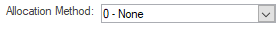

- Shipped Items? – This checkbox is not on the Item Creation Form, but is part of the “Ship” tab on the Items form. All items, whether they are Finished Goods, or components, have the potential to be shipped. Click the checkbox to allow shipping for all items.

Click the Save icon in the tool bar to save the Item and move to the next step.

Click the Item Certifications button on the right side of the Items Form to add the item’s RoHS Status. This will direct the Document Control Clerk to the Item Information page of the Items Form. Open the Regulatory tab in the bottom half of the form.

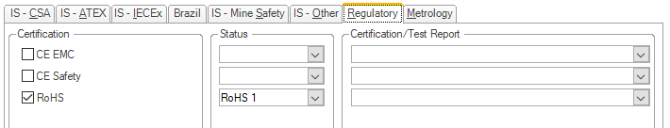

- RoHS Status – Verify that the RoHS Status drop-down is completed. If it states “please select from list”, send the form back to the Engineer for the information. On the Regulatory Tab, click the RoHS checkbox under Certification. Then choose the RoHS Status listed on the Item Creation Form from the drop-down menu. Next, choose the Certification/Test Report. This will usually be “Manufacturer Declaration.” Return to the main Items page when this is complete.

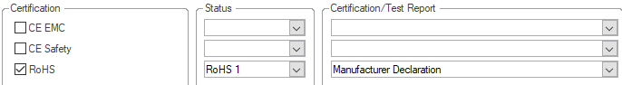

Click the Save icon in the tool bar to save the RoHS Status and move to the next step.

Click the Notes icon in the tool bar to open the Object Notes page.

- Subject – The Subject field needs to be completed. The note will not save if the field is left blank. Choose “General” from the drop-down menu.

- Note – The Note field is where the Document Control Clerk will enter any notes required for the item. Start with entering the item’s RoHS status, as the Regulatory Tab is only visible to certain employees. If there are multiple Manufacturers and Manufacturer’s Item Numbers, enter them here so that all Manufacturer information is saved in the BSD. Check the Additional Notes or Specification field on the Item Creation Form. If there is information regarding the item listed, add it here. Click the Save icon to save the Notes, and then return to the main Items page when all notes have been entered.

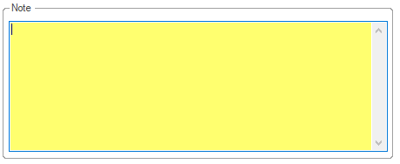

Click the DocTrak icon in the tool bar to open the DocTrak page.

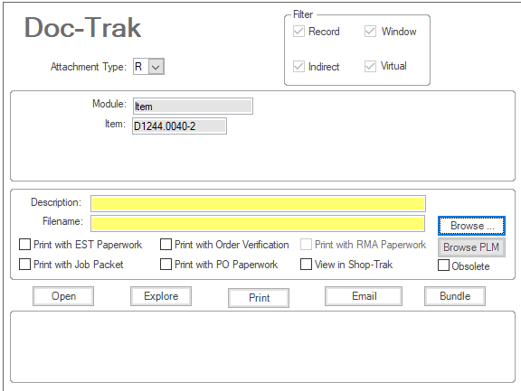

Once Step Number 5 is completed below, the Document Control Clerk will be able to complete the DocTrak requirements.

- Description – Enter “ITEM CREATION” in the Description field. This will allow anyone looking for the item’s documentation to be able to identify the Item Creation Form.

- Filename – This is the file’s location on the R:\ Drive. Use the “Browse” button to complete the Filename field.

- Browse – Click the “Browse” button to open an Attach file window.

- Use the attach file window to find the correct Item Creation Form and click “Open” to add the file to DocTrak.

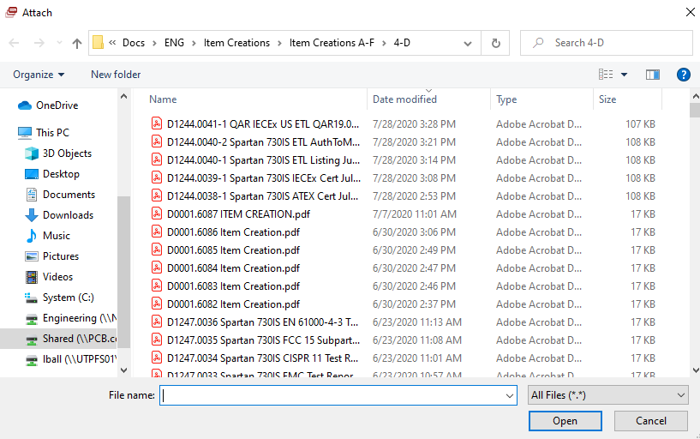

- Inspect Incoming Items – If the checkbox in the Inspect Incoming Items section is marked “Yes,” verify that the Engineer has filled in the Inspection Requirements in the provided box. The Inspection Requirements will need to be added into the QC Items Form.

To do this, first save the item number. Then click the “Open a Form” icon in the toolbar.

This will open the Select Form popup window.

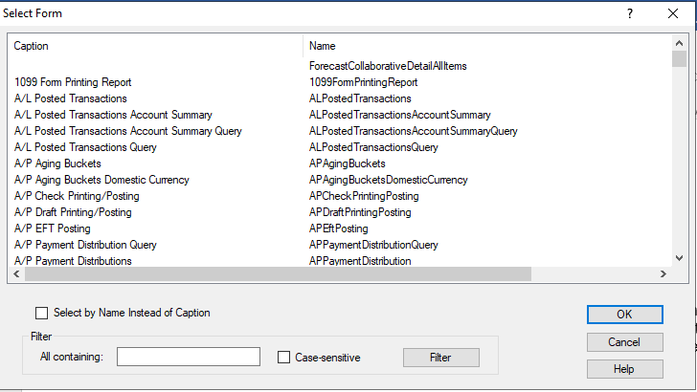

Filter the forms list by entering “QC Items” in the “All containing” field in the Filter section at the bottom of the window, and click the “Filter” button.

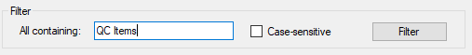

“QC Items” will appear in the Select Form box. Highlight the selection and click “OK.”

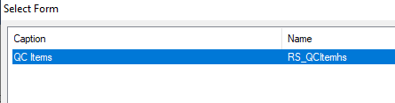

The QC Items form will open.

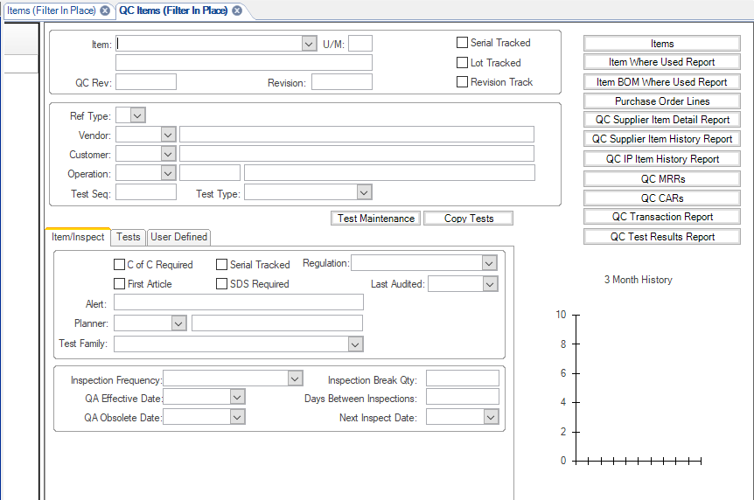

Add the new item to the QC Items list by clicking the “New” icon in the Items list to the left of the BSD.

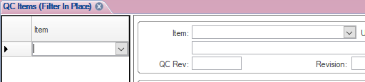

Add the new item number to the Item field at the top of the form. This will auto-populate the description and U/M fields.

- Ref Type – Select “P” from the “Ref Type” drop-down menu in the upper portion of the page. This signifies “Supplier.”

- Inspection Frequency – Select “FREQUENCY” from the “Inspection Frequency” drop-down menu at the bottom of the page.

Click the Save icon in the tool bar to save the QC Item and move to the next step.

Click the Notes icon in the tool bar to open the Object Notes page.

- Subject – The Subject field needs to be completed. The note will not save if the field is left blank. Choose “PD-General” from the drop-down menu.

- Note – The Note field is where the Document Control Clerk adds inspection requirements provided by the Engineer. These will be in the Inspection Requirements field on the Item Creation Form. Click the Save icon in the toolbar, and close the Object Notes page when all Inspection notes have been entered.

Close the QC Items form and return to the Items page.

- Marketing Items – Items that are in blue text on page 2 of the Item Creation Form are provided by Sales/Marketing. The Document Control Clerk enters the item into the BSD when it is received from the originating Engineer. If the item is a Finished Good, the Document Control Clerk sends the Item Creation Word file to Sales/Marketing to provide the additional information.

The Sales/Marketing information includes the Pricelist Information, Service Items Repair Pricing, Calibration Pricing, Service Item and Marketing Description.

The Document Control Clerk will update the Marketing Description once Sales/Marketing returns the Word file to Document Control. To do this, go to the BSD Items page and click the “Overview” tab and enter the Marketing Description in the Overview field.

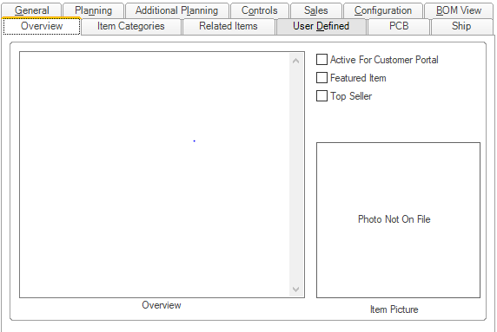

Electronically save an updated version of the Item Creation Form in the appropriate Item Creations folder on the R:\ Drive.

The Document Control Clerk will need to Email a copy of the updated Item Creation Form to the CSRs in Depew to be added to the PCB BSD. See step 8 below.

- Bill of Manufacturing (BOM) – If there is a Bill of Manufacturing (BOM) listed on the Item Creation Form, follow the instructions listed in D0001.4001 Document Control Bill of Manufacturing Responsibilities.

- When all the information has been entered in the BSD the Document Control Clerk initials and dates the bottom of the Item Creation Form. If the Item has an inspection requirement, and the QC Items fields are complete, the Document Control Clerk clicks the “Yes” checkbox, and initials and dates the QC line. If the item is a Finished Good, the Document Control Clerk clicks the “Yes” checkbox, types “Sent to [Legal Import/Export Specialist]” and dates the Export Control Review line. Save the Word file and create a PDF copy of the Item Creation Form for filing purposes.

- Electronically file the Item Creation Form in Document Control in the appropriate folder in R:\Provo\Engineering\Docs\ENG\Item Creations. Verify that the Item Creation Form has been added to DocTrak.

- Email the new number and Item Creation Form to the Originating Engineer, Director of Operations, Production Manager, Logistics Manager and Supervisor, QA Manager, Purchasing, and the Technician Supervisor. They will be alerted to the new item, and be able to enter any information they require in the BSD.

- If the Item is a Finished Good, email a copy of the PDF file to Legal’s Import/Export Specialist for Import/Export review. If there are issues, the Specialist will let the Document Control Clerk know. Send any concerns to the Item Creation Form’s originating Engineer for clarification or correction. Then corrections can be made to the BSD before any orders are entered.

- If the Item is a Finished Good, email the original Word file to Sales/Marketing to complete the Pricing information. Once those fields are complete, Sales will return the completed form to the Document Control Clerk. Save this updated file and create a new PDF file and save them in the appropriate Items Creations folder on the R:\ Drive. Then email a copy of the new PDF file to the CSRs in Depew to add the item to the Depew BSD.

- The Item Creation Forms are stored indefinitely on the R:\ Drive, and are kept at a minimum for the life of the item number.
(See Quality Records Matrix (D0001.1126-1))

7.0 EVALUATION

No additional evaluation is needed.

8.0 RECORDS

The Item Creation Forms are stored indefinitely on the R:\ Drive, and are kept at a minimum for the life of the item number.
(See Quality Records Matrix (D0001.1126-1))

9.0 REVISION HISTORY

DCO # | REV | DATE | INITIALS | CHANGES MADE
 | A | 7/20/01 | LC | Initial Release
392 | B | 3/7/02 | SW | Took out number for purchased burden percent
465 | C | 9/23/02 | MB | Added that part cannot be created without a product and a commodity code.
535 | D | 5/13/03 | MB | Strengthened the instruction for Product Code and Commodity Code.
568 | E | 7/14/03 | SLB | Add a description of what to do if the part is a CUSTOM part
586 | F | 8/4/03 | SLB | Some minor changes clearing up prototype parts
801 | G | 8/24/04 | SLB | Added notes to prototype parts, modified CUSTOM parts, added sections on inactive parts and manuals
855 | H | 4/25/05 | SLB | Added a section regarding the creation of PCB parts
1022 | I | 7/2/07 | HKB | Updated to new BSD
1056 | J | 11/29/07 | HKB | Updated to add new steps to procedure
1172 | K | 3/30/09 | WJM | Editorial and allowed paperless system
1237A | L | 7/13/09 | WJM | Added info for In-Process state & minor changes.  Changed some part references to items.
1358 | M | 1/4/12 | H S A | Clarified as to if the product is a FG, and if serial numbers need to be tracked
1977 | N | 7/31/20 | LAB | Complete rewrite to update to current procedures and current BSD.

