Non-BSD Part Purchase Order Creation

- PURPOSE AND SCOPE

This document provides the instructions necessary to create a purchase order for a Non-BSD part.

- RESPONSIBILITY

Purchasing
Quality Assurance

- MATERIALS AND EQUIPMENT
BSD
Purchase Order Request

- INSTRUCTIONS for creating Purchase Orders for non-BSD part numbers

- Open Vendor form.
- Enter Vendor Name in Vendor text field. Use the wildcard symbol * to save yourself from entering the entire vendor name.
- Click Filter or hit F4 key.
- Click Purchase Orders button
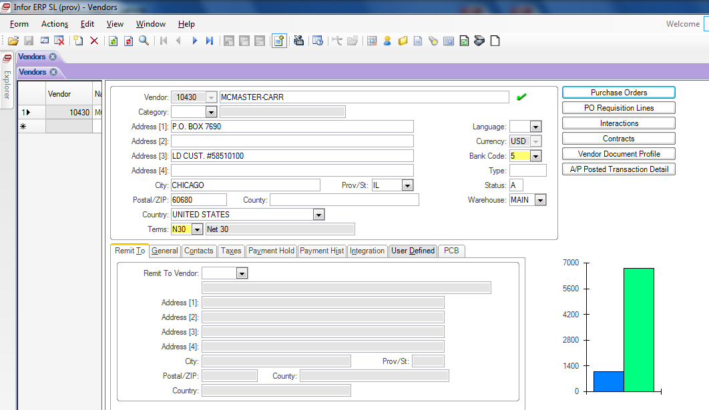

- Click the New Record icon or hit Ctrl-N to create a new PO
- Click the Save Icon or hit Ctrl-S to save the PO and generate the PO number
- Go to the Ship Via field to select or change ship method. Click Save if ship method is changed.
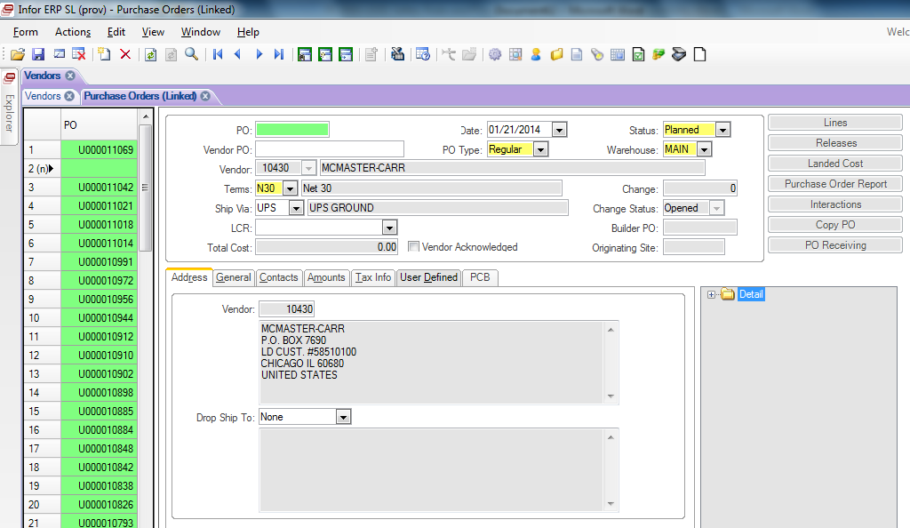

- Click Lines Button
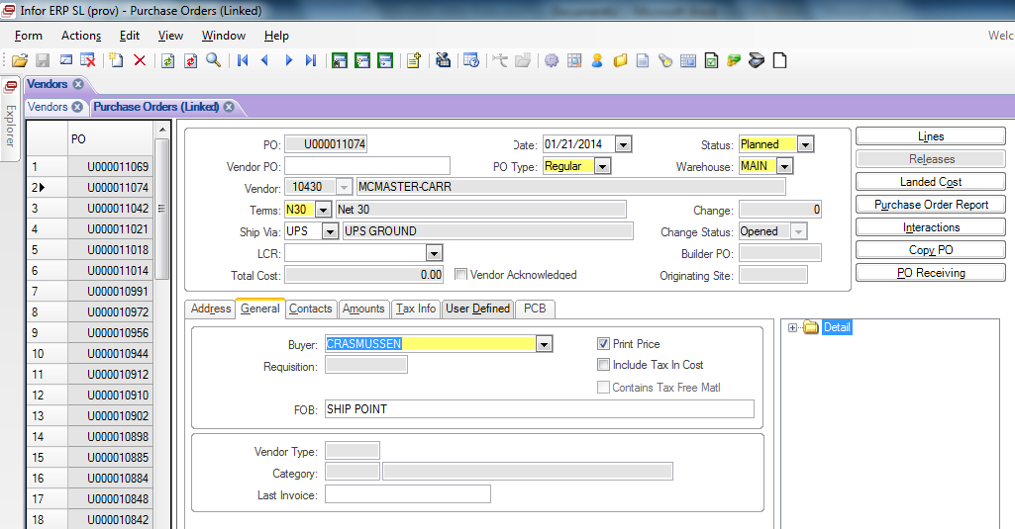

- Enter the manufacturing part number or a summary of what is being ordered in the Item text box.
- Hit Tab, or click on another field
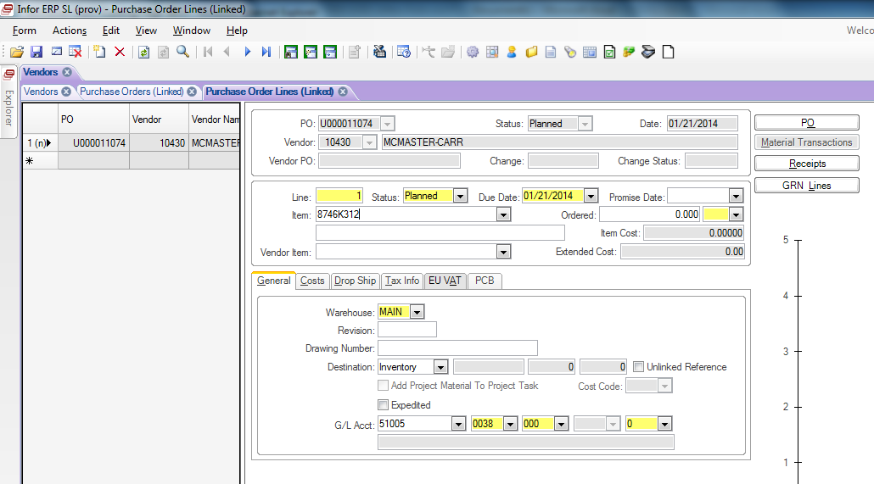

- A warning will come up. Click OK
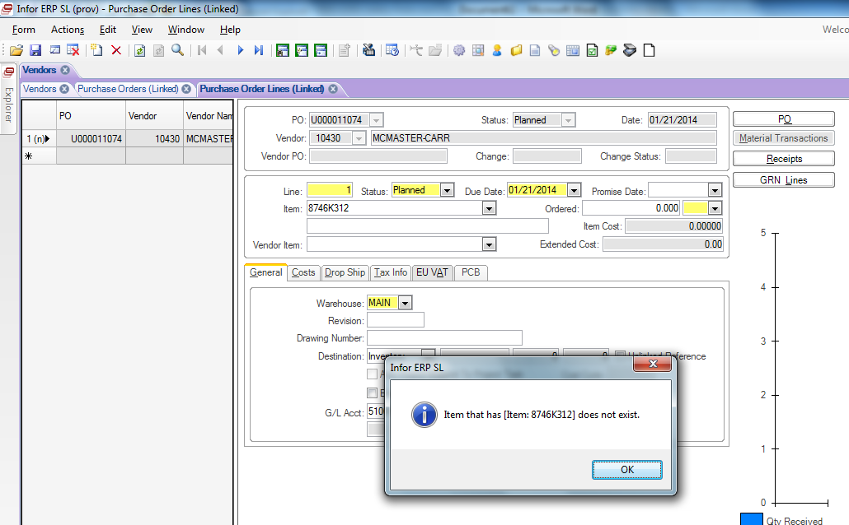

- Click OK on the second warning
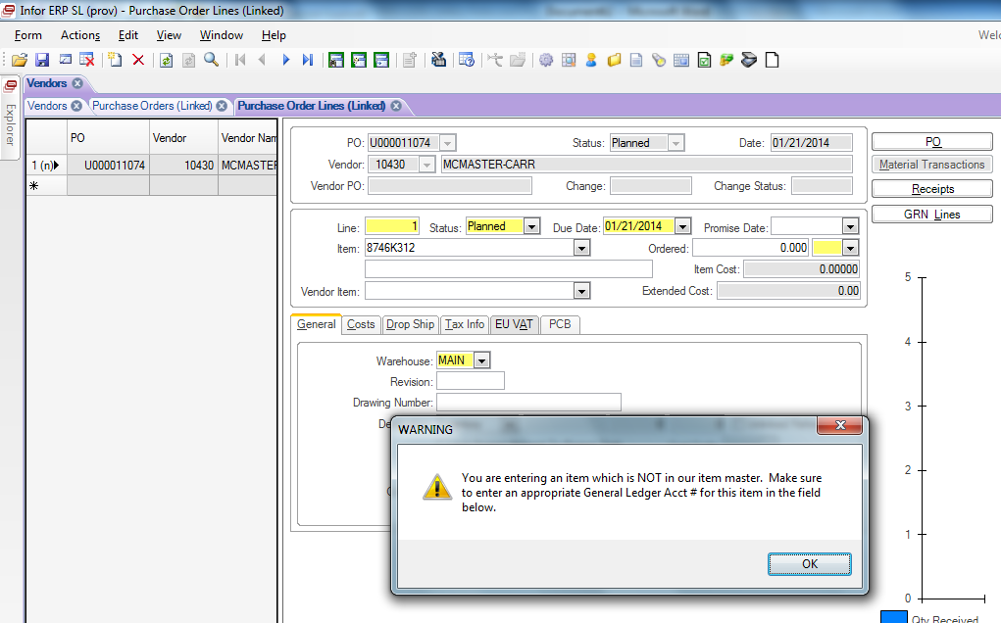

- Enter a description of what is being purchased in the text box below the Item text box.
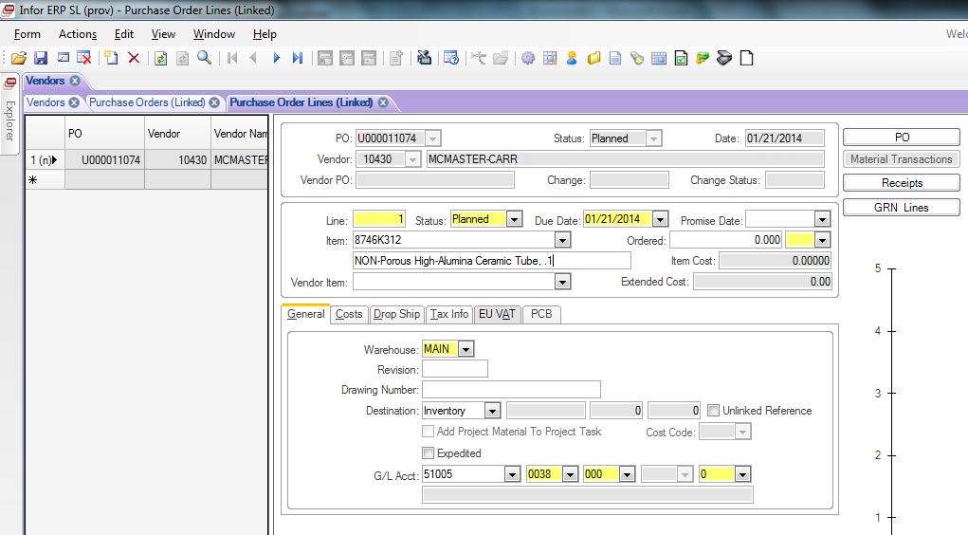

- Select due date of when parts will arrive on our dock.
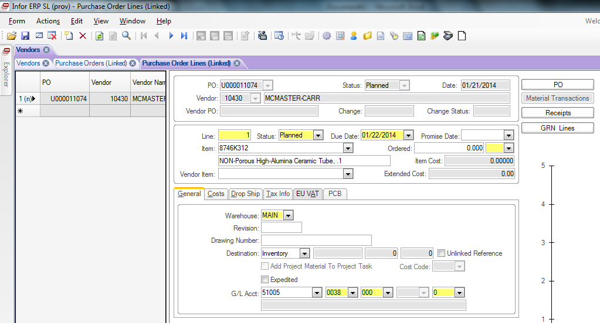

- Enter Order quantity in Ordered text field.
- Select Unit of measure. This should match as close as possible to the unit of measure noted by the supplier, usually from the quote or Purchase Request.
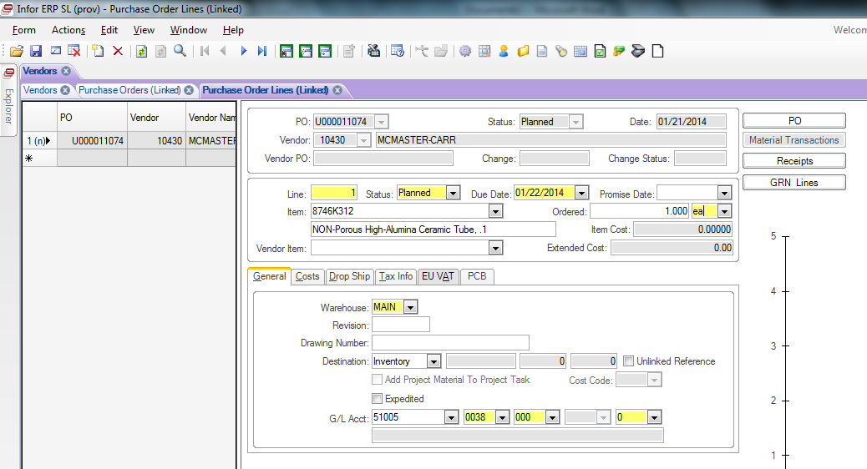

- Select the General tab
- Enter the G/L account codes from the Purchase Request 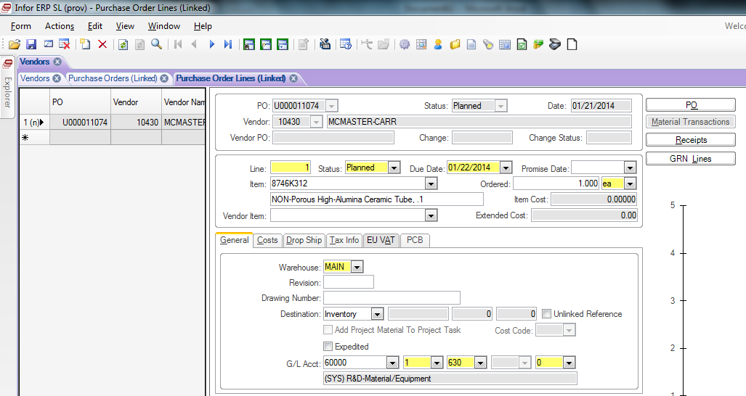

- Click on the Costs tab.
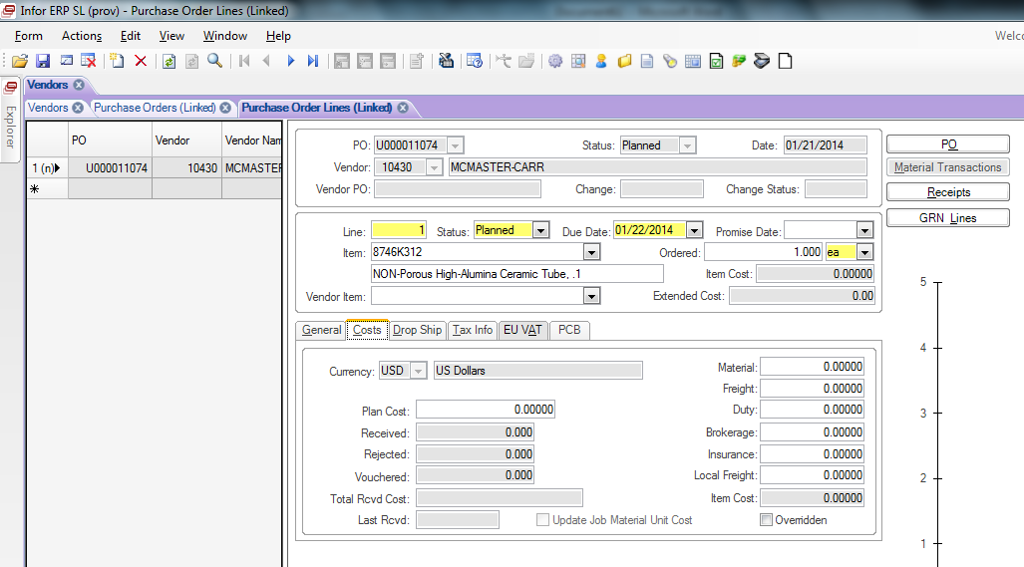

- Enter unit price in Materials text box.
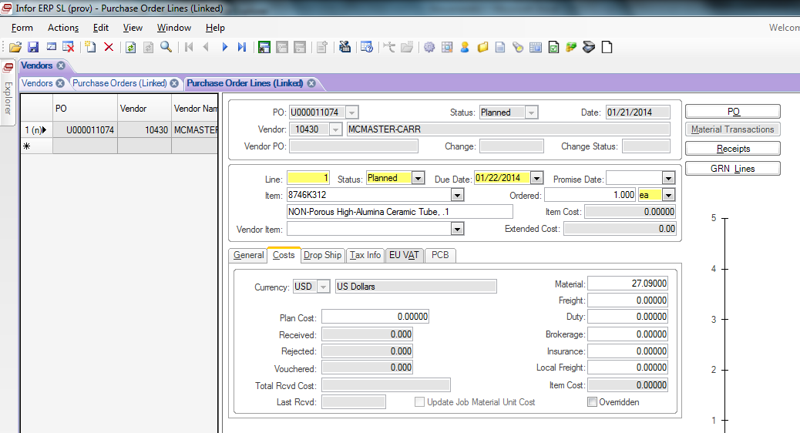

- Click the Save Icon or hit Ctrl-S to save the line.
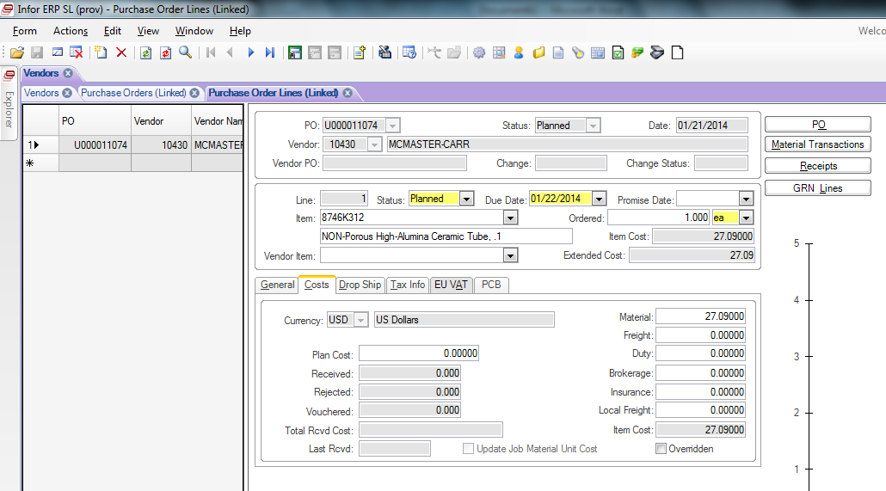

- Click the Object Notes icon
- Enter PD-GENERAL in the Subject field
- Check the internal box and enter the requestors name in the notes field.
- If additional information needs to be communicated to the vendor, create an additional note and enter the information.
- Click Save or hit Ctrl-S to save the changes and close this tab. 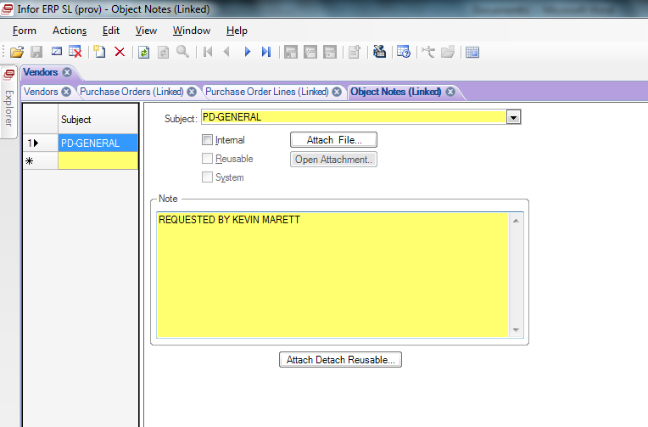
- If you have multiple items to order, click the New Object icon or hit Ctrl-N for a new PO line entry form.
- Repeat steps 9 thru 25 for each line item being ordered if not go to step 29.
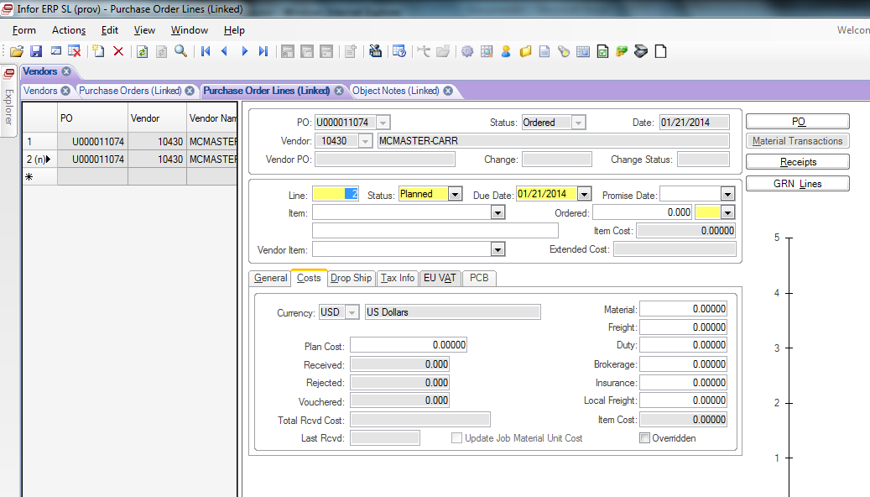

- Click on the Purchase Orders tab
- Click on the Purchase Order Report button

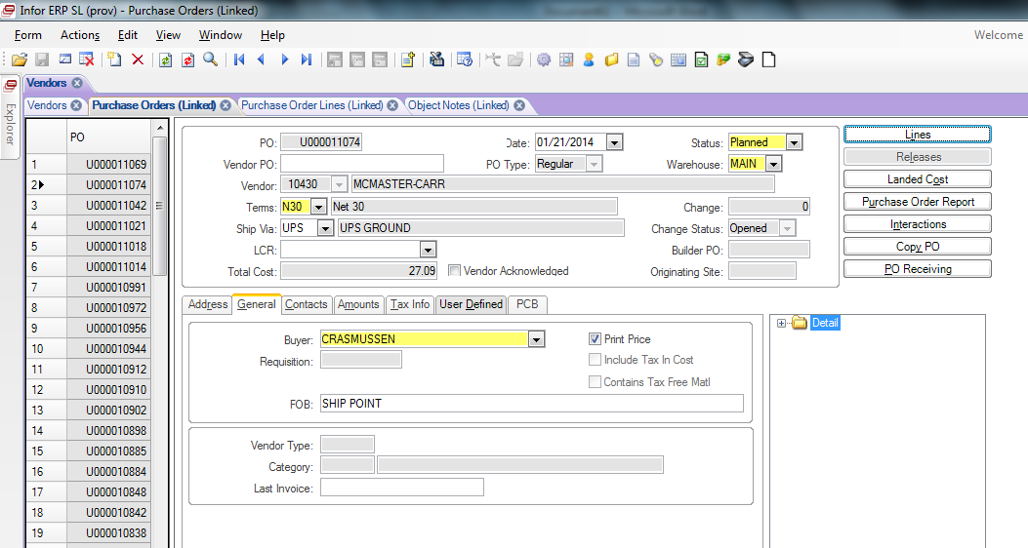

- A new window will open in Syteline: Purchase Order Report.
- Click the Post Status Change box.
- Click the Print button
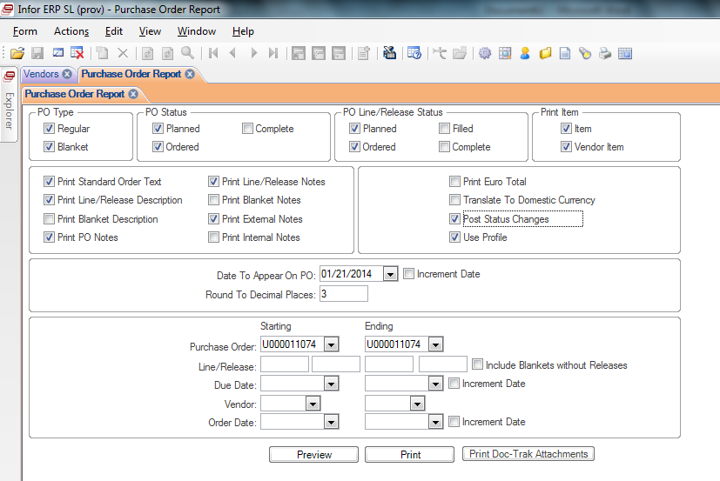

- Click OK
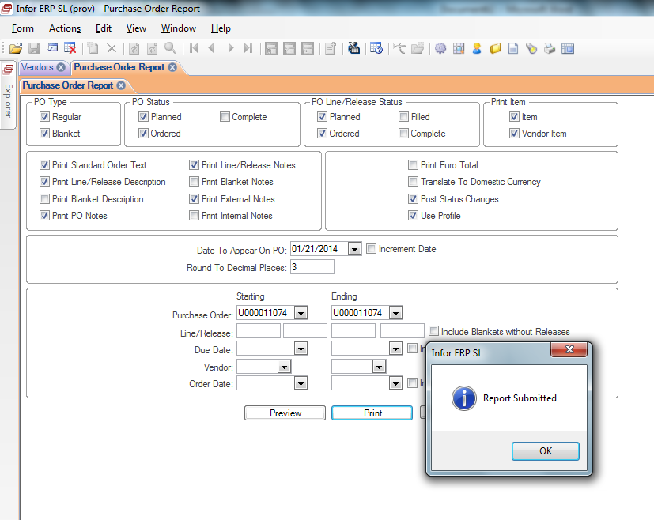

- Go to R:\Syteline Reports. You will find a folder with your user name. Open that folder

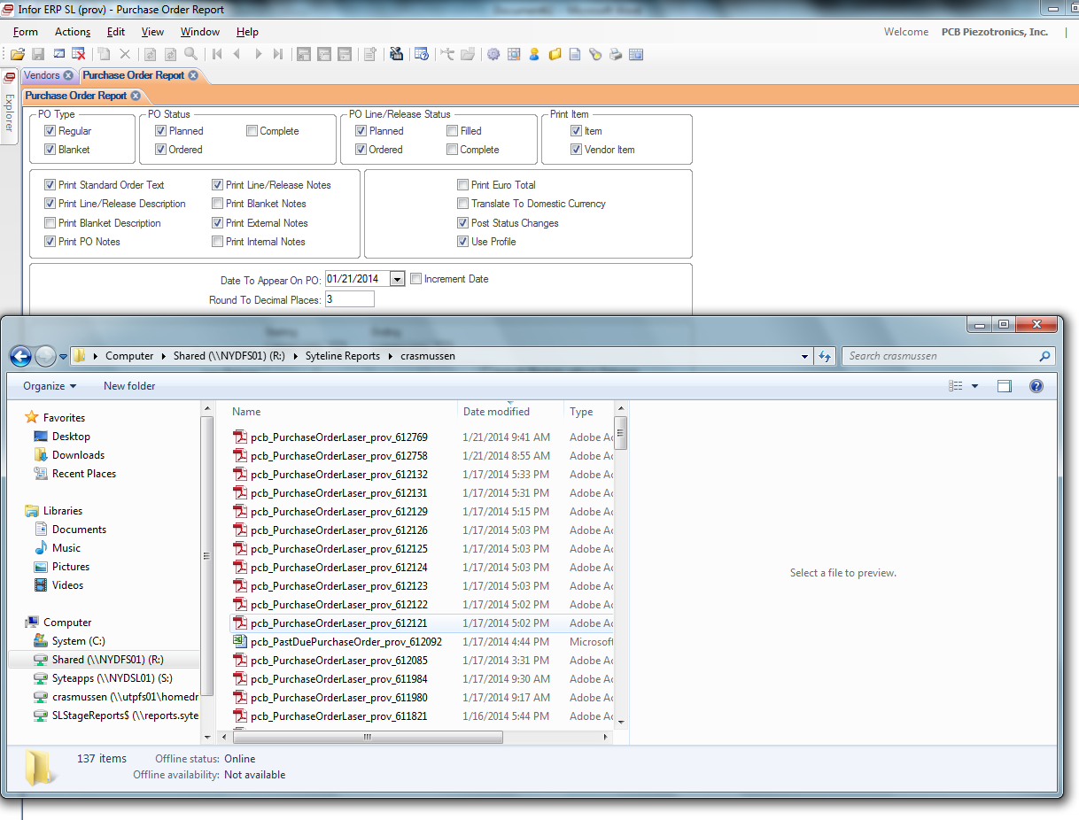

- Select the most recently created file. This should be your PO. If it isn’t, you may have to wait a minute or so while it is being processed.
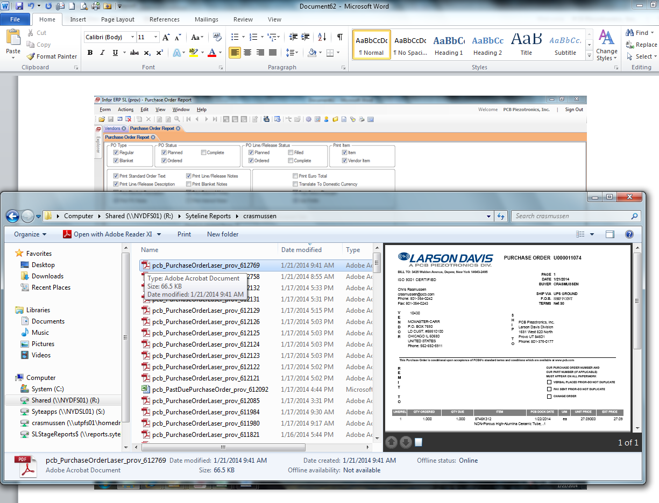
- Write assigned PO# on the purchase request, scan it to yourself, and put a copy of the scanned document in the PO Pending Acknowledgement folder. R:\Provo\Logistics\Purchasing\PO Pending Acknowledgement.
- Email created Purchase Order with the scanned Purchase Request to the Logistics manager. In the subject line of email, type the assigned PO#, Vendor and the name of the person requesting the part.
- If the item is being ordered on-line, there is nothing else to do with the PO. Just finish processing the order through the Vendor’s website.
- If the PO needs to be emailed to someone, click the Open with Adobe Reader button.
- After the PO is approved, put the initialed copy in the PO Pending Acknowledgement folder.
- Place order via email or online depending on the vendor.
- If it is a credit card purchase, the Purchase Request must be signed by the General Manager. Print a copy of the created PO, receipts, order confirmation, invoices.

- REVISION HISTORY

DCO# | REV | DATE | INITIALS | CHANGES MADE
1801 | A | 4/19/18 | AC | Initial Release of Document

