BSD Part Purchase Order Creation

- PURPOSE AND SCOPE

This document provides the instructions necessary to create a purchase order for a BSD part and process the request through a vendor.

- RESPONSIBILITY
Logistics Manager
Purchasing
Quality Assurance

- MATERIALS AND EQUIPMENT
BSD
Purchase Order Request

- INSTRUCTIONS for creating Purchase Orders for BSD part numbers

- Open the Vendors form
- Enter the vendor name in the Vendor text box. You can use the wildcard character * to abbreviate the vendor name.
- Click the Filter icon or hit the FClick the Filter icon or hit the F4 key.
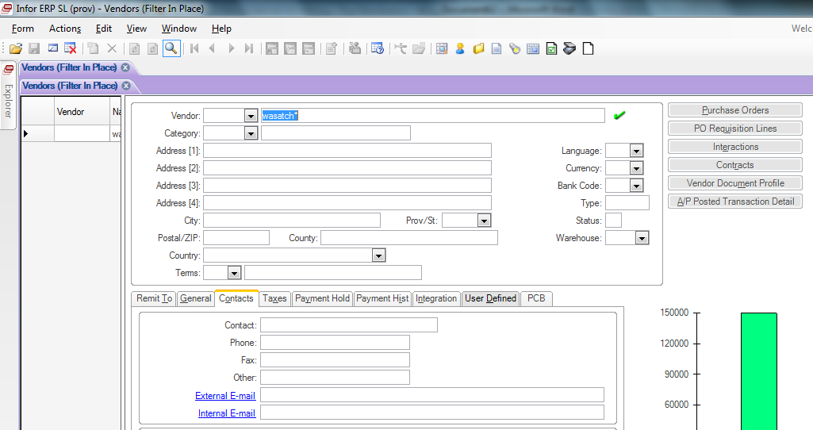

- Click the Purchase Order button
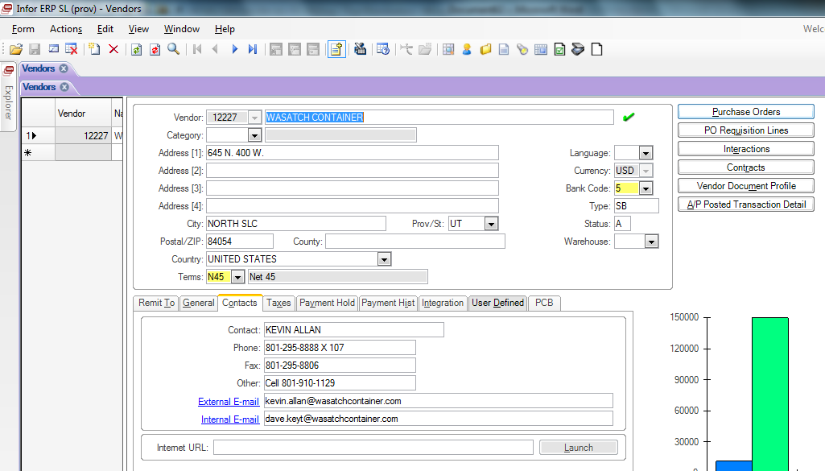

- Click the New Object icon of hit the Ctrl-N key to create a new PO entry.
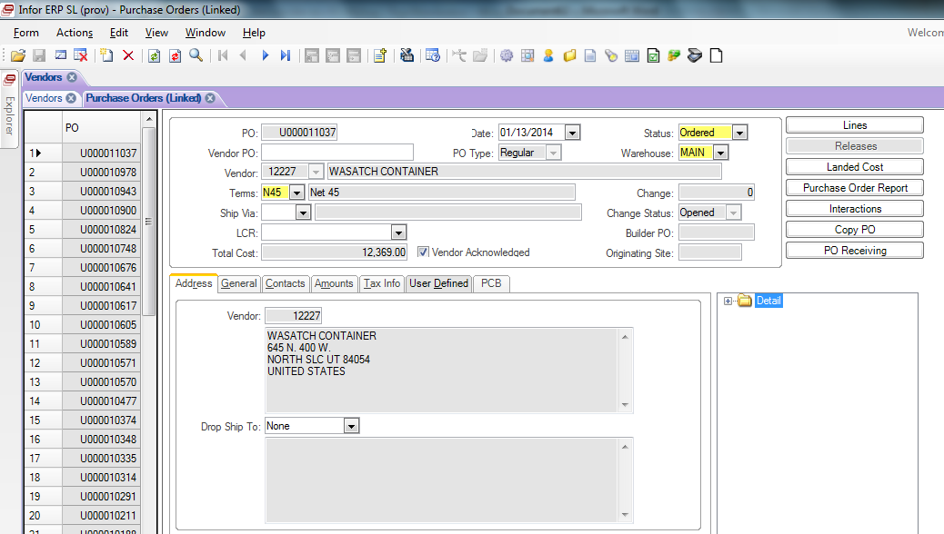

- Hit the Save button.
- Go to the Ship Via field to select or change ship method. Click Save if ship method is changed.
- Click the Lines button.
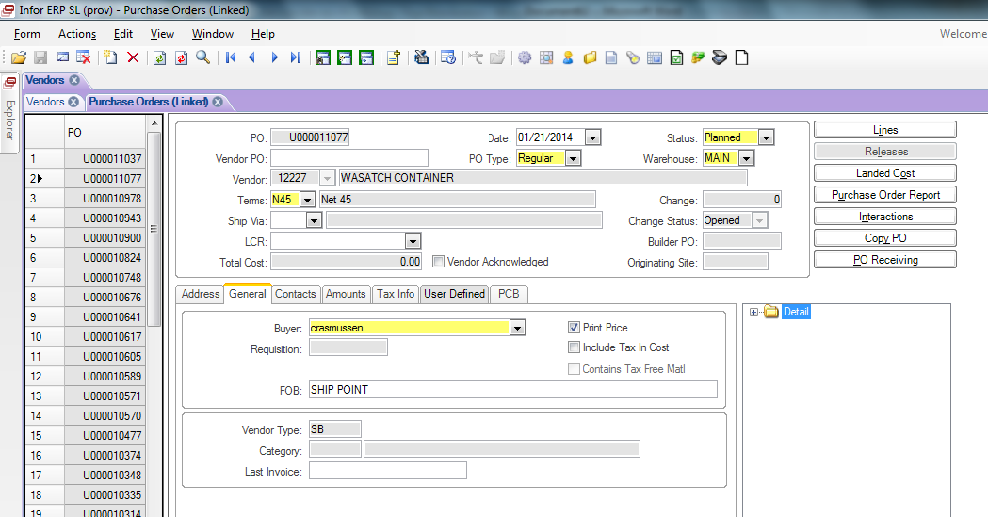
- Enter the Larson Davis part number into the Item field. Hit Tab or click on another field.
- Select the Due Date when parts are expected to arrive on our dock. This will be based on standard lead time or a quote from the factory, or shipping time.
- Enter the number of pieces to order in the Ordered field.
- Click the Save icon or hit Ctrl-S to save.
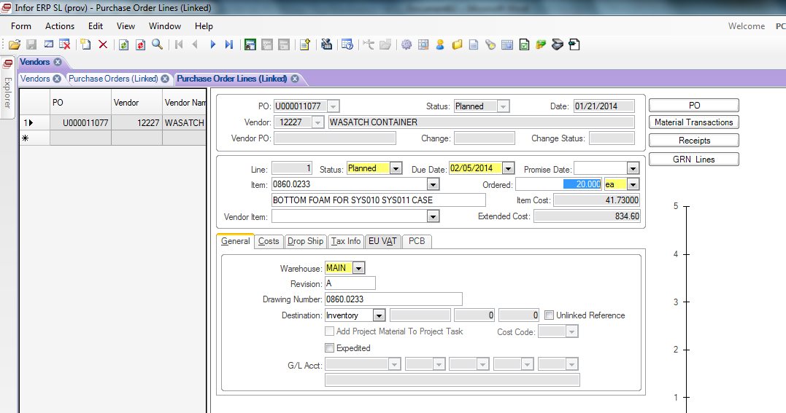

- If the cost needs to change, select the Costs tab and enter the new unit cost in the Materials field. To check the price you can go to the vendor website, or contact the sales representive for current price or quote, or verfiy the price on the current quote received.
- Be sure to hit Save after all of your changes are made.
- For multiple lines, click on the New Object icon or hit Ctrl-S
- Repeat steps 9 thru 13.
- Click on the Purchase Orders tab.
- Click on the Purchase Order Report button
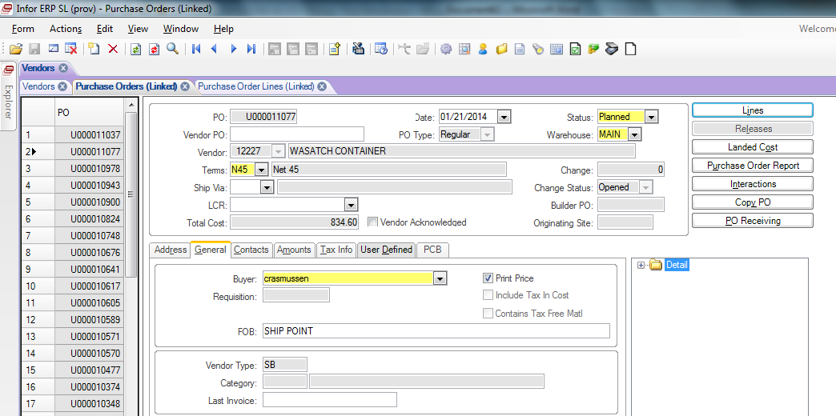

- This will open a new Syteline tab called Purchase Order Report.
- Click the check box titled Post Status Changes.
- Click Print.
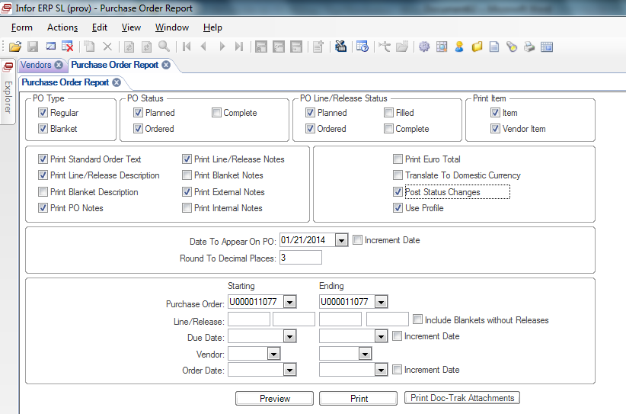

- Click OK
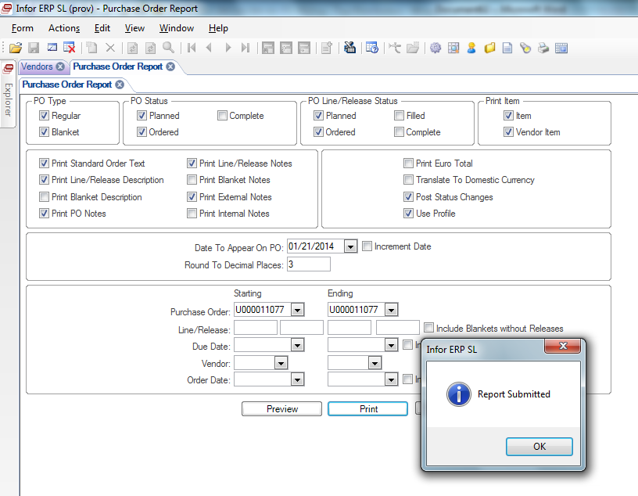
- Open folder R:\Syteline Reports
- Find the folder that has your user name and open that.
- Email created Purchase Order to the Logistics manager. In the subject line of email, type the assigned PO# and Vendor name.
- After the PO is approved, put the initialed copy in the PO Pending Acknowledgement folder.
- If the PO needs to be emailed to someone, click the Open with Adobe Reader button.
- Place order via email or online depending on the vendor.
- If it is a credit card purchase, the Purchase Request must be signed by the General Manager. Print a copy of the created PO, receipts, order confirmation,
- REVISION HISTORY

DCO# | REV | DATE | INITIALS | CHANGES MADE
1816 | A | 4/26/18 | AC | Initial Relase

