G4 Paid-Feature License Tracker Work Instruction

1.0 PURPOSE

The License Tracker system software application that is used to generate and assign licenses to customers that allow them to access the HVM (Human Vibration Monitor) and future cost-item features in G4. The application is used to generate, recall, and send license keys to customers who pay for the features. Evaluation keys may also be generated and sent.

2.0 AFFECTED DEPARTMENTS

Manufacturing
Logistics

3.0 REFERENCE DOCUMENTS

IG4.01 G4 Software Manual

4.0 RESPONSIBILITIES & AUTHORITY

Authorized users of the software are responsible to…
- Generate license key(s) in response to a customer order that includes “HVM Support”
- Email the key(s) to a customer email account
- Restore previously-generated keys to customers who misplace their original key.
- Issue evaluation keys as needed.

The PCB Piezotronics IT Group will control access to the servers used by the software to store license keys.

Manufacturing and Logistics managers will recommend to IT which personnel should be given access to the license tracking servers.

5.0 DEFINITIONS

License Key – Unique number consisting of 8 groups of four hexadecimal digits, separated by dashes
Evaluation Key – Temporary key that expires after a defined period, usually 30 days.
SWW-G4-HVM – Order item number for the HVM200 G4 feature
SWW-G4-HVM-6MO – Order item number for rental use of the HVM200 G4 feature
SWW-G4-HVM-1MO – Order item number for evaluation use of the HVM200 G4 feature

6.0 SAFETY PRECAUTIONS

No safety precautions indicated for operation of the equipment or performance of this procedure.

7.0 EQUIPMENT & MATERIALS

A desktop PC is required to run the application. Authorized users of the application must be added by IT to the AD Group, “Infralution_Users”.

8.0 INSPECTION

There is no inspection associated with this work instruction.

9.0 INSTRUCTION

9.1 Configure License Tracker
Run the “G4 License Tracker” application and verify that the “Products” tab contains three products, as shown below:
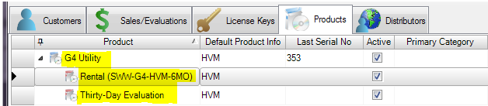
If this is not the case, please notify the Engineering contact.

9.2 Generate License Key for Line Item SWW-G4-HVM

- Run the “G4 License Tracker” application.

- Click the “New Sale” icon. | 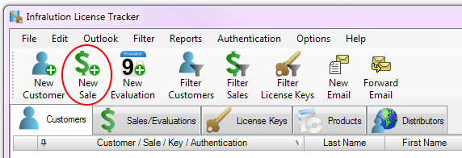

- In the form that appears, the Product will default to “G4 Utility”. Keep this selection. | 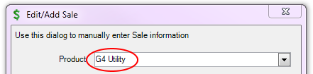
- Select the existing customer from the “Customer” drop-down list, or click the “New…” button to add a new customer, if the customer doesn’t already exist. | 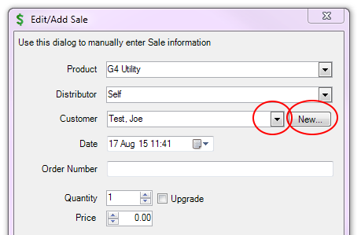

- If the “New…” button was clicked, the “Add/Edit Customer” form will appear.  Enter the appropriate information for the customer.  The following fields should be filled out:  - Last Name  - First Name  - Company Name  - Email  The other fields may be filled out as needed.  The license file will be sent to the email address, so be sure it is correct.  Click OK when finished. | 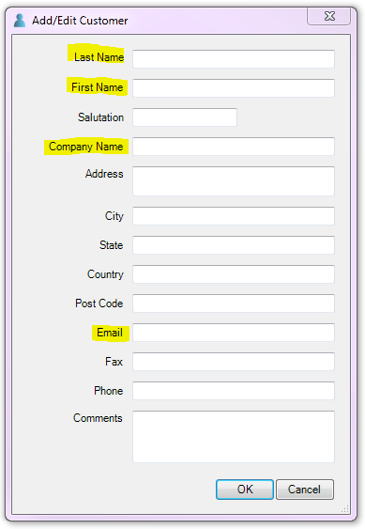

- On the “Edit/Add Sale” form, fill in the Order Number from the sales order.  If more than one key is needed, fill in the “Quantity” by typing in the number or by using the up/down arrows.  The “Upgrade” checkbox should be left unchecked. “Distributor” and “Price” may be ignored. | 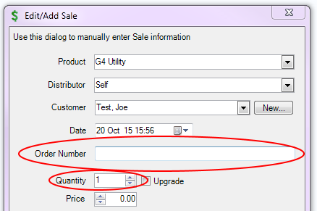

- Click the “Generate” button to generate the license key(s).  After a few moments, the key(s) will appear in the “License Keys” window, as shown below:  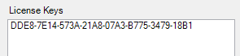 | 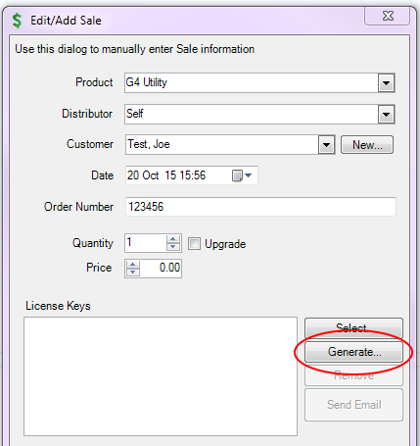

- Click on the “Send Email” button.  An email will be generated with all of the information filled out.  Verify that the “From” address contains licensing@pcb.com. | 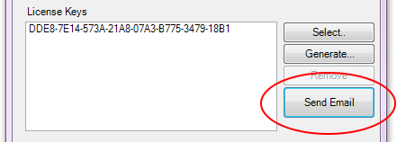  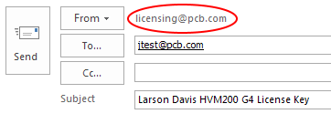
Note: Setting the “From” address to licensing@pcb.com will prevent customers from responding directly to your personal PCB email address. Your workstation will need to have permissions set by the IT Group in order to send emails from the “licensing@pcb.com” address. If the permissions aren't set properly, the message will appear to be sent, but a minute later you will receive an email with the following content. If this happens, contact the Helpdesk.
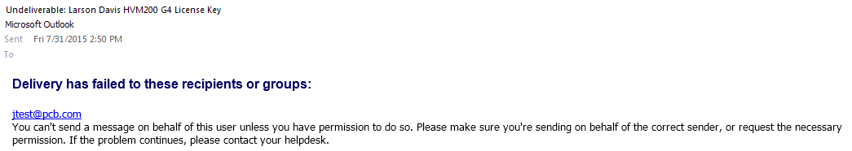

- On the email, copy the license file number and paste it into the label program.
Print the label and place it on the back of the SWW-UTILITY-G4 CD.

- On the email, select  “File”  then  “Print” | 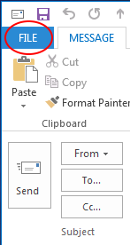 | 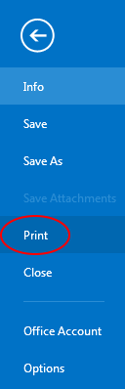

- If your name appears at the top of the generated email, as shown below,
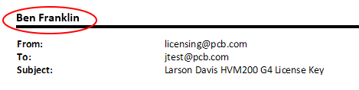
do the following to suppress it:
- Select “Print Options”. | 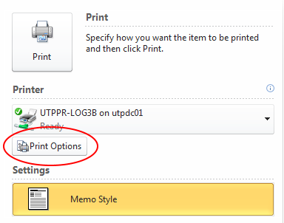
- Select “Page Setup”. | 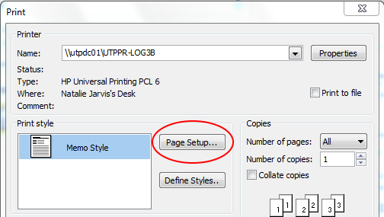

- Click the top “Font” button. | 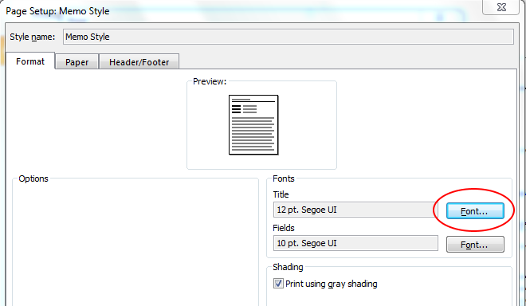
- Set the font to  “Wingdings 2”,  “Regular”, and “1”. | 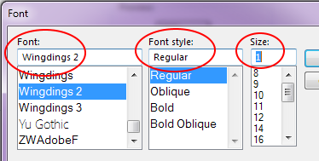

- Click “OK”, “OK”, and then “Preview”, to get back to the “Print” screen.

This will only need to be done once, as these settings will be retained for all of the emails that you print from this PC.
- Click the “Print” button to print the page.  - Insert the page into the shipping box.  - Click the “Send” button to send the email. | 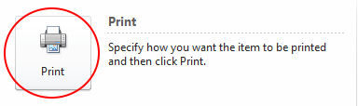
 | 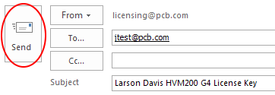

9.3 Generate Rental License Key

License keys generated for use by a rental shop, such as the Modal Shop, will expire in 6 months. Rental keys will be specified by the part number SWW-G4-HVM-6MO on the order form.

The following steps show how to generate a rental license.

- Click the “New Sale” icon.

- In the form that appears, click on the Product down-arrow.  Then select “Rental (SWW-G4-HVM-6MO)”. | 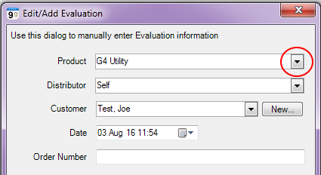  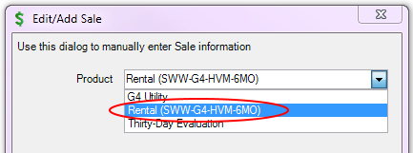
- In the form that appears, enter the Customer information as described in section 9.1, steps 3 and 4 above. | 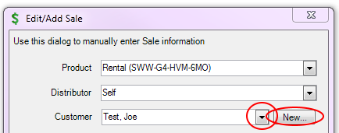

- On the “Edit/Add Sale” form, fill in the Order Number with sale order number. | 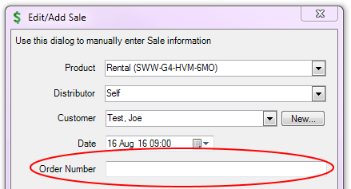

- Click the “Generate” button.  After a few moments, the key will appear in the “License Keys” window.  Proceed as directed in section 9.1, steps 7 and 8 above. | 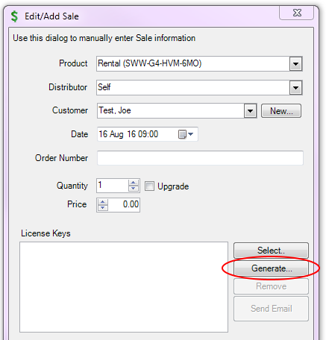

9.4 Generate Evaluation License Key

If a customer does not order the SWW-G4-HVM option, the G4 software will automatically provide a 30-day evaluation time period. If this evaluation period expires and the customer needs additional time, Larson Davis sales personnel may request an evaluation license to be sent to the customer. The sales person should provide the length (in days) of the evaluation license and the email address to which the license should be sent. The following steps show how to generate an evaluation license.

- Click the “New Evaluation” icon. | 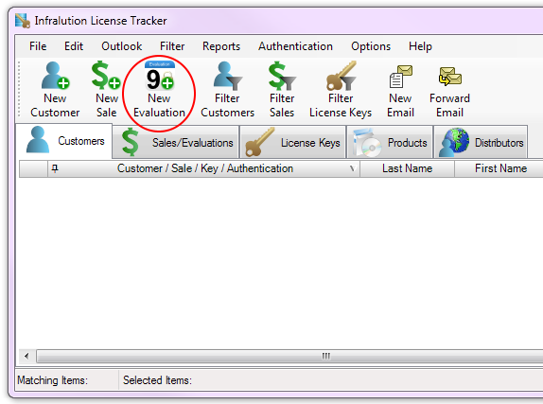

- In the form that appears, click on the Product down-arrow.  Then select “Thirty-Day Evaluation”. | 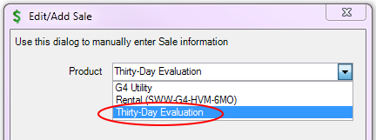
- In the form that appears, enter the Customer information as described in section 9.1, steps 3 and 4 above. | 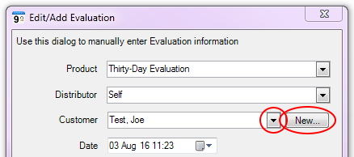

- On the “Edit/Add Sale” form, fill in the Order Number with “EVAL”. | 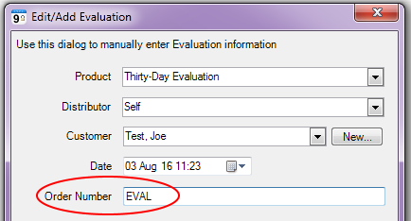

- Click the “Generate” button.  After a few moments, the key will appear in the “License Keys” window.  Proceed as directed in section 9.1, steps 7 and 8 above. | 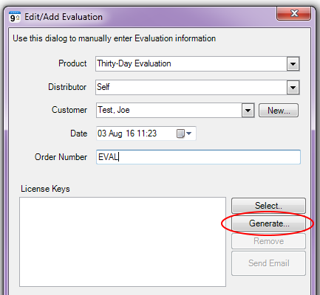

9.5 Deactivate a License Key
If a license key needs to be deactivated, so that it can no longer be used by a customer, follow the instructions above for “Look Up a Previously-Generated License Key”, then select “Deactivate” on the right-click menu.

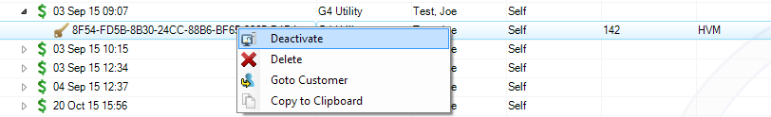

The next time the customer tries to authenticate with this key, when reinstalling G4 or when trying to move the license key to a different PC, for examples, the key will not be allowed to be used. The following error will be displayed in G4:

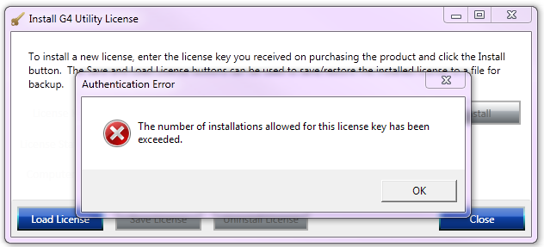

9.6 Instructions for Customer to Transfer a License Key to Another PC

As long as the customer has the original printed or emailed copy of their license key, the customer may transfer the license to another PC without contacting Larson Davis. Note that each license key may be used on up to five PC’s at a time.

- Run G4. In the “Tools” menu, click on “Install Licenses”. | 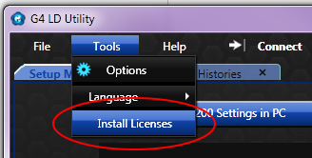

- A dialog may pop up stating that “HVM License or Evaluation License is already installed. Do you want to run the License Manager anyway?”. Click on the “Yes” button.
- Click on the “Uninstall License” button to remove the license from G4 on the current PC.
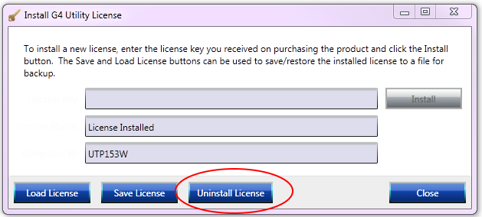

- Install G4 on the new PC, run G4, and go to the “Tools/Install Licenses” menu item. Paste or type the license key into the top text field and click on the “Install” button.

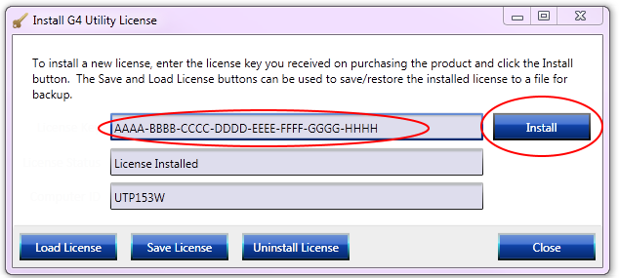

Note: The license key may be found in the original email message sent when the license was purchased or on the printed form included with the product. Customers who do not have the license key will have to call PCB Customer Support to have the key sent again via email.

9.6 Instructions for Authenticating a Customer-Generated License File
If a customer doesn’t have an internet connection on the PC where G4 is being run, he or she will not be able to get their license key authenticated and won’t be able to use any of the licensed features of G4. An alternative authentication process has been provided to cover this scenario.

Following are the steps the customer must follow:

In G4, click on “Tools”, “Install Licenses”.

Paste in the license key from the email into the top box and click on the “Install” button. | 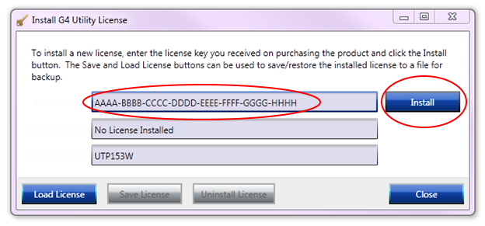
If no internet connection is available, the license will not be authenticated and the message shown at right will appear.  The customer should click the “Yes” button, which will direct the customer to save the file to a known location.  Alternatively, the customer may follow the instructions circled in orange at right, if a PC with an internet connection is available. Then they won’t need to send any files to Larson Davis Support. | 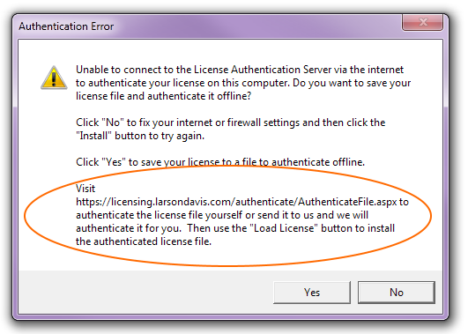

The customer emails the license file to ldSupport@pcb.com as directed in the license key email they received with their new meter.

Following are the steps that Logistics must follow when a license file is received:

- Run License Tracker
- In the top menu bar, click on “Authentication”, then “Authenticate License File” | 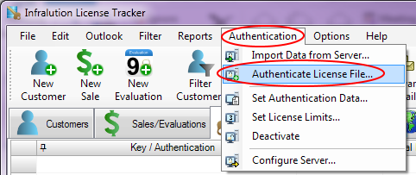
- Navigate to where you stored the License file from the customer, select it, and click “Open”. The authentication process may take a minute or so. The customer’s license file will be updated with the authentication information.

- Email the updated file back to the customer.

The customer then follows these steps as outlined in the license key email received with the new meter:

In G4, click on “Tools”, “Install Licenses”.

Click on the “Load License” button and navigate to the location of the license file received back from Larson Davis Support.  Click on “Open”. | 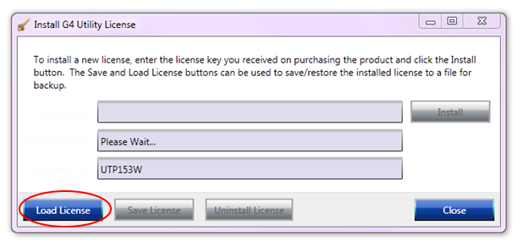
- The license file will be loaded and “License Installed” will appear in the second box.  The “Close” button may be clicked to exit the License Manager. | 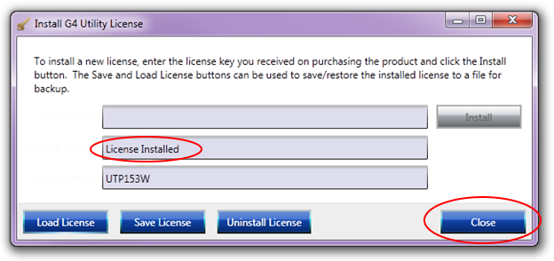

10.0 RECORDS

The only records generated by this work instruction are the license key entries in the database that is accessed by the application.

11.0 DISTRIBUTION

This Work Instruction is available online in the work instruction area of Document Control.

12.0 ATTACHMENTS

No attachments applicable to this process.

13.0 REVISION HISTORY

DCO # | REV | DATE | INITIALS | CHANGES MADE
1577 | A | 8/28/15 | SWL | Initial release.
1583 | B | 10/21/15 | SWL | Added email printing and barcode instructions.
1588 | C | 11/10/15 | SWL | Clarified instructions for placing bar code on box.
1623 | D | 5/12/16 | SWL | Added directions to deactivate and transfer licenses.
1634 | E | 8/2/16 | SWL | Modified sections 9.1 and 9.3 to updae images to include drop-down option for “Thirty-Day Evaluation”. Slightly modified procedure in 9.3.
1635 | F | 8/16/16 | SWL | Added new rental license part number. Added section to address a customer-sent license file that needs authentication.

