G4 AudCal Kit Configuration Work Instruction

#### 1.0 PURPOSE

When assembling AudCal kits (SYS014, SYS015, SYS016 and SYS017), information about the various components included with the kit needs to be entered into a database inside the kit’s 831C.

G4 includes a utility that will write this information into the 831C’s AudCal database.

#### 2.0 AFFECTED DEPARTMENTS

Manufacturing

Logistics

#### 3.0 REFERENCE DOCUMENTS

**IG4.01** G4 Software Manual

#### 4.0 RESPONSIBILITIES & AUTHORITY

Authorized users of the software are responsible to…

* Enter the information requested by the utility, which will be written to the AudCal database inside the 831C.
* QA personnel will verify that this information has been entered correctly.

#### 5.0 DEFINITIONS

**G4 Command Line** – A way to run G4 that enables certain features that are not normally available.

**SYS014, SYS015, SYS016, SYS017** – Order numbers for particular configurations of the AudCal Kit.

#### 6.0 SAFETY PRECAUTIONS

No safety precautions indicated for operation of the equipment or performance of this procedure.

#### 7.0 EQUIPMENT & MATERIALS

A desktop PC is required to run the application.

#### 8.0 INSPECTION

There is no inspection associated with this work instruction.

#### 9.0 INSTRUCTION

##### 9.1 Install and Configure G4 Desktop Icon

*NOTE: The steps in this section will need to be performed by someone with proper administrator privileges.*

Install G4 version 3.1.0 or later. To enable the AudCal Kit Configuration utility in G4, add a command line parameter to the icon that will launch G4, as shown in the following steps.

1. Right-click the desktop G4 icon and drag it away from the original icon. Release the right-click button. The following menu will pop up:

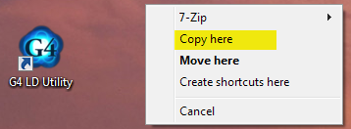

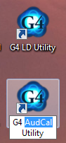Click “Copy here” to create a new G4 icon that will be used to run G4 with the configuration script enabled.

1. On the new G4 icon, click on the “G4 LD Utility” label and select the “LD”. Replace it with “AudCal” and press **Enter**. The original icon will run G4 normally.
2. Right-click on the new icon and select “Properties”.

|  |  |
| --- | --- |
| 1. On the dialog that pops up, edit the **Target** entry to add -showKitCfg to the end of the entry, after the quotation mark, as shown below. Include a **space** between the quotation mark and the dash.      1. Click **OK** to close the dialog. This icon will now run G4 with the **KIT** button visible. |  |

##### 9.2 Prepare the Frequency Response Files

|  |  |  |  |  |  |  |  |  |  |  |  |  |
| --- | --- | --- | --- | --- | --- | --- | --- | --- | --- | --- | --- | --- |
| 1. Create the frequency response “.csv” file for the **½” microphone** (if included in the kit) using the Mic program as follows:  |  |  | | --- | --- | | 1. Open Mic program |  | | 1. Open folder icon. | | 1. Scroll and select microphone      1. Scroll and select microphone serial number. If more than one, select data with the latest date. |  | | 1. Open Sweep results folder |  |  |  |  | | --- | --- | | 1. Click the **Make Response File** button. |  | | 1. Select Actuator 2. Select Ok and close the Mic program 3. Open shortcut to the Mic icon. File with microphone data should be at the top.   Drag this file into:  **R:\Provo\Logistics\Mic data** |  |  1. Copy the frequency response “.csv” file for the **artificial mastoid** (if included in the kit) from the folder:   **R:\Provo\Data\CertData\Mastoid\Automated tests\Export data Mastoids**  to the folder:  **R:\Provo\Logistics\Mic data** | |
| 1. To create a “.csv” file for the **1” microphone**, copy the Excel file for this microphone from the folder:   **R:\Calibration\general\CAL\377SeriesMicrophones**  to the folder:  **R:\Provo\Logistics\Mic data**  Open the Excel file. Save it as a **CSV** file by selecting the **data** tab, selecting **Save As**, then clicking the **Browse** icon. In the dialog that pops open, click on the drop-down box next to the **Save as type** label and select the entry  **CSV (Comma delimited) (*.csv)**  and click the **Save** button. Select **Okay** and **Yes** for the dialogs that pop up. |  |

##### 9.3 Optional – Create CSV File for AEC304 Coupler

1. Run the **PDF AEC304 Frequency Response Extractor** utility to create a frequency response CSV file from the Calibration Certificate PDF file that ships with the coupler.

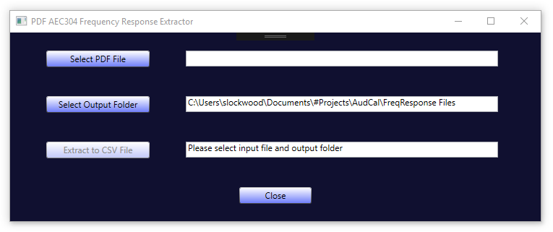

1. Click the **Select PDF File** button and select the PDF Calibration Certificate file for the AEC304 coupler.
2. Click the **Select Output Folder** button, if necessary, to set the path to the location where the CSV file will be stored. This path will be remembered from previous sessions and may not need to be changed.
3. Click the **Extract to CSV File** button, which will only be enabled after the PDF file has been selected and the output folder specified. The CSV file will be created with a name *AEC304_SN_CalDate.csv*, such as “AEC304_0139_23-Feb-2018.csv”.

##### 9.4 Ensure Auto-Sync of AudCal Database is turned off in G4

Open your G4 software and follow the instructions below before connecting to a meter.

|  |  |
| --- | --- |
| Select **Tools/Options.** |  |
| Click on **AudCal Options** tab. |  |
| Uncheck the checkbox shown.  We don’t want the AudCal database to automatically sync when connecting to meter. |  |

##### 9.5 Configure the Kit Using G4

|  |  |  |
| --- | --- | --- |
| 1. Run G4 by double-clicking the icon modified in step 9.1. 2. Connect to the 831C from the AudCal kit. | | |
| 1. Click the **AudCal** mode button if not in AudCal mode. If the AudCal View pane is not full-screen, click in the bar as indicated in the image at right. 2. After a few seconds, the **KIT** button will appear as shown at right. 3. Click the **KIT** button to show the AudCal Kit Configuration Utility. 4. Drag the bottom edge of G4 down to show the entire Configuration Utility screen. |  |
|  | | |

*Note: Leave the fields blank for any item not included in the kit.*

1. The SLM values will be read from the meter and populated automatically.
2. Select the Preamp Model and enter its Serial Number and Calibration Due date.
3. Select the Coupler Model and enter its Serial Number and Calibration Due date.
4. Click the Microphone (Coupler) **Load Data** button and select its frequency response file from the local folder.
5. Click the Artificial Mastoid **Load Data** button and select its frequency response file from the local folder. Leave the fields blank if a mastoid is not included.
6. Select the Calibrator Model and enter its serial number and calibration due date. Verify that the Freq and Level values are correct.
7. *Optional* – Click the Microphone (1”) **Load Data** button and select its frequency response file from the local folder. Leave the fields blank if 1” microphone is not included.
8. *Optional* – AEC304 coupler - Enter the coupler serial number. Click the **Load Data** button and select the CSV file created in section 9.3. The Serial Number will be filled in automatically. Leave the fields blank if the AEC304 coupler is not included. Note that by adding an AEC304 coupler, a microphone is automatically added to the equipment list since
9. *Optional* – AEC202 and AEC203 couplers (type IEC60318-5) cannot be added in the KIT configurator. These must be loaded manually in the drop down menu for the equipment. Note that an AEC202 (Coupler type IEC60318-5) goes with a ½” microphone and an AEC203 (Coupler type IEC60318-5) goes with a 1” microphone.

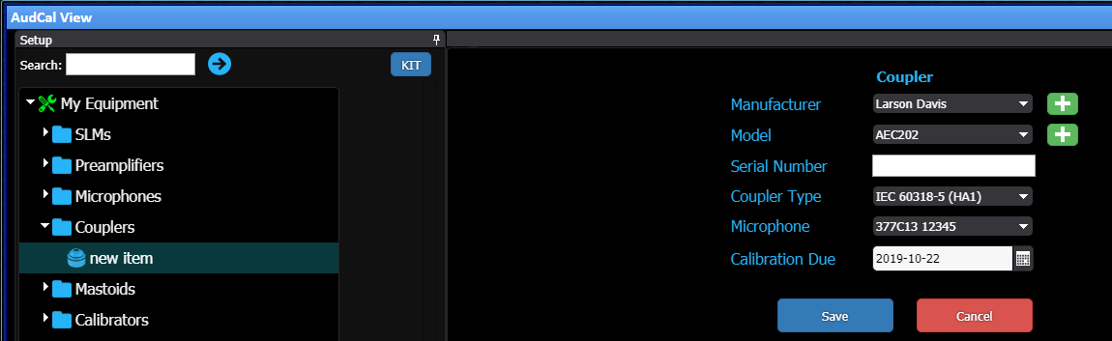

1. Verify that all required fields are filled in correctly.
2. Click the **Save to Database** button.

|  |  |
| --- | --- |
| 1. Click the **X** close button in the meter tab to disconnect the meter. |  |

#### 10.0 RECORDS

The only records generated by this work instruction are the database entries on the 831C.

#### 11.0 DISTRIBUTION

This Work Instruction is available online in the work instruction area of Document Control.

#### 12.0 ATTACHMENTS

No attachments applicable to this process.

#### 13.0 REVISION HISTORY

|  |  |  |  |  |
| --- | --- | --- | --- | --- |
| **DCO #** | **REV** | **DATE** | **INITIALS** | **CHANGES MADE** |
| 1822 | A | 4/16/18 | SWL | Initial release. |
| 1928 | B | 10/22/19 | DPW | Added instructions for G4 Auto-Sync |
|  |  |  |  |  |
|  |  |  |  |  |
|  |  |  |  |  |
|  |  |  |  |  |
|  |  |  |  |  |
|  |  |  |  |  |
|  |  |  |  |  |
|  |  |  |  |  |
|  |  |  |  |  |