**730 & 730IS Options and Shipping Instructions**

1. **PURPOSE AND SCOPE**

This document provides the instructions necessary to perform a pre-shipment configuration of the Spartan Model 730 and Model 730IS. All references to “meter” refers to either of the models, **730** or **730IS**. Certain instructions are specific to one of these models and will be clearly identified by model.

🛈

Instructions for Intrinsic Safe (IS) Model **730IS** will be highlighted with this gold shaded background.

1. **RESPONSIBILITY**

Logistics, or designated person, has the responsibility to follow this instruction when inspecting the products listed in section 1.0.

1. **MATERIALS AND EQUIPMENT**

* Computer with LDKeyGen program to authorize options
* Computer with G4 LD Utility program to install options into meter

1. **INSTRUCTIONS**
2. Generate the options ordered for the meter.
   1. Run **LDKeyGen** program.
   2. 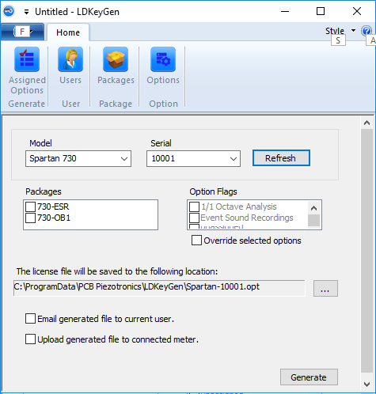Login by selecting your user name and entering your password. The **LDKeyGen** display will look similar to this image:
   3. Select **Spartan 730** or **Spartan 730IS** from the **Model** drop-down list as appropriate.
   4. Enter the meter’s **Serial Number** and press **Refresh**.
   5. Select the purchased **Packages** by checking the box next to the option.
   6. Use the default file location as shown in this example, or browse to a file storage location on the computer to store the file using the  button.
   7. Press **Generate** to create the file in the select location.
3. Program the options into the meter.
   1. Connect meter to the PC with a USB cable.

Meter will turn on automatically.

* 1. Run **G4 LD Utility** 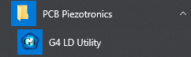
  2. Locate the attached meter on the **Meters** list by its serial number.



* 1. 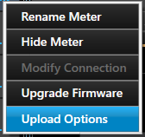Left click with the mouse on the “**. . .**” menu icon.
  2. Click **Upload Options** from the “**. . .**” menu.
  3. In the file open dialog, browse to the option file generated above.

|  |
| --- |
| *If the meter is not shown, check for the meter in the “Hidden” list.*  Double-click on the plus sign in the “Meter” heading.  Then select the **Hidden Instruments** tab.  Select the items in the list that should be visible and press **Unhide.** |

* 1. 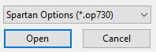With the correct file selected, click on **Open**.

Options are programmed into the meter. The meter will reboot a few times.

* 1. 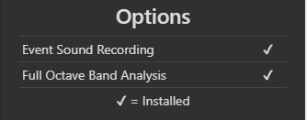On the **Tools** > **About** display, scroll down to the **Options** and verify that they were installed correctly.
  2. 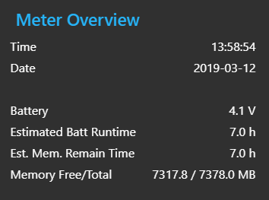On the **Live View** scroll the screen to the **Meter Overview**, verify that **Total** memory is >7000MB.

1. *(FOR REFERENCE)*

Meter information is available on the meter’s **About** display.

➊ 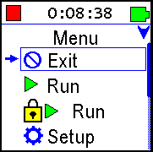 ➋ 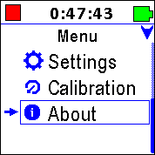 ➌➍ 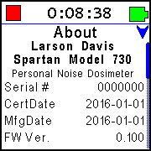 ➎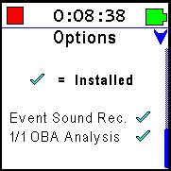

* 1. From main screen hold the  button until the menu is displayed.
  2. Press  once to select **About** and then press .
  3. Verify the **Serial Number**, **Certification Date**, and **Firmware Version** shown match those on the calibration certification.
  4. Verify that the **Manufactured Date** is appropriate.
  5. Press the  once to view the **Options** page (as shown above).
  6. Verify the options match those shown on the sales order.
  7. Press  once from the **About** display to exit to the main screen.
  8. 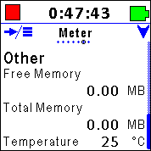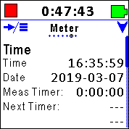From the main screen press (do not hold) the  multiple times until the **Meter** screen is shown. Press  once to see the **Other** page. Verify that the **Total Memory** is >7000 MB.

1. Turn the meter OFF
   1. Press and hold the  power button; the display will show a countdown sequence and then turn off. Release the button after it turns off.

   

* 1. Save the certificates to a flash drive that ship with the meter.
  2. Update the database with the options they installed, the order number, ship date and customer information. Document Control can also do this step.
  3. Complete the **Order Assembly - Features (Options)** section of the **Model 730IS Final Checklist** and save to the network.
  4. Add 730IS serial number(s) to the Shipped IS Unit Log (D0001.8315).

1. **PAPERWORK**

Initial and date the order.

1. **REVISION HISTORY**

|  |  |  |  |  |
| --- | --- | --- | --- | --- |
| **DCO#** | **REV** | **DATE** | **INITIALS** | **CHANGES MADE** |
| 1876 | A | 13 Mar 2019 | AJR | Initial release |
| 1954 | B | 14 Apr 2020 | AJR | Added 730IS specific items |
| 1996 | C | 22 Sep 2020 | TLB | Added recording 730IS sn to Shipped IS Unit Log |