**Purchase Order Returns**

1. **SCOPE**

The purpose of this document is to provide the detail and instruction necessary to perform the return of a line on a purchase order in the BSD.

1. **REFERENCE DOCUMENTS**

PD015 Material Return Form

# AFFECTED DEPARTMENTS

Logistics/Receiving

Purchasing

Quality Control

1. **TERMS AND DEFINITIONS**

**BSD:** Business System Database

**QCR:** Quality Control Return

# RESPONSIBILITIES & AUTHORITY

Logistics responsibilities and authority:

* Process return

Quality Control responsibilities:

* Make sure QCR returns are vouchered
* Provide correct return information to Logistics

Purchasing responsibilities and authority:

* Resolve any invoice discrepancies
* Support logistics/quality control in obtaining invoices to be vouchered as needed

1. **PROCEDURES**

A purchase order may need a line returned when:

* Quality control rejects a part due to inspection
* Logistics made an error when receiving (ie: wrong amount, wrong line, etc)
* Purchasing needs to adjust a price
* Purchasing needs to create credit for finance
  1. **Vouchered**

To process a QCR return, it must be vouchered. To check, open up the lines tab at the top right of the purchase order screen. The purchase order lines screen will open and the graph on the right shows what quantity was received (blue) and the quantity that has been vouchered (yellow). If the line hasn’t been vouchered or not enough have been vouchered, you will be unable to check the DR return box.

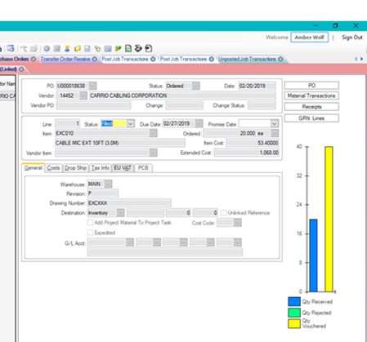To process a return, check the box of the line to be turned, check the DR return box, enter quantity to be returned, select QCR under reason code, select the correct location parts are being returned from, usually QC or CONTAINMENT, and process by clicking receive.

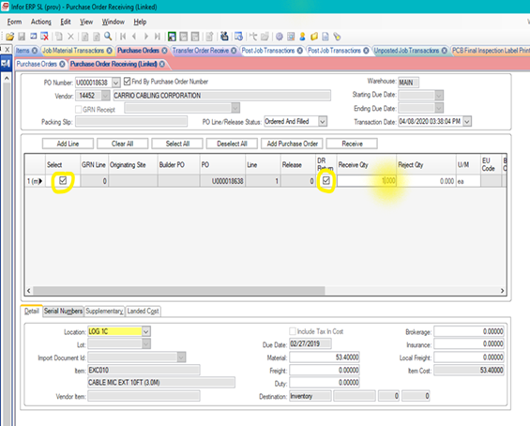

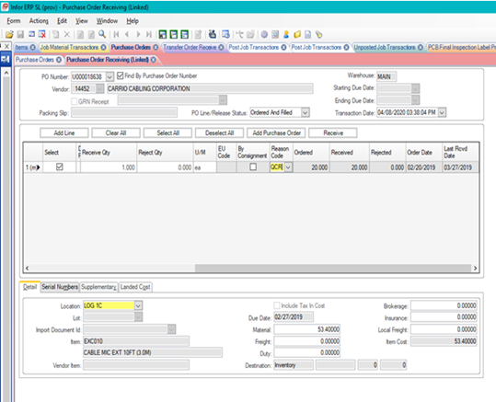

After completing the steps in the BSD, fill out PD015, Material Return form and email a copy to Accounts Payable. This is required by PCB Accounting procedure. This form is completed only when a QCR is processed.

* 1. **Unvouchered**

To process an unvouchered line, check the box of the line to be returned, enter quantity to be returned with negative (-1), select correct Reason Code, usually PE (purchasing error) or RE (receiving error), select the correct location parts are being returned from(if applicable) and process by clicking receive.

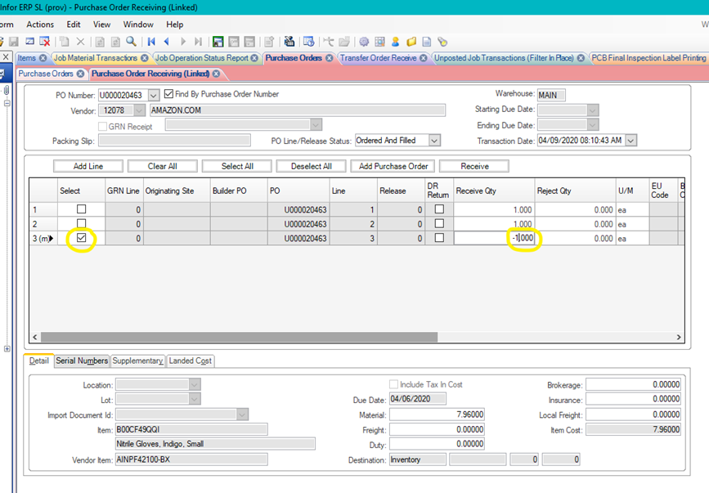

**6.0 REVISION HISTORY**

|  |  |  |  |  |
| --- | --- | --- | --- | --- |
| **DCO #** | **REV** | **DATE** | **INITIALS** | **CHANGES MADE** |
| 1967B | A | 6/30/2020 | AW | Initial Release. |
|  |  |  |  |  |
|  |  |  |  |  |