**Transfer Order Ship/Returns**

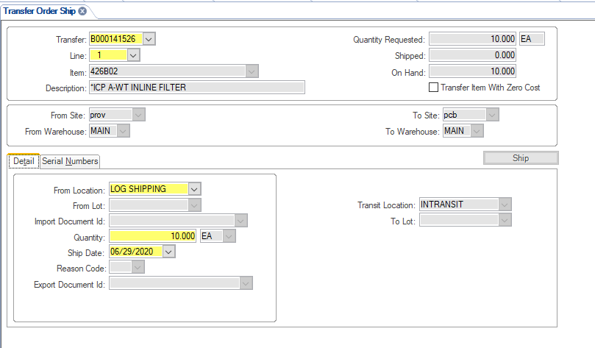

1. In Syteline bring up the TRANSFER ORDER SHIP form
2. Type in the Transfer Order number (arrow), TAB off the field
3. Check/Verify the Line from the Transfer Order you are shipping, change it if needed; Tab off field
4. Click the “From Location” field in the “Detail” sub-tab; choose the correct location from the drop-down that you are shipping the product from. (arrow)
5. TAB to the “Quantity” field in the same tab and change the QTY if needed.
6. If the product you shipping has a serial number click the “Serial Numbers” sub-tab.

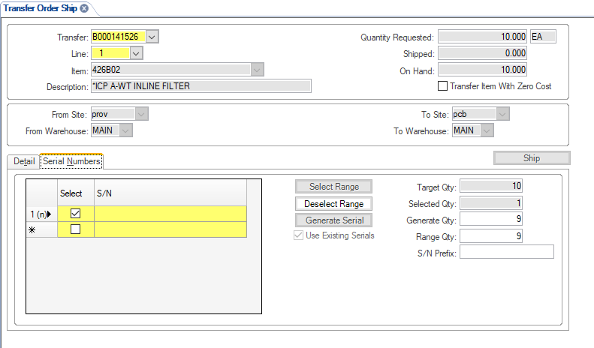

1. Click the  to highlight the “Serial Numbers” field yellow. Check the Select box, Tab over and then start SCANNING the serial numbers (arrow).

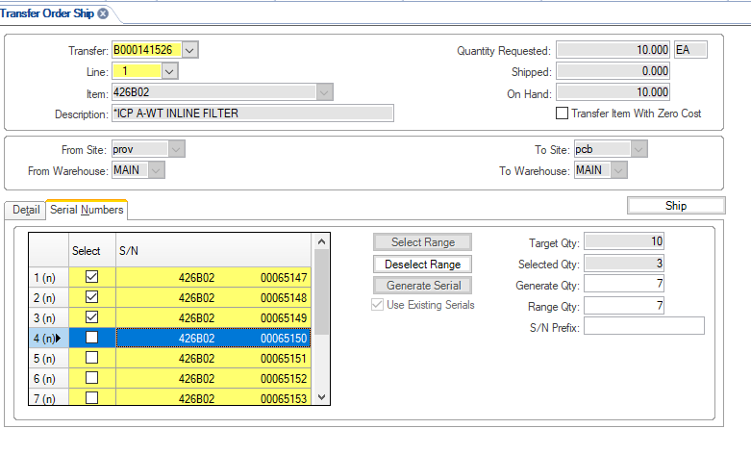

1. Click the appropriate box (see arrow above) next to the serial number(s) you are trying to ship until the TARGET QTY is the same as your SELECTED QTY( see arrow below)
2. Then hit the SHIP tab (red arrow below)

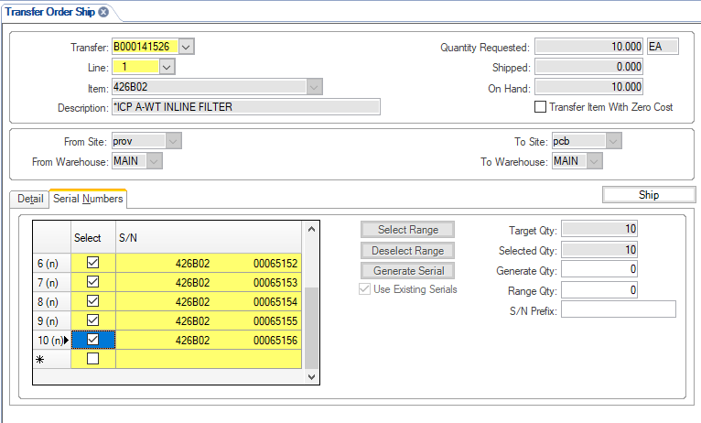

9.

1. In Syteline bring up the TRANSFER SHIP PACKING SLIP form

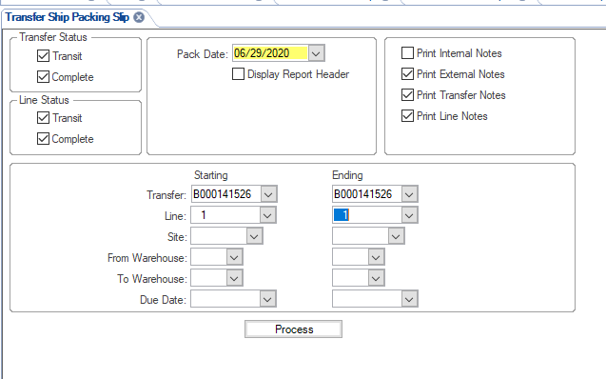

1. Make sure all 3 boxes are checked on the top right (arrow)
2. Enter in your Transfer Order number in the Starting and Ending boxes
3. Enter the line # in the Starting and Ending boxes
4. Click Process
5. You will get a pop-up screen where it will show you the product and Qty you shipping. VERIFY these two and click Print (arrow)

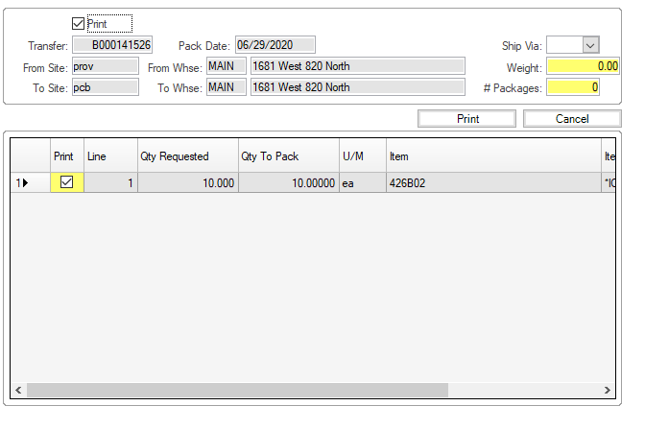

1. You will get another pop-up stating it was successful or not.
2. The packing lists will then go to your SYTELINE REPORTS folder and you can print them from there. Print 2 Copies, 1 with the product and 1 for the shipper to keep. If you have a serial number sheet or set of serial number sticker they go in with the packing list. We keep one copy of the serial number sheet that QC has signed with our packing list.

DOING A RETURN ON A TRANSFER ORDER:

1. In Syteline bring up the TRANSFER ORDER SHIP form

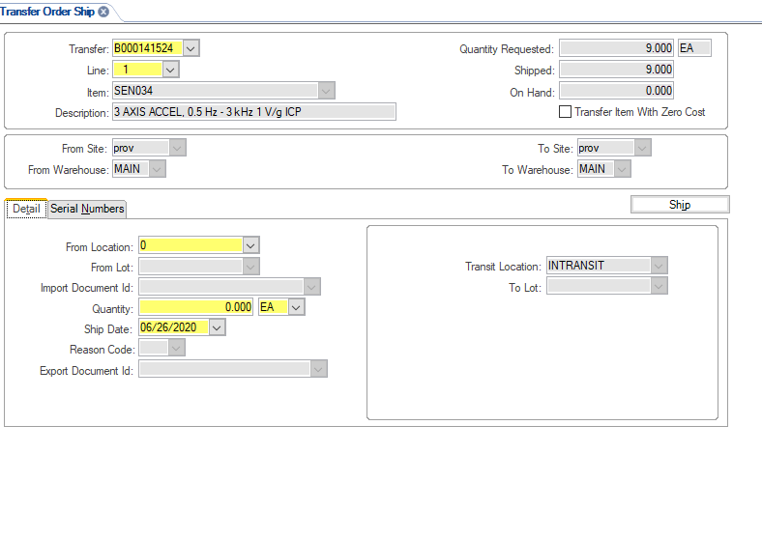

1. Type in the Transfer Order number (arrow), TAB off the field
2. Check/Verify the Line from the Transfer Order you are returning, Tab off field
3. Click the “From Location” field in the “Detail” sub-tab; choose the correct location from the drop-down that you are shipping the product from. (arrow)
4. TAB until the Quantity field in the same tab and change the QTY to be a NEGATIVE qty (arrow)

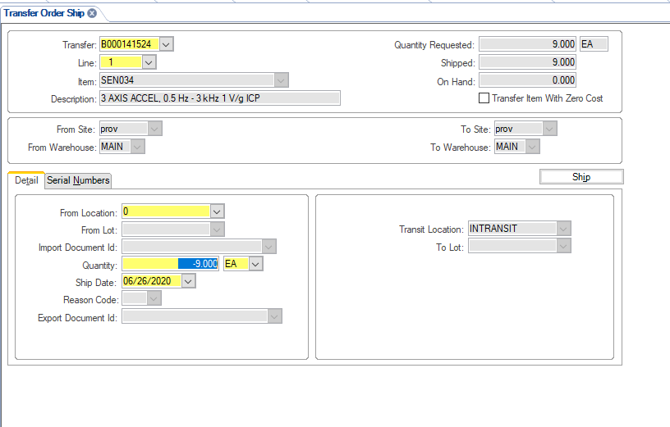

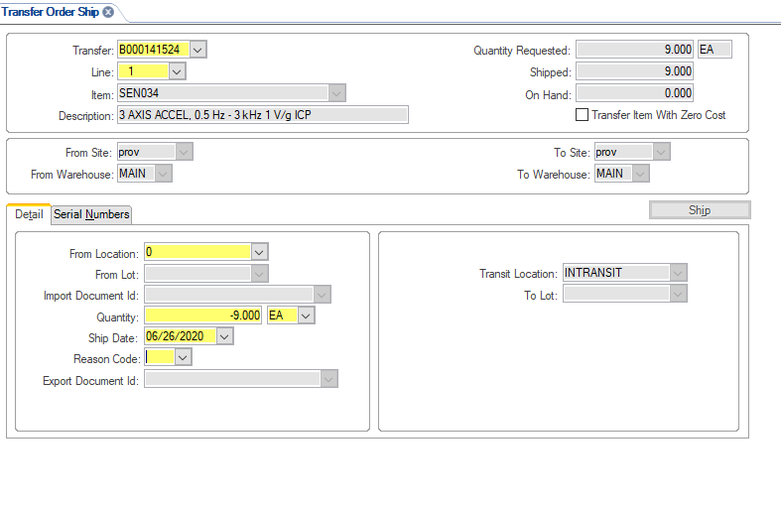

1. In the REASON field (arrow) Choose RET Return Transfer Order from drop down
2. If the product you shipping has a serial number click the Sub-Tab- Serial Numbers
3. Click the  to highlight the Serial Numbers area yellow. Check the Select box, Tab over and then start SCANNING the serial numbers.
4. Click the appropriate box next to the serial number(s) you are trying to ship until the TARGET QTY is the same as your SELECTED QTY( see arrow below)
5. Then hit the SHIP tab (red arrow below)

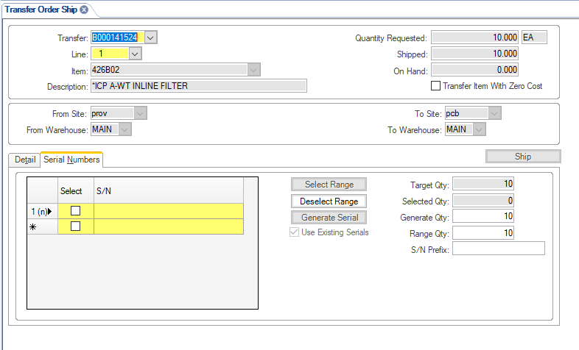

**REVISION HISTORY**

|  |  |  |  |  |
| --- | --- | --- | --- | --- |
| **DCO #** | **REV** | **DATE** | **INITIALS** | **CHANGES MADE** |
| 1968 | A | 06/30/2020 | NJ | Initial Release. |
|  |  |  |  |  |
|  |  |  |  |  |