**Credit Memo Instructions**

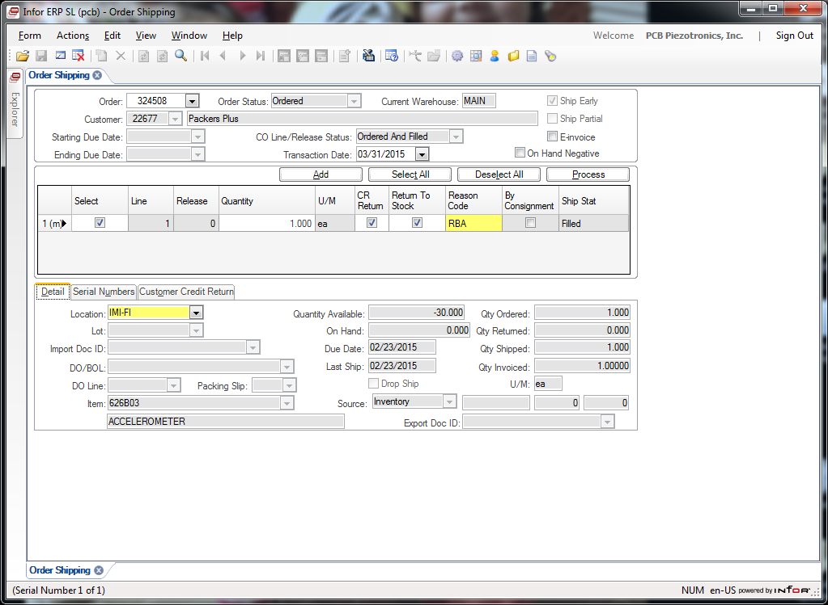

1. Bring up ORDER SHIPPING form in BSD, enter the *Original* order number (found at the top left of the Credit Memo paperwork). CLICK magnify glass in tool bar.
2. Change the CO Line/Release Status to ORDERED and FILLED, CLICK magnify glass in tool bar again. (Arrow)
3. This will show all open and closed lines on the order.
4. Next to the Line you need to Credit, check the box in the SELECT column, “TAB” to next field (QUANTITY) and enter in the number you are crediting. REMEMBER THIS WILL BE A POSITIVE NUMBER if you are putting inventory back into STOCK to reship.
5. CLICK the “CR RETURN” box, TAB to REASON CODE, this will be on the CREDIT MEMO paperwork. If you do not see it, choose RBA for RE-Bill Adjustment. (DEFAULT reason if none)
6. Check the location to make sure it is a good location to put the inventory back into, you can choose from the drop down, or try entering in one.
7. PROCESS ONE LINE at a TIME

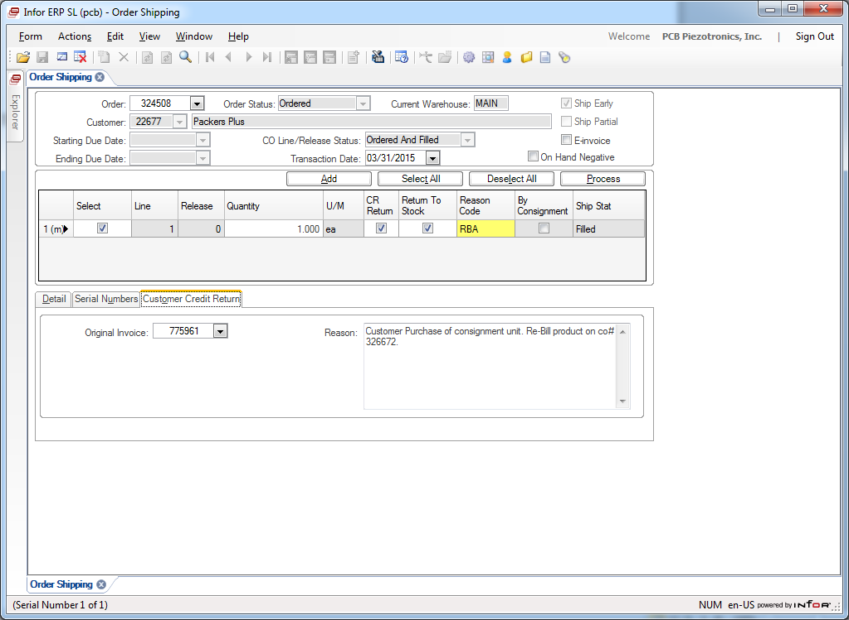

1. Click on the Customer Credit Return tab and in the REASON box (arrow) write why doing the return. Normally written on the CREDIT/MEMO paperwork.
2. To get the ORIGINAL INVOICE #
   1. Open up INVOICE LISTING FORM
   2. Enter CO# and TAB
3. Click PROCESS and you should get a pop-up stating transaction was posted.
4. Go to Pacejet and pull the NEW order from the CR RETURN. ***The CO# will be at the bottom right of the Credit/Memo paperwork.*** Process it in Pacejet like any other order. ***Normally done as an Invoice Only shipment.***
5. Make sure you pack the order to get packing list(s), use **Invoice Only and the CSR’s initials** for the tracking number. If physically re-shipping then put the actual Tracking number in if it does not come back after scanning.
6. Sign the CREDIT/MEMO paperwork and return to the CSR Supervisor with 1 copy of the NEW packing list.
7. If shipped and packed in PaceJet, remember to PROC for Carrier the shipment in the LOAD screen. Close & Checkout the Load so it is invoiced that day.

**REVISION HISTORY**

|  |  |  |  |  |
| --- | --- | --- | --- | --- |
| **DCO #** | **REV** | **DATE** | **INITIALS** | **CHANGES MADE** |
| 1969 | A | 6/30/2020 | NJ | Initial Release. |
|  |  |  |  |  |
|  |  |  |  |  |