**Updating MetTeam Prior to Shipping**

1. **SCOPE**

The purpose of this document is to provide the detail and instruction necessary to update the Customer Name on a unit prior to shipping.

1. **AFFECTED DEPARTMENTS**

Logistics

Shipping

Quality Assurance

1. **TERMS AND DEFINITIONS**

Logistics is responsible to change the name and address on the cert of the unit prior to shipping.

Quality Assurance is responsible to make sure the unit’s certs were updated correctly and customer and calibration information is correct.

1. **PROCEDURE**

When a unit is pulled from the shelf to ship on an order, the Customer Name and Job Number need to be updated prior to shipping. The Customer Name, address and job number need to match the information on the order.

* 1. **Updating Information**

Select assets from maintenance drop down menu. Enter the serial number in search value and select find. Double click correct unit/serial number.

Change customer name by selecting …

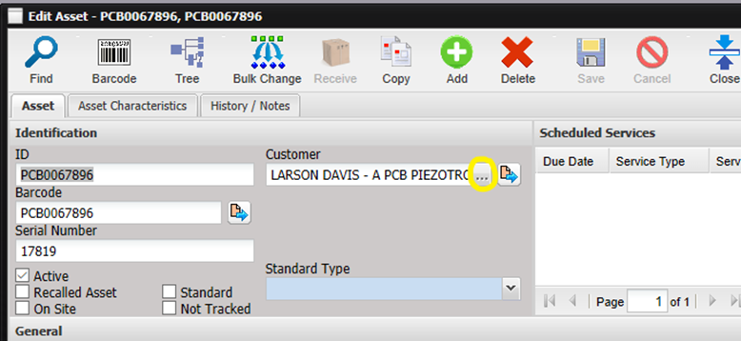

Enter customer name in Search Value and select find. Double click correct customer name and SAVE

Select History/Notes tab and double click the most recent rest results.

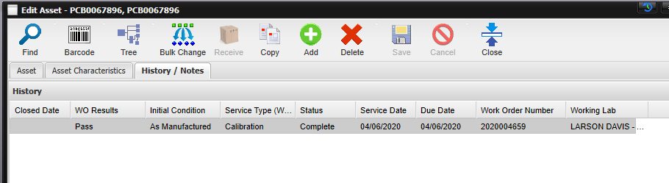

Add the job number by selecting …

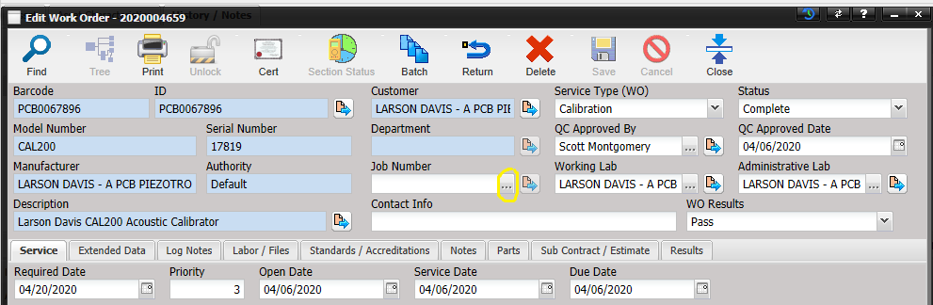

Enter job number in Search Value, check include overhead* and select find. Double click correct job. Change status to complete and SAVE.

When the Status is set to Complete, a prompt will ask if the User would like to update the owner from the database. Select YES.

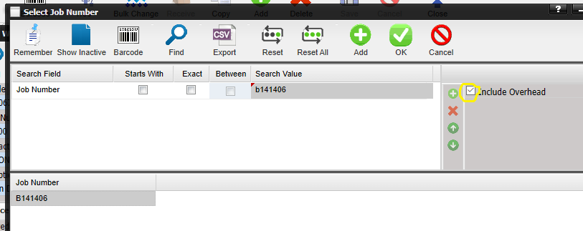

*If you forget to check the include overhead box, no job numbers will be displayed*

* 1. **Add/Create a Job Number**

To add or create a Job Number, select ADD. Enter Job Number, check Level of Effort and SAVE.

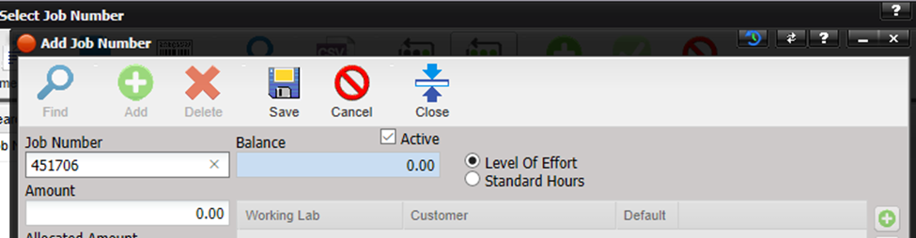

* 1. **Address**

Some customers have multiple addresses. To switch the address or enter a new one, select . The Edit Facility screen will open. It lists all saved addresses for the Facility. To add a new address, click the add button. The Edit Address screen will 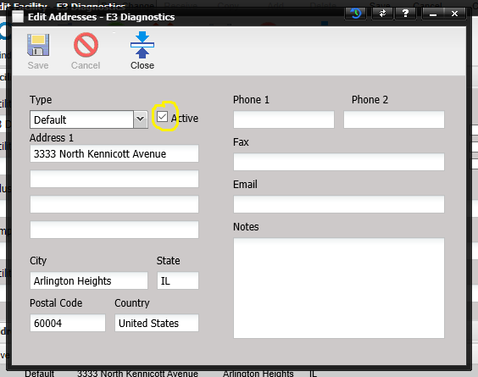open. Enter the new address. Select SAVE.

Make sure the address you want to use is marked active. Double click the address checked active. Uncheck the Active box and select SAVE. Double click the address you would like to use, click the Active box and select SAVE.

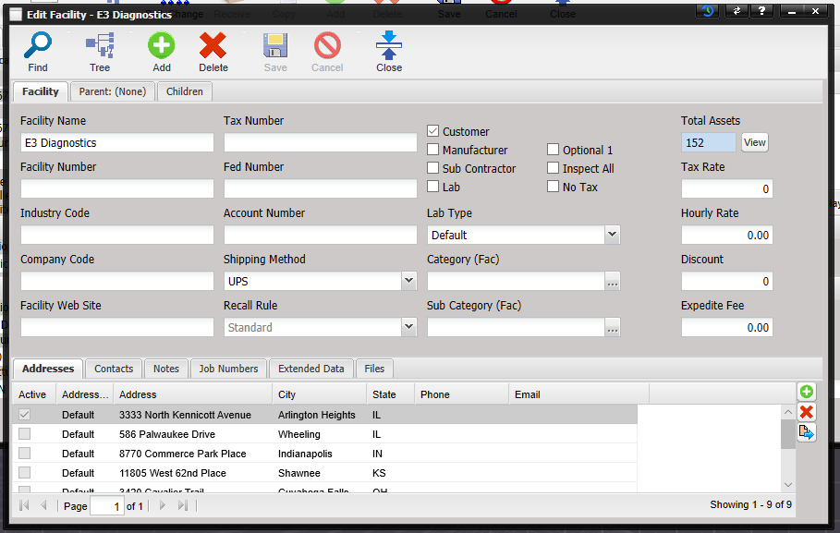

1. **BATCH PRINTING**

To print more than one cert at a time for a specific order number

* Select batch printing from Reports drop down menu
* Enter job number in Search Value
* Double click each unit that you want to print and select OK when finished

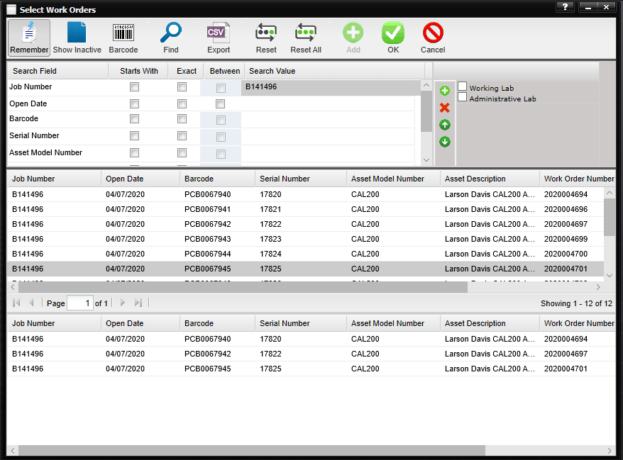

Click PRINT and report will generate

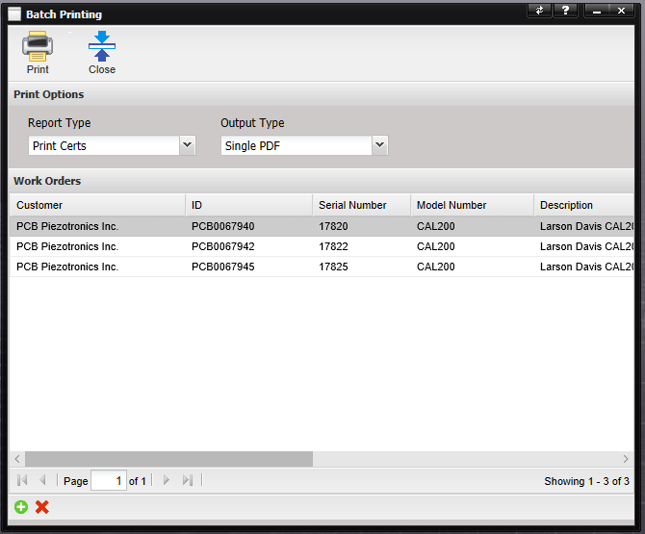

1. **CLOSING ORDER NUMBER AFTER SHIPMENT**

After a unit is shipped to a customer, the job order needs to be returned.

Select returning from Workflow drop down menu. Enter the job number in search value and select find. Double click each Asset Model Number. Select OK when finished.

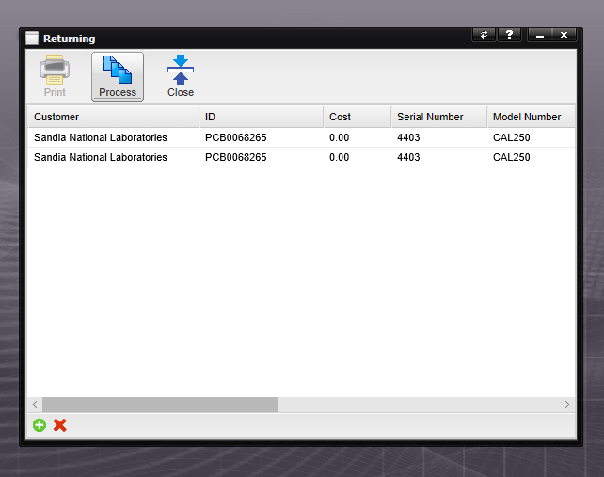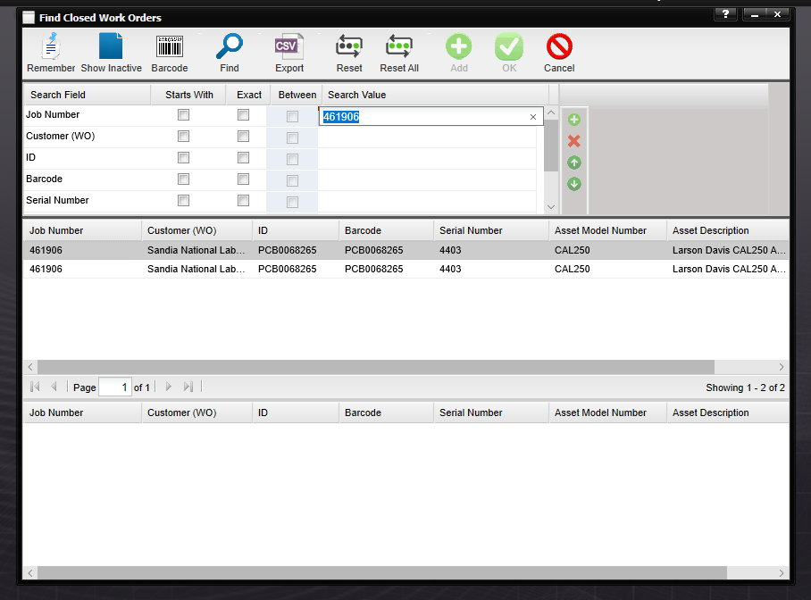Select PROCESS. Pop will generate after the return has been successful. Select close. Repeat steps for each Job Number that needs to be closed.

If unit was shipped without a job number (ie: Demo), close out using the serial number instead.

Select returning from Workflow drop down menu. Enter the serial number in search value and select find. Double click the Asset Model Number. Select OK when finished.

Select PROCESS. Pop will generate after the return has been successful. Select close. Repeat steps for each Serial Number that needs to be closed.

1. **REVISION HISTORY**

|  |  |  |  |  |
| --- | --- | --- | --- | --- |
| **DCO #** | **REV** | **DATE** | **INITIALS** | **CHANGES MADE** |
| 1970 | A | 6/30/2020 | AW | Initial release. |
|  |  |  |  |  |
|  |  |  |  |  |