**PC Returns**

This is the process to return previously shipped equipment back into our stock in order to give our customer credit.

1. The Service Repair department will bring us the returned equipment and the paper you see below. The RMA number is our PC # (arrow)

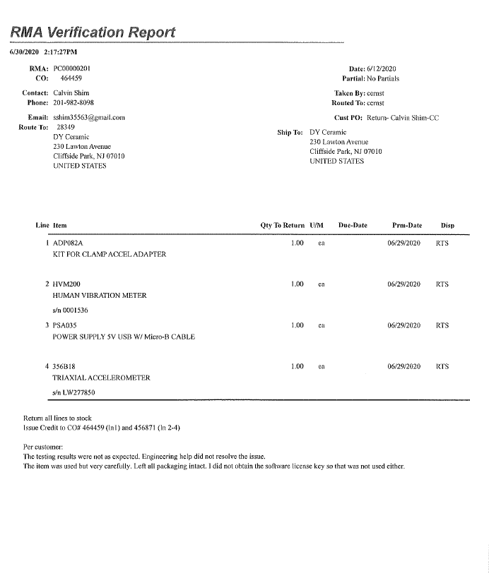

1. Open up RMA Return Transaction form in the BSD.

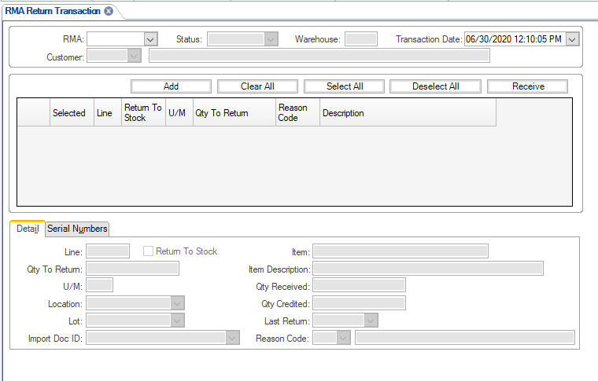

1. Enter the RMA # (see arrow below) and hit TAB for items to populate.

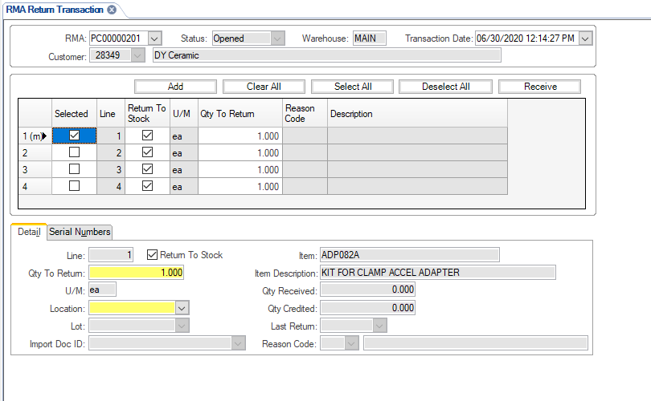

1. Hit SELECT ALL if you are returning all items or check mark the selected lines. Add the correct location for each item to be returned to.

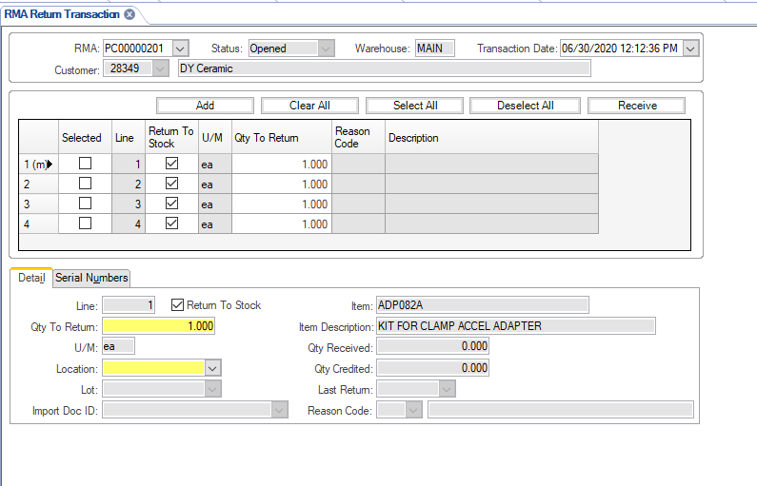

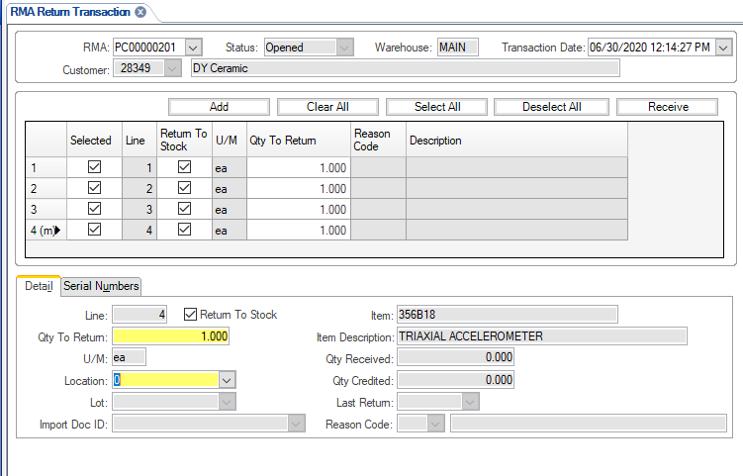

1. Hit RECEIVE to process (arrow) and return items to stock.



1. Send EMAIL to CSR that created the RMA PC Return to let them know we have processed the PC return and the items have been put back in to our stock.

**REVISION HISTORY**

|  |  |  |  |  |
| --- | --- | --- | --- | --- |
| **DCO #** | **REV** | **DATE** | **INITIALS** | **CHANGES MADE** |
| 1972 | A | 06/30/2020 | NJ | Initial Release. |
|  |  |  |  |  |
|  |  |  |  |  |