**Creating Proforma Invoice**

1. **SCOPE**

The purpose of this document is to provide a general guideline for preparing a proforma invoice for shipping internationally.

1. **REFERENCE DOCUMENTS**

R:\Provo\Logistics\SHIPPING DOCUMENTS/PCB Blank Invoice.docm

1. **TERMS AND DEFINITIONS**

**BSD:** Business System Database

**TCS**: Total Customer Satisfaction

1. **INSTRUCTIONS**

When shipping items internationally that are not on a sales order, we will use the following guidelines to create the proforma invoice for customs.

Fill out form found on R:\Provo\Logistics\SHIPPING DOCUMENTS/PCB Blank Invoice.docm

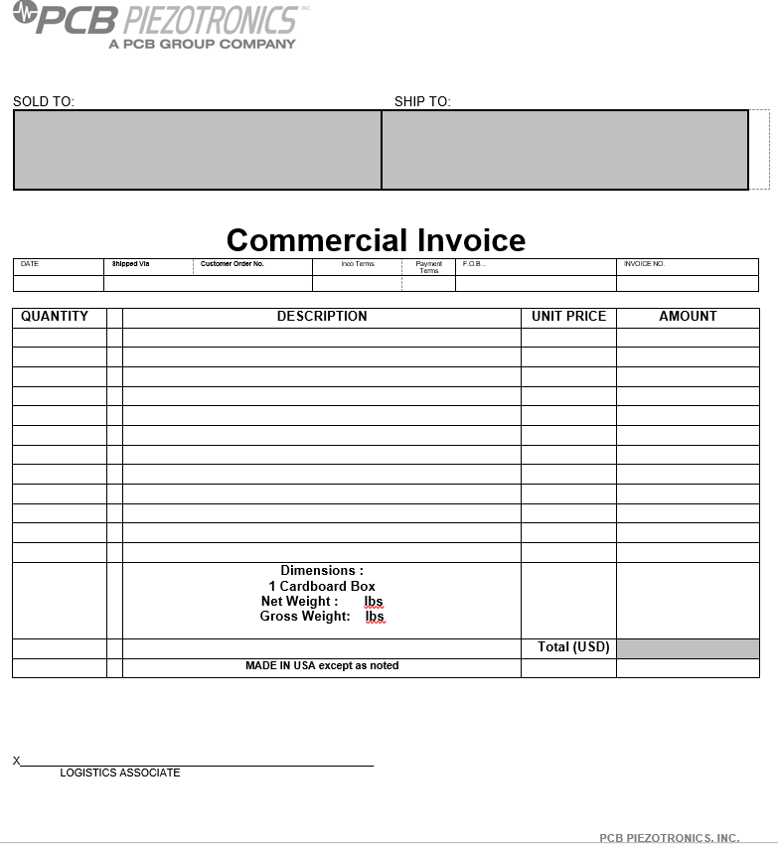

Determine who is responsible for shipping and customs duties/taxes so you can properly fill out form. The person requesting the shipment should be able to provide this information.

Fill in all information required:

* Sold to/Ship to
* Date
* Shipped Via
* Enter Inco Terms
  + DDU- we are paying for shipping costs, the customer/receiver are paying the duties and taxes
  + DDP- we pay for everything(shipping, duties and taxes)
  + FCA- using customer/receiver account
* Invoice number: Enter DEMO, SHOW,WARRANTY or TCS
* Qty
* Description – Part number, Description and Schedule B number
* Unit Price $ *See notes below on how to determine unit price
* Amount $ unit price x qty
* Dimension of box, Net (refers to only the weight of the goods) and Gross (refers to the total weight of goods plus the box and packaging) Weight
* Country of Origin
* Script note stating why the equipment is being sent. See examples below
  + The above items are being sent to customer. Fair market value for customs (USD) $
  + The above "No Charge" product is provided for promotional purposes. Value of promotion (USD) $
  + The above product is provided as a no charge donation for educational purposes. Value of donation (USD) $
  + Goods sent for trade show or exhibition purposes only. No commercial value. Not for resale. Goods to be returned to Larson Davis. Fair market value for customs (USD) $
  + Return of U.S. goods repaired by U.S. Manufacturer. Not for resale. Product value not enhanced by repair. Fair market for customs (USD) $
  + Return of U.S. goods calibrated by U.S. Manufacturer. Not for resale. Product value not enhance by calibration. Fair Market for customs (USD) $
  + Return of U.S. goods repaired under warranty by U.S. Manufacturer. Not for resale. Product value not enhanced by repair. Fair market for customs (USD) $
  + Return of U.S. goods replaced under warranty by U.S. Manufacturer. Original goods supplied were defective and unrepairable. Not for resale. Fair market for customs (USD) $

Sign in blue ink

Six copies required

**\*SHIPPING NEW TCS PROMOTIONAL ITEMS AT NO COST**

Use the unit cost that is found in the BSD.

**\*SHIPPING WARRANTY REPLACEMENT ITEMS AT NO COST**

Use the unit cost that is found in the BSD.

**\*SHIPPING DEMO/SHOW EQUIPMENT**

Determine the unit cost by using the following:

* If product is less than two years old, use the unit cost found in the BSD system.
* If product is more than two years old, minus 10% for each year.

If we are having the equipment returned to us, state in description column that it is going in on a temporary export. Put a time period in which it should be returned back to us. One month is the normal amount of time used. See example below:

* **Temporary Export: Exhibition show purposes only.**

**Demo equipment will be returned to Larson Davis.**

**Time period from September 3, 2020 to October 3, 2020**

If we need to create return invoices for the equipment to be returned to us, we need to add to the description column the following:

* **Customs Broker: FedEx Trade Networks**

1. **REVISION HISTORY**

|  |  |  |  |  |
| --- | --- | --- | --- | --- |
| **DCO #** | **REV** | **DATE** | **INITIALS** | **CHANGES MADE** |
| 1973 | A | 7/7/20 | NJ | Initial Release. |
|  |  |  |  |  |
|  |  |  |  |  |