**Pacejet**

**Click on the Pacejet link**

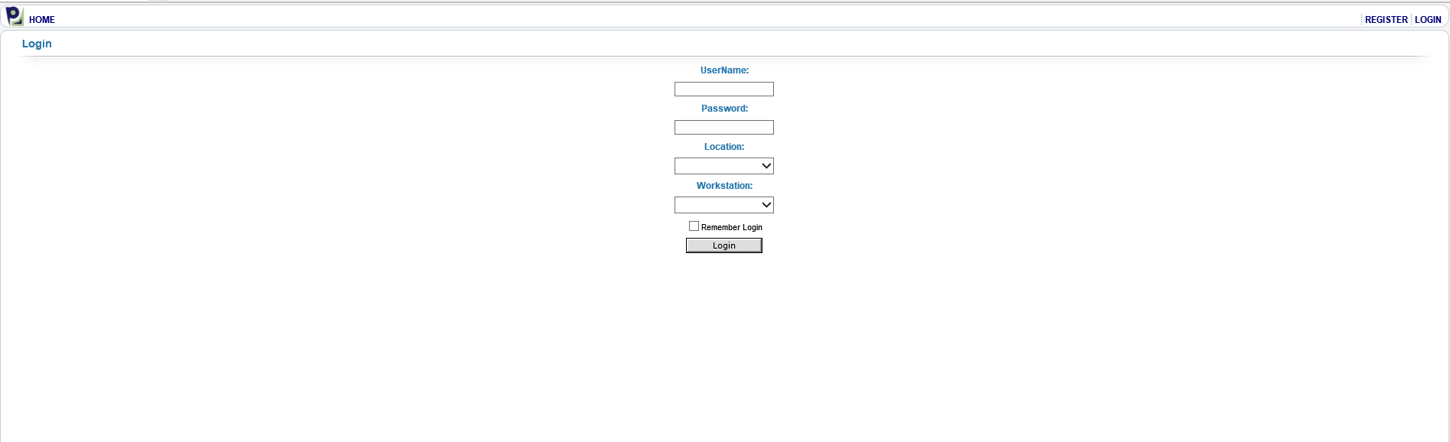

**Enter your Username and Password**

**Location will be Provo and Workstation will be Default**

**Hit the Login button**

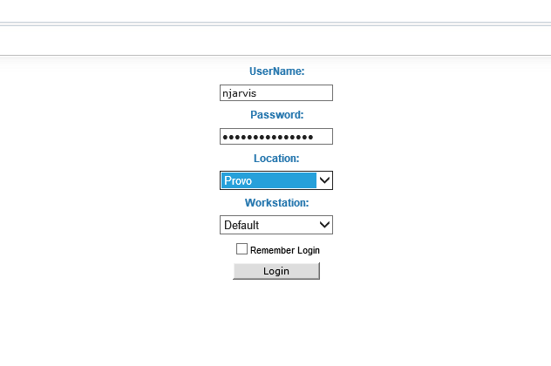

**This is the Pacejet HOME screen**

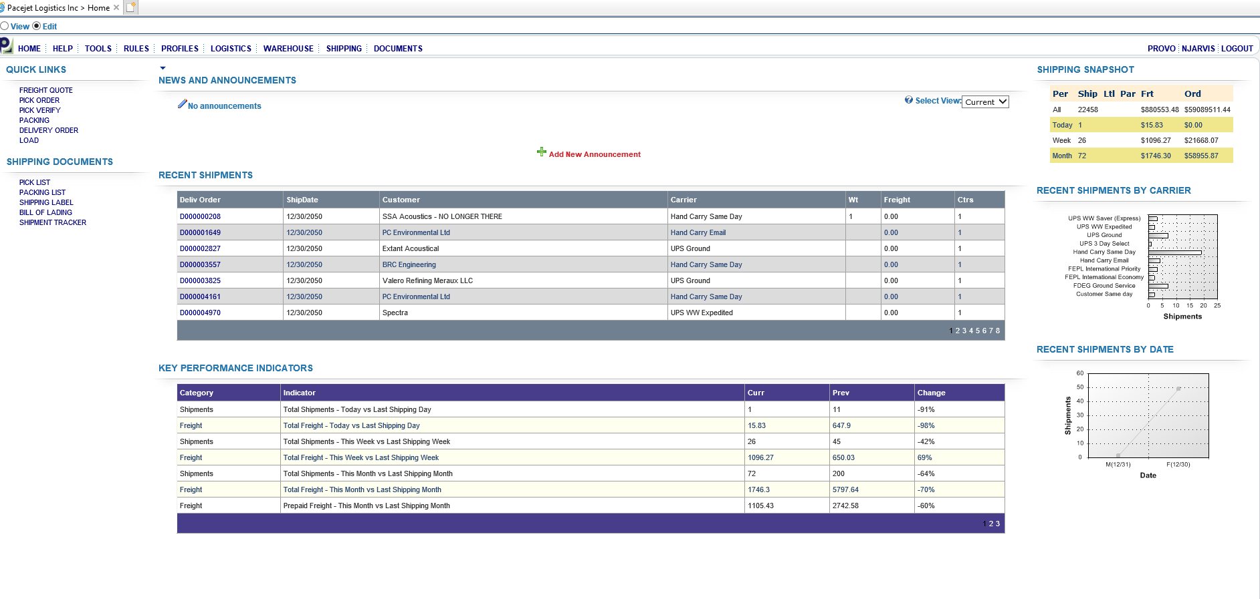**Go to the WAREHOUSE TAB, choose PICK ORDER from the drop down**

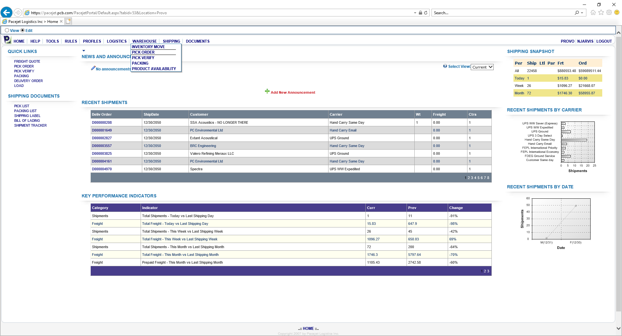

**Click on the PLANNED TAB, then hit the binoculars (black arrow) to bring up all orders showing in Pacejet**

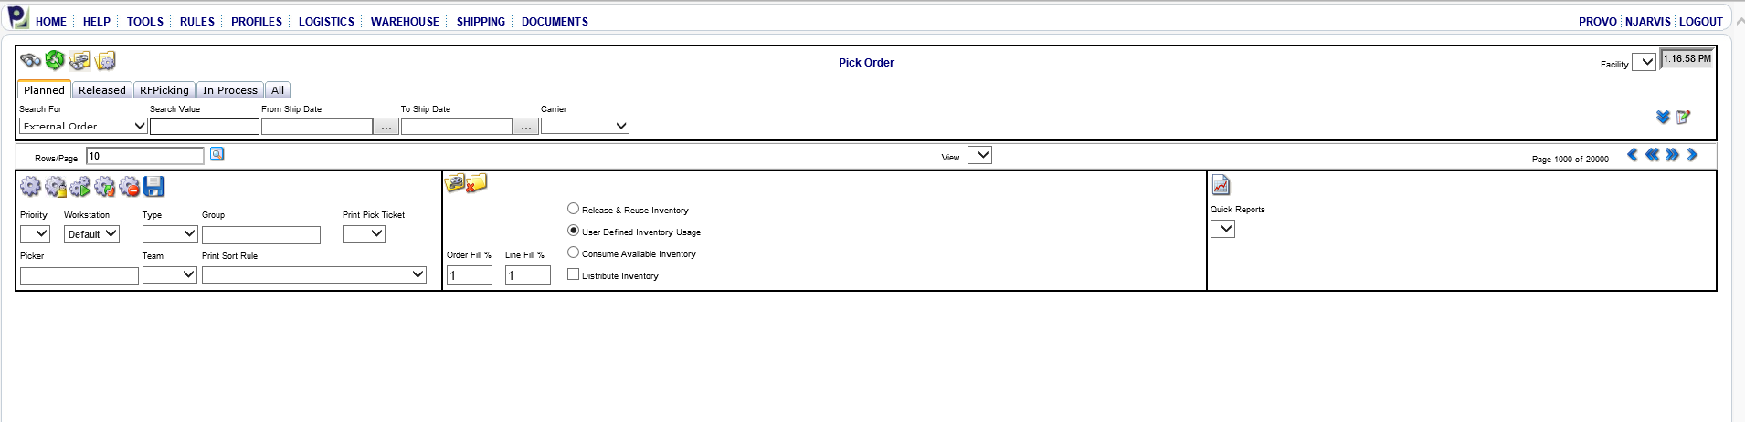

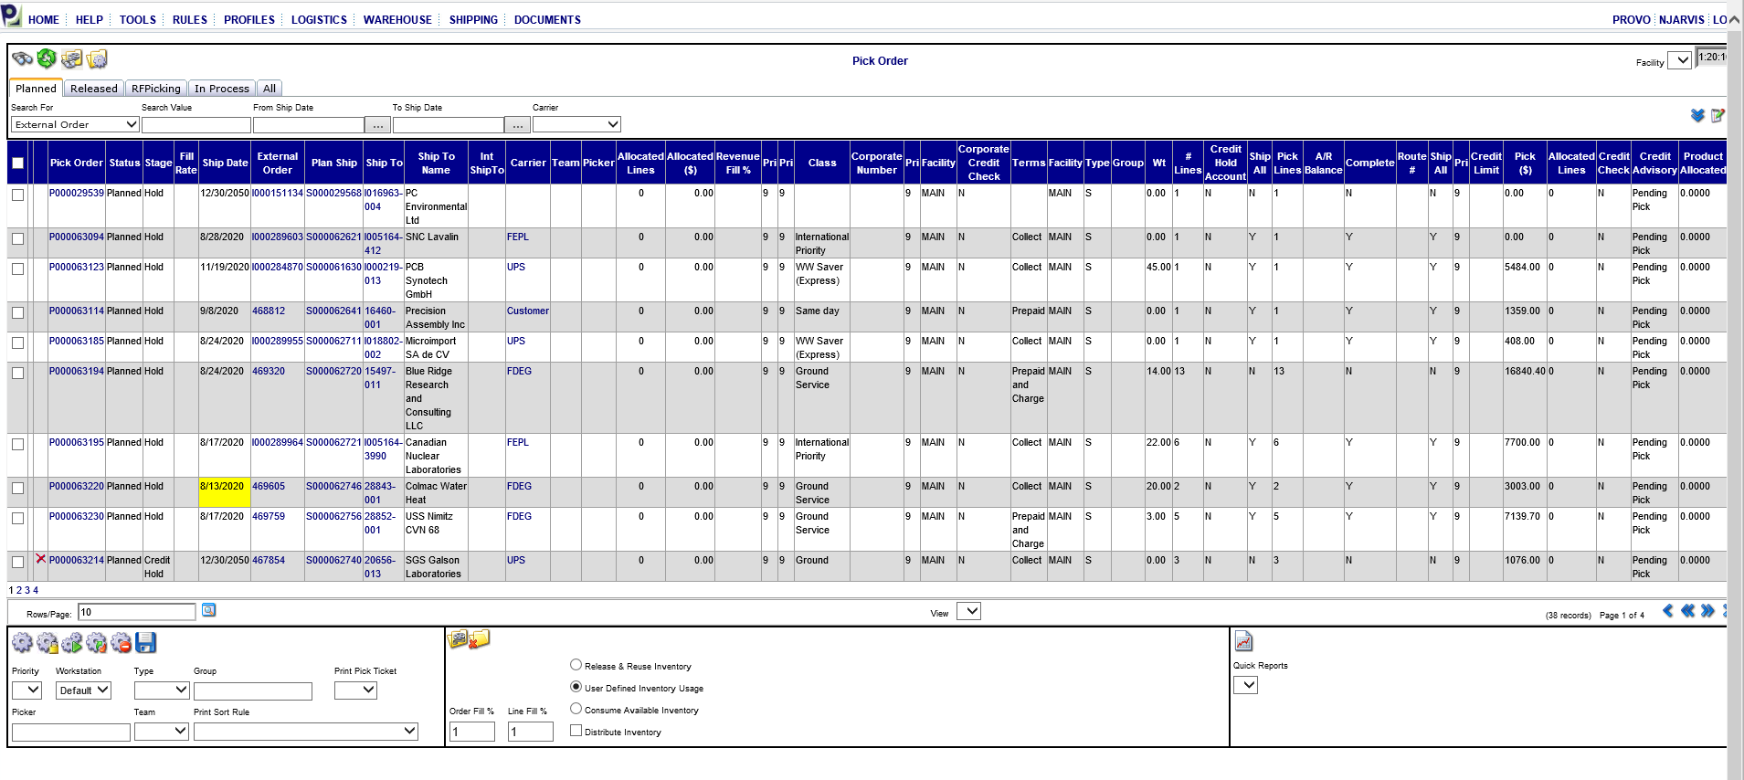

**Enter current date in the TO SHIP DATE (arrow) or you can enter what range you want to look at. Hit binoculars (black arrow) to show orders.**

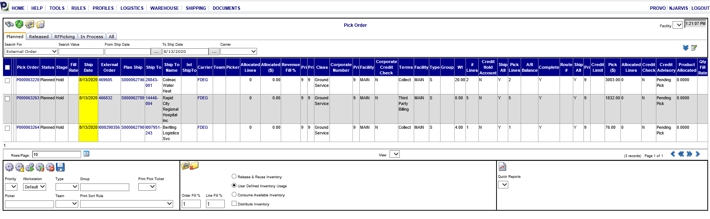

**Enter a check mark (arrow) on the order or orders that you want to release to the handheld**

**Then hit the GEAR (arrow).**

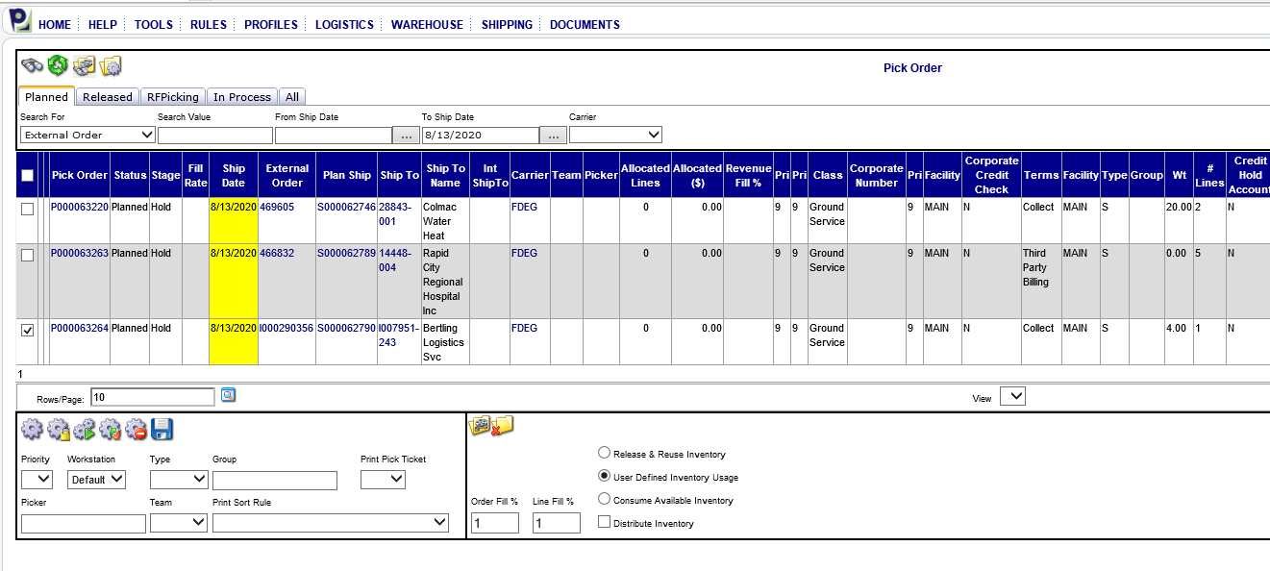

**It will show at the top: *1 pick order updated and saved to workflow***

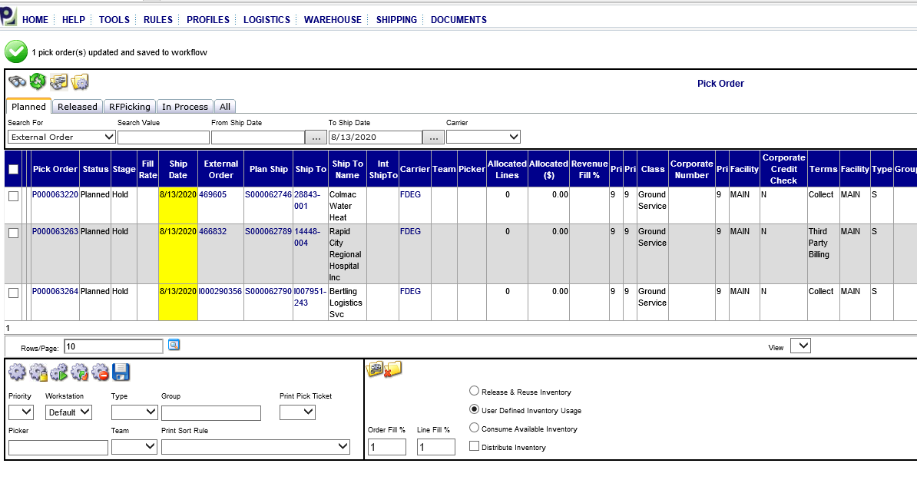

**Click on the RELEASED TAB (arrow) to show what is currently ready to ship on the handheld.**

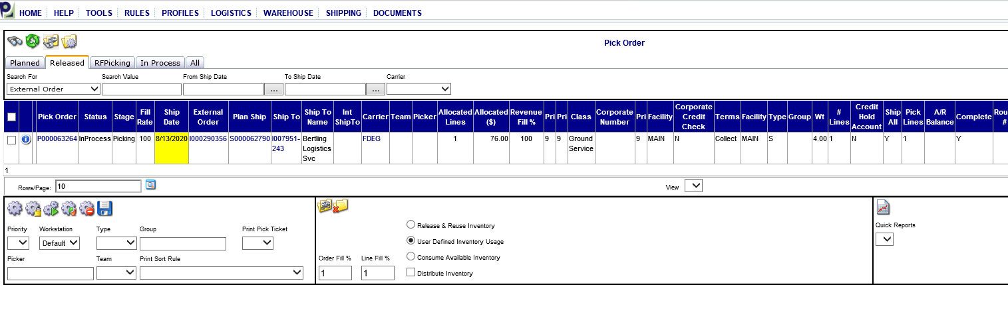**Go and Log onto the Handheld- Click on the Pacejet Icon**

* + **USERNAME: UTP005H or UTP009H**
  + **LOCATION: PROVO**
  + **WORKSTATION: DEFAULT**
  + **SCAN barcode for password**

**Handheld Main Menu:**

* **1 PICKING**
* **1 PCB PICK FLOW**
* **Handheld will give you a PICK ORDER # P0000xxxx has been assigned**
* **HIT GO**

**Pick order paper will print from printer**

**\*\*\*\*\*If an order does not show up or release to the handheld, then go back to this screen and click on the P number it will show down below what is on the order and if you have everything available to ship(arrows below)**

**You may need to adjust in an option, or transfer item to a log location to get it to release. Or see page 20 for other helpful tips.**

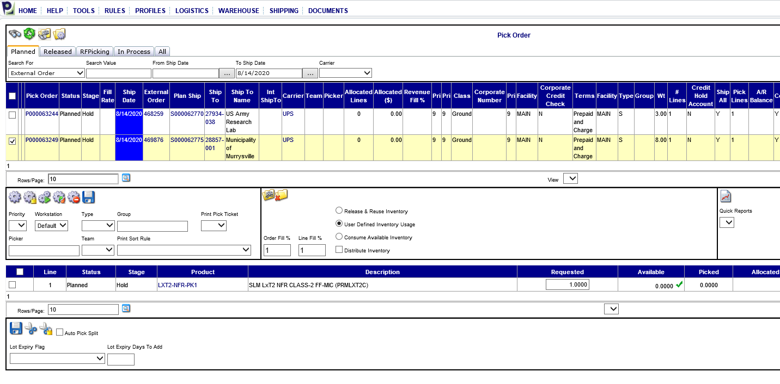

**Go back to Handheld Main Menu:**

* **1 PICKING**
* **1 PCB PICK FLOW**
* **Handheld will give you a PICK ORDER # P0000xxxx has been assigned**
* **HIT GO**

**Pick order paper will print from printer**

* **Scan barcodes for all items on order**
* **Check quantity and hit GO—This will close that PICK ORDER and assign another one by hitting YES**
* **Check all serial numbers and quantity of equipment and write down serial numbers on order verification**
* **Fill out Pick order (See highlighted areas on pick order below)**

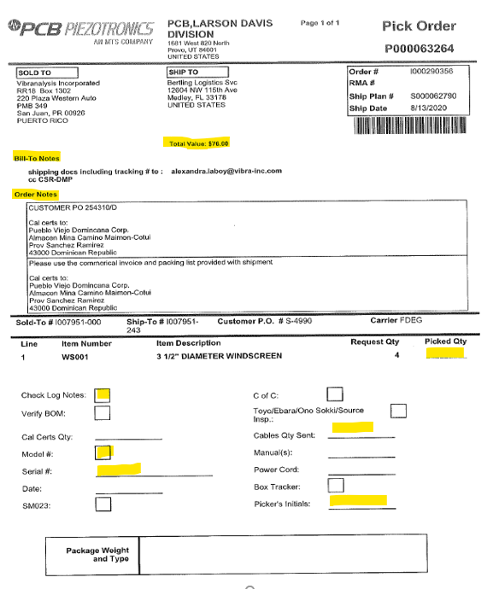

* **Box up Shipment**
* **Write weight and box size on the copy of the order verification**

**Go back to Pacejet to pack and print packing list.**

**To Print Packing List:**

**Go to WAREHOUSE TAB, Choose PACKING from Drop down**

**Hit the Binoculars**

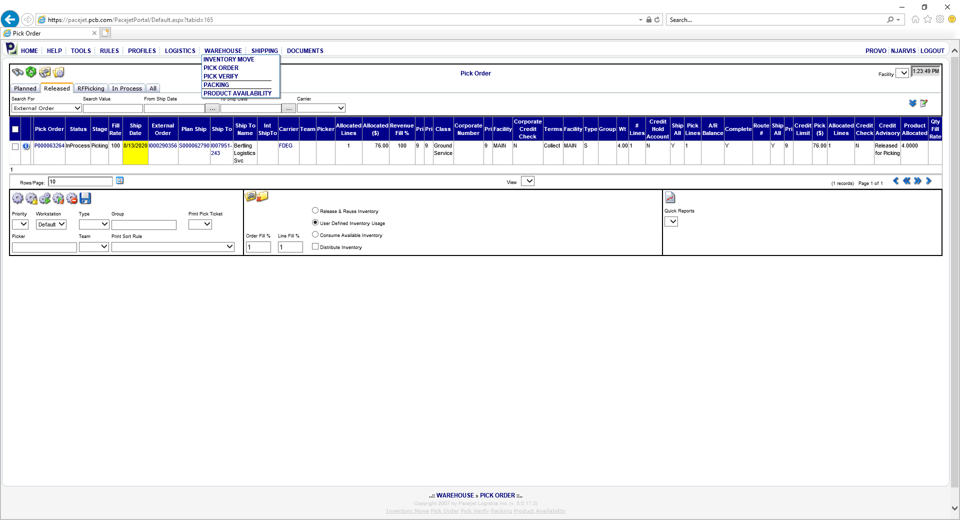

**This will bring up the order or orders you need to pack**

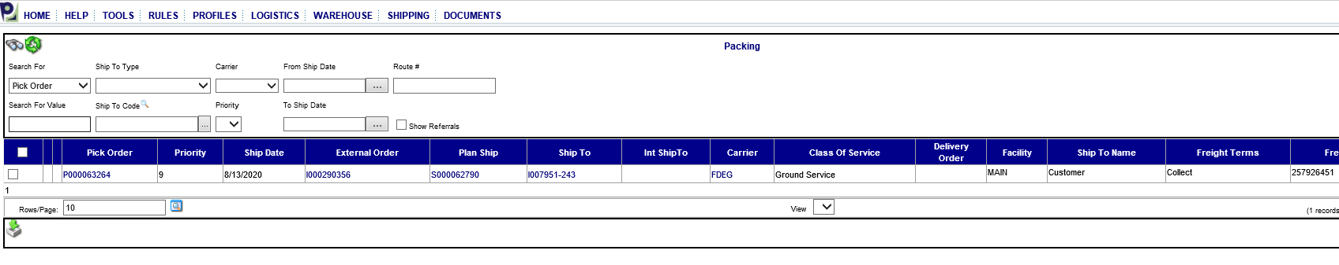

**Put a check mark next to the order you are packing. Hit the pack order button (black arrow)**

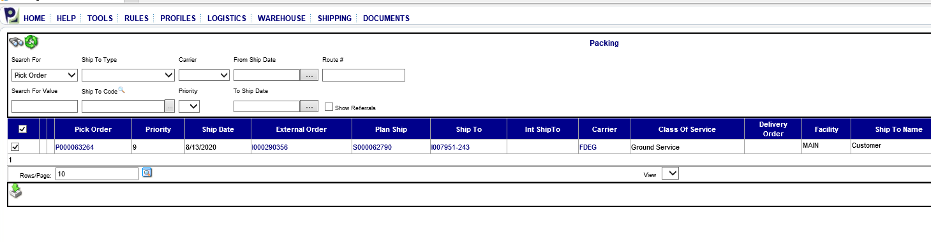**Choose container type from drop down menu, add piece, quantity and weight**

***\*\*If you are shipping just an option or invoice only item, choose email in the container type drop down, choose zero for weight. Then add note to the tracking number field that says” invoice only and the CSR’s initials” or “Option file sent and the CSR’s initials”.***

***Staple the packing list to the copy of the order and this order is complete and ready for load at end of day.***

**Then hit the gear (black arrow) Click OK on pop-up message.**

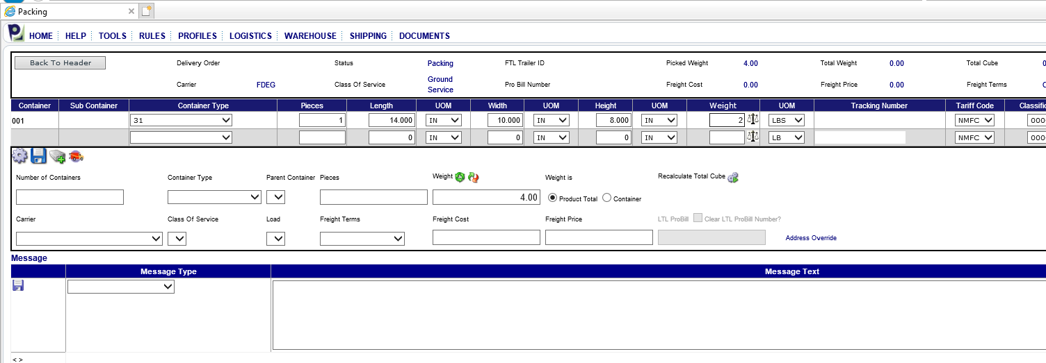

***\*\*If order is shipping by another carrier beside UPS or FedEx (DHL, UPS Supply Chain, Ceva, or Customer Pick up) Choose container type, quantity, and weight. Then add a note in the tracking number section- CUSTOMER PICKUP, DHL etc. or the tracking number if you have it.***

**This will print a packing list (see below). The packing list barcode will scan on the FedEx or UPS computer to populate customer’s shipping information. If shipping another method, you are unable to scan barcode and the information will need to be typed in manually.**

**Process shipment according to shipping procedure.**

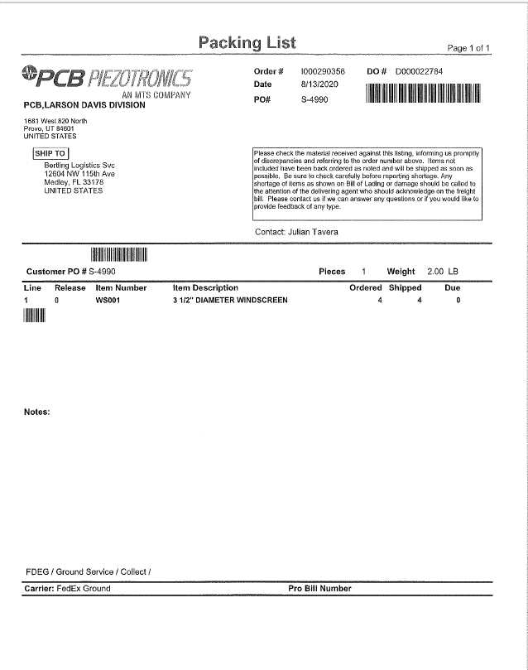

**After ALL shipping is completed for the day—you must DO the LOAD**

**HOW TO DO THE LOAD**

**Go to the SHIPPING TAB- choose LOAD from the drop down**

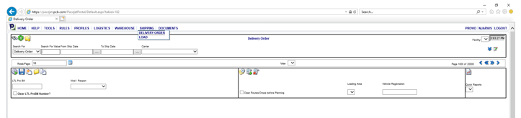**Hit the binoculars.**  **This will show all orders that shipped that day categorized by the carriers.**

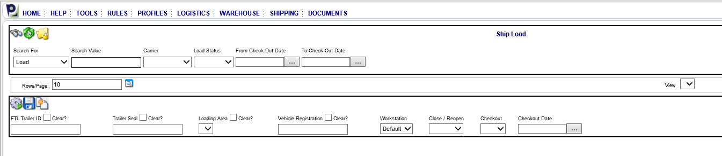

**Look at the PROC to ensure that they all say YES for all types of Shipping (UPS, FEDEX GROUND, FEDEX EXPRESS, and HAND CARRY). If you see any that says NO in the PROC - you will need to figure out why.**

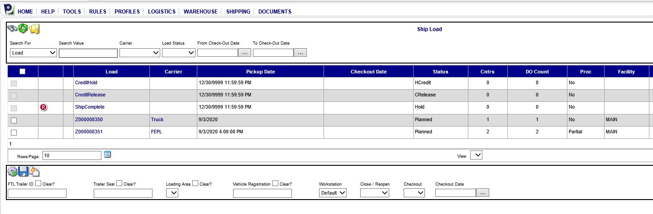

**Click on the Z# (highlighted below) for the line that shows a NO in the Proc**

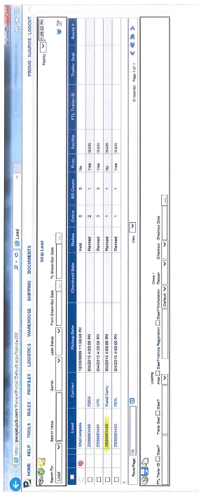

**Check the box of the one you need to look at or change. Click on the D number (black arrow)**

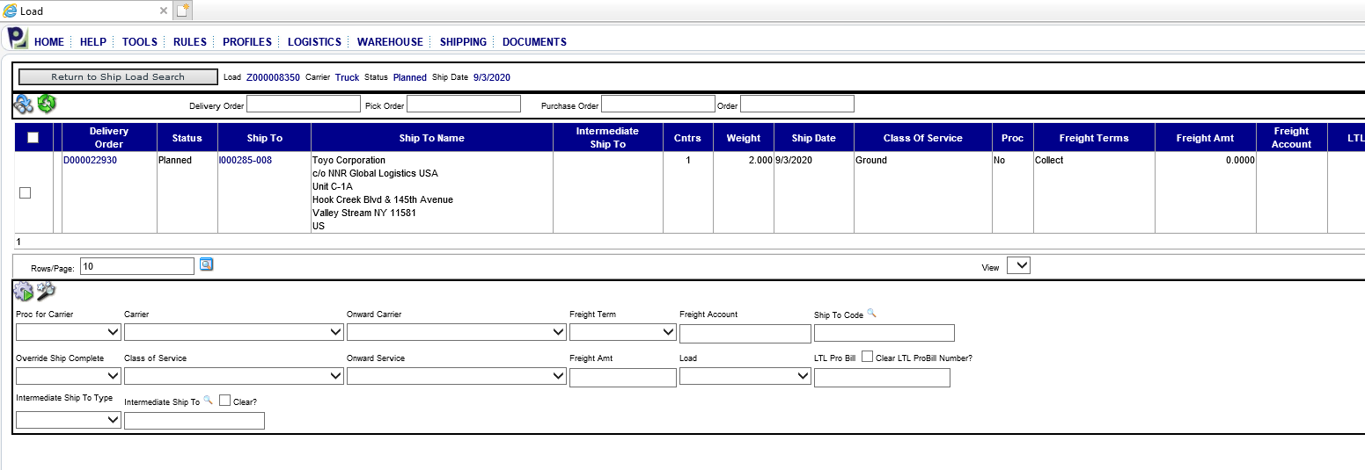

**You MUST have something in the TRACKING NUMBER section. Enter customer supplied tracking number, NNR pick up, customer pick up, DHL tracking, email option, invoice only.**

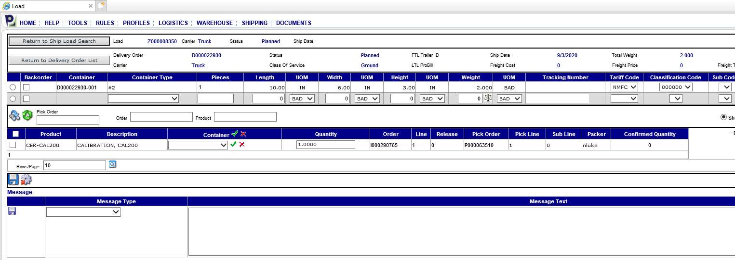

**Example below: Mark dot in circle, entered NNR pick up, then hit the Save**

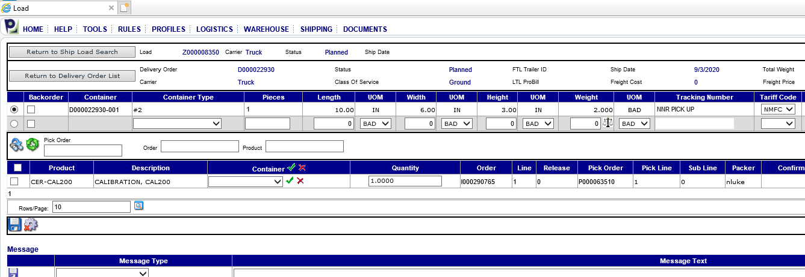

**It will show SAVE COMPLETE, Hit the RETURN TO DELIVERY ORDER LIST**

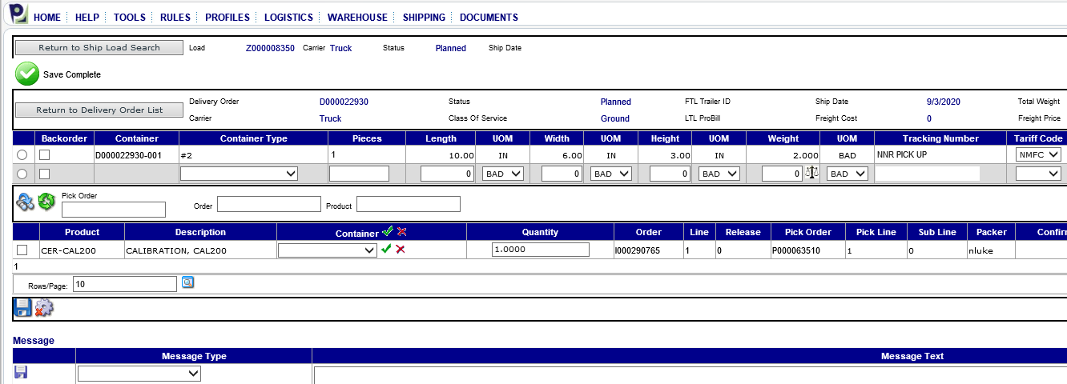

**It will take you back to this screen, here you will change the PROC.**

**Check mark the box, choose YES from the PROC for Carrier drop down, then hit the GEAR (black arrow)**

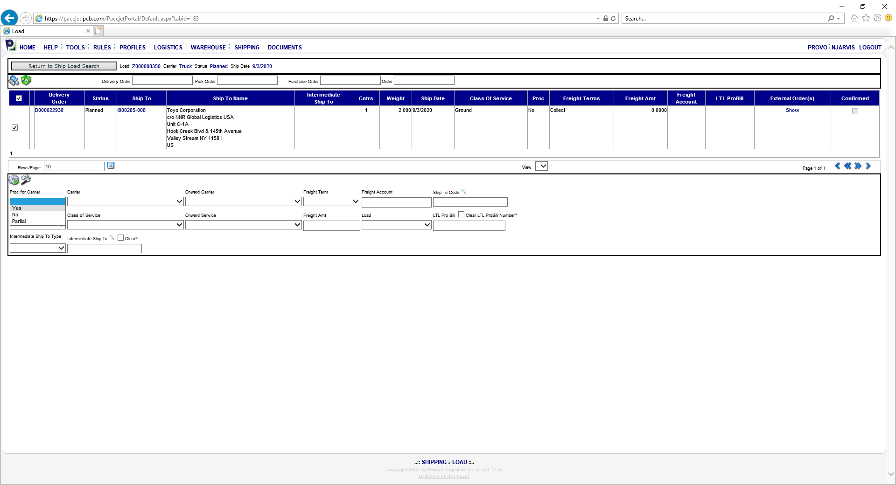

**This will change the PROC to be YES, and then hit the RETURN TO SHIP LOAD SEARCH button**

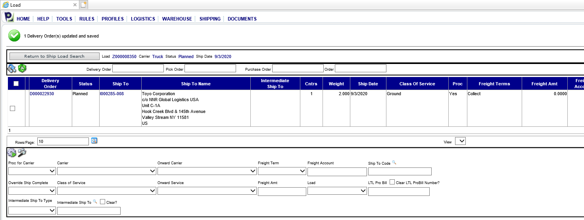

**Once you are back to this screen, Click on each carrier to check on customer shipping accounts and freight charge is correct.** 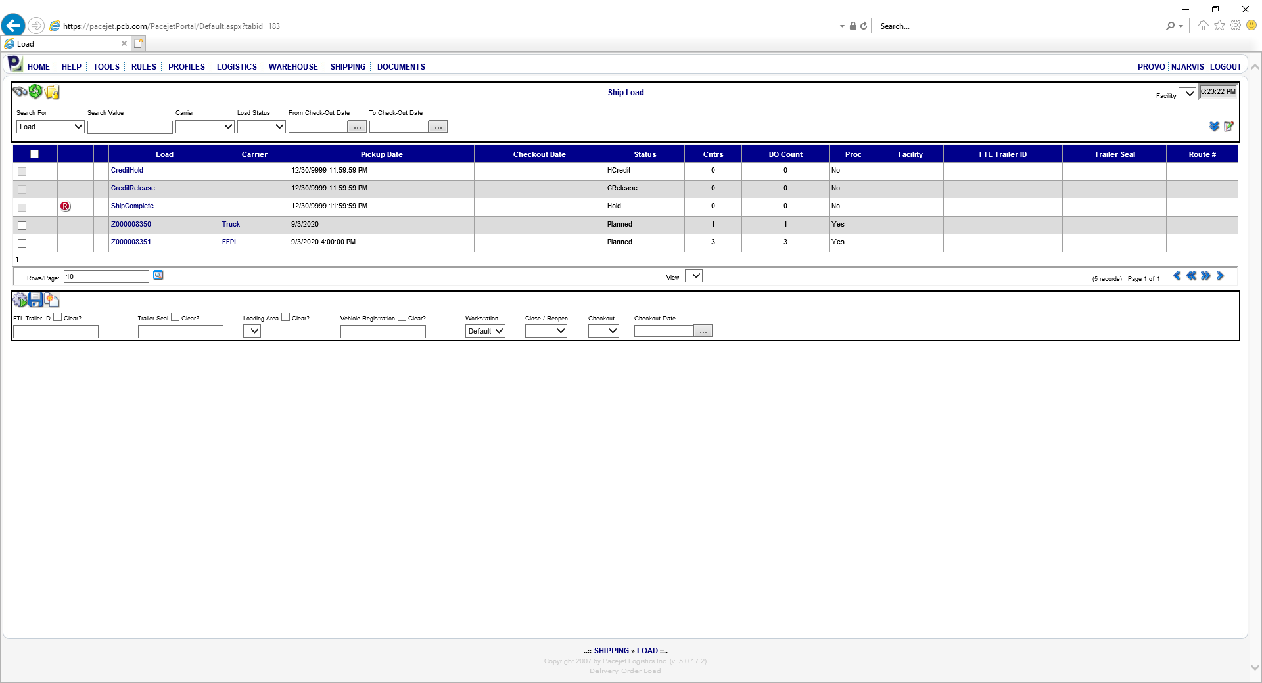

**If there is a freight account # there should be zero dollars in the freight amount.**

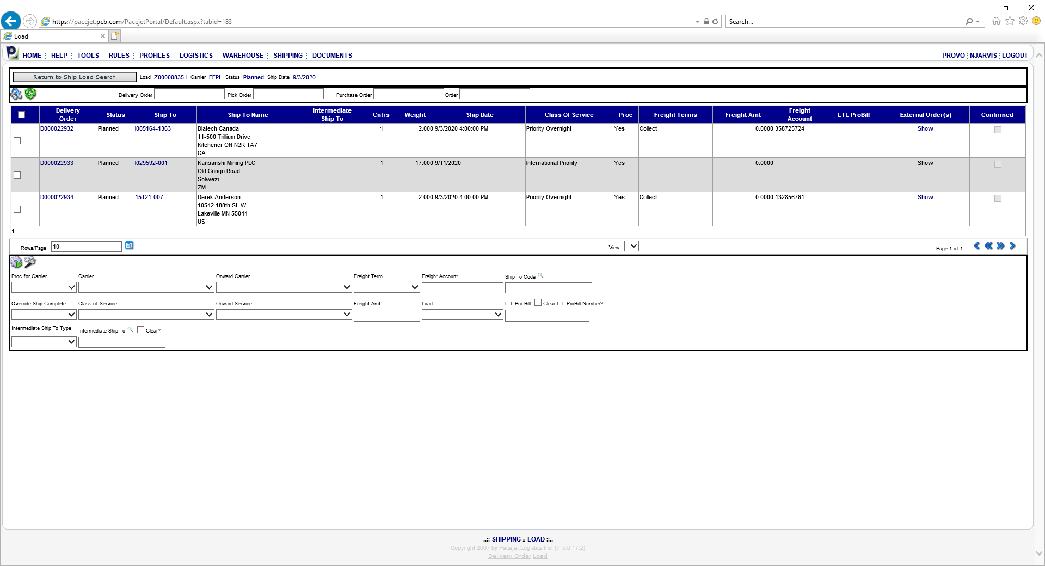

**Click CLOSE (red arrow) and then GEAR (black arrow)**

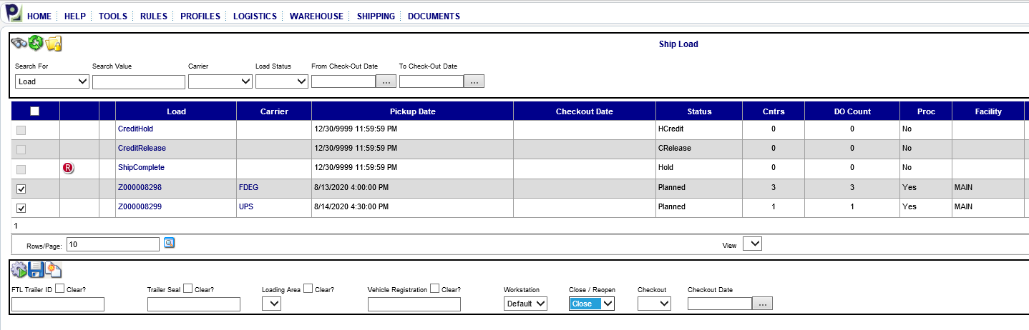

**Choose YES (red arrow), Select current DATE (red arrow), then click GEAR again (black arrow)**

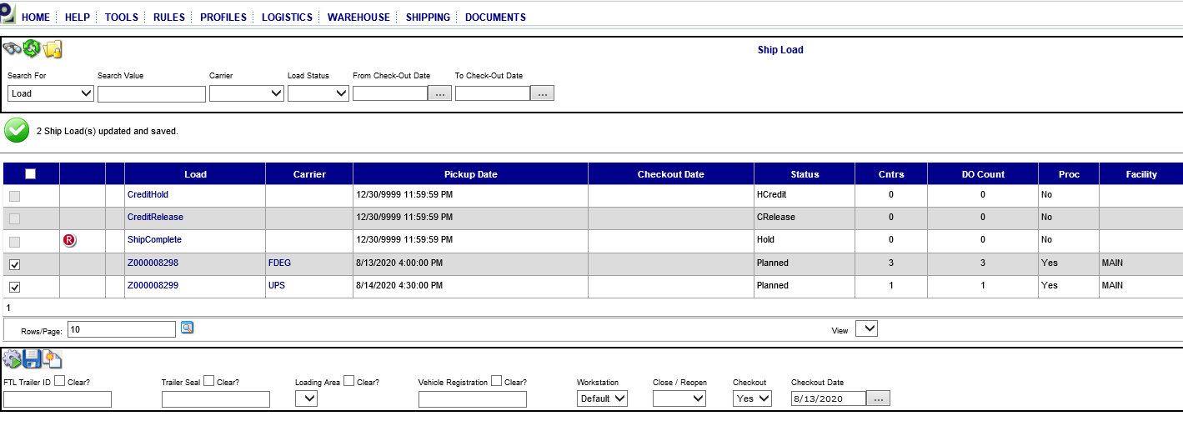

**Status will show closed**

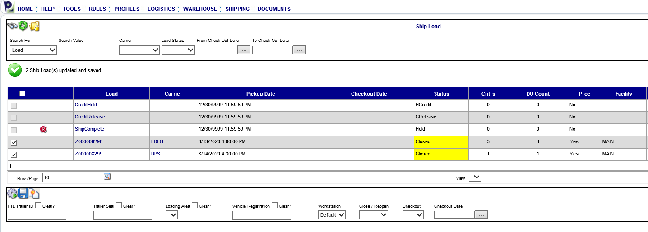

**Return to SYTELINE**

**Open up Customer Order Shipping Error Processing Form (COSEP)**

**Hit the magnifying glass a few times to make sure all lines shipped show up**

**Hit POST button (black arrow)**

**Then OK to post on the pop-up window**

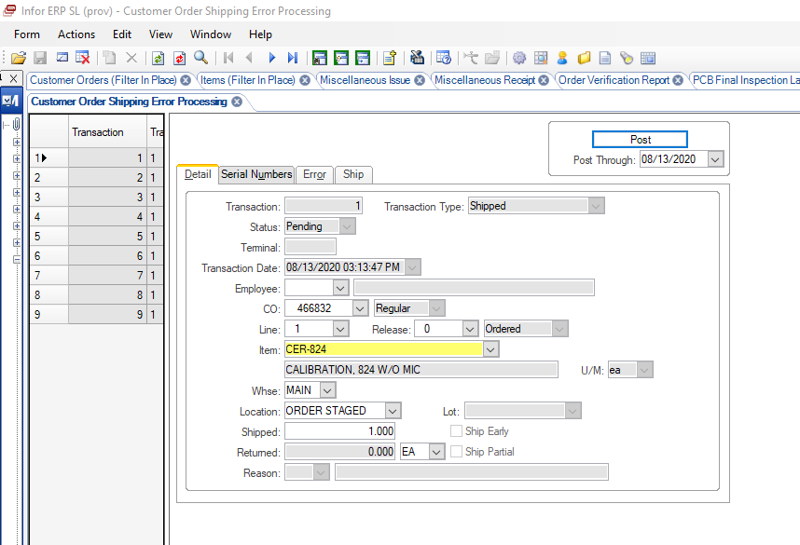

**If any lines remain, you will need to fix the errors.**

**Click on the Error tab**

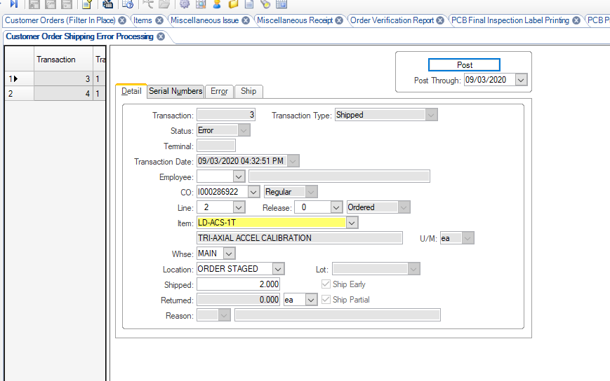

**Check OVERIDE for each transaction line and then save. Hit the POST button (black arrow. Then Ok to Post on pop-up. All lines should go away.**

**If all lines do not disappear check page 20 for other helpful tips.**

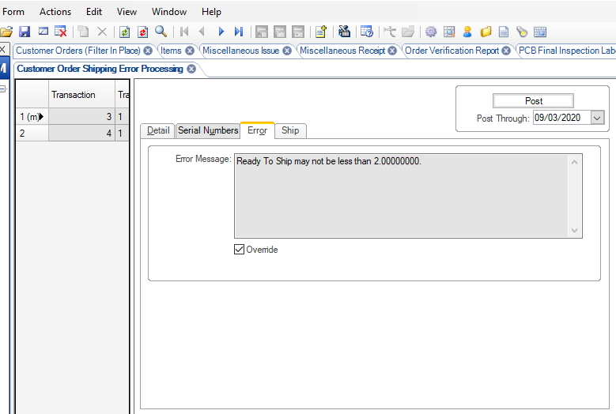

**Return to PACEJET and hit the binoculars**

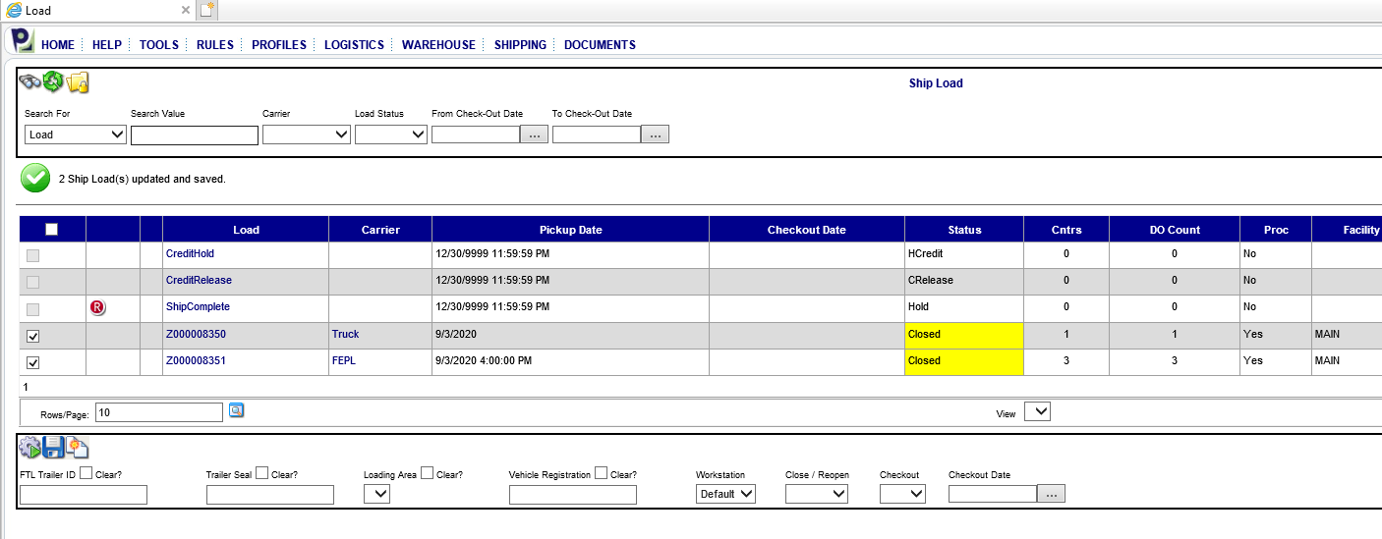

**ALL lines shipped should disappear.**

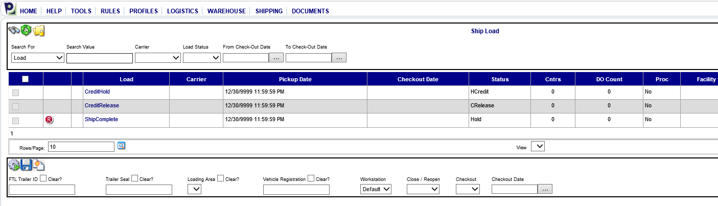

**The LOAD is DONE**

**HELPFUL TIPS IN VERIFICATION AND CORRECTING ERRORS**

**If still having issues getting orders to release**

* **Go to the Customer Orders Form in Syteline**

**Check that the Ship Release has been check marked**

**Click on Lines then Check Source (make sure it says: INVENTORY)**

* **Go to the Items Form:**

**Click on the Ship Tab**

* + - **Allocation method 2-location/lot/serial allocation**
    - **√ shipped items (needs to be checked**

**Here is a temporary solution if you are getting errors in the CUSTOMER ORDER SHIPPING ERROR PROCESSING (COSEP) and are unable to get it fixed.**

* **Have a CSR Temporarily uncheck the Ship Release check box for each of the orders that are in the COSEP posting screen**
* **Post**
* **After posting, have a CSR go and re-check the Ship Release check box on the orders.**
* **Post again**

**If an item was obsolete that shipped out, it will not post in the CUSTOMER ORDER SHIPPING ERROR PROCESSING form even if you change it to Slow Moving it still won’t POST.**

**See the IT departments fix: *The trick is getting the override checkbox to become available. Go through the motions of changing something on the record and saving it. As an example, change the warehouse to WHSE, save and then change it back to MAIN and save. Now the override checkbox is available, Check it and POST***

**RE-PRINTING A PACKING LIST**

**Click on Shipping Tab, click on Delivery Order**

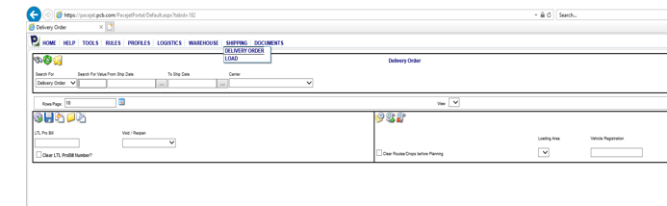

**In the SEARCH FOR field choose External Order, Enter the CO#.**

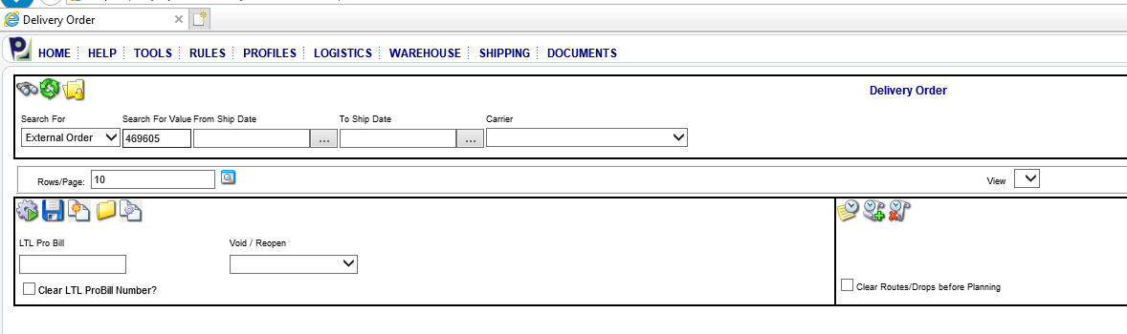

**Click the folder icon with the and then click binoculars (black arrow)**



**It will bring up a list of Delivery Order(s) numbers; choose the one that you need to print a packing list for (copy or write down the delivery order number)**

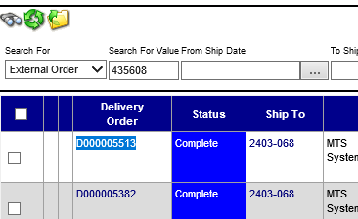

**Go to Documents Tab**

**Choose Packing List – click and it will bring you to the screen to use**

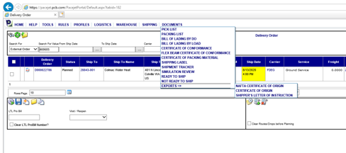

**Enter Delivery Order number**

**Printer choose UTPPR-LOG4B**

**No for barcodes**

**Hit the Magnifying glass (black arrow)**

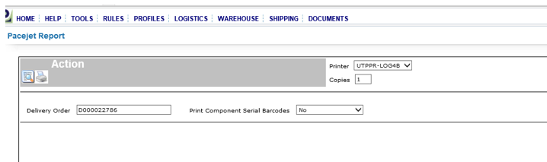

**HIT THE PRINT BUTTON**

**\*\*If you need to make any changes to the Packing list (See example below)**

**Change to Word or Excel and hit Export (arrows below)**

**Make any necessary changes in Word or Excel**

**Print.**

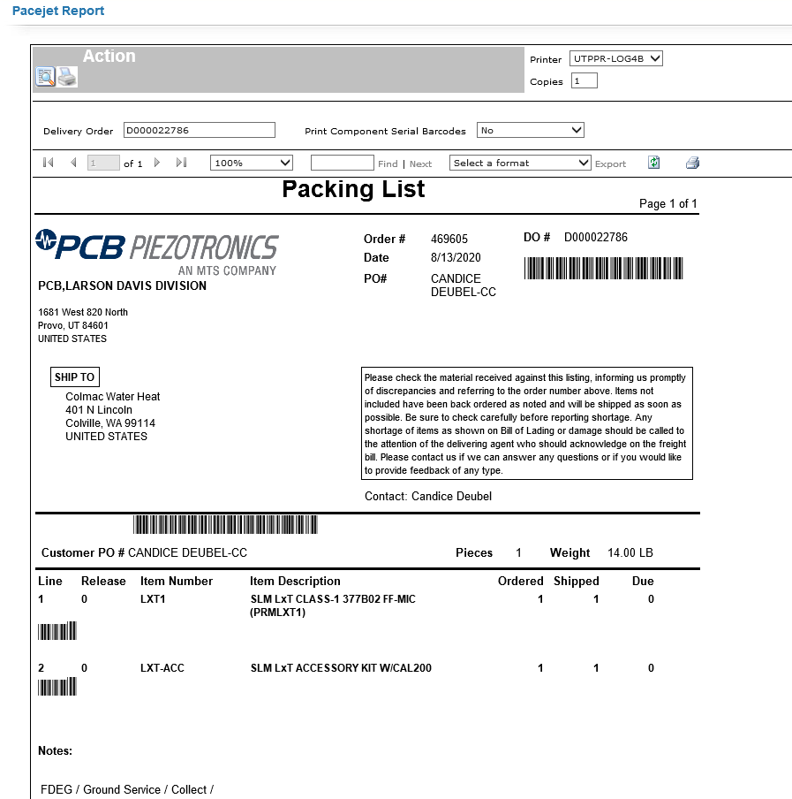

**PRINTING CERT OF ORIGIN**

**Click on Shipping Tab, click on Delivery Order**



**In the SEARCH FOR field choose External Order, Enter the CO#.**



**Click the folder icon with the and then click binoculars (black arrow)**



**It will bring up a list of Delivery Order(s) numbers; choose the one that you need to print cert of origin for (copy or write down the delivery order number)**



**Go to Documents Tab**

**Choose EXPORTS– and then click on CERTIFICATE OF ORIGIN .**



**Type in the Control Number (Delivery Order Number)**

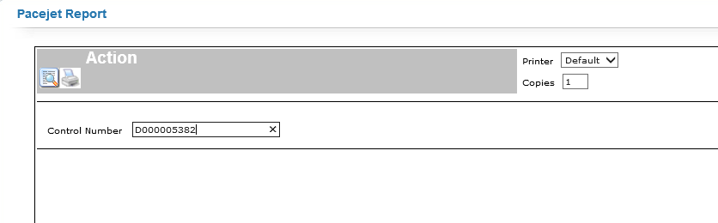

**Brings up the Cert of Origin (below)**

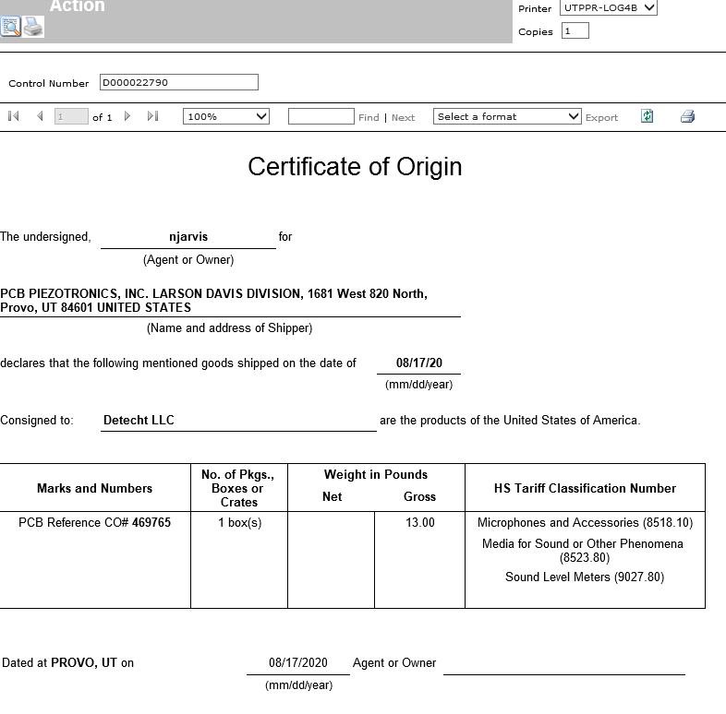

**If you don’t need to make any changes to the C of O.**

**Print and Sign the C of O where it says Agent or Owner**

**\*\*If you need to make any changes (See example below)**

**Change to Word and Export (arrows below)**

**This will open WORD**

**DBL Click in front of the “C” in Certificate in HEADER; then enter 2X**

**Make any necessary changes**

**Print.**

**Sign the C of O where it says Agent or Owner**

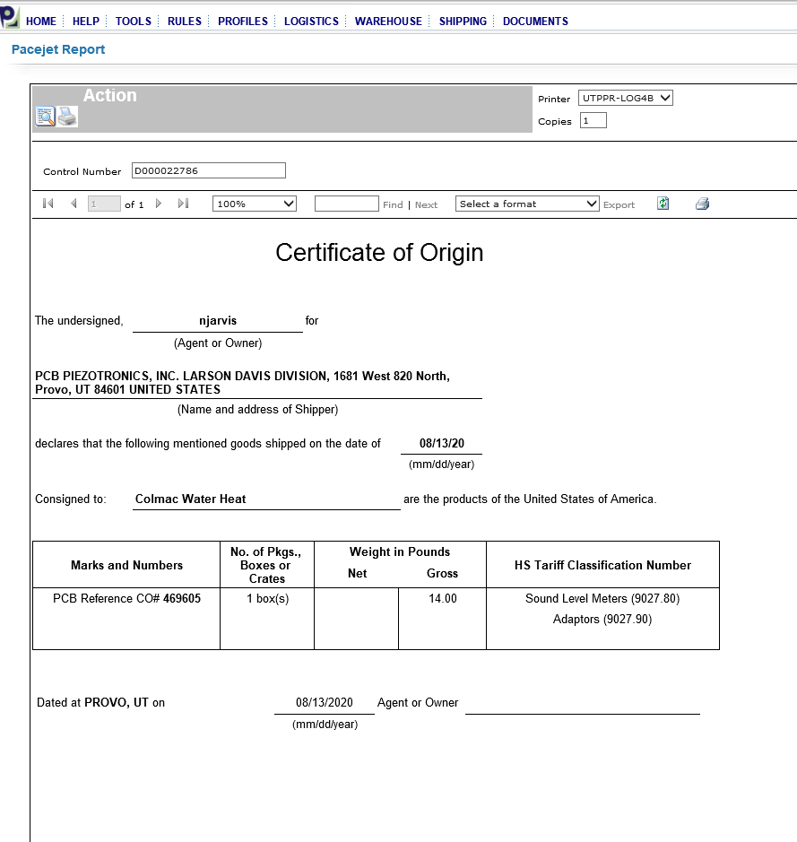

**VOIDING ORDER OR PICKS**

**If you need to Void Delivery Order and Picks or you need to Reopen Delivery Order to the Packing screen**

**Go to SHIPPING TAB- choose Delivery Order from drop down**

**Choose Delivery order from the Search For drop down and then scan barcode on your packing list in the Search For Value field**



**This will open up this screen, put a check mark in the order you need to change. Then choose VOID/or REOPEN from the drop down**

**Choose VOID for the following reason: Order was shipped and packed but the CSR needs to make changes to the order. If you void an order you must MOVE all items shipped from ORDER STAGED back to their LOG location.**

**Choose REOPEN for the following reasons: Order was shipped and packed but you need to change the box size or pack it with an additional order.**

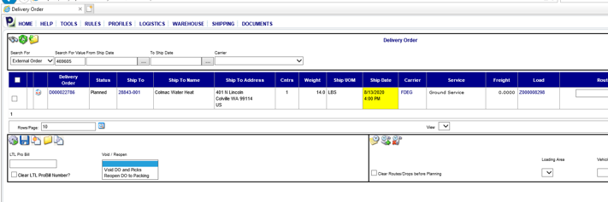

**FIXING XML ERRORS**

**This should be done 1-2 times a day to catch any potential errors that may hold up an order**

**Click on TOOL, and then XML IMPORTS from the drop down**

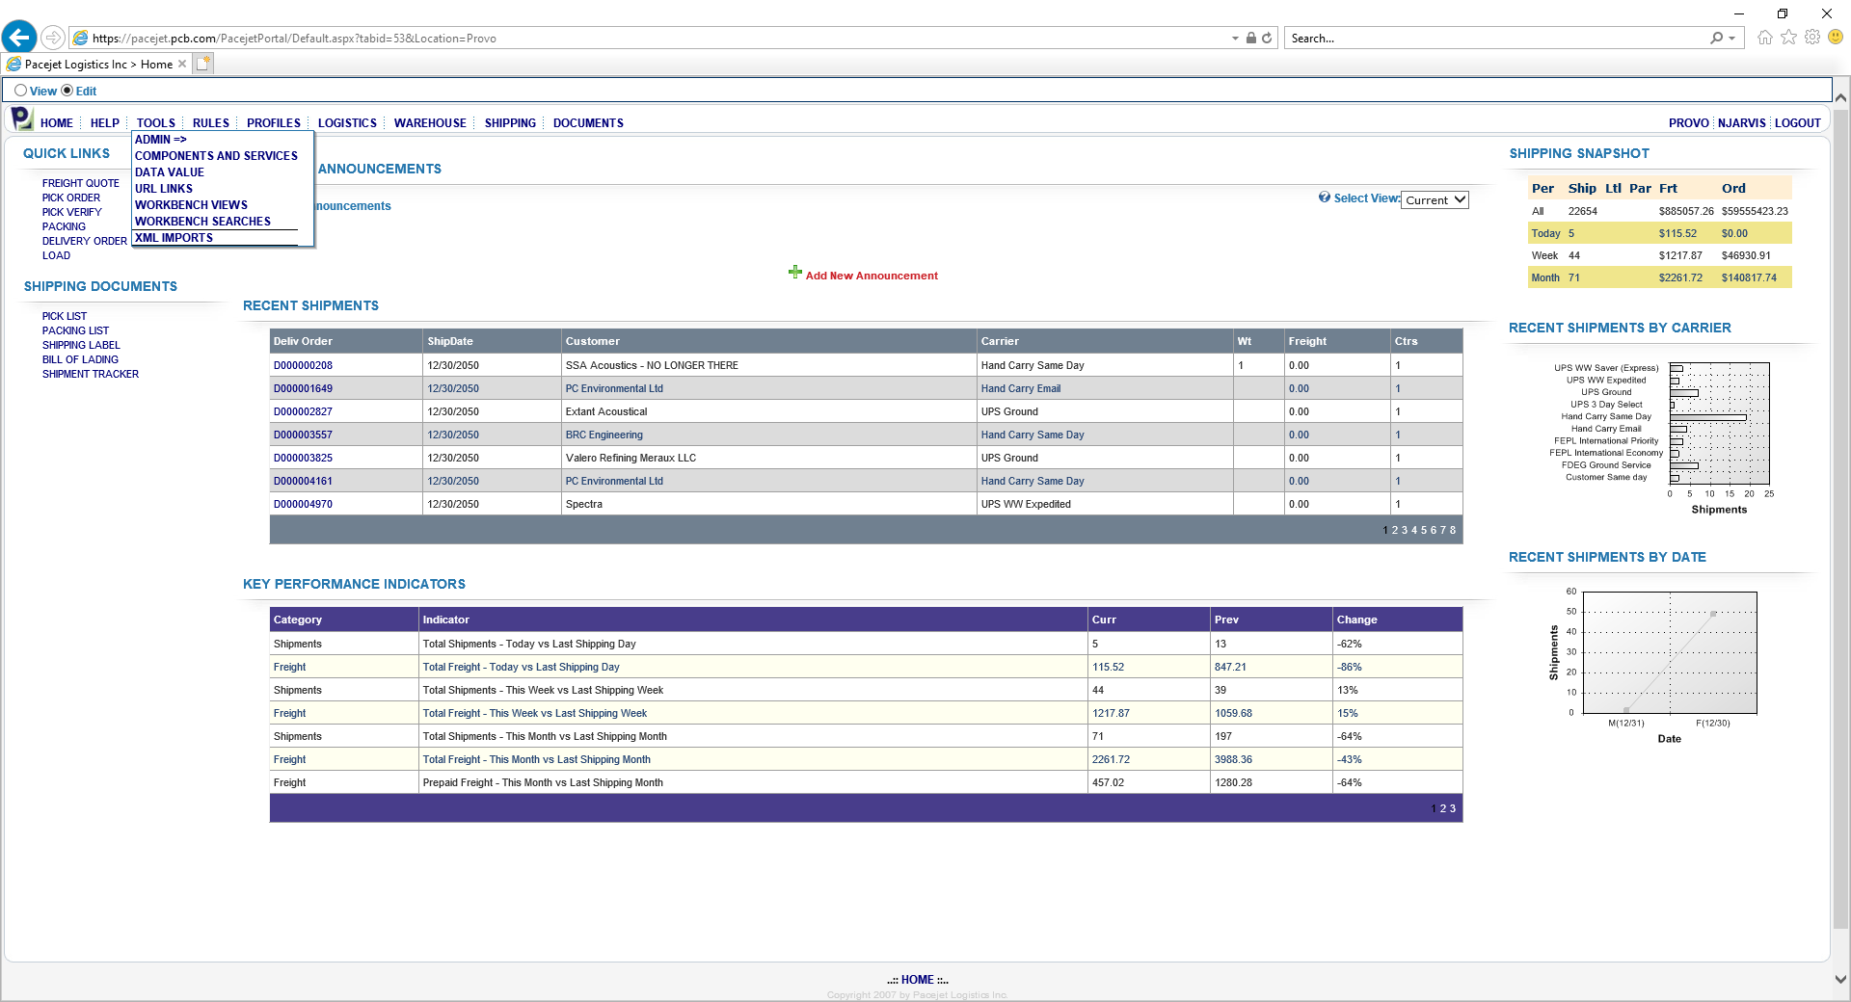

**Click on the binoculars to bring up the collection of errors. These are orders/items where changes were attempted and Pacejet will not allow them for some reason or other.**

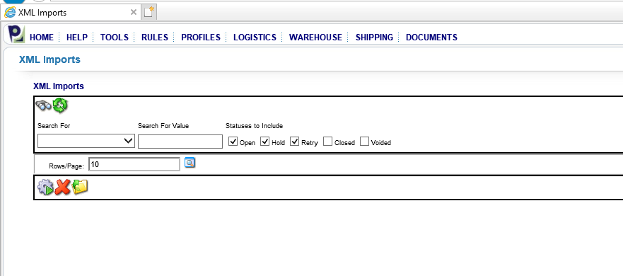

**Click on the box next to the message and click the Gear with the triangle. This will push the attempt through if whatever the error was has been fixed prior to Pacejet automatically doing it.**

**If the error is still there; review the Error message (black arrow) to see if it is valid or not. Then click the box next to the X to delete it.**

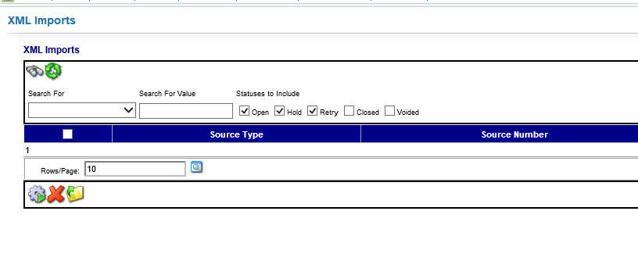

**REVISION HISTORY**

|  |  |  |  |  |
| --- | --- | --- | --- | --- |
| **DCO #** | **REV** | **DATE** | **INITIALS** | **CHANGES MADE** |
| 1990 | A | 9/11/20 | NJ | Initial Release |
|  |  |  |  |  |
|  |  |  |  |  |