S814.02 - 824 LCD Assembly

1.0 INTRODUCTION

Several modifications must be made to the stock LCD module (1895.0012) for use in the 824 (S814.02 subassembly):

- Solder a connector to the module

2.0 APPLICABILITY & RESPONSIBILITY

An Electronics Assembler will make the modifications and verify that the modifications have been made correctly.

3.0 LIMITATIONS

None

- MATERIALS, TOOLS, & EQUIPMENT

- Standard Electronics Assembler tools

5.0 PROCEDURE

The following steps are to be performed by the Electronics Assembler on all LCD modules:

- Insert a 1x20 female socket strip connector (1208.0034) into the 20 holes in the circuit board of the LCD module with the female sockets (and plastic carrier tape) on the side opposite the LCD (the side with the ICs). Solder in place from the back side of the circuit board. Remove the plastic carrier strip.
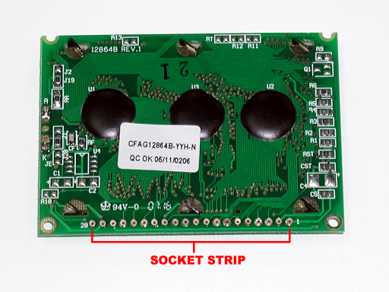
LCD module with socket strip installed and plastic carrier strip removed

6.0 EVALUATION

Test and evaluation is incorporated in the procedure steps above.

7.0 RECORDS

None.

8.0 REVISION HISTORY

DCO # | REV | DATE | INITIALS | CHANGES MADE
2737 | A | 22 Oct 2001 | KN | Initial Release
2879 | B | 18 Jun 2002 | KN | Changed from leaded capacitor (0750.0003) to SMT capacitor (0751.0005) and added jumper wire.
2906 | C | 26 Aug 2002 | KN | Removed the steps for bending the metal tab.
3028 | D | 05 Aug 2003 | KN | Changed from Optrex to CrystalFontz LCD module, EMC modifications removed.

