A824.01 Microprocessor Board Assembly

1.0 INTRODUCTION

Two spring contacts must be added to the 824 microprocessor board (A824.01) to reduce RF susceptibility as required by the latest standards for sound level meters. The spring contacts should be soldered to the board along with the after-flow parts.

2.0 APPLICABILITY & RESPONSIBILITY

An Electronics Assembler will solder the spring contacts to the PCB and verify that the modifications have been made correctly.

3.0 LIMITATIONS

None.

- MATERIALS, TOOLS, & EQUIPMENT

- Soldering iron and solder
- Diagonal cutters

5.0 PROCEDURE

The following steps are to be performed by the Electronics Assembler at the same time as the after-flow parts are installed.

- Add a little more solder to the two pads on the corners of the 824 microprocessor board (see photo).

- If the two spring contacts (1132.0025) from the kit are connected, cut them apart.

- The flat surface of the spring contacts is too long so trim it back by cutting near the hole in the flat surface (see illustration below).

- Solder the spring contacts to the pads as shown in the photo. Roughly align the bend in the spring contact with the edge of the PCB.

- Test the solder joint by pushing on (flexing) the spring contact.
Cut here
bend
Spring contact trimming illustration

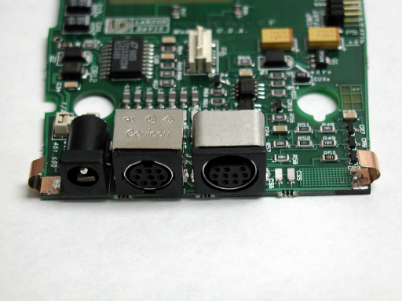
824 microprocessor board with two spring contacts soldered in place.
6.0 EVALUATION

Test and evaluation is incorporated in the procedure steps above.

7.0 RECORDS

None.

8.0 REVISION HISTORY

DCO # | REV | DATE | INITIALS | CHANGES MADE
 | A | 2 Nov 2001 | KN | Initial Release
366 | B | 19 Nov 2001 | KN | Fixed some obvious errors, added the trimming illustration, removed the contact tinning step.

