A824.02 Revision E PCB ESD Modification

1.0 INTRODUCTION

During some ESD (ElectroStatic Discharge) tests the 824 would report a DSP error. The DSP board (A824.02) must be modified to fix the problem. The “ESD modification” consists of adding a resistor and capacitor to the circuit. This modification should be performed at the same time as the after-flow parts are added.

2.0 APPLICABILITY & RESPONSIBILITY

An Electronics Assembler will perform the modifications and verify that they have been made correctly.

3.0 LIMITATIONS

Only perform this modification on the E revision of the board (P824.02).

- MATERIALS, TOOLS, & EQUIPMENT

- Soldering iron and solder
- Multimeter that can measure opens and shorts (resistance)

5.0 PROCEDURE

The following steps are to be performed by the Electronics Assembler:

- Cut the trace leading from pin 12 of U211 to pin 12 of U210 (see figures).

- Desolder and gently lift pin 12 of U211 then insert a 3 kΩ, 0402 SMT resistor between the pad and pin and solder the resistor to the pad and pin.

- Solder a 330 pF 0603 SMT capacitor between pin 12 and pin 13 of U210.

- Solder a jumper wire between the lifted pin 12 of U211 and pin 12 of U210.

- Check for shorts and solder bridges by eye and using a multimeter.
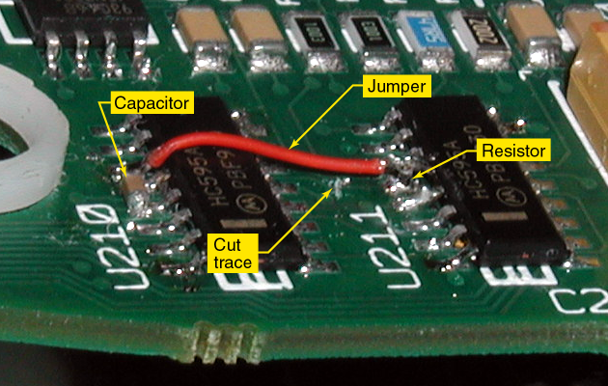
Figure 1 - Photo of 824 DSP board with ESD modifications added.

Figure 2 - Diagram of 824 ESD modifications.

