703(-ATEX), 703+(-ATEX) FINAL ASSEMBLY

*This is a Manufacturer’s Document related to a product that has been approved by a notifying body for use in an explosive environment.  This document shall be reviewed by Engineering and the ISP Manager before it is released or revised.  Any changes to this document could result in modifications to approved design that could result in an unsafe condition.

**1.0 PURPOSE AND SCOPE**

This document outlines the final assembly for the 703, 703-ATEX, 703+ and 703+-ATEX instruments. This document also describes the final testing that will verify that the assembled instrument is functioning within specified parameters. All employees who have responsibility for testing these products are required the follow the instructions detailed in this procedure.

**2.0 AFFECTED DEPARTMENTS**

Manufacturing

**3.0 REFERENCE DOCUMENTS**

* Current SPARK & BLAZE User Manual
* Digital test procedure D0001.8131-IS
* Analog Board test procedure D0001.8132-IS
* MetCal procedure D0001.8375.

**4.0 RESPONSIBILITIES & AUTHORITY**

The technician has the following responsibilities and authority:

* Verify compliance of the product under test to specifications.
* Troubleshoot and correct product as required.
* Communicate concerns to the Supervisor of Quality Assurance.
* Request management review of product concerns.
* Follow established ESD standards.

**5.0 DEFINITIONS**

Several of the following test procedures require that an electrical test adapter be connected to the input of the Spark instrument being tested. Spark instruments use the MPR001 or MPR001-ATEX mic/preamp, which has a Knowles BL-7046 microphone (LD# 6610.0005). ***Therefore, the ADP046 (with CBL118) is the electrical test adapter that is to be used when testing Spark instruments.***

The term “analog board” will be used in this document to refer to board assemblies A705.12 or A705.22.

The term “digital board” will be used in this document to refer to board assemblies A705.11 or A706.11.

**6.0 SAFETY PRECAUTIONS**

Safety glasses when soldering, lead clipping, or testing power supplies.

**7.0 EQUIPMENT AND MATERIALS**

## #1 Pozidrive Screwdriver

* 7251.2600 – 26 AWG STRANDED BLACK WIRE (floor stock).
* 7251.2602 – 26 AWG STRANDED RED WIRE (floor stock).
* #24 AWG SOLID BUS WIRE, 7252.24BUS or equivalent, (floor stock) for ATEX units.
* ¾” X ⅜” piece of weather stripping (2505.0004 – floor stock).
* DC Power Supply.
* CBL066 Cables (BNC to BNC cables).
* Computer (PC that is compatible with Windows ME, 2000, XP or later).
* Larson Davis Test Station (2900, 2209/2239, Computer).
* MetCal test station.
* IR Communications interface module (DVX008 IR Dongle) or equivalent.
* Electrical Test Adapter ADP046 with a CBL118.
* Kapton Tape (Small strips).

**8.0 INSTRUCTIONS**

* 1. **Installing the Digital Board**

1. The A705.11 board assembly needs a conformal coating. For the A706.11(ATEX versions), move onto 8.2. The A705.11 needs to be conformal coated on the main processor side (A quick spray covering the whole surface, to begin, and then a full coat that flows around the components (See the instructions on the can for further details)). Cover the main board connector (P1) and the IR chip (U8) with Kapton tape before spraying to prevent conformal coating of these areas. Allow 10 - 15 minutes to air dry and the coating will be tack free. Once dry, remove the Kapton tape and discard it.
2. Place the digital board into the front half of the case with the 2 LED's facing the 2 holes in the case. Secure the digital board into place with four screws. The holes are found in the four corners of the board. Use the correct screwdriver, these are Pozidriv #1 screws, not Phillips (0986.0018). Solder the wires from the battery clips to the digital board.

**8.2 Installing the Battery Clips and Terminals and Preparing the Case**

* 1. For the A705.11, cut two 1 inch long wires for the battery terminals, one red (7251.2602) and one black (7251.2600). Strip and tin the wires and solder them to the battery clips.
  2. For the ATEX A706.11, gently bend over the metal loop found on the back of the clip (See the bottom right piece of the clip shown in **Figure 1**). Solder a ¼” piece of bus wire (7252.24BUS or equivalent) folded through the hole of the battery clip as shown by the blue line in **Figure 1.** Bend the bond wire into a c shape prior to soldering onto the digital board.

1. ECO 2310 mandated that the battery clip be modified as shown below. The modification prevents the battery clip from breaking when the batteries are installed. Refer to **figure 1**. This modification should be done to the clip that will be placed on the positive side only. To modify the clip, simply cut the tip of the clip off using some small wire cutters.
2. Use DEXTER Hysol 9462 epoxy adhesive to glue the battery clips in place (This epoxy has a working life of approximately 55 minutes and it fully cures in 3-5 days).

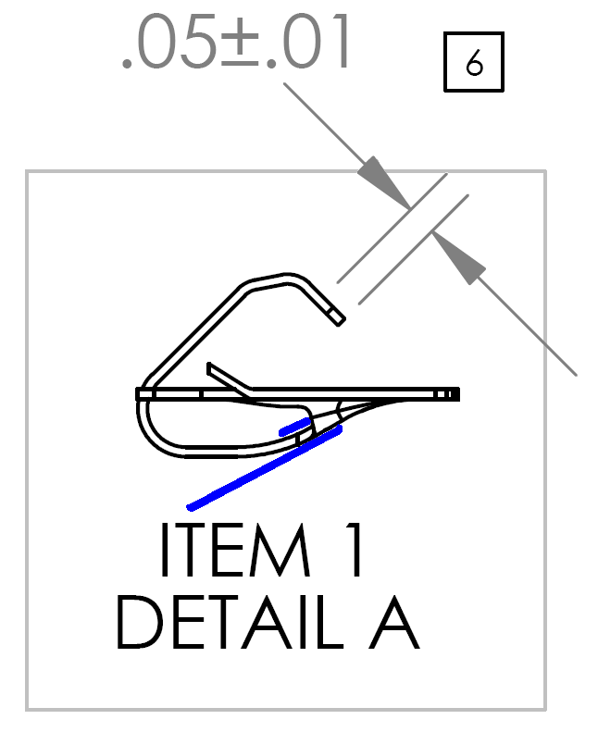

**Figure 1**

Press the battery clips into place. The battery clips have some small barbs on them that keep them from coming back out. Make sure these barbs are facing the correct direction (See**figure 2**).

Note: If faster cure times are desired, heat between 66-73C for approximately 1.5 hours for a full cure after clips and terminal are in place (This should only be done with the bare case, the clips with wires in place, and the battery terminals attached).

1. The battery terminal, S706.03, must be glued in place to prevent it from dislodging when the batteries are inserted or removed (See **figure 3**).
   1. Glue the terminal in place using the DEXTER Hysol 9462 Epoxy Adhesive by applying it to the backside vertical edges of the S706.03 (The backside is the side opposite the plastic insulator). After applying the epoxy, slide the S706.03 into place as shown in **figure 3.** Make sure the plastic insulator faces towards the digital board, where they will contact the battery.

 

**Figure 2 Figure 3**

E. Some of the back cases have residual mold material, or flashing left from the coating process. Remove this flashing to prevent shorts and other problems in the future. The flashing is typically located along the front edge of the battery compartment opening (**See figure 4**).

 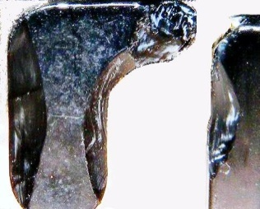

**Figure 4 Figure 5 Figure 6**

1. When the epoxy has hardened, trim the battery terminal and case post plastic. Round the inner edge with a 45 degree bank and cut the tip to allow the battery to ramp out when removed. Trim the right side of the plastic only if needed (See **Figures 5-6**).

G. Line up and attach the front label. Print the proper serial number and model onto a back label (M706.12 for the 703 or 703+, M706.15 for the 703-ATEX or 703+-ATEX) and center it and attach it. Start pressing in the middle and then move outward as the label is attached to avoid label bubbling later.

**8.3 Installing the Analog Board**

1. Prior to inserting the analog board into the bottom case, cut a ¾” length of weather strip (2505.0004 – floor stock) and place it, adhesive side down, over the inside opening of the battery door tab hole. ***Figure 7*** shows the battery door tab hole. ***Figure 8*** shows the correct placement of the weather strip.

 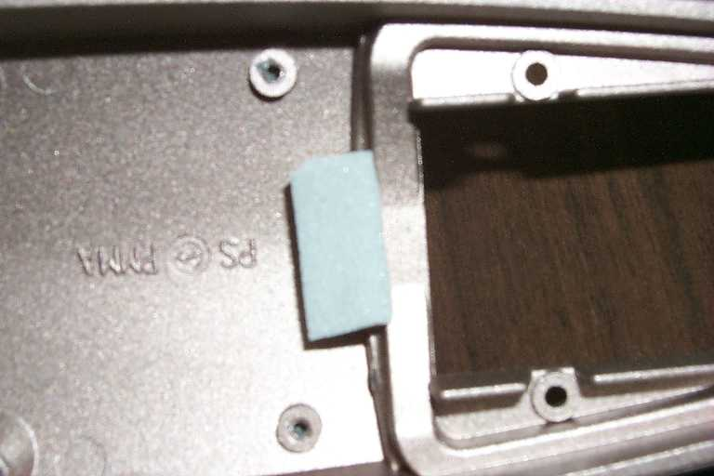

Figure 7 Figure 8

1. Place the EMI washer (2460.0003) over the barrel of the Lemo connector. prior to inserting the analog board into the case.
2. With the weather strip and EMI washer in place, insert the analog board into the bottom case and secure it with four screws (0986.0018). Use the correct screwdriver, these are Pozidriv #1 screws, not Phillips (0986.0018).

**8.4 Final Assembly**

1. With the battery door removed, gently join the two case halves. The connector on the analog board and its mating connector on the digital board must be aligned to engage properly. You can look in from the battery compartment and get a fair view of the connector as you close the case. If you don’t get them lined up properly the fuse will very likely blow. Once you are sure the connector is engaged properly, close the case the rest of the way,
2. Firmly press the cases halves together and while pressing insert the screws (***Figure 10***). Use the floor stock case screws that come with the cases (**See figure 9**).

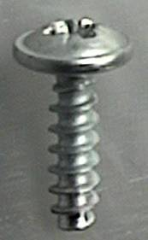 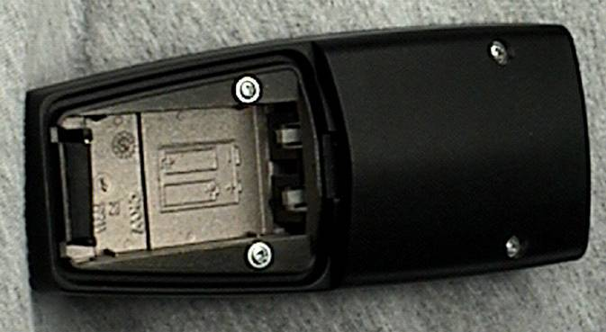

Figure 9 Figure 10

1. Now do a quick final check. Put in two batteries and verify that the unit powers up. Apply gentle pressure near the bottom of the batteries and push them side to side while watching the LED’s for any power glitches. If the unit does not remain on the entire test, remove the batteries and fix the problem (This problem is usually resolved by further trimming the battery terminal plastic). Remove the batteries and replace the battery door.

**8.5 Measure the Instrument’s Current Draw and Final Calibration**

1. Setup the DC power supply with voltage = 3V and power the instrument. Make sure that the instrument turns on, has time to settle, and then measure its power supply current. The measured current should be 20mA or less. If the SPARK is drawing more than 20mA, disconnect power and fix the problem before proceeding.
2. Connect the ADP046 test adapter to the input of the Spark found on the analog board (Use a CBL118). Connect the input of the ADP046 test adapter to the signal output of the 2209 / 2239 (Use a CBL066).
3. Open the SLMtest software and follow these steps to start testing.
   1. Make sure the Spark is in front of the IR interface module and that the Spark is on.
   2. Click the connect icon or open the **Commands** menu and select **Connect**. The software will report if it has successfully connected to the Spark.
   3. Select the LogLin and Do-Scale-offset checkboxes.
   4. Click the run icon and let the test run and finish.
   5. After the test, click the disconnect icon and disconnect the unit from the test station.

**8.6 Final Test of the Spark Instrument with the MetCal Software**

1. Enter the SPARK units into MetCal. Refer to MetCal procedure D0001.8375.
2. Install fresh batteries in the unit or setup the DC power supply with the voltage and current limit set as shown in **Table 1** of instruction 8.2 of the D0001.8132-IS procedure (Limit the current if the power supply used has this capability). Power the Spark.
3. Connect the ADP046 test adapter to the input of the SPARK found on the analog board (Use a CBL118). Connect the input of the ADP046 test adapter to the signal output of the USB attenuator.
4. Make sure the SPARK is in front of the IR interface module and that the SPARK is on.
5. Run the SPARK test in MetCal. Refer to MetCal procedure D0001.8375.
6. IF THE TEST FAILS, TROUBLESHOOT THE PROBLEM BEFORE CONTINUING.
7. Finish the work order in MetCal. Refer to MetCal procedure D0001.8375.

SwitchCraft connector for output signal

Switch

BNC connector for input signal

Move switch to this position for “INPUT”

Switch position for “NOISE”

**Figure 11: Top View of ADP046**

**9.0 INSPECTION**

Visually inspect the finished unit for any obvious defects including LCD alignment, unusual gaps in the case, nicks, scratches, gouges, stray paint, etc.

**10.0 RECORDS**

The test data will be stored in the MetCal database.

**11.0 DISTRIBUTION**

Manufacturing

**12.0 ATTACHMENTS**

Not applicable to this procedure.

**13.0 REVISION HISTORY**

|  |  |  |  |  |
| --- | --- | --- | --- | --- |
| **DCO #** | **REV** | **DATE** | **INITIALS** | **CHANGES MADE** |
|  | A | 10/09/18 | JGG | Initial release of intrinsic safe procedure. This is an updated version of D0001.8032. Changed from certifying the unit using the SLMTest software to using MetCal. Added intrinsic safe note. Added –IS to the end of the document number. |
|  |  |  |  |  |
|  |  |  |  |  |
|  |  |  |  |  |
|  |  |  |  |  |
|  |  |  |  |  |
|  |  |  |  |  |
|  |  |  |  |  |
|  |  |  |  |  |
|  |  |  |  |  |
|  |  |  |  |  |
|  |  |  |  |  |
|  |  |  |  |  |