704, 706, 706RC, (And ATEX) FINAL ASSEMBLY

*This is a Manufacturer’s Document related to a product that has been approved by a notifying body for use in an explosive environment.  This document shall be reviewed by Engineering and the ISP Manager before it is released or revised.  Any changes to this document could result in modifications to approved design that could result in an unsafe condition.

**1.0 PURPOSE AND SCOPE**

This document outlines the final assembly for the 704, 704-ATEX, 706, 706-ATEX, 706RC, 706RC-ATEX. This document also describes the final tests that will verify that the assembled instrument is functioning within specified parameters. All employees who have responsibility for testing these products are required the follow the instructions detailed in this procedure.

**2.0 AFFECTED DEPARTMENTS**

Manufacturing

**3.0 REFERENCE DOCUMENTS**

* Current SPARK & BLAZE User Manual.
* Digital test procedure D0001.8131-IS
* Analog Board test procedure D0001.8132-IS
* MetCal procedure D0001.8375.
* LCD Bonding Procedure D0001.7001-IS

**4.0 RESPONSIBILITIES & AUTHORITY**

The technician has the following responsibilities and authority:

* Verify compliance of the product under test to specifications.
* Troubleshoot and correct product as required.
* Communicate concerns to the Supervisor of Quality Assurance.
* Request management review of product concerns.
* Follow established ESD standards.

**5.0 DEFINITIONS**

Several of the following test procedures require that an electrical test adapter be connected to the input of the Spark instrument being tested. Spark instruments use the MPR001 or MPR001-ATEX mic/preamp, which has a Knowles BL-7046 microphone (LD# 6610.0005). ***Therefore, the ADP046 (with CBL118) is the electrical test adapter that is to be used when testing Spark instruments.***

The term “analog board” will be used in this document to refer to board assemblies A705.12 or A705.22.

The term “digital board” will be used in this document to refer to board assemblies A705.11 or A706.11.

**6.0 SAFETY PRECAUTIONS**

Safety glasses when soldering, lead clipping, or testing power supplies.

**7.0 EQUIPMENT AND MATERIALS**

## #1 Pozidrive Screwdriver

* 7251.2600 – 26 AWG STRANDED BLACK WIRE (floor stock)
* 7251.2602 – 26 AWG STRANDED RED WIRE (floor stock)
* #24 AWG SOLID BUS WIRE, 7252.24BUS or equivalent (floor stock) for ATEX units.
* ¾” X ⅜” piece of weather stripping (2505.0004 – floor stock).

## DC Power Supply

* CBL066 Cable (BNC to BNC cables)
* Larson Davis Test Station (2900, 2209/2239, Computer).
* MetCal test station.
* Computer (PC that is compatible with Windows ME, 2000, XP or later).
* IR Communications interface module (DVX008 IR Dongle) or equivalent.
* Electrical Test Adapter ADP046 with a CBL118.
* Kapton Tape (Small strips).

**8.0 ASSEMBLY INSTRUCTIONS**

**8.1 Installing the Battery Clips and Terminals and Preparing the Case**

* 1. For the A705.11, cut two short wires for the battery terminals. The red (7251.2602) and the black (7251.2600) wires should be 1 inch long before stripping. Strip and tin the wires and solder them to the battery terminals.
  2. For the ATEX A706.11, gently bend over the metal loop found on the back of the clip (See the bottom right piece of the clip shown in **Figure 1**). Solder a ¼” piece of bus wire (7252.24BUS or equivalent) folded through the hole of the battery clip as shown by the blue line in **Figure 1.**

1. ECO 2310 mandated that the battery clip be modified as shown below. The modification prevents the battery clip from breaking when the batteries are installed. Refer to **figure 1** below. This modification should be done to the clip that will be placed on the positive side only. To modify the clip, simply cut the tip of the clip off using some small wire cutters.

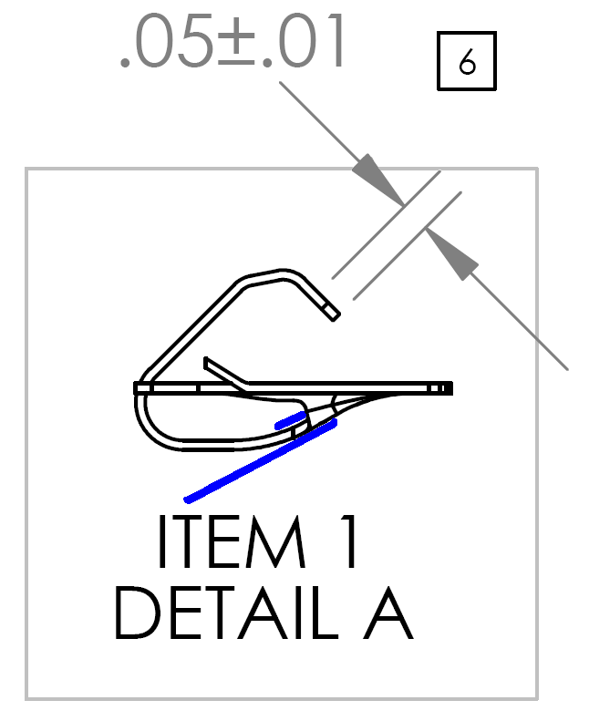

**Figure 1**

1. Now use DEXTER Hysol 9462 epoxy adhesive to glue the battery clips in place (This epoxy has a working life of approximately 55 minutes and it fully cures in 3-5 days).

Press the battery clips into place. The battery clips have some small barbs on them that keep them from coming back out. Make sure these barbs are facing the correct direction (See**figure 2**).

Note: If faster cure times are desired, heat between 66-73C for approximately 1.5 hours for a full cure. Do this after clips and terminal are in place (This should only be done with the bare case, the clips with wires installed, and the battery terminals attached).

1. The battery terminal, S706.03, must be glued in place to prevent it from dislodging when the batteries are inserted or removed (See **figure 3**).
   1. Glue the terminal in place using the DEXTER Hysol 9462 Epoxy Adhesive by applying it to the backside of the S706.03 (The backside is the side opposite the plastic insulator). After applying the epoxy, slide the S706.03 into place as shown in **figure 3.** Make sure the plastic insulator face towards the digital board, where they will contact the battery.

 

**Figure 2 Figure 3**

E. Some of the back cases have residual mold material, or flashing left from the coating process. Remove this flashing to prevent shorts and other problems in the future. The flashing is typically located along the front edge of the battery compartment opening (**See figure 4**).

  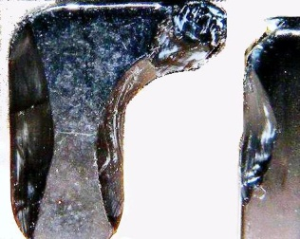

**Figure 4 Figure 5 Figure 6**

1. When the epoxy has hardened trim the battery terminal and case post plastic. Round the inner edge with a 45 degree bank and cut the tip to allow the battery to ramp out when removed. Trim the right side of the plastic only if needed (See section 8.6, C). See **figures 5-6**.

G. Print the proper serial number and model onto a back label (M706.12 for the 704, 706, 706RC and M706.15 for the 704-ATEX, 706-ATEX or 706RC-ATEX) and center it and attach it. Start pressing in the middle and then move outward as the label is attached to avoid label bubbling later.

**8.2 Board Preparation**

1. Test the Digital Board following procedure D0001.8131-IS.
2. Test the Analog Board following procedure D0001.8132-IS.
3. Attach the display to the Digital Board following LCD Bonding Procedure D0001.7001-IS. Note: The display/digital board is fragile in this state, and you must handle it with care. PROBLEMS CAN OCCUR if the display is allowed to fold away repeatedly from the digital board at the display connector. This excessive folding can fatigue and break the contacts that are soldered to the digital board and delicate ribbon wires.

B. If not already installed, solder on two(1220.0092 Male R/A BERG) connectors for the keypad to attach to.

1. Cut two, stranded, insulated wires, one red (7251.2602) and one black (7251.2600), each 1.5 inches long. Attach the black wire to the “K” terminal of the display as shown in the photo below. Attach the red wire to the “A” terminal. (See **Figure 7**). The wires must be moved gently once soldered or the white end piece of the LCD can be accidentally bent off.

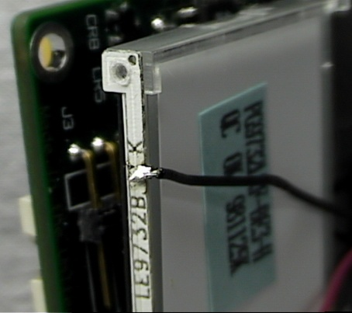 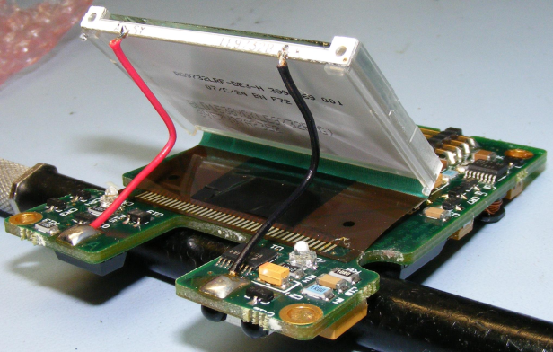

**Figure 7 Figure 8**

D. Fold the LCD into position while tucking the wires back into the crease (**Figures 8**).

Solder the other ends of the wires to the corresponding “K” and “A” on the digital board (See **figures 8**). Power the instrument. Verify that the display back-light is working properly.

E. The A705.11 board assembly needs a conformal coating. For the A706.11 (ATEX versions), move onto 8.3. The A705.11 needs to be conformal coated on the main processor side (A quick spray covering the whole surface to begin, and then a full coat that flows around the components (See the instructions on the can for further details)). Cover the main board connector (P1) and the IR chip (U8) with Kapton tape before spraying to prevent conformal coating of these areas. Allow 10-15 minutes to air dry and the coating will be tack free. Once dry, remove the Kapton tape and discard it.

**8.3 Attaching the Keypad**

1. Use an X-acto knife to lightly score the backing of the keypad below the window and above the keypad connector; remove the lower section of the backing. Be sure to get the small rectangle of backing that is behind the keyboard connector and make sure that the floating piece that it covers will not show from the front side (see arrows below – **figure 9**). Then feed the connectors through the hole in the front of the case. You will need to feed one connector through, and then the other (See**figure 10)**. At this point the blue protective film can be removed from the keypad window, front and back. Attach the keypad to the case (See **figure 11**).

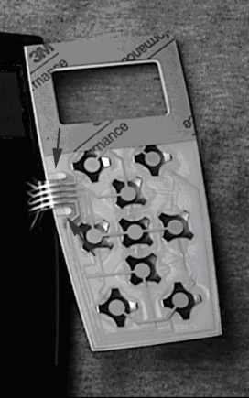 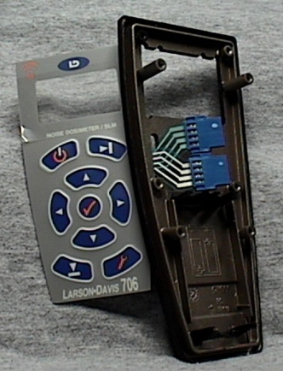 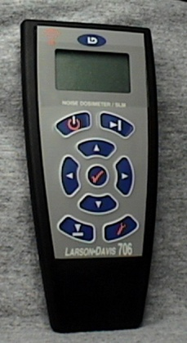

### Figure 9 Figure 10 Figure 11

**8.4 Installing the Digital Board**

1. Connect the keypad to the digital board (See **figure 12)**. Then place the display up through the window in the case. Be careful not to flex the display at its connection to the digital board. The display goes through the lower section of the display hole, and then angles up, over the support shelves (See **figure 13**).

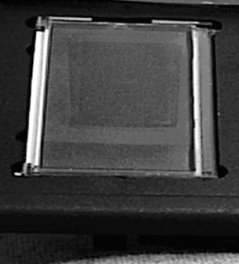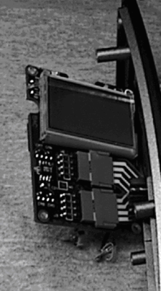 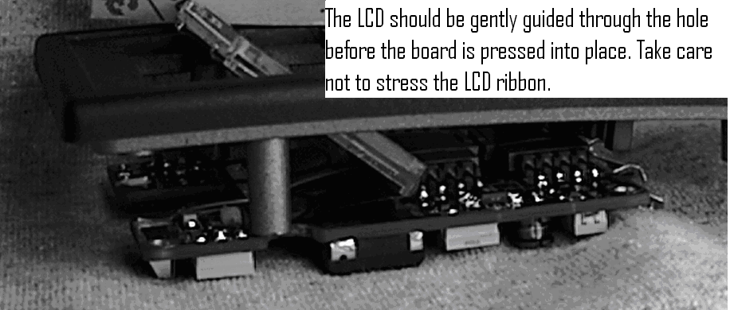

Figure 12 Figure 13 Figure 14

B. Gently slide the digital board into place while guiding the LCD into position. As the digital board contacts its mounting posts, fold the display flat with the top surface of the case (See**figure 14)**.

C. Secure the digital board with four screws. The holes are found in the four corners of the board. Use the correct screwdriver, these are Pozidriv #1 screws, not Phillips (0986.0018).

D. Solder the battery clip wires, or bend the bond wire in an c shape and solder to the digital board battery contacts.

E. Power the instrument. Inspect the display for any missing columns or rows. Verify that the display back-light is working properly. Perform a keypad check by pressing all of the keys 2-3 times in a manner that the result of the key-presses can be visually confirmed on the LCD screen. If the keypad fails this check, replace it and submit the defective keypad to QA for inspection and for quality concern procedures. Disconnect the power. If the protective film is still on the LCD display carefully remove it and place it on the front of the keypad window. Check carefully to make sure there are no prints or debris on the display or the inside of the keypad window. Verify that all debris and prints/markings have been removed.

1. Once satisfied with the position of the keypad, carefully bend back the upper section so you can see the LCD and the inside of the keypad window. Use compressed air to blow out any dust. Remove the remaining backing (**Figure 16**) and press the top of the keypad firmly into place. The keypad adheres to the LCD around the window, bonding the LCD, keypad and case together (See**figures 15-16)**.

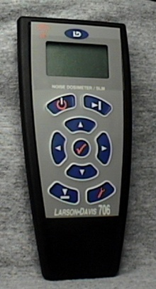 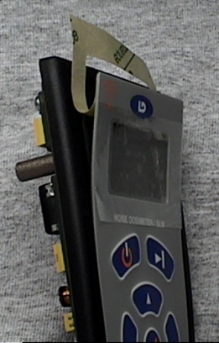

**Figure 15 Figure 16**

**8.5 Installing the Analog Board**

1. Prior to inserting the analog board into the bottom case, cut a ¾” length of weather strip (2505.0004 – floor stock) and place it, adhesive side down, over the inside opening of the battery door tab hole. **Figure 17** shows the battery door tab hole. **Figure 18** shows the correct placement of the weather strip.

 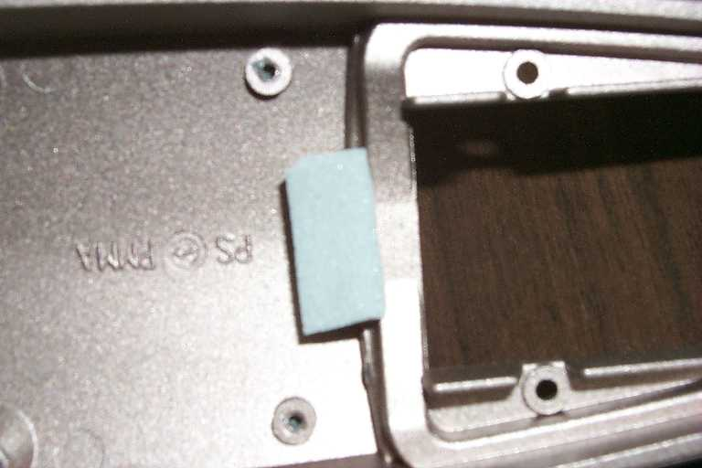

Figure 17 Figure 18

1. Place the EMI washer (2460.0003) over the barrel of the Lemo connector prior to inserting the analog board into the case.
2. With the weather strip and EMI washer in place, insert the analog board into the bottom case and secure it with four screws (0986.0018).

**8.6 Final Assembly**

1. With the battery door removed, join the two case halves. The connector on the analog board and its mating connector on the digital board must be aligned to engage properly. You can look in from the battery compartment and get a fair view of the connector as you close the case. If you don’t get them lined up properly the fuse will very likely blow. Once you are sure the connector is engaged properly, close the case the rest of the way.
2. Firmly press the cases halves together and while pressing insert the screws (**Figure 19**). Use the floor stock case screws that come with the cases (See **Figure 20**).

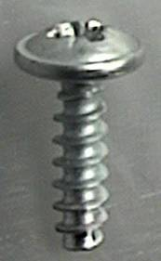 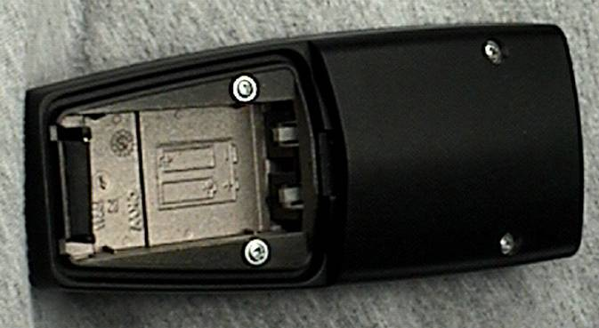

**Figure 19 Figure 20**

1. Now perform a final check. Put in two batteries and verify that the unit powers up. Apply gentle pressure near the bottom of the batteries and push them side to side while watching the LCD for any power glitches. If the unit does not remain on the entire test, remove the batteries and fix the problem (This problem is usually resolved by further trimming the battery terminal plastic (See section 8.1.F)). Remove the batteries and replace the battery door.

**8.7 Measure the Instrument’s Current Draw and Final Calibration**

1. Setup the DC power supply with voltage = 3.0V and power the instrument. Make sure that the instrument turns on and then measure its power supply current. The measured current should be 23mA or less. If the SPARK is drawing more than 23mA, disconnect power and fix the problem before proceeding.
2. Connect the ADP046 test adapter to the input of the Spark found on the analog board (Use a CBL118). Connect the input of the ADP046 test adapter to the signal output of the 2209 / 2239 (Use a CBL066).
3. Open the SLMtest software and follow these steps to start testing.
   1. Make sure the Spark is in front of the IR interface module and that the Spark is on.
   2. Click the connect icon or open the **Commands** menu and select **Connect**. The software will report if it has successfully connected to the Spark.
   3. Select the LogLin and Do-Scale-offset checkboxes.
   4. Click the run icon and let the test run and finish.
   5. After the test, click the disconnect icon and disconnect the unit from the test station.
   6. **Final Test of the Spark Instrument with the MetCal Test Software**
4. Enter the SPARK units into MetCal. Refer to MetCal procedure D0001.8375.
5. Install fresh batteries in the unit or setup the DC power supply with the voltage and current limit set as shown in **Table 1** of instruction 8.2 of the D0001.8132-IS procedure (Limit the current if the power supply used has this capability). Power the Spark.
6. Connect the ADP046 test adapter to the input of the SPARK found on the analog board (Use a CBL118). Connect the input of the ADP046 test adapter to the signal output of the USB attenuator.
7. Make sure the SPARK is in front of the IR interface module and that the SPARK is on.
8. Run the SPARK test in MetCal. Refer to MetCal procedure D0001.8375.
9. IF THE TEST FAILS, TROUBLESHOOT THE PROBLEM BEFORE CONTINUING.
10. Finish the work order in MetCal. Refer to MetCal procedure D0001.8375.

SwitchCraft connector for output signal

BNC connector for input signal

Switch

Move switch to this position for “INPUT”

Switch position for “NOISE”

**Figure 21: Top View of ADP046**

**9.0 INSPECTION**

Inspect the finished unit for any obvious defects

**10.0 RECORDS**

The test data is stored in the MetCal database.

**11.0 DISTRIBUTION**

The document is available to employees in the online Document Control area.

**12.0 ATTACHMENTS**

Not applicable to this procedure.

**13.0 REVISION HISTORY**

|  |  |  |  |  |
| --- | --- | --- | --- | --- |
| **DCO #** | **REV** | **DATE** | **INITIALS** | **CHANGES MADE** |
| 1856 | A | 10/09/18 | JGG | Initial release of intrinsic safe procedure. This is an updated version of D0001.8033. Changed from certifying the unit using the SLMTest software to using MetCal. Added intrinsic safe note. Added –IS to the end of the document number. |
|  |  |  |  |  |
|  |  |  |  |  |
|  |  |  |  |  |
|  |  |  |  |  |
|  |  |  |  |  |
|  |  |  |  |  |
|  |  |  |  |  |
|  |  |  |  |  |
|  |  |  |  |  |
|  |  |  |  |  |
|  |  |  |  |  |
|  |  |  |  |  |
|  |  |  |  |  |
|  |  |  |  |  |