CAL250.F Assembly & Test

1.0 SCOPE & APPLICABILITY

This instruction covers the assembly and test of new CAL250.F product.

2.0 RESPONSIBILITY

The individual that is authorized to test and assemble the CAL250.F has the responsibility to follow the applicable instructions and references to produce a quality product.

3.0 MATERIALS, TOOLS, & EQUIPMENT

Current CAL250 assembly drawing
Current A250.1 bill of materials
Current A250.1 schematic
Current A250.1 loading diagram
Calibrator Test System
½” Reference microphone
Adjustable DC power supply
Calibrator power cable (1.0 Ω resistor in line on positive side)
Technician tool kit
ESCPEC Chamber
D0001.8282 CAL250 Final Checklist
D0001.8189 Chamber Test
ADP019 ½” adapter

4.0 PROCEDURE

Note: Multiple units may be tested at each step. Multiple steps may also be performed for each unit. Wherever “mbar” is specified, test software now reads in k Pascals. Conversion from mbar to k Pascals is done by shifting decimal point one place to the left.

4.1 Calibrators are partially assembled by production and delivered to the technician

4.1.1 Insert the 915 preamp with the current ½ “ reference microphone from the “Calibrator Test System” into the base of the MTS1000. If multiple units are being certified, this step is only performed for the first unit.
4.1.2 Tighten the front retainer ring on the back cavity of the speaker until the wave spring is fully compressed then back off ½ turn. Visually inspect the board for defects.
4.1.3 Insert the board into the tube and secure with 2 screws P/N 5290.0040.
Ensure that the adjustable DC power supply is set to 10 V.
4.1.4 Use the “Calibrator Power Cable” to supply power to the unit being tested.
4.2 Checking Tone & Power Shut-off Voltage

4.2.1 Turn the unit on. It should emit a clear, audible tone.
4.2.2 Lower the voltage on the power supply to approximately 6.6 Vdc. The unit should turn off.
4.2.3 Turn the voltage back up to 10 Vdc. The unit should remain off.
4.2.4 Place a jumper over P1 so the unit will run continuously when powered up.

4.3 Setting Frequency, 114 dB level, and Temperature compensation

Note: Steps 4.3.1 through 4.3.6 are performed for the first unit only if testing multiple units.
4.3.1 Double click on the icon labeled “Static Pressure Test” on the computer desktop of the “Calibrator Test System.”
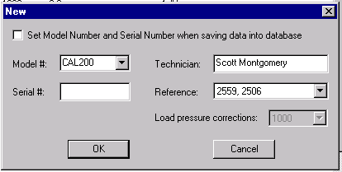4.3.2 In the main menu under “Files” click on “New” or click the “New” file icon in the toolbar. The screen below will appear:

4.3.3 Enter something such as “test” in the Serial # box and click on “OK.”
Note: change the pressure correction to 250 Hz.
4.3.4 Click on the ← → (Previous or Next) icons in the toolbar until the 114-dB certification screen appears:

114-dB certification screen

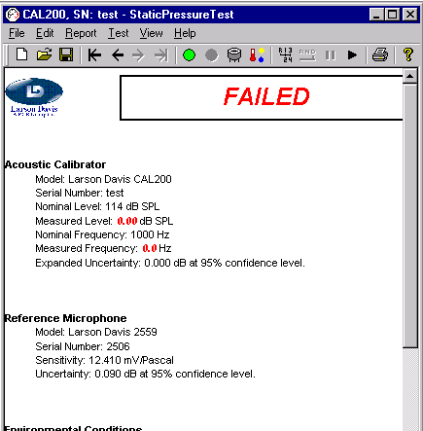 Previous Next Set Voltage

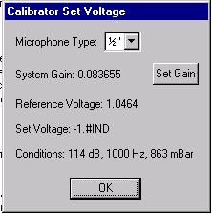4.3.5 Click on the “Set Voltage” icon in the toolbar as in the previous diagram. The window below will appear:

4.3.6 Make sure the “Microphone Type” is set to ½”. Use the listed “Reference Voltage” to set the level of the calibrators hereafter. The displayed level is for 114 dB.
4.3.7 Insert an ADP019 adapter and place the calibrator over the ½ inch reference microphone and 915 preamp.
4.3.8 Make sure the temperature compensation pot has been adjusted to approximately the 1:00 position on the clock while viewing the calibrator as in the following diagram. (Compensation may be adjusted during visual inspection of calibrator in section 4.1 if desired)

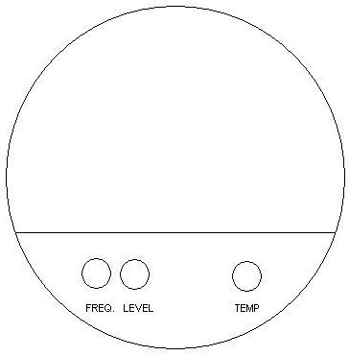

4.3.9 Turn the unit on, adjust the frequency to 251.2 Hz ± 0.2 Hz Then set the 114-dB level to the reference voltage(use the HP multimeter). Fine adjustment is not necessary at this time, just close.
Refer to the previous diagram for potentiometer locations.

4.4 Check Current Draw & Place Calibrators in ESPEC Temperature / Humidity Cabinet.

4.4.1 Set the oscilloscope to read DC volts on the multimeter inputs. Toggle switch on right side of oscilloscope to the forward position to measure current draw.
4.4.2 There is a 1.0-ohm resistor in line on the positive side of the calibrator power cable plugged into the adjustable DC power supply. The power supply should be set at 10 Vdc.
4.4.3 Leads are clipped across this resistor to measure the current draw of the units being tested.
4.4.4 The leads are connected to a BNC to BNC cable that plugs into the multimeter inputs of the oscilloscope using a Double Banana to BNC adapter.
4.4.5 At the 114 dB level: 0.0040 to 0.0070 Vdc. (4 mA to 7 mA, typically about 5)
4.4.6 Remove the calibrator from mic and preamp and disconnect power.
4.4.7 Place the calibrators in the ESPEC chamber with power connected so that the unit(s) function continually.
4.4.8 Cycle continuously on the default cycle(50°C to -10°C) for 48 hours. Retrieve when time has elapsed. Refer to D0001.8189 Chamber Test.

4.5 Pressure Test (This test is automated. The test is done AFTER heat snap of 48 hours. May be done before or after Temperature test though listed prior to test in this document. PRM915 or PRM902 may be used. Steps 4.5.1 through 4.5.3 are performed for the first unit only if testing multiple units.)

4.5.1 Double click on the “Static Pressure Test” icon on the computer desktop
4.5.2 Insert the 915 or 902 preamp with the current ½ inch reference microphone from the “Calibrator Test System”, into the base of the MTS1000.
4.5.3 Obtain a “Reference Voltage” to set the 114 dB level again before testing. Refer to step 4.3.2 through 4.3.6.
4.5.4 Connect a 9 V battery to the calibrator, and insert in the battery compartment. The jumper should still be in place so the unit runs continuously.
4.5.5 Place the calibrator over the Reference microphone and adjust the frequency and the 114-dB level if necessary.
4.5.6 Place the pressure vessel over the calibrator and latch securely in place.
4.5.7 Under “Files” in the main menu click on the “New” option or click the “New” file icon.
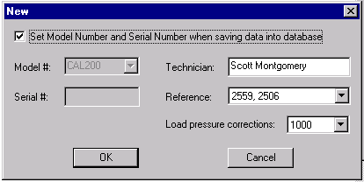The screen below will appear:

4.5.8 Be sure the options are set as listed (The pressure correction window should be set to 251.2 instead of the 1000 shown and model should say CAL250) with the correct reference microphone and your name. Click on “OK.”
4.5.9 Be sure the options are set as in the toolbar below (Unselect “Pause”) and click on the “Start” button to begin the test:
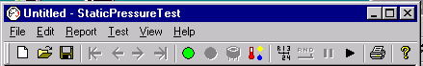
Start Stop Manual Auto Pause Continue

4.5.10 The test will run automatically until completed.
4.5.11 CAL250 limits are ± 0.3 dB 650 to 1080 mbar.
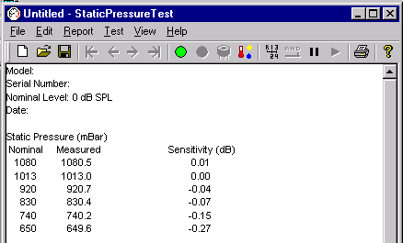
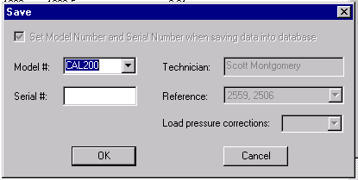
4.5.12 After a successful pressure test is completed, click on the “save” icon. The screen below will appear:

4.5.13 Enter the correct Model # and Serial # for the unit that has just been tested. (The tube of the CAL250 is serialized.)
4.5.14 Click “OK” to complete the save.
4.5.15 Make sure the pressure has been released. Then remove the pressure vessel and calibrator.
4.5.16 The calibrator is now ready to be run over temperature. Refer to Chamber test procedure (D0001.8189).
4.5.17 After successful completion of Temperature Test, final certification is completed using work instruction D0001.8192 CAL250 Final Certification-New Product.

5.0 EVALUATION

The test and assembly process detailed includes evaluation.

6.0 RECORDS

Test data generated from this process is stored in the test software’s database.

7.0 REVISION HISTORY
DCO # | REV | DATE | INITIALS | CHANGES MADE
868 | A | 5/17/05 | SM | Initial Release
1094 | B | 6/10/08 | SM | Updates
1149 | C | 10/16/08 | SM | Minor edit and changes
1234 | D | 7/01/09 | SM | Changed reference to resistor used for measuring.
1340 | E | 6/23/11 | SM | 4.1.2 Changed step to specific instructions on tightening front retainer ring, 4.3.8 changed 12 to 1, 4.5 Added line: Pressure test may be done before or after temperature test.
1392 | F | 8/6/12 | SM | Minor edits and changes

