COPYING RELEASED SOFTWARE TO COMPACT DISK (CD)

1.0 PURPOSE AND SCOPE

The purpose of this document is to describe the procedure to copy released software to recordable compact disk(s) (CD-R) for shipment to customers.

2.0 AFFECTED DEPARTMENTS

Engineering
Manufacturing

3.0 REFERENCE DOCUMENTS

None

4.0 RESPONSIBILITIES & AUTHORITY

Engineering has the responsibility to maintain released software in Document Control and/or in the electronic area of Document Control.

Manufacturing has the responsibility and authority to make copies of released software for sale and/or distribution to customers. It is the responsibility of the person copying released software to recordable CDs to follow the process in this document.

5.0 DEFINITIONS

CD-R Recordable Compact Disk
PC Personal / Desktop computer
Production CD-RW PC The PC in Production that contains the CD-RW Drive

6.0 SAFETY PRECAUTIONS

None

- EQUIPMENT & MATERIALS

- The Production CD-RW PC Recordable CDs.
- IBM compatible PC with network connectivity (if not copying the files from the CD-RW PC).
- NTI CD-Maker 6.5 (installed on Production CD-RW PC)
8.0 INSTRUCTIONS

- Open the NTI CD-Maker 6.5 program.

- In the Project selector click on “data” and then select “Data CD”.

- The top left box is the equivalent to "Windows Explorer". Select the files to be copied from the field next to it. For example to copy the "Blaze" software, the display would need to show ‘Q:\software\blaze\5499.0002\code’ in the field at the left.
NOTE: Engineering has specified which Software files to copy on the travelers.

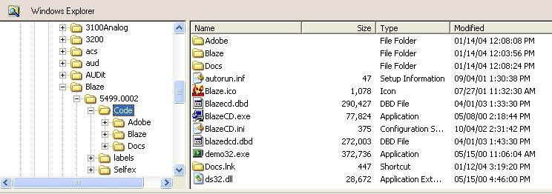

- Using the mouse, "Select All" of the required files and drag them to the bottom box titled CD layout.

- To change the title of the CD, right click on the empty data layout and select “rename” and type in a name for the CD that is descriptive of what is being copied onto the CD (11 characters max). For example, for DNA, enter “DNA 4.001” (The standard format is software name-version.)
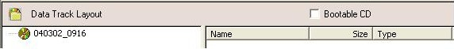

- The CD Image File can now be created.

- Go to the File menu, then select “Create ISO disc Image File”.

- A window will appear (Save As), type the name you want for the CD Image file (For example, Blaze 4.11.ISO). Click the “Save” button.

NOTE: This procedure from step 3 to step 8 should be performed one time per Image file
(The Image file is saved in the Hard Drive of the PC and can be recalled for future work orders). Also, make sure to double check for the latest version of the software to be copied.

- Insert a CD-R in the CD-RW Drive. Go to the File menu, and then select “Create Disc from ISO Disc Image File”. A new window will appear (Open), select the Image file to be used. Click the “Open” button.

- A new window will pop up (Write CD), click on “Write” and select the number of copies you want to create. Click the “Start” button.

- Close the program when finished. Do not save the changes to the CD.

9.0 INSPECTION

N/A

10.0 RECORDS

N/A

11.0 DISTRIBUTION

Manufacturing

12.0 ATTACHMENTS

None

13.0 REVISION HISTORY

DCO # | REV | DATE | INITIALS | CHANGES MADE
184 | B | 1/25/01 | AP | Change the program to Easy CD Creator and changed the instructions to use this new program.
390A | C | 3/7/02 | EO | Clarified instructions simplified process. Changed author to current employee.
728A | D | 2/6/04 | RC | Total Rewrite of work instruction

