PRM902 PRETEST AND TRIM

- PURPOSE AND SCOPE

The purpose of this document is to provide the detail and instruction necessary to ensure the compliance of the specified product to established specifications. This instruction is applicable to both new product and to customer owned product that has been returned for repair and/or calibration.

2.0 LIMITATIONS

This instruction is limited to the pre-testing and trimming of the PRM902, PRM902LF, PRM905, and 426A30 products.

3.0 AFFECTED DEPARTMENTS

Manufacturing

4.0 REFERENCE DOCUMENTS

Applicable drawings and instructions for the PRM902, PRM902LF, PRM905, and 426A30.

5.0 RESPONSIBILITIES & AUTHORITY

The technician has the following responsibilities and authority:
- Verify compliance of the product under test to specification.
- Troubleshoot and correct product as required.
- Communicate concerns to Supervisor or Quality Assurance.
- Request management review of product concerns.
- Use proper ESD protective equipment.

6.0 SAFETY PRECAUTIONS

- Safety Glasses are required when soldering, lead clipping, or testing power supplies.
- Follow general electrical precautions for working with energized, low voltage circuits

7.0 EQUIPMENT & MATERIALS

ADP015
EXC001.5 (or any short EXCxxx cable)
BNC to BNC cable
CBL071
2200B (or 2200C)
Function Generator
Oscilloscope (with a DMM (Digital Multimeter))
BNC to test clips

8.0 INSPECTION

Perform a visual check of the board. Check for any shorts or mis-loaded parts.

9.0 INSTRUCTIONS

9.1 Setup

- Configure test cables as shown below.

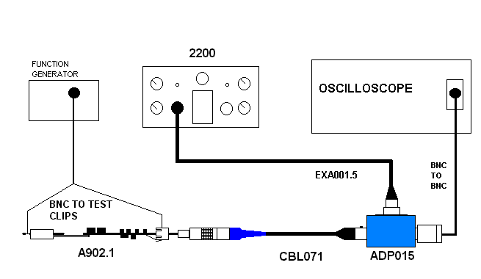
EXCxxx
- Setup 2200B for a 0V BIAS and 0dB of GAIN.
- Connect the A905.1 board (or older 902.1 board) to be tested to the open end of the CBL071 cable.
(Lineup the ear on the 902.1 board connector with the red dot on the connector of the CBL071 cable)
- Turn on the 2200C.

9.2 Check preamp current

- Measure the voltage across R3 using the mutimeter.
- The voltage across R3 should read between 18 and 24 mV. If the voltage is not in range, adjust the value of R4 to correct the problem. For example: if the current is high try changing R4 from 8.4K to a 10K resistor (LD part #4937.1002)

9.3 Signal Check

- Set the function generator to produce a 1,000Hz and 1 Volt RMS sine wave..
- Hook the signal from the signal generator (red) to the pogo in the top end of the Preamp, and (black) ground it to the connector body.
- Check for a clean sine wave on the O-Scope and 0.96 to 1.0 AC Volts on the DMM (or about 0.65 AC Volts for the PRM902LF).

9.4 Check DC Offset

- Switch O-scope or DMM to read DC and verify the DC offset is less then + or - 2Vdc.
- Turn off the 2200B and disconnect Preamp board.
- Return Preamp board to production for final assembly.

- RECORDS

No records are generated as part of this instruction.

11.0 DISTRIBUTION

Instruction is available online in the “Preamp” folder in the “Technician work instruction” folder in Document Control.

12.0 REVISION HISTORY

DCO # | REV | DATE | INITIALS | CHANGES MADE
753 | A | 3/16/04 | JEB | Initial Release
1088 | B | 6/4/08 | JGG | Changed current limits and added notes for PRM905 and 426A30.
1434 | C | 07/26/13 | SRC | incorrect signal level for PRM902LF  Also the rev was changed from rev. A
1867 | D | 1/16/19 | SRC | Added clarity so it was more production friendly

