PRM902 FINAL TEST

- PURPOSE AND SCOPE

The purpose of this document is to provide the detail and instruction necessary to ensure the compliance of the specified product to established specifications. The instruction applies to both new and customer owned equipment that has been returned for repair and/or calibration.

2.0 LIMITATIONS

The use of this instruction is limited to testing the PRM902 and the PRM902LF.

3.0 AFFECTED DEPARTMENTS

Manufacturing

4.0 REFERENCE DOCUMENTS

D0001.1126 Quality Records
Applicable revision drawings for the PRM902 and PRM902LF

5.0 RESPONSIBILITIES & AUTHORITY

The technician has the following responsibilities and authority:
- Verify compliance of the product under test to specification.
- Troubleshoot and correct product as required.
- Communicate concerns to Supervisor or Quality Assurance.
- Request management review of product concerns.
- Use proper ESD protective equipment.

6.0 SAFETY PRECAUTIONS

- Safety Glasses are required when soldering, lead clipping, or testing power supplies.
- Follow general electrical precautions for working with energized, low voltage circuits

7.0 EQUIPMENT & MATERIALS

ADP015
EXC001.5 (or any short EXCxxx cable)
TWO BNC to BNC cable’s
CBL071
2200B/C
Function Generator
Oscilloscope (with a DMM (Digital Multimeter))
CAL250
2540
ADP005
2900 TEST STATION

- INSPECTION

- Examine the cosmetic appearance of the preamplifier
- Verify that the contacts and connectors are properly aligned on the part
- Questions about appearance or quality are to be brought to the attention of the supervisor, manager or QA

- INSTRUCTIONS

9.1 Setup

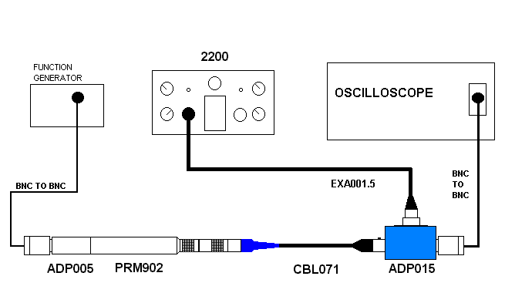
- Configure test cables as shown below.
EXCxxx

- Setup 2200 for a 200V BIAS and 0dB of GAIN.
- Attach ADP005 to the end of PRM902.
- Connect the PRM902 to the open end of the CBL071 cable.

9.2 Dummy Load Test

- Turn on the 2200, the overload light may turn on for a few seconds but it should not remain on.
- Connect a 1Vac sin wave to ADP005.
- Monitor the output of the PRM902 on the scope.
- The AC signal should be ≅ 970 mVac. (note for PRM902LF ≅ 137 mVac)
- The DC level should settle to 0Vdc ± 2Vdc. If the DV voltage is too high, turn off the 200V bias on the 2200 and re-check. If it is now within tolerance, replace the cap in the front end.
- Turn off 2200.
- Remove the ADP005.

9.3 Microphone Test

- Connect 2540 to the PRM902. (Any ½” condenser Microphone could work).
- Turn on the 2200.
- Attach an active CAL250 to the microphone.
- Wait a few seconds for the overload light to go out,
- Monitor the output of the PRM902 on the scope.
- The signal should be ≅ 120 mVac and undistorted. (note for the PRM902LF ≅ .017 mVac)
(This level is dependent on the microphone used it is best to note this level and always use the same microphone for this test)

9.4 2900 Test Station Test setup

- Using one of the test stations in the technician area, connect the preamp as follows.
- Set the data switch box to the 2900, 2800, 875 position.
- Connect the RS-232 cable to the HP multimeter.
- Connect a BNC to BNC cable from the input of the multimeter to an ADP015.
- Connect a 5-pin Switchcraft cable from the ADP015 to channel one of the 2900.
- Connect the CBL071 to the ADP015.
- Screw an ADP005 onto the PRM902 to be tested.
- Connect the BNC to BNC cable coming from the output of the 2209 to the ADP005.

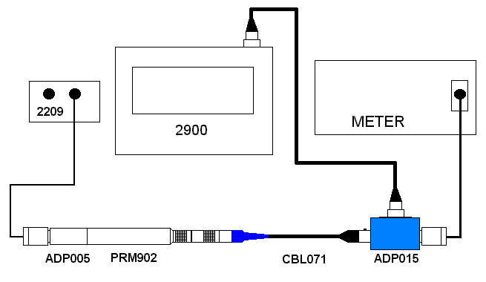
EXCxxx

9.5 Run Automated test

- Run the “PreampTest” program
- Select your name in the Technician field.
- For Model: select 902(SMD) or PRM902LF if applicable.
- Click on the play button.
- When it asks for the serial number, enter it and press OK.
- Print results when finished

9.6 Cert.

- Create & Print Certificate of Conformance (without due date) in the LD database
- Sign cert and include above test results
- Print cal sticker and barcode sticker with s/n and place on outside of blue tube.

- RECORDS

- Test results are saved per the Quality Records Matrix, D0001.1126-1.
- Enter a new record in the “Larson Davis Online Database” for each S/N tested.

11.0 DISTRIBUTION

This instruction is available online in the Technician work instruction folder in the “Preamp” folder in the Document Control area.

12.0 REVISION HISTORY

DCO # | REV | DATE | INITIALS | CHANGES MADE
754 | A | 3/16/04 | JEB | Initial Release
1867 | B | 1/16/19 | SRC | Added clarity so it was more production friendly

