PRM828 TEST PROCEDURE

1.0 INTRODUCTION

This instruction provides the detail necessary to allow testing and verification of the PRM828 product to Larson Davis specifications.

2.0 DESCRIPTION

The technician has the following responsibilities and authority:
- Verify compliance of the product under test to specifications,
- Troubleshoot and correct product as required.
- Communicate concerns to the Supervisor or Quality Assurance.
- Request management review of product concerns.
- Use proper ESD protective equipment.

3.0 LIMITATIONS

This instruction is to be used to verify new or repaired PRM828 preamplifiers. Section 5.3 should be used when performing a routine re-certification of a customers instrument and Section 6.0 should be used to verify as received status of a customers instrument.

Safety precautions that should be followed:
- Safety Glasses are required when soldering, lead clipping, or testing power supplies.
- Follow general electrical precautions for working with energized, low voltage circuits.

4.0 MATERIALS, TOOLS, & EQUIPMENT

- LD SigGen Test System (2900 with 2209)
- Test 820
- ADP015
- ADP005
- Alligator clip leads.
- CBL063
- Function Generator
- Oscilloscope
- HP DMM (Digital Multimeter)
- CBL001
- BNC to BNC cable

5.0 INSTRUCTIONS

5.1 Setup the Test 820

- Turn on the 820
- On the keypad press the "Shift" then press the "Reset" twice
- Press "Setup" "SLM" "Left Arrow"
- Select SLOW, then press "Enter"
- Press the 'Down Arrow" then press the "Left Arrow" twice
- Select C
- Press the "Down Arrow" three times to mic polarization
- Press the "Left Arrow" twice
- Select 0 V by pressing the "Enter" key (Select 200 V for step 6.0).
- Press the "On" key
- Turn off

5.2 Connect the pre-amp to be tested as follows (Fig. 1)

- Connect extension cable from the 820 to the ADP015.
- Attach a BNC-BNC cable from the output of ADP015 to the Oscilloscope.
- Connect the Pre-amp under test to the ADP015
- Place the black alligator clip lead on the ground of the Pre-amp and connect to the Generator.
- Place the red alligator clip lead on the pogo.
- Set the generator to output a signal of 0.5 V_{rms} @ 1Khz

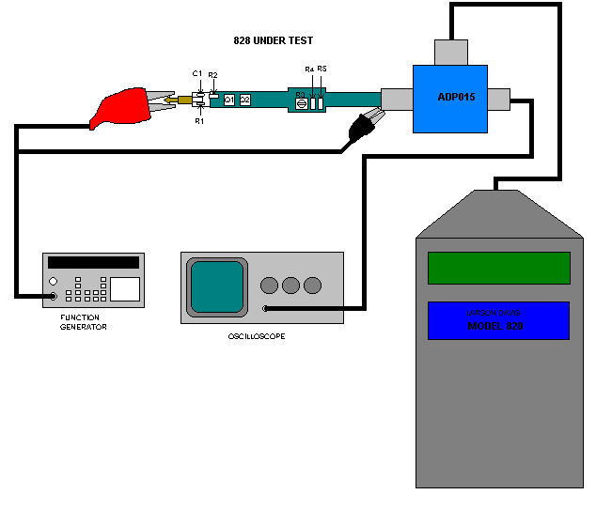
Figure 1

5.2 Adjust current.

- Turn on the 820.
- Place the instrument in "Run" mode.
- Using the voltmeter, measure the voltage across either R4 or R5
- The voltage measured across R4 or R5 should be between 105 – 145 mV. If it is not within those limits, replace R3 until within range.
- Look at the signal on the Oscilloscope; it should be a uniform sinewave.
- If instrument passes return to Production for final assembly or if customer instrument, reassemble and proceed to "Final Test".
- If instrument fails, troubleshoot and repair.

5.3 Final Test

Test the pre-amp on the 2900 Test system as follows: (FIG. 2)

- Connect the extension cable from the Test 820 to the ADP015.
- Attach a BNC to BNC cable from the ADP015 to a Tee-connector on the input of the HP DMM (Digital Multimeter).
- Connect cable CBL001 from the tee-connector on the DMM to the input on the 2900.
- Connect the Pre-amp under test to the ADP015
- Attach the ADP005 to the pre-amp as shown
- Connect a BNC to BNC cable from the ADP005 to the output from the 2209 (part of the LD SigGen Test system).
- Turn on the 820.
- Place the instrument in run mode.
- Select and open the "LD Lab Test" program on the computer
- Select "828 (20Gohm SMD)" on the menu. 
- Enter the serial number of the preamp being tested
- Select Start
- Automated program then tests the pre-amp
- If instrument passes, save the test results and generate "Certificate of Compliance" (if applicable)
- If instrument fails, troubleshoot and repair.

NOTE: For repair and calibration units, check for the two options for PRM828 on the LD Lab Test {“828” or “828 (20Gohm SMD)”}.

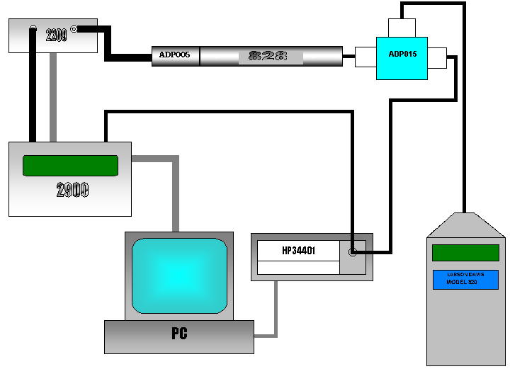
Figure 2

6.0 CALIBRATION CHECK

- Connect the pre-amp to the 820
- Attach a 2541 microphone to the pre-amp
- Place a CAL250 onto the microphone
- Turn on the 820 and check if it still has the 200-volt bias turned on (see set-up in section 5.1)
- Select the calibration mode and calibrate the unit to 114 dB. Unit will give a calibration offset of approximately 7-12 dB.
- Select the run mode and the reading will be 114 dB.
- Return pre-amp to Production if this is a new instrument. If pre-amp belongs to a customer (internal or external), return the instrument to customer along with the appropriate documentation.

7.0 RECORDS

- Print out and save the Automated test results for 2 years or the life of the warranty. If this is a re-certification, the records are maintained for one year.
- Record pre-amp serial number, board number, revision number, and test station number into the LD Database.
- Generate "Certificate of Compliance" prior to the unit shipping (if applicable).
- Records of the test results and certificate of compliance are also maintained electronically for the minimum retention time listed above.

11.0 REVISION HISTORY

DCO # | REV | DATE | INITIALS | CHANGES MADE
 | A | 7/16/01 | RH | Initial Release
384A | B | 2/14/02 | RC | Updated procedure for fixed resistor R3.

