TEDS_RW Software

1.0 PURPOSE AND SCOPE

The purpose of this document is to describe how to use the TEDS_RW software to test the digital memory chip (Dallas Semiconductor 256 bit EEPROM DS2430A and 1024 bit EEPROM DS2431) incorporated in various preamps. It can be used to read or write the manufacturer, model number and serial number from/to the digital memory in TEDS format.

2.0 AFFECTED DEPARTMENTS

Manufacturing

3.0 REFERENCE DOCUMENTS

D0001.8341 378xnn ICP Preamp with Attached Microphone

4.0 RESPONSIBILITIES & AUTHORITY

It is the responsibility of the person testing the preamp with digital memory to follow the procedure in this document.

5.0 DEFINITIONS

TEDS – Transducer Electronic Data Sheet

6.0 SAFETY PRECAUTIONS

None

- EQUIPMENT & MATERIALS

  - Any PC that is set up with the TEDS_RW program. Note that if using a serial adaptor the program will only work on COM1 or COM2.
If this program is not installed on the PC to be used, it can be found at
{network drive}\Engineering\Tools\teds_rw.
  - Dallas Semiconductor DS9097U-9 Serial comport adapter or Maxim Integrated DS9490R USB adapter for one-wire technology
  - Cable (see Attachment A)

8.0 INSTRUCTIONS

This section contains the steps to test the preamp.

  - Connect the preamp to the computer

- Using any computer that is set up with the TEDS_RW program, connect the adapter to a serial port or USB port on the computer.
Note: If using a serial adaptor, the TEDS_RW program will only work on COM1 or COM2.
- Connect the RJ11 connector end of the cable to the adapter.
- Connect the opposite end to the preamp.

  - Use TEDS_RW to read/write the manufacturer data, and test memory

- Start TEDS_RW. This will bring up the program’s interface as shown below:
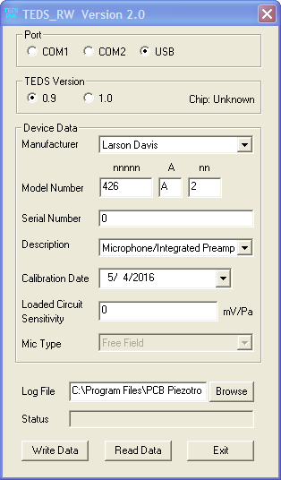
- Enter or select a log file. You must enter a log file before you can test the memory or write out the manufacturer data. Once a log file has been entered, the program will remember and pre-enter the last used log file on that machine.
- Select the port on which the adaptor is attached by clicking the appropriate button in the Port box. Once a port has been selected, the program will remember it and have it preselected the next time the program is run.
- If writing data to the device…
- Select the correct TEDS version
Note: If you are not sure what chip is in the preamp, select the Read Data button. It will return an error message if the chip has not been programmed, but it will tell you the chip model and auto select the proper version to use.
- If programming the DS2430A chip use version 0.9.
- If programming the DS2431 chip use version 1.0.
- Select the manufacturer.
- Enter the model number.
Note: The first field will not accept letters. If the model has leading letters, such as HT426E01, leave off the beginning letters and just enter 426 E 01. Also note that the last field will truncate any leading zeros. So after you program 01 in this field, if you read the memory back, it will only show 1.
- Enter the serial number.
Note: This field will not accept letters either. If the serial number has letters, such as LW012345, leave off the beginning letters and just enter 012345. Also note that this field will truncate any leading zeros. So after you program 012345 in this field, if you read the memory back, it will only show 12345.
- Select the description. “Microphone Preamplifier” for a preamp only, “Microphone/Integrated Preamp” for a preamp with an attached microphone.
- Select the calibration date.
- If you selected Microphone/Integrated Preamp, enter the loaded circuit sensitivity. See document D0001.8341 378xnn ICP Preamp with Attached Microphone for instructions on how to calculate the loaded circuit sensitivity.
- If you selected Microphone/Integrated Preamp, and are programming TEDS version 1.0, select the microphone type.
- Select the “Write Data” button. This will first test the memory and then write the entered data to the digital memory.
As the current action of the program is completing, the result of the action will be displayed in the status box. A progress dialog box will display the progress of the memory test.
- After the programming is complete, verify that the program displays “Manufacturer data was successfully written.” If it displays something different, troubleshoot and repair the preamp.

- If just checking the currently entered manufacturer data, select the “Read Data” button. This will load the information in the appropriate fields in the program interface.

- When finished with all the preamps you will be doing, select the “Exit” button.

9.0 INSPECTION

N/A

10.0 RECORDS

Each tested preamp’s EEPROM id will be listed in the entered log file with the associated manufacturer data for each successful test. If the test fails, the EEPROM id will be followed by a note that the memory test failed.

If the instrument has a microphone mated with it, include in the database record of the preamp the model and serial number of the microphone.

11.0 DISTRIBUTION

Manufacturing

12.0 ATTACHMENTS

Attachment A: Cable Pin-Out
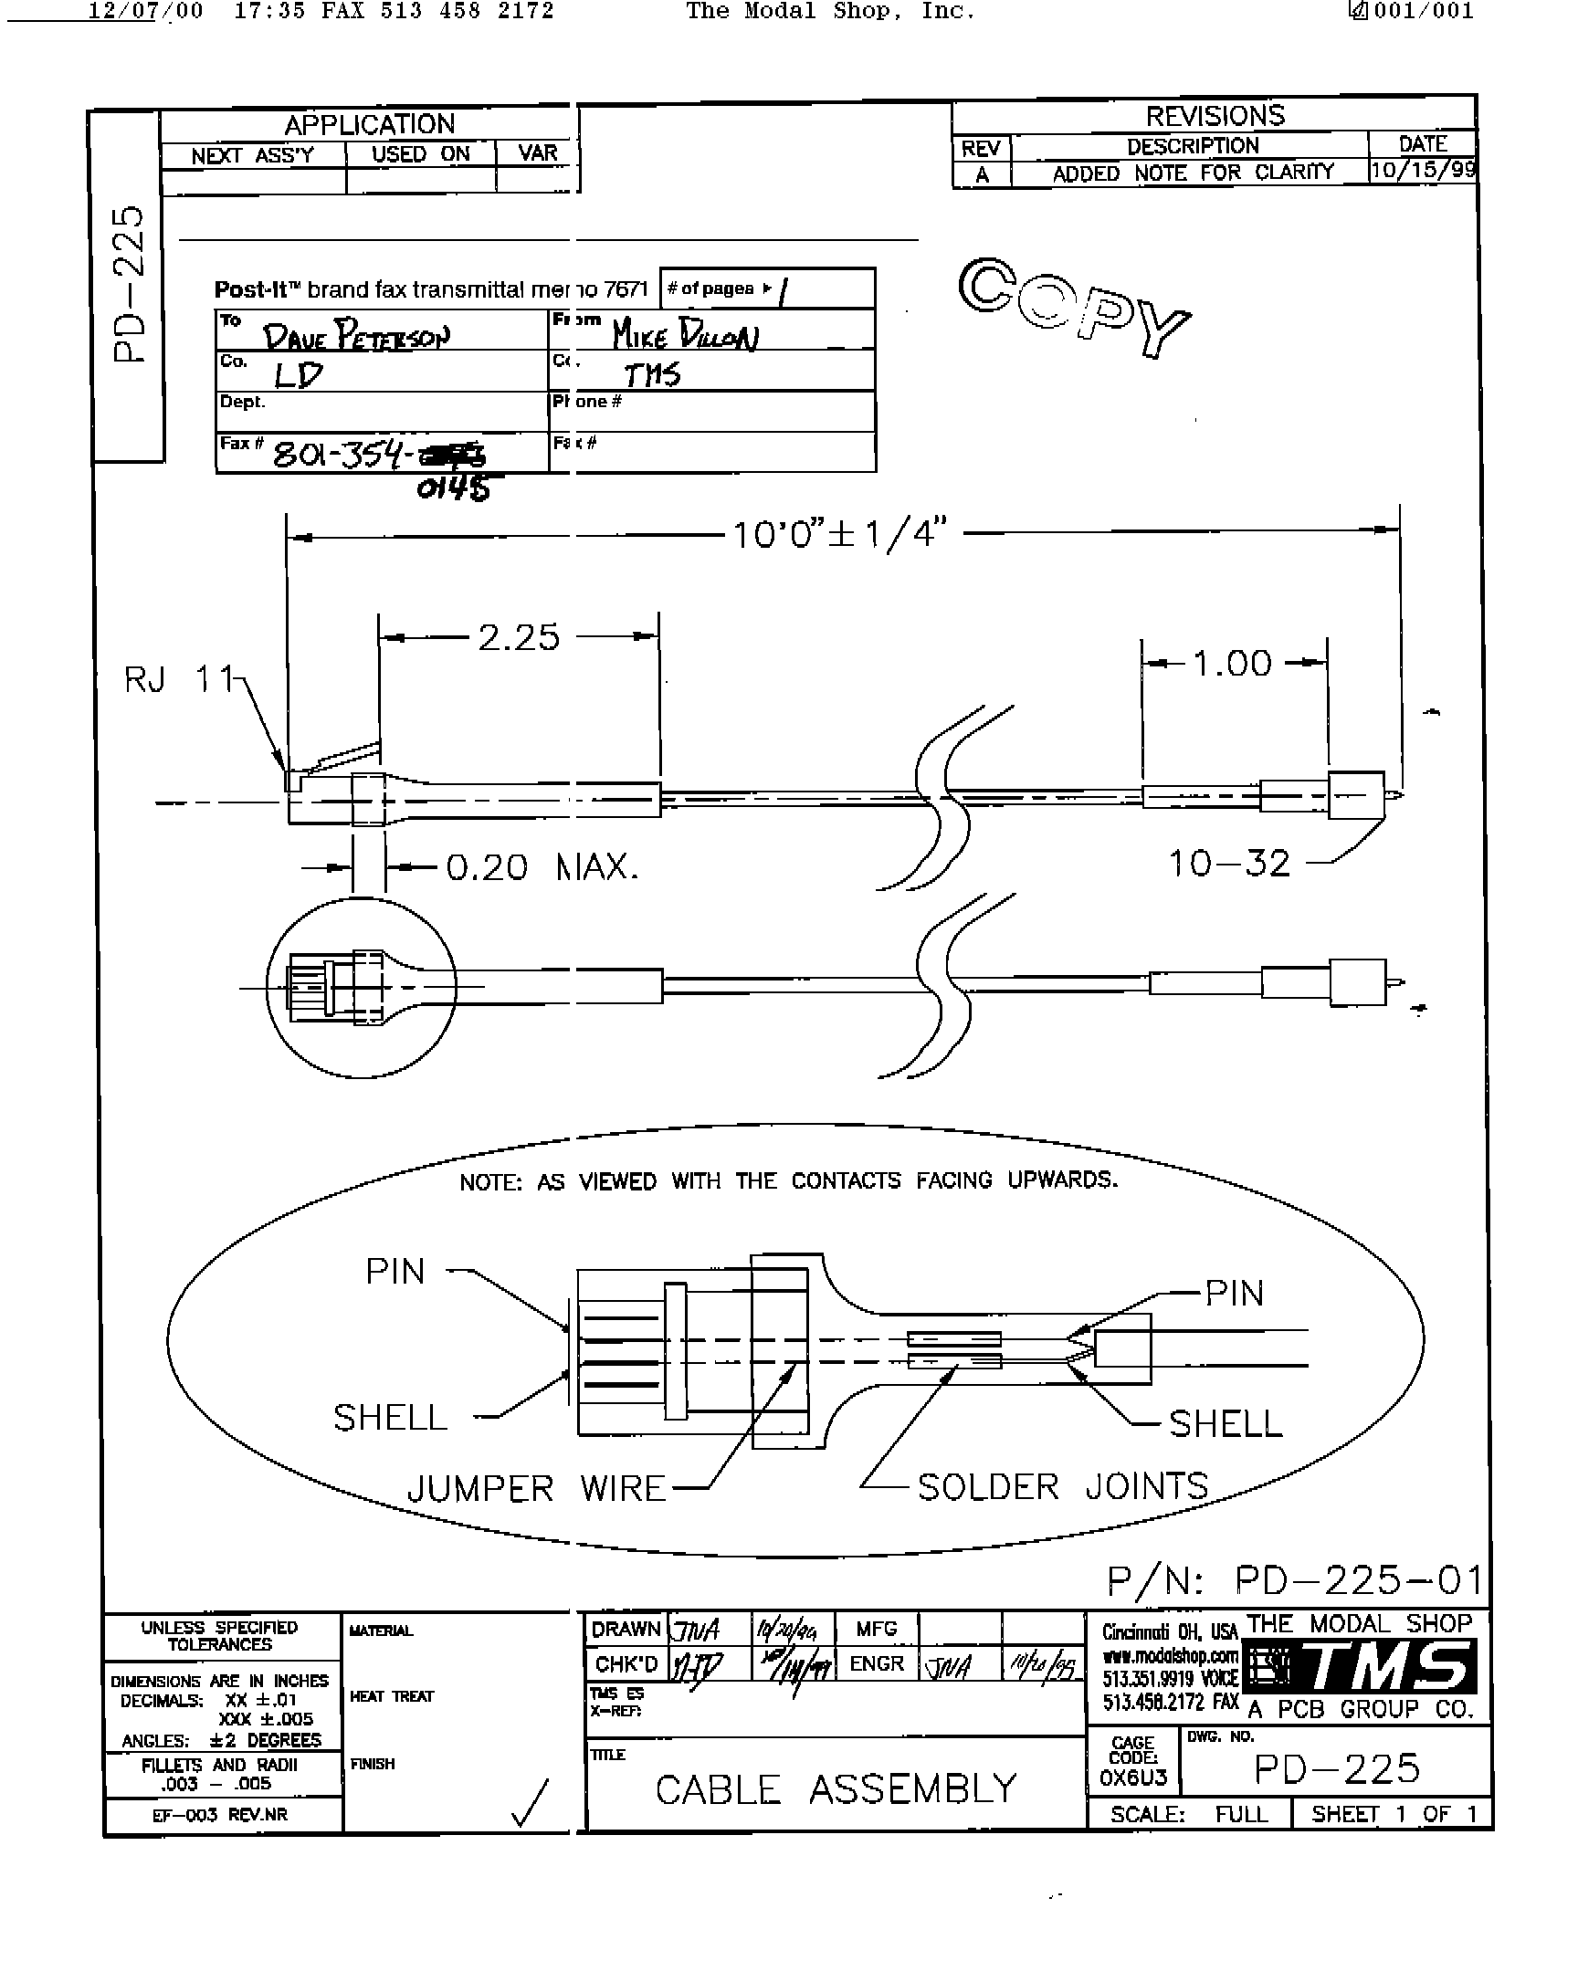

13.0 REVISION HISTORY

DCO # | REV | DATE | INITIALS | CHANGES MADE
0399A | B | 3/28/02 | RC | Updated procedure to match TEDS_RW 1.03 and PRM426.
1225 | C | 6/19/09 | JGG | Minor changes to more closely match the current process.
1399 | D | 8 Aug 2012 | JGG | Added references to D0001.8341 and a few minor notes.
ECO 4461 | E | 5 May 2016 | JGG | Changed to version 2.0 of TEDS_RW and added the USB adaptor.

