PRA951 FAMILY FINAL TEST

- PURPOSE AND SCOPE

The purpose of this document is to provide the detail and instruction necessary to ensure to test and verify the function of the members of the PRA951 Family.

- AFFECTED DEPARTMENTS

Manufacturing

3.0 REFERENCE DOCUMENTS

PRA951 schematics for the version & revision being tested

4.0 RESPONSIBILITIES & AUTHORITY

The technician has the following responsibilities and authority:
- Verify compliance of the product under test to specification.
- Troubleshoot and correct product as required.
- Communicate concerns to Supervisor or Quality Assurance.
- Request management review of product concerns.
- Use proper ESD protective equipment.

5.0 DEFINITIONS

ESD - Electro-Static Discharge

6.0 SAFETY PRECAUTIONS

- Safety Glasses are required when soldering, lead clipping, or testing power supplies.
- Follow general electrical precautions for working with energized, low voltage circuits

7.0 EQUIPMENT & MATERIALS

Frequency test fixture
Current test fixture
Trim resistor fixture
Function generator
HP 34401A digital multimeter

PCB model 002C10 cable

ADP040 adapter

CBL066 Male BNC to Male BNC (or equivalent)

CBL071 5 pin switchcraft to 7 pin Lemo
EXAxxx 7 pin Lemo extension cable

(PRA951-2 and –4 units)
- Power supply capable of 18 – 28 Vdc (Model 824, etc.)

(PRA951-L2 and –L4 units)
- Power supply capable of 27- 37 Vdc (Model 2900/3000+, etc.)

8.0 INSPECTION

- Examine assembly for misloaded parts, shorts, etc.
- Check PRA951-2 and PRA951–4 units and verify that a jumper wire has been loaded in place of the CR1 and CR2 components.

9.0 INSTRUCTIONS

There are three fixtures used in the instructions, each is described and illustrated on the following pages.

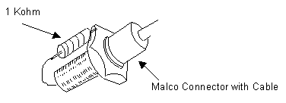Current Test Fixture with PCB model 002C10 cable:

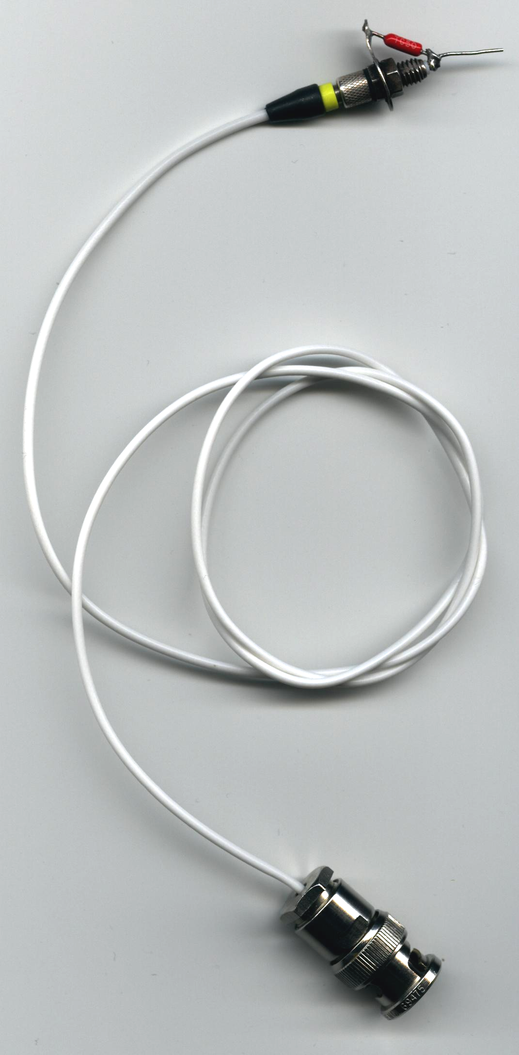

Frequency Test Fixture with PCB model 002C10 cable:
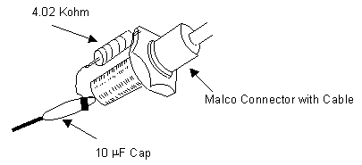
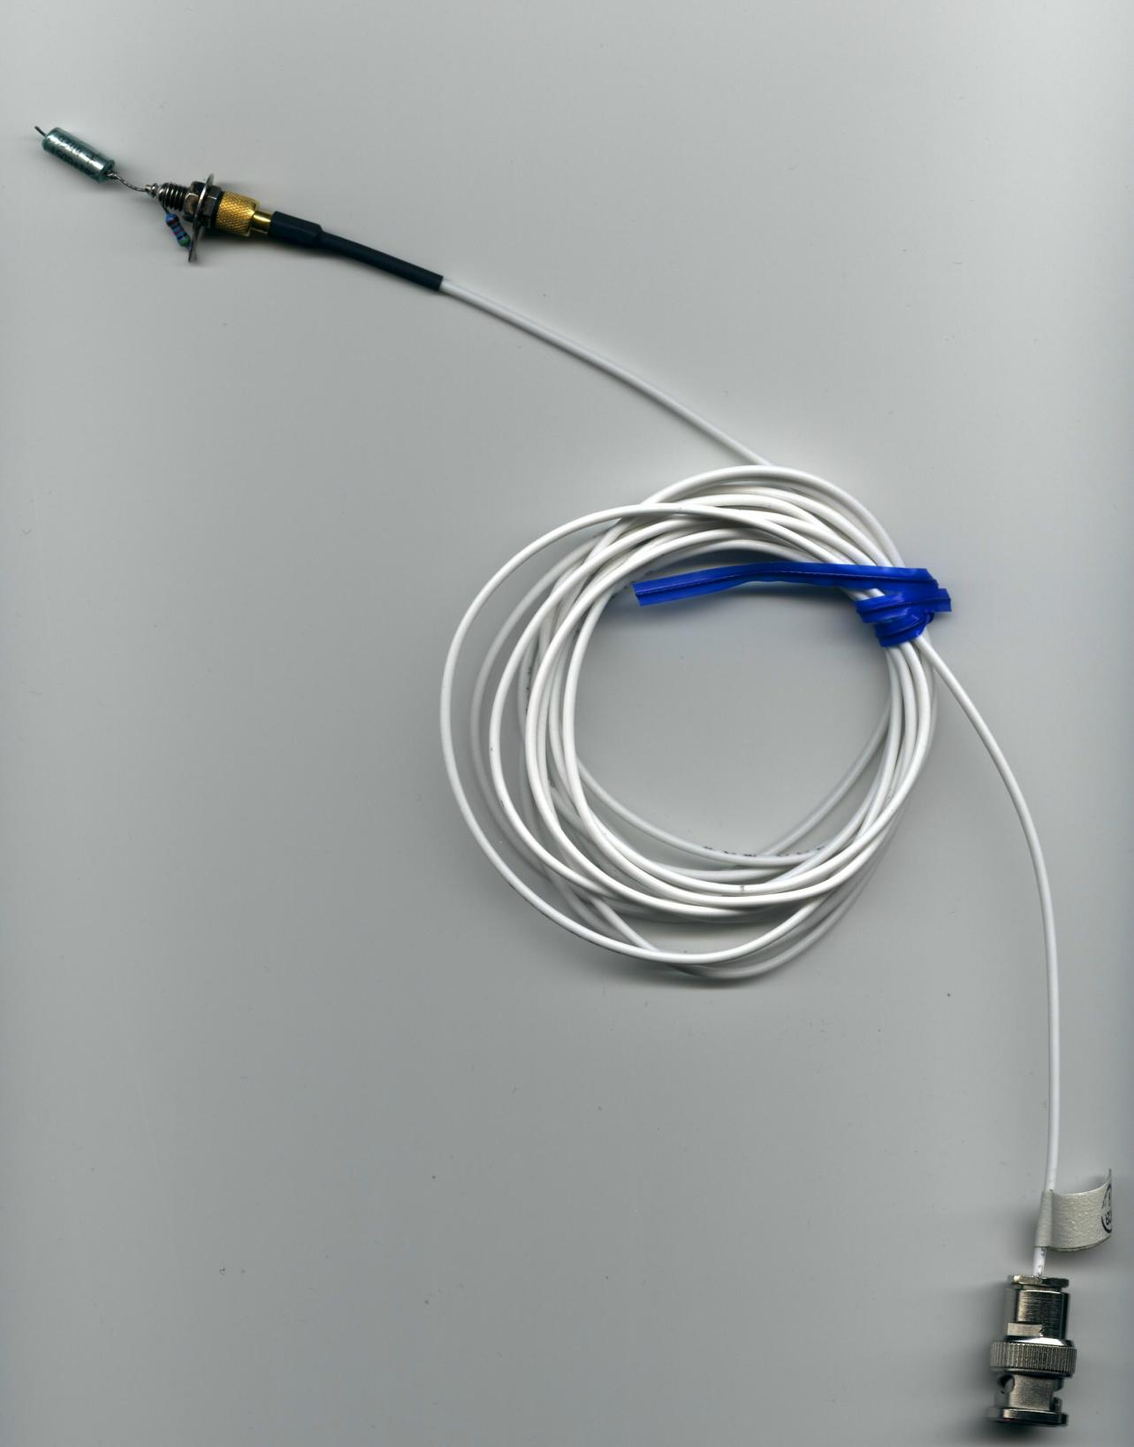

Trim Resistor Fixture

20 Kohm Pot

9.1 TEST EQUIPMENT SETUP

- .824 for PRA951-2 and PRA951-4
- Plug the top of the ADP040 into the 824 and plug the other end of an EXAxxx to the side of the ADP040 adapter.
Connect a CBL066 BNC cable between the BNC output of the ADP040 and the input of the HP 34401A multimeter.

- 3000+ for PRA951-L2 and –L4
- Plug the switchcraft end of the CBL071 cable into the 5 pin male connector of the 2900. The Lemo end will be connected to the top of the ADP040
- Plug the Male end of the EXAxxx into the female end of the ADP040 with the female end into the PRA951 preamp.
Connect a CBL066 BNC cable between the BNC output of the ADP040 and the input of the HP 34401A multimeter.

NOTE: If these tests are being performed on an instrument that has been returned for re-certification or repair, skip to section 9.3.

9.2 RESISTOR TRIM

- Remove the Pre-amp body from the PRA951 to be trimmed and assemble it back together without the body, using a jumper cable in place of the body.
- Now connect the PRA951 being tested to either the 824 or the 2900/3000+.
- Connect the Malco test cable to the unit under test and connect the Current test fixture to the other end of the malco cable.
- Connect the Trim resistor fixture onto the unit under test at R1.
- Turn on either the 824 or 2900/3000+ and read the DC voltage on the HP 34401A multimeter. Adjust the trim pot on the resistor fixture until you have one of the following readings in table 1:

PRA951-2 = 2.000 +/- .05 Vdc
PRA951-4 = 4.000 +/- .10 Vdc

PRA951-L2 = 2.000 +/- .05 Vdc
PRA951-L4 = 4.000 +/- .10 Vdc

Table 1

9.2 RESISTOR TRIM (cont)

- Turn off the 824 or unplug the cables from the 2900/3000+ and remove the trim resistor fixture. Measure the resistance across the trim pot on the resistor fixture.
- Select an equivalent resistor size and solder it into R1.

- Re-assemble the unit under test using the Pre-amp body.

9.3 DC OUTPUT AND SIGNAL VOLTAGE TEST

- Plug in the PRA951 to the 824 or 2900/3000+ if it’s not already connected.
- Connect the Malco test cable to the unit under test and connect the Current test fixture to the other end of the malco cable.
- Turn on either the 824 or 2900/3000+ and read the DC voltage on the HP 34401A multimeter.
- Check that the dc output voltage falls within the limits listed in table 1 above. If within tolerance then record the value on the "PRA951 Family Final Checklist" (D0001.8163-1). If not then the unit will need to be retrimmed as in section 9.2.
- Remove the Current test fixture and replace it with the Frequency test fixture. Apply a 1 Volt_{(rms)} at 1 KHz signal from the function generator into the capacitor on the Frequency fixture.
- Turn on the 824 or 2900/3000+. View the AC signal out on the multimeter. The level should be 0.95 - 1.00 Vac. Record the voltage on the checklist.

9.4 Finish

- Testing is completed. Turn off the power to the unit and remove the unit under test.
- If unit passes mark the "Pass" box on the checklist. If unit fails mark the "Fail" box.
- Verify that the model, serial number and date have been entered onto the checklist.
- For passing units, generate a certificate of compliance
- Technician signs the checklist and the certificate
- Certificate goes to customer; the technician files checklist.

- RECORDS

- Complete and turn in the technician inspection and rework report.
- Complete checklist and file appropriately. The technician group will maintain checklist for the life of the instrument warranty or re-certification interval.

11.0 DISTRIBUTION

Manufacturing

12.0 ATTACHMENTS

None

13.0 REVISION HISTORY

DCO # | REV | DATE | INITIALS | CHANGES MADE
 | A | 11/14/01 | RH | Initial Release
DCO  397 | B | 3/18/02 | KD | Improved test procedures needed documentation. Removed Oscilloscopes and replaced with HP34401 to provide test traceability.
DCO 1142 | C | 9/26/08 | EO | Improve test procedure to accommodate 824/3000+

