S200 Assembly Test

1.0 INTRODUCTION

This work instruction is for the testing of the S200 assembly.

2.0 DESCRIPTION

The S200 test is a verification of the assembly for the CAL150 and the CAL200 products.

3.0 LIMITATIONS

The instruction applies only to the S200 assembly.

4.0 MATERIALS, TOOLS, & EQUIPMENT

Current CAL200 assembly drawing
Current A200.1 bill of materials
Current A200.1 schematic
Current A200.1 loading diagram
Calibrator Test System
½” Reference microphone
Adjustable DC power supply
Calibrator power cable (1.0 Ω resistor in line on positive side)
Technician tool kit

5.0 PROCEDURE

Note: Multiple units may be tested at each step. Multiple steps may also be performed for each unit. Wherever “mbar” is specified, test software now reads in k Pascals. Conversion from mbar to k Pascals is done by shifting decimal point one place to the left.

5.1 Calibrators are assembled by production and delivered to the technician

5.1.1 Insert the 915 preamp with the current ½ “ reference microphone from the “Calibrator Test System” into the base of the MTS1000. If multiple units are being certified, this step is only performed for the first unit.
5.1.2 Visually inspect the calibrator’s outward appearance for proper assembly and defects.
5.1.3 Remove the battery door from the calibrator.
5.1.4 Disassemble, quick visual & check screws on back cavity have been tightened, adjust temperature compensation pot to approximately the 11:30 position. Reassemble, securing case with rubber band.
5.1.5 Adjust DC power supply to 10V, use the “Calibrator Power Cable” to supply power to the unit being tested.

5.2 Checking Tone & Power Shut-off Voltage

5.2.1 Turn the unit on. It should emit a clear, audible tone on both the 114 dB and 94 dB settings. Refer to the diagram below:

114-dB 94-dB On button

5.2.2 Lower the voltage on the power supply to approximately 6.6 Vdc. The unit should turn off.
5.2.3 Turn the voltage back up to 10 Vdc. The unit should remain off.
5.2.4 Place a jumper over P1 so the unit will run continuously. The position for the jumper is shown in step 5.3.8 or technician may refer to the loading diagram A200.1.

5.3 Setting 114dB, 94dB, and Frequency Level.

Note: Steps 5.3.1 through 5.3.6 are performed for the first unit only if testing multiple units.

5.3.1 Double click on the icon labeled “Static Pressure Test” on the computer desktop of the “Calibrator Test System.”
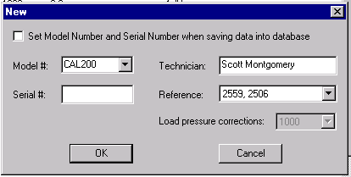5.3.2 In the main menu under “Files” click on “New” or click the “New” file icon in the toolbar. The screen below will appear:

5.3.3 Enter something such as “test” in the Serial # box and click on “OK.”
5.3.4 Click on the ← → (Previous or Next) icons in the toolbar until the 114-dB certification screen appears:

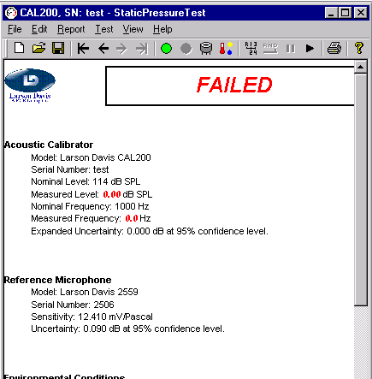 114-dB certification screen

Previous Next Set Voltage

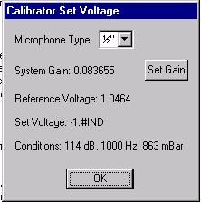5.3.5 Click on the “Set Voltage” icon in the toolbar as in the previous diagram. The window below will appear:

5.3.6 Make sure the “Microphone Type” is set to ½”. Use the listed “Reference Voltage” to set the level of the calibrators hereafter. The displayed level is for 114 dB. The decimal place is shifted 1 place to the left for the 94 dB level.
5.3.7 Place the calibrator over the ½ inch reference microphone and 915 preamp.
5.3.8 Turn the unit on, adjust the frequency to 1000 Hz ± 0.4 Hz. Set the 114-dB level to the reference voltage(use the HP multimeter). Fine adjustment is not necessary at this time, just close. The 94-dB level is set last. Refer to the diagram below for potentiometer locations:
Frequency
114 dB level
Temperature Compensation
94 dB Level
Jumper inserted here to run continuously

5.4 Check Current Draw & Place Calibrators in ESPEC Temperature / Humidity Cabinet. (5.4.1 through 5.4.4 done first time through only if checking multiple units)

5.4.1 Set the oscilloscope to read DC volts on the multimeter inputs.
5.4.2 There is a 1.0-ohm resistor in line on the positive side of the calibrator power cable plugged into the adjustable DC power supply. The power supply should be set at 10 Vdc.
5.4.3 Leads are clipped across this resistor to measure the current draw of the units being tested.
5.4.4 The leads are connected to a cable that plugs into the multimeter inputs of the oscilloscope using a Double Banana to BNC adapter.
5.4.5 With the calibrator switched to the 114 dB level: current draw is 0.0030 to
0.0050 Vdc. 94 dB level: 0.0020 to 0.0040 Vdc.
5.4.6 Remove calibrator from microphone and disconnect power from the calibrator.
5.4.7 Place the calibrators in the ESPEC cabinet with power connected so that the unit(s) function continually. Cycle continuously on the default cycle(50°C to -10°C) for 48 hours. (Refer to D0001.8189 Chamber Test For Calibrators). Retrieve when time has elapsed.

5.5 Pressure Test (This test may be done automatically, manually, or a combination of both. PRM915 or PRM902 may be used. Steps 5.5.1 through 5.5.3 are performed for the first unit only if testing multiple units.) Switchbox set to 2900

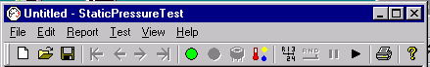5.5.1 Double click on the “Static Pressure Test” icon on the computer desktop. Click on the “Open” icon in the toolbar. Look in the database under CAL200 and CAL150 to find the next available serial number. You should be looking at the screen shown below: (Use scratch paper to keep track of the serial numbers to assign hereafter as calibrators are tested.)

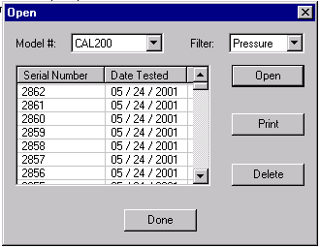 Open

5.5.2 Insert the 915 or 902 preamp with the current ½ inch reference microphone from the “Calibrator Test System”, into the base of the MTS1000.
5.5.3 Obtain a “Reference Voltage” to set the 114 dB level again before testing. Refer to step 5.3.5, 5.3.6.
5.5.4 Connect a 9 V battery to the calibrator and insert in the battery compartment. The jumper should still be in place so the unit runs continuously.
5.5.5 Place the calibrator over the Reference microphone and adjust the frequency and the 114-dB level if necessary.
5.5.6 Place the metal bell jar over the calibrator and latch securely in place.
5.5.7 Under “Files” in the main menu click on the “New” option or click the “New” file icon.
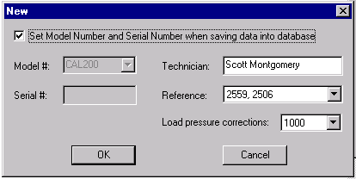The screen below will appear:

5.5.8 Be sure the options are set as listed with the correct reference microphone and your name. Click on “OK.”
5.5.9 Be sure the options are set as in the toolbar below and click on the “Start” button to begin the test:
Start Stop Manual Auto Pause Continue

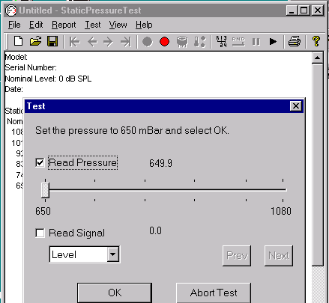
5.5.10 The screen below will appear when 650mbar is reached. Click on “Read Signal” to look at the level of the calibrator. By observing this level it can be determined if and how much adjustment of the size of the vent hole in the back cavity is necessary. It may be necessary to run a few calibrators completely through the test to get an idea of what is acceptable & what isn’t. When determinination is made click on “Abort Test” or “OK” and “Continue” if you wish to complete the test. The test will run automatically until completed. If “Abort” was selected, skip to step 5.5.12.
Continue

5.5.11 When the “Test Completed” window pops up click “OK” and pressure will be released in the bell jar.

5.5.12 CAL200 limits are ± 0.25 dB 650 to 1080 mbar.
CAL150 limits are ± 0.35 dB 650 to 1080 mbar.

If necessary, vent hole size may be increased by drilling (typically .020” to .021” bit. Depth needed to drill may vary as well as size of bit. Increasing the vent hole size causes the correction to shift positive at 650 mbar..

Vent hole size may be reduced by inserting magnet wire (usually 34 gauge) into vent hole and securing with a strip of mylar tape. Length of wire needed will vary. Decreasing the vent hole size causes the correction to shift negative at 650 mbar.

Rerun the pressure test if vent hole size is adjusted.

Occasionally you may be required to change the speaker and start over again at step 5.2 of this procedure with that calibrator.

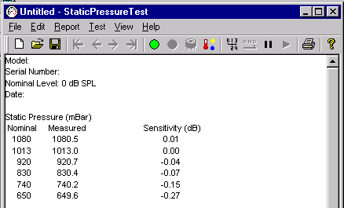
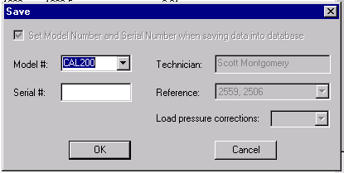
5.5.13 After a successful pressure test is completed, click on the “save” icon. The screen below will appear:

5.5.14 Enter the correct Model # and next Serial # in sequence for the unit that has just been tested.
5.5.15 Click “OK” to complete the save.
5.5.16 Remove the bell, remove the calibrator, and use a paint marker to write the serial number on the back of the calibrator.
5.5.17 Test calibrators over temperature. Refer to D0001.8189 Chamber Test For Calibrators.

5.5.18 Close out the completed work order.

6.0 EVALUATION

This instruction is a test and evaluation procedure. No further evaluation is required.

7.0 RECORDS

Model and serial number records are maintained electronically in the company database for the life of the instrument.

8.0 REVISION HISTORY

DCO # | REV | DATE | INITIALS | CHANGES MADE
733 | A | 6/12/01 | SM | Initial Release
1093 | B | 6/10/08 | SM | Updates
1146 | C | 10/15/08 | SM | Minor Edits and Changes
1231 | D | 7/1/2009 | SM | Added temperature testing & resistor references
1393 | E | 8/6/12 | SM | Minor edits, more detail in pressure test section

