CAL250 Final Certification – New Product

1.0 SCOPE & APPLICABILITY

This instruction covers the final certification process for new CAL250 product.

2.0 RESPONSIBILITY

The individual that is authorized to test and certify the CAL250 has the responsibility to follow the applicable instructions and references to produce a quality product.

3.0 MATERIALS, TOOLS, & EQUIPMENT

Current CAL250 assembly drawing
Current A250.1 bill of materials
Current A250.1 schematic
Current A250.1 loading diagram
Calibrator Test System
METCAL Run Time software
½ inch reference microphone
Technician tool kit
D0001.8282 CAL250 Final Checklist
ADP019 ½” adapter

4.0 PROCEDURE (This procedure lists the detail needed to complete the certification. All steps must be completed but in some instances may be done in a different order than listed according to the technician’s preference. Some steps may also be completed at one time when doing multiple units.)
Wherever “mbar” is specified, test software now reads in k Pascals. Conversion from mbar to k Pascals is done by shifting decimal point one place to the left.

  - Prep for Certification

    - Enter the information for each calibrator in the Larson Davis database.

    - Each unit being certified must be added in the MET/CAL database as an asset. Open the MET/CAL program.

    - Select “Configure”, then “Add Asset”.

    - After the “Add Asset” window opens, type in the serial number of the asset being added.

    - Select “Description” by clicking on the tab to the right of the empty field with [. . .]

    - After the “Find Type” window opens enter “CAL250” in the search field for “Model”.

    - Click on the “Find” tab in the menu bar at the top of the screen.

    - Double click on the model description that will appear in the bottom half of the screen.

    - A popup will appear which states: “Update all Asset data with current Type data?”, select “YES”.

    - The “Add Asset” window will now reappear and allow you to continue.

    - Enter the manufacture date in the “Manufacture Date” field.

    - Go to the “Customer” field, click on the tab to the right of the empty field with [. . .]

    - The “Find Facility” window will pop up, enter “Lar” for the “Search Value” for the “Facility Name”.

    - Click on the “Find” tab in the menu bar at the top of the screen.

    - Double click on “Larson Davis, a division of PCB Piezotronics Inc” that will appear as an option in the bottom half of the screen.

    - The “Add Asset” window will reappear. Click on the “Save” tab in the menu bar to save the new record.

    - If creating multiple records, click on the “Copy” tab. This creates a copy of all the information of the asset that was just created EXCLUDING the serial number.

    - Enter the serial number of the next asset you wish to create in the blank “Serial Number” field.

    - Click on the “Update” tab in the lower left corner of the screen, then click “Yes” in the pop up that appears.

    - Click on the “Save” tab in the menu bar to save the new record.

    - Repeat steps 4.1.17 through 4.1.20 until all assets are created.

4.1.22 Remove the jumper through the access hole on the front of the calibrator.

    - Connect a new 9V battery to the battery clip, tuck the battery into the battery compartment.

4.1.24 Place the calibrator over the ½ inch reference microphone and a 915 preamp, connect the jumper wire from the base of the MTS1000 to the connection on the front of the calibrator.

4.1.25 Under “Files” click on the “New” option or click the “New File” icon. The screen below will appear:

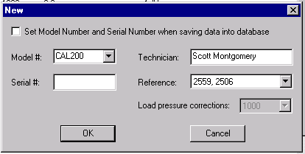

4.1.26 Enter the Model # and Serial # of the unit being certified. (“Load pressure corrections” window should say 251.2 Be sure the correct reference is selected and your name is entered. Click “OK.”
4.1.27 Click on the ← → (Previous or Next) icons in the toolbar until the 114-dB certification screen appears, then click on the “Set Voltage” icon. See diagram below:
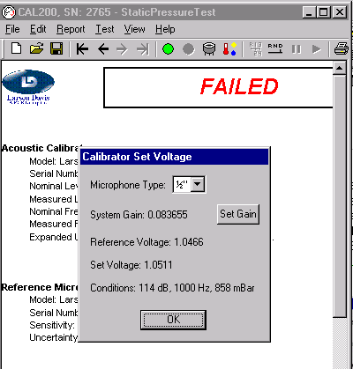
Set Voltage

4.1.28 The “Set Voltage” shown above is the level specific to the serial number of the calibrator that was entered previously. Make sure the Microphone Type is ½”.

4.2 Certification

4.2.1 Click on the CAL250 Final Checklist shortcut on the computer desktop.
Note: May also retrieve forms from controlled document area on line.

4.2.2 Arrange the “Static Pressure Test” screen and “ Final Checklist” on the desktop as shown below: All items on checklist to be completed. Checklist shown below lists CAL200 as example. CAL250 Checklist will show on desktop.

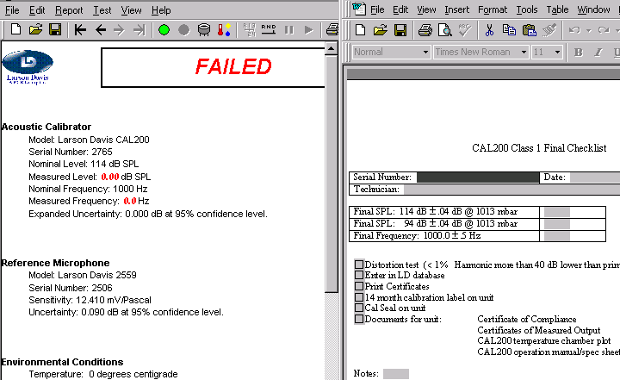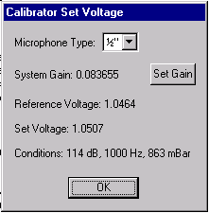

4.2.3 Turn the unit on. Make any needed adjustments in this order: Frequency, then 114-dB level. Use the HP 34401A to monitor levels. See diagram below for potentiometer locations: Note: switchbox on Calibrator Test System should be set to 2900.

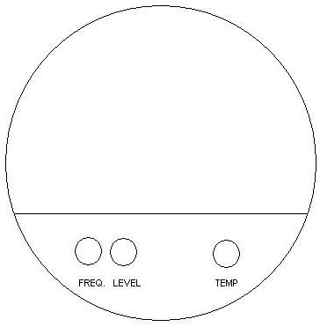

4.2.4 After adjustment, place a LDL calibration sticker with the date certified and initials of tech who performed the certification over the access holes to the frequency and 114 dB pots.

4.2.5 Screw the battery door onto the end of the unit.

4.2.6 Place the pressure vessel over the calibrator and latch securely to the base of the MTS1000.
4.2.7 Use the ← → keys in the toolbar to toggle between the 114-dB certification and pressure test screen. Run the 114-dB certification. This can be done automatically or manually depending on the selection in the toolbar. The diagram below shows the automatic option, deactivate the pause button.
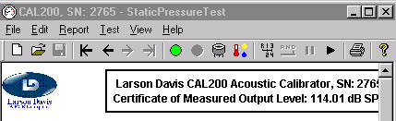
Previous Next Start Stop Manual Auto Pause Continue

4.2.8 Click on the “OK” button in the “Calibrator Set Voltage” window to close if you haven’t already done so. Click on the “Start” button shown above to begin the test. Toggle the rocker switch on the front of the MTS1000 to the on position to start the calibrator.

4.2.9 As the test runs a window will appear with a bar that progresses from left to right. When the level is stable & before the bar reaches the far right toggle the switch on the front of the MTS1000 to the off position.

4.2.10 “Test Completed” window appears at end of test. Click “OK” to depressurize the vessel, then unlatch and remove vessel. Make sure pressure has been released before unlatching vessel!

4.2.11 Final limits:
114.00 dB ± 0.03 dB @ 1013 mbar
251.2 Hz ± 0.1 Hz @ 1013 mbar

4.2.12 Click on the “Save” icon in the toolbar to save the test results. Record the final levels on the Final Checklist.
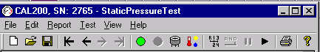
Save
Print

4.3 Completion

4.3.1 Complete the final checklist. In the main menu select “File” then “Save As” option. Save file by serial number_day, month, year. Example: Serial number 2000 would be saved as 2000_02Mar2002.doc. Files are stored in
R:\Provo\Data\CertData\Calibrators\CAL250\Production CAL250.

4.4 Label placement

4.4.1 Place a Warranty Calibration Seal #3255.0014 over the access hole to P1 on the front of the calibrator towards the bottom. The seal should cover both the screw and the hole.

4.4.2 Place a small cal label with date certified on the opposite side as the Warranty Calibration Seal in approximately the same position.

4.5 Transfer data to METCAL system

4.5.1 From the “Open” dialog with the filter set to “Certificates”, select the correct tested date for the model and serial number of the calibrator and then click on the “Export” button.

4.5.2 A window will open for the SERIAL NUMBER of the calibrator to be entered, Enter the number & hit “Save”. Data writes to C:\EXPORTDATA.

4.5.3 Close the “Open” dialog box; from the MET/CAL Run Time window click “Calibrate” then “Run Procedures Executable…”

4.5.4 Run the procedure D0001.8386 (B) Acoustic Calibrator Import.

4.5.5 When the “MET/CAL Procedure – Import Calibrator” window opens click on “OK”.

4.5.6 “Select Asset” window will open. Enter the correct MODEL and SERIAL NUMBER then click the “Find” tab at the top of the screen.

4.5.7 Double click on the asset that appears in the bottom half of the screen.

4.5.8 When the “Open” window appears(C:\EXPORTDATA) double click on the SERIAL NUMBER to be exported to MET/CAL.

4.5.9 When the “Work Order” window appears, set “Initial Condition:” to “As Manufactured” then click “Save”.

4.5.10 The “Edit Work Order” will appear, verify that the model and serial number are correct.

4.5.11 Set the following fields: Status: Complete
QC Approved By: Technicians name
Cert Format: Cal_cert.rpt
ISOCert: checked

4.5.12 Click on the “Save” tab in the menu at the top of screen.

4.5.13 Repeat from step 4.1.22 if certifying multiple calibrators.

4.5.14 When all calibrators have been completed, close out the completed work
order and deliver product to stores along with the temperature plots.

5.0 EVALUATION

The test and assembly process detailed includes evaluation.

6.0 RECORDS

Test data generated from this process is stored in the test software’s database.

7.0 REVISION HISTORY

DCO # | REV | DATE | INITIALS | CHANGES MADE
869 | A | 6/13/05 | SM | Initial Release
1096 | B | 6/10/08 | SM | Updates
1148 | C | 10/16/08 | SM | Minor updates and changes
1302 | D | 8/6/10 | SM | Changed references to M:\CertData to R:\Provo\Data\CertData.
1342 | E | 6/23/11 | SM | 4.5.2 deleted manual , 4.5.3 Deleted line requiring signed technician’s inspection.
1396 | F | 8/6/12 | SM | Minor clarifications on order of steps, detail
1489 | G | 11/13/15 | SM/JWH | METCAL System

