PRM900C TEST

1.0 PURPOSE AND SCOPE

This instruction contains the necessary detail to ensure that the PRM900C is tested and verified to Larson Davis specifications.

- AFFECTED DEPARTMENTS

Manufacturing

3.0 REFERENCE DOCUMENTS

Current loading diagram, schematic and B.O.M. for A900.1 assembly

4.0 RESPONSIBILITIES & AUTHORITY

The technician has the following responsibilities and authority
- Verify compliance of the product under test to specification.
- Troubleshoot and correct product as required.
- Communicate concerns to Supervisor or Quality Assurance.
- Request management review of product concerns.
- Use proper ESD protective equipment.

5.0 DEFINITIONS

LD - Larson Davis
ESD - Electro-static Discharge

6.0 SAFETY PRECAUTIONS

- Safety glasses are required when soldering, lead clipping, or testing power supplies.
- Follow general electrical precautions for working with energized, low voltage circuits.

- EQUIPMENT & MATERIALS

ADP015.
CAL250.
2900 Test System.
DC power supply.
2540 microphone.
ADP005.
2200C.
EXC003 Extension Cable.

- INSTRUCTIONS

If the instrument has been returned from a customer for re-certification then go to section 8.2. If the instrument requires repair, follow the procedure as applicable.

8.1 Check Current and Frequency Response

- Check to see that pin 2 & pin 6 are connected together on U1.

- Check for any solder shorts and/or misloaded parts.

- Connect the 900C preamp (without a guard tube) to channel 1 on the 2200C.

- Set the gain knob on the 2200C to 0 gain and the bias at 0 volts.

- Measure the voltage across R4 on the 900C with a voltmeter (between 18 and 24 mV).

- Set the function generator to produce a 1-Volt_{RMS}, 1 KHz sine wave. Adjust the sine wave on the scope using the cal knob to fill 7 divisions peak to peak.

- From the generator, hook the black clip to the connector body and the red clip to the pogo on the preamp (Figure 1).

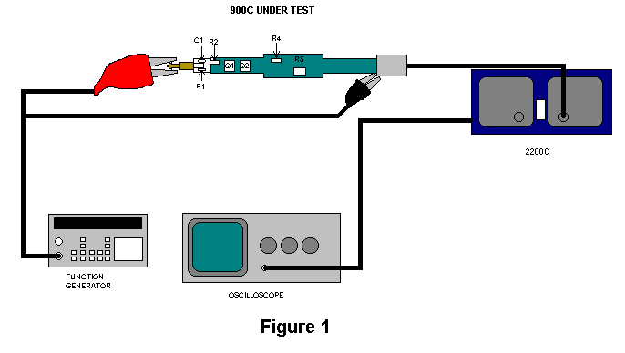

- Starting at 1 KHz sweep the preamp down to 9Hz and watch for the signal to stay above the –3dB point. Now sweep the preamp up to 600 kHz watching for the signal to stay above the –3dB point. (–3dB point is measured when the signal only fills 5 divisions peak to peak on the scope) The sine wave should remain undistorted and the overload light on the 2200C should remain off through out the sweep.

- Turn the 2200C off, disconnect the 900C preamp and return it to production to be washed and the assembly completed.

8.2 Initial Verification

- Upon return from Production or from a customer, apply power to the 900C preamp through a 2200C, set to 200 V bias, and verify that it does not overload the 2200C.

- Attach a 2540 microphone to the 900C preamp, use a CAL250 to put a signal on the 2540 microphone and check the signal from the output of the 2200C with an oscilloscope. The signal should be a clean sine wave that reads about 0.13 Vac. (this will vary slightly depending on the individual microphone used.).

8.3 PRM900C Automated Test

- On the Data Transfer Switch Box, Select the option 3200/2900. This enables the communication between the Computer (COM1) and the HP 34401A.

- Attach an EXC003 extension cable from channel 1 of the 2900 to the top of an ADP015 adapter (Figure 2).

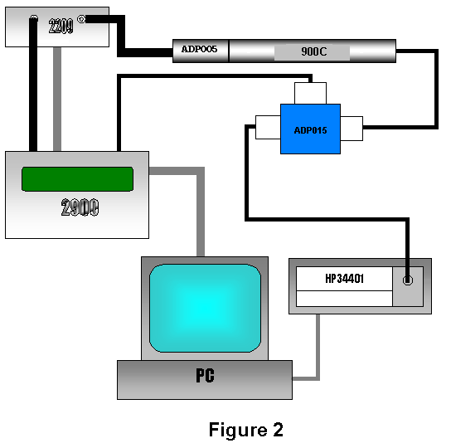

- Connect a BNC-to-BNC cable (CBL066) from the BNC connector on the ADP015 to the input of the Hewlett-Packard 34401A Multimeter. Plug the RS-232 cable into the back of the multimeter

- Connect a BNC-to-BNC cable (CBL066) from the "Out" jack of the 2209 to an ADP005 (18pf) adapter. Plug a second EXC003 extension cable into the ADP015.

- Screw the preamp into the ADP005 and insert the preamps switch craft connector into the EXC003 extension cable.

- Double click the “Lab.exe” icon on the computer.

- Click on the arrow in the instrument window and select the proper preamp. Select the technician’s name performing the test from the Tech window.

- Select the instrument; either a 900C or a 900C (20 Gohm SMD).

- A window will be displayed asking for the preamp’s serial number, enter the number engraved on the tube and click OK.

- Select "All Tests" on the Lab program and the click Start.

- When the test is complete, select "Results" and then "Print". After the information is sent to the printer select "Close".

- Enter the preamp serial number, board number, revision number, test station and test date in the Larson Davis Database.

9.0 INSPECTION

This instruction is an inspection of the function of the instrument. No additional inspection is required.

10.0 RECORDS

The results of the automated test are maintained electronically for a minimum of two years or the life of the warranty. If the test was a re-certification of an instrument for a customer, the test results are maintained for a minimum of one year.

11.0 DISTRIBUTION

Manufacturing
Engineering

12.0 ATTACHMENTS

None

13.0 REVISION HISTORY

DCO # | REV | DATE | INITIALS | CHANGES MADE
 | A | 7/10/01 | RC | Initial Release
 | B | 2/14/02 | RC | Updated for fixed resistor R5
396 | C | 3/13/02 | RC | New limits for fixed resistor R5.

