PRM900B TEST

- PURPOSE AND SCOPE

This instruction contains the necessary detail to ensure that the PRM900B is tested and verified to Larson Davis specifications.

2.0 AFFECTED DEPARTMENT

Manufacturing
Repair & Calibration

3.0 REFERENCE DOCUMENTS

Current loading diagram, schematic and B.O.M. for A900B.1 board.

4.0 RESPONSIBILITIES & AUTHORITY

The technician has the following responsibilities and authority:
- Verify compliance of the product under test to specification.
- Troubleshoot and correct product as required.
- Communicate concerns to Supervisor or Quality Assurance.
- Use proper ESD protective equipment.

- DEFINITIONS

LD - Larson Davis
ESD - Electro-static discharge

- SAFETY PRECAUTIONS

- Safety Glasses are required when soldering, lead clipping, or testing power supplies.
- Follow general electrical precautions for working with energized, low voltage circuits.

- EQUIPMENT & MATERIALS

- ADP015
- CAL250
- 2540 microphone
- ADP005
- DC power supply
- 2200C Preamplifier Power Supply
- Function Generator
- EXC003 Extension Cable
- HP 34401A Digital Multimeter
- Computer with 2900 Test System

- INSTRUCTIONS

If this test is for a new or repaired instrument, follow the entire procedure. For instruments returned to LD for re-certification start at section 8.2.

8.1 Check Current and Frequency Response

- Check for any shorts and misloaded parts.

- Verify that pin 2 and pin 6 are connected together on U1.

- Connect the PRM900B preamp (without the guard tube) to channel 1 on the 2200C.

- Set the gain knob on the 2200C to 0 gain and the bias to 0 volts.

- Attach the preamp to the 2200C with an EXC003 extension cable.

- Turn on the 2200C and watch for the overload light to turn on. Wait approximately 1 minute for the overload light to turn off. If the light does not turn off after 1 minute, troubleshoot the problem and repair it.

- Verify that the current draw on the power supply is below 200mA.

- Measure the voltage across R13. Value should 2.0 to 4.2 mV.

- Turn off the 2200C and set the function generator to produce a 1 KHz .5 Vrms sine wave. Attach the 2200C channel 1 FLT output to channel 1 on the oscilloscope.

- From the function generator, hook the red clip to the pogo on the preamp and the black clip to the connector body of the preamp.

- Turn on the 2200C, using the cal knob; adjust the sine wave on the oscilloscope to fill 7 divisions (peak to peak voltage Vpp).

- Starting at 1 KHz, sweep the preamp down to 9 Hz watching for the signal not to drop below 5 division’s peak to peak, (5 divisions peak to peak is the –3dB point). Then sweep the preamp up to 500 KHz watching for the signal not to drop below 5 division’s peak to peak. The sine wave should remain undistorted and the overload light should remain off through the sweep.

- Turn off the 2200C and return the preamp to production to be completed.

8.2 Initial Verification

- Upon return from production or from a customer, apply power to the 900B through a 2200C and verify that it does not overload the 2200C.

- Attach a 2540 microphone to the preamp and check the signal from the output of the 2200C with a scope. The signal should be a clean sine wave that reads about 0.13 Vac. (this will vary slightly depending on the individual microphone used.)

8.3 PRM900B Automated Test

- On the Data Transfer Switch Box, Select the option 3200/2900. This enables the communication between the Computer (COM1) and the HP 34401A.

- Attach an EXC003 extension cable from channel 1 of the 2900 to the top of an ADP015 adapter (Figure 2).
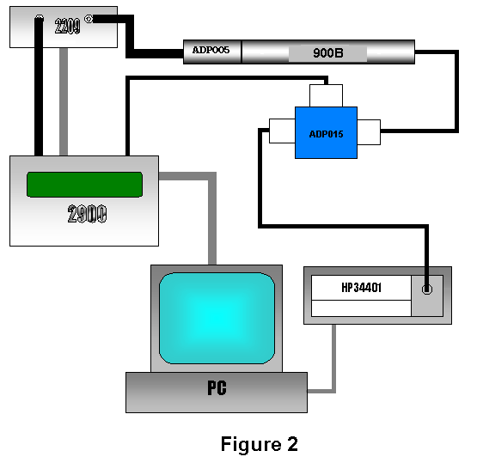

- Connect a BNC-to-BNC cable (CBL066) from the BNC connector on the ADP015 to the input of the HP 34401A Multimeter. Plug the RS-232 cable into the back of the multimeter

- Connect a BNC-to-BNC cable (CBL066) from the out jack of the 2209 to an ADP005 (18pf) adapter. Plug a second EXC003 cable into the ADP015.

- Screw the preamp into the ADP005 and insert the preamps switch craft connector into the EXC003 extension cable.

- Double click the “Lab.exe” icon on the computer.

- Click on the arrow in the instrument window and select the proper preamp. Select the technician’s name performing the test from the Tech window.

- A window will be displayed asking for the preamp’s serial number, enter the number engraved on the tube and click OK.

- Select All Tests on the Lab program and then click Start.

- When the test is complete, select Results and then Print. After the information is sent to the printer select Close.

- Enter the preamp serial number and test date in the Larson Davis Database.

9.0 INSPECTION

This instruction is an inspection of the function of the instrument. No additional inspection is required.

10.0 RECORDS

The results of the automated test are maintained electronically for a minimum of two years or the life of the warranty. If the test was a re-certification of an instrument for a customer, the test results are maintained for a minimum of one year.

11.0 DISTRIBUTION

Manufacturing
Repair & Calibration
Engineering

12.0 ATTACHMENTS

None

13.0 REVISION HISTORY

DCO # | REV | DATE | INITIALS | CHANGES MADE
325 | A | 7/13/01 | RC | Initial Release

