S426.6 PREAMP HIGH TEMP ENVIRONMENTAL TEST

PURPOSE AND SCOPE

The purpose of this document is to provide the details and instruction necessary to test the S426.6 to established specifications. Because the HT426E01 is to be used in severe environments, to ensure quality, the S426.6 1/2" high temperature ICP preamplifier assembly is to be periodically tested under extreme environmental conditions. This will entail pulling a sample of four preamplifiers out of a periodic build, and testing them over high temperatures and high humidities to ensure that the manufacturing processes are still good for this preamp. This instruction is applicable to both new product as well as returned S426.6 preamp assemblies if necessary.

This test obtains reference levels at T=23°C at 50% RH, and then performs a temperature test, sweeping the temperatures from -40 to 130°C at 50% relative humidity (RH). And then a humidity test, sweeping the humidity from 50% to 95% RH at 40°C, to ensure that the preamp characteristics do not deviate more than specified. This procedure tests the preamplifiers' DC bias output and frequency responses at these various temperatures and humidities. The entire test takes about 28 hours to complete.

warnings and LIMITATIONS

This work instruction is limited to the testing of only the S426.6 1/2" high temp preamplifier. It exposes the assembly to temperatures above 130°C. These temperatures could possibly destroy other preamplifiers (and anything else not rated for these temperatures inside the chamber, i.e. cables).

This test assumes that the S426.6 preamps being tested have already passed the production testing described in D0001.8204 and that certification has already been performed on them (i.e. LAB.EXE program test).

AFFECTED DEPARTMENTS

Production

REFERENCE DOCUMENTS

- S426.61 Four Channel Test Cable Assembly.
- S426.6 Periodic High Temp High Humidity Test Log.xls.
- D0001.8204 ICP Preamp Test Procedure
- Previous test results from LAB.EXE.

RESPONSIBILITIES & AUTHORITY

Quality assurance has the responsibility of ensuring that the high temperature testing of the S426.6 assembly is performed periodically.

The technician has the following responsibilities and authority:
- Verify compliance of the product under test to specification.
- Troubleshoot and correct product as required.
- Communicate concerns to Supervisor or Quality Assurance.
- Request management review of product concerns.

SAFETY AND PRECAUTIONS
- This test reaches temperatures up to 130 °C (266 °F). Caution should be used if handling the product or equipment that is located inside the chamber, when they reach these temperatures, as they can burn the skin. Also, most equipment, cables, and items WILL melt at these temperatures, so ensure that only the approved equipment that is listed in this work instruction are used.

- Ensure that all equipment is taken out of the environmental chamber that does not pertain to this test, including test cables, foam, etc. Only use the specified cables that are called out for this test. Cables made of PVC or other plastic insulations WILL melt.

EQUIPMENT & MATERIALS

- S426.6 Preamps. 4 ea.
- Environmental Chamber
- PC Computer
- HP 34401A digital volt meter.
- Dual banana-jack-to-male BNC adapter.
- Larson Davis Chamber Program.
- PCB Piezotronics USBSwitch Program.
- Larson Davis SigGen Program.
- PCB Piezotronics ReportGen Program.
- SeaLevel SeaDAC 8111 or 8114 four channel data acquisition module.
- S426.61 Four Channel BNC Test Cable Assembly.
- ADP090 1/2" preamp-to-microphone adapter, 12 pF equivalent capacitance. 4 ea.
- 2800/2900 Real Time Analyzer.
- DB25 male-to DB25 male cable.
- DB9 female to DB9 female NULL serial cable.
- DB9 female to DB9 female serial cable.
- CBL061 1/8" jack-to-BNC cable (for signal generator output of 2900).
- 2209 or 2239 signal isolation amplifier.
- Signal conditioner with up to four channels, either:
- 482A22 – PCB Piezotronics – Four channel ICP signal conditioner or
- 482C05 – PCB Piezotronics – Four channel ICP signal conditioner or
- 2210 - Ten channel preamp signal conditioner/power supply (with 4 ea. PRA950-4 4 mA current sources, and 4 ea. CBL079 7 pin male LEMO to 5-pin male Switchcraft cable).
- PCB Piezotronics 002T003 3' Teflon high temp coaxial cables (or other high temp coaxial cables that can withstand up to 130 °C). 9 ea.
- 15' coaxial cables, male-to-male BNC. 5 ea.
- Female-to-female-to-male BNC Tee. 8 ea.
- Female-to-female BNC barrel connectors. 10 ea.
- Coaxial cables w/ BNC male connections on both ends, 3 ft or longer. 5 ea.

test INSTRUCTIONS

Setup

- Configure test setup as shown below in Figure 1.

Figure 1. Test Configuration
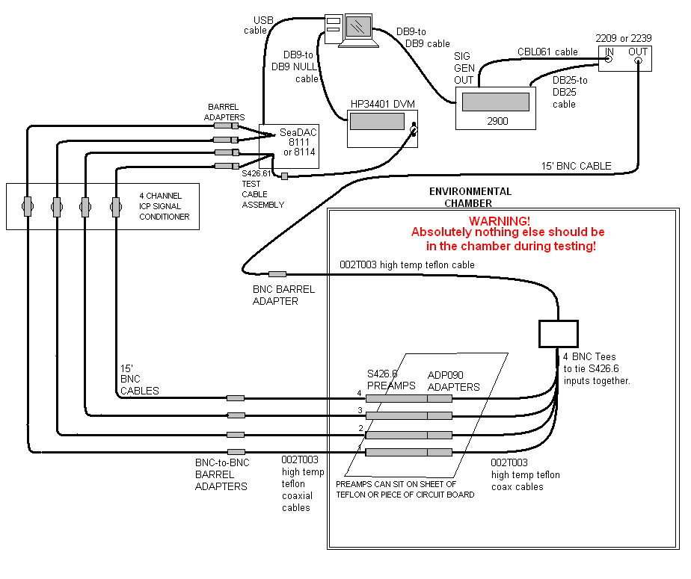

Setup pretest
Before starting the chamber program, make sure the entire setup is correct by doing the following procedure:
- Open the PCB Piezotronics USBSwitch program.
- Open the Larson Davis SigGen program (either SG2209 or SG2239, depending on which isolation amplifier is being used).
- Check CONNECT in the SigGen program.
- Set SigGen signal to 0 dBuV @ 1 kHz.
- Switch HP 34401 DVM to read DC voltage.
- Set USBSwitch program to channel 1. Ensure that preamp #1 is DC biased to around 12 ± 1.5 VDC.
Caution: USBSwitch Program allows multiple channels to be connected simultaneously. Do not allow this! To switch preamp channels, uncheck current channel and THEN check the next channel to prevent preamp signals from being connected to each other.
- Repeat step 6 for preamps on channels 2, 3, and 4.
- Set USBSwitch to channel 1 again.
- Set signal on SigGen program to 120 dBµV at 1 kHz.
- Set HP 34401 DVM to read AC voltage, and ensure that the signal coming in on channel #1 is 0.991 VAC or higher.
- Repeat step 10 for channels 2, 3, and 4.
- Close the USBSwitch program.

Chamber high temperature limits configurations
The environmental chambers usually contain temperature failsafe limits that put the chamber into error mode and/or shut the chamber down if these limits are passed. These limits will need to be adjusted before starting the test.
For the Thermotron SE-1000L chamber
- To adjust the upper temperature limit in the Thermotron chamber, go to the System Setup Panel, and adjust the Air Temp High Limit in Process Alarms to 140 °C.
- Remember to set this limit back to its original value after the testing is finished.

For the Espec PLA-4GP chamber:
- Set the OVERHEAT PROTECTOR dial switch on the front of the Espec chamber to 140°C.
Note: There are small + and - tabs that pull out above and below each digit of this switch. Rotate them out and then push to increment/decrement digits.
- Also, using the button interface of the Espec display, scroll down until "4. LIMIT SET" is highlighted and press ENTER key.
- Set high temp limit to 140°C and hit ENTER key.
- Keep hitting ENTER key until back to main screen.
- Remember to set this limit back to the original value after the testing is finished.

Environmental Test
- Open Chamber Program
- In MENU>CHAMBER>SETUP...
  - Select which environmental chamber is being used.
  - Ensure that the GPIB or IP address is correct for the chamber.
- In MENU>GENERATOR>"GENERATOR SELECTION":
  - Select the "LD 2900" radio button
  - Set "LD 2900 Function Generator Setup" to correct COM port.
- Select the "MIC/PREAMP TEST" tab.
- In the "Measurement Setup" area:
  - Select the "34401A" radio button.
  - Check the "USBSwitch" checkbox.
  - Click on the CHANGE button to ensure that serial port for HP 34401 DVM is set to correct COM port.
- In the "Sequence File" area, browse and select the HT426E01.SEQ test script file.
- In the "Microphone/Preamp Setup" area:
  - Check four preamp check boxes.
  - In the MODEL pulldown boxes, select all four to be HT426E01 (or type in 'HT426E01' if it is not available yet).
  - Type in the serial numbers for all four preamplifiers.
- Click on BEGIN TEST.
  - Environmental chamber should startup.
- Wait to ensure that test starts with no problems.
  - Chamber set environment variables on chamber display should eventually be set to T=23° at 50% RH.
  - Test takes approximately 28 hours to finish.

post test
- Set the chamber’s upper temperature limit back to its original value after the testing.
- Retest and recertify the preamplifier assemblies using the D0001.8204 work instruction and ensure assemblies still pass this testing.

Inspect test results
- Open the ReportGen Program.
- In the TYPE pulldown box, select ENV. (MIC/PREAMP) TEST RESULTS.
- In the INSTRUMENT pulldown box, select HT426E01.
- In the right SERIAL NUMBER pulldown box, select one of the preamp serial numbers that was tested.
- Click on the LOOKUP button.
- In the TEST DATE area, select the date which the test was performed. This will bring up test report links to the right.
- In this area, click on the RELATIVE SPL VS. TEMPERATURE @ 10.0 Hz link. This will bring up a graphical test plot of the SPL level deviations over temperature at the 10.0 Hz test point (see Figure 2 below).
  - Ensure that all temperatures were reached (from -35 to 130°C) in the plot.

If not, there could have been a problem with the chamber during the test,
and the test will have to be performed again.

  - The SPL level deviations across all temperatures (from -35° to 130°C) should not exceed ±0.17 dB.
  - If there is uncertainty about values being read graphically, the actual numeric values can be read by clicking on the ReportGen back button and clicking on the RAW DATA link at the bottom of the list. Read the 10.0 Hz data values.

Figure 2. Typical SPL level deviations over temperature at 10.0 Hz.

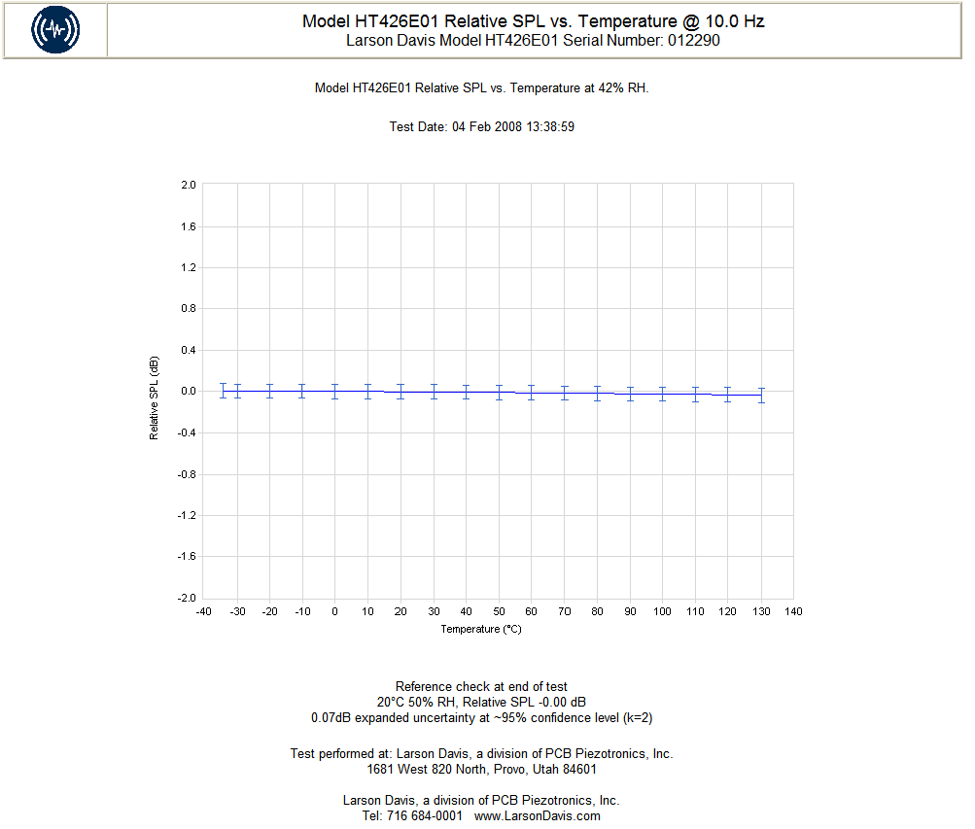

- Click on the ReportGen back button: .
- Click on the RELATIVE SPL VS. HUMIDITY @ 10.0 Hz link. This will bring up a graphical test plot of the SPL level deviations over humidity at the 10.0 Hz test point (see Figure 3 below).
  - Ensure in the test data on the plot that the chamber actually reached 95% RH.
If not, there may have been a problem with the test, and it will have to be performed again.
  - The SPL level deviations across all humidities (50% to 95% RH) should not deviate by more than ±0.17 dB.

Figure 3. Typical SPL level deviations over humidity at 10.0 Hz.
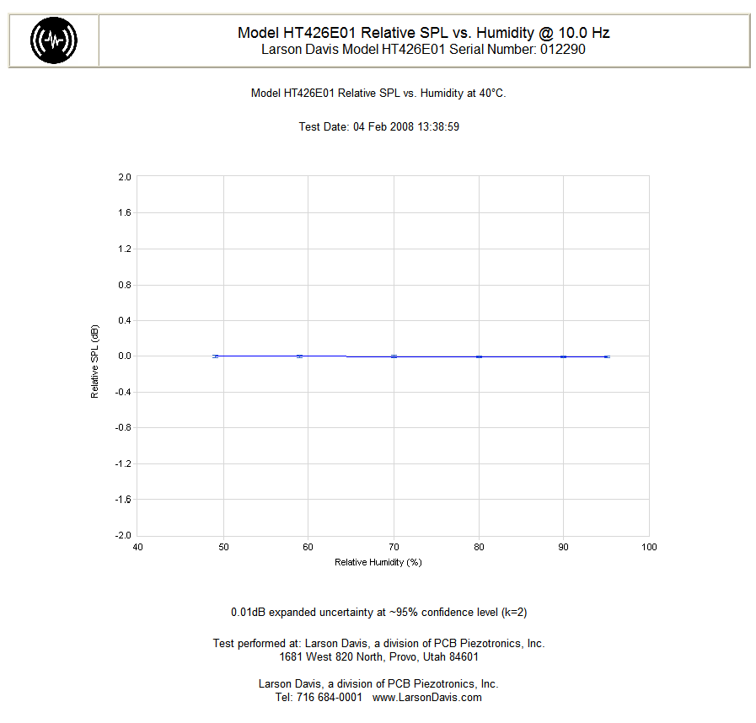
- Click on the ReportGen back button: .
- Click on the HUMIDITY ENDURANCE @ 10.0 Hz link.
  - The SPL level deviations for the entire time length of the test, should not deviate by more than ±0.17 dB.
- Click on the ReportGen back button.
- Click on the RELATIVE SPL VS. FREQUENCY @ 120°C link.
  - For frequencies above 10.0 Hz, the SPL level deviations should not exceed ±0.17 dB. The plot will look similar to Figure 4 below.

Figure 4. Typical SPL level deviations over frequencies at T=120°C.
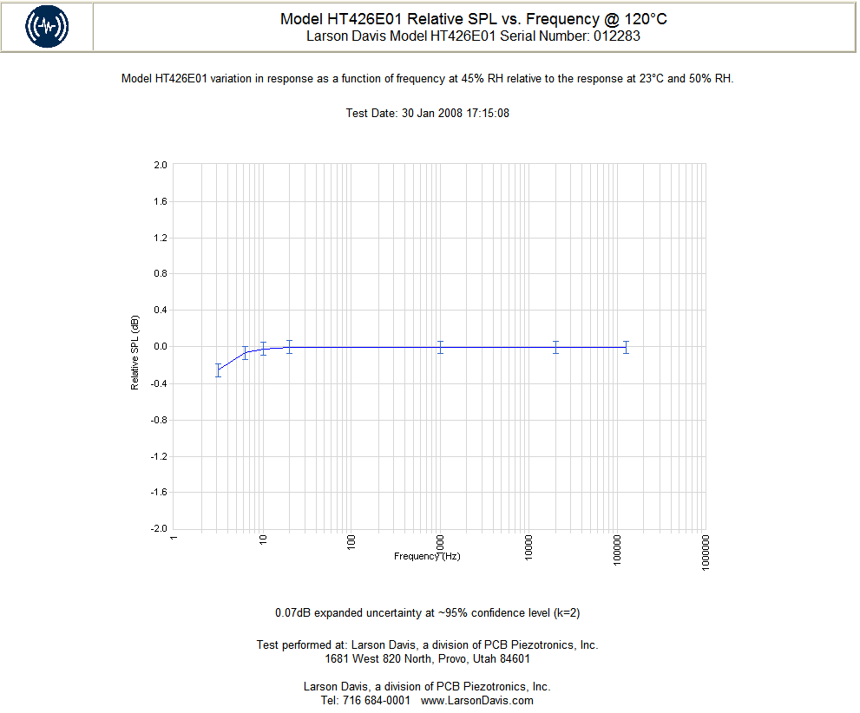

- Click on the ReportGen back button: .
- Click on the VDC VS. TEMPERATURE link.
  - The DC output bias voltage should stay within the limits between 10.0 to 14.0 VDC over all the temperatures. The VDC out plot should look similar to Figure 5 below.

Figure 5. Typical VDC output bias over temperature.
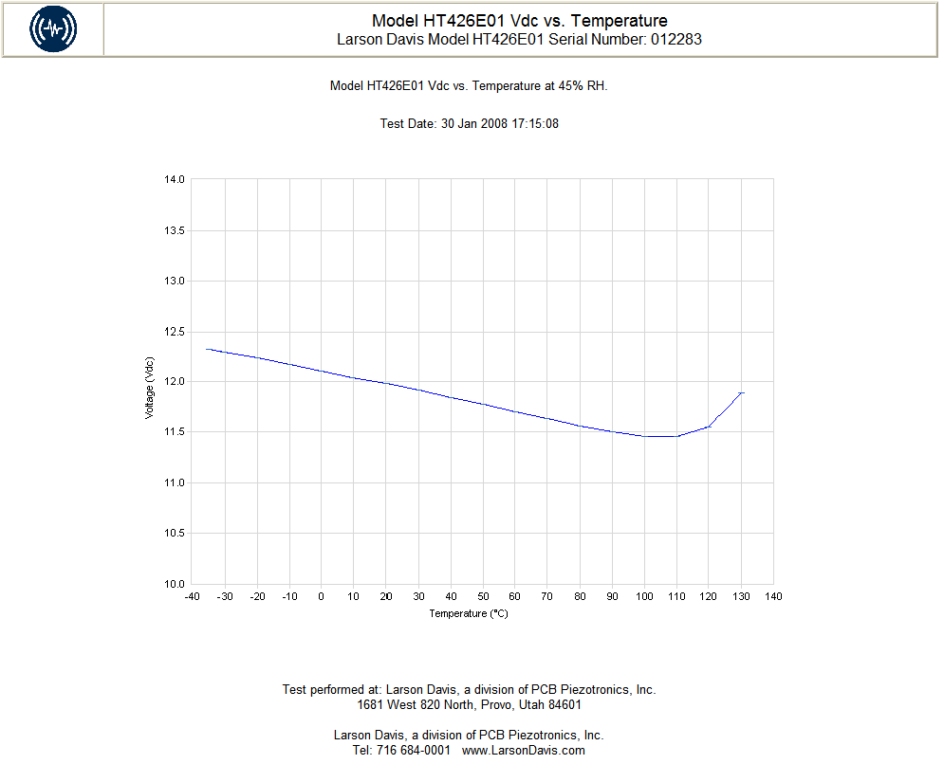

- Click on the ReportGen back button: .
- Click on the VDC VS. HUMIDITY link.
  - The DC output bias voltage should stay within the limits between 10.0 to 14.0 VDC over all the humidity values. The VDC out plot should look similar to Figure 6 below.
- Repeat steps 4 through 18 for the other three remaining preamplifiers that were tested.
Figure 6. Typical VDC output bias over humidity
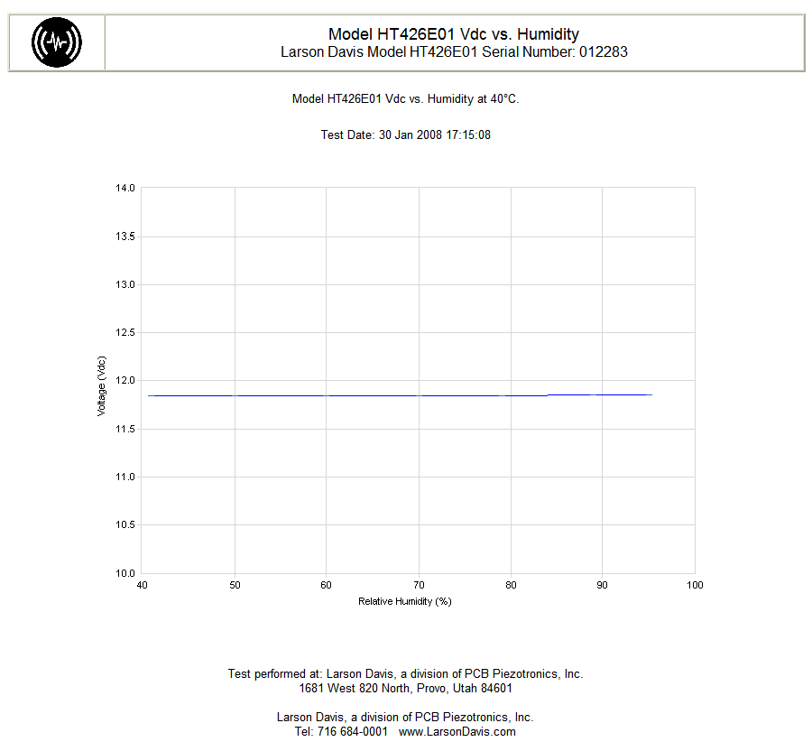

annotate test results
- Select one of the serial numbers for the units that had been tested in ReportGen.
- Click on the Look Up button.
- Click on the date that the test was performed.
- Click on Raw Data at the bottom of the test results.
- Annotate the following test data to be recorded:
  - dB SPL error at the 10 Hz point at 130 °C. Should be < 0.17 dB.
  - dB SPL error at the 10 Hz point at 95% RH, 40 °C. Should be < 0.17 dB.
  - VDC at reference conditions. Should be 12.0 ± 1.5 VDC.
  - VDC at 100 °C. Should be 12.0 ± 2.0 VDC.
  - VDC at 130 °C. Should be 12.0 ± 2.0 VDC.
  - VDC at 95%, 40 °C. Should be 12.0 ± 2.0 VDC.
- Repeat step 1 through 5 for all four preamps that were tested.
- QA will record these values in the ”S426.6 Periodic High Temp High Humidity Test Log.xls” spreadsheet to allow looking for trends.

RECORDS
The results of the tests are kept in the ENVTEST SQLServer database and can be viewed using the ReportGen program.

Results of tests on all four preamplifiers should also be logged in the QA ”S426.6 Periodic High Temp High Humidity Test Log.xls” to easily observe trends.

DISTRIBUTION

This instruction is available online in Document Control.

REVISION HISTORY

DCO # | REV | DATE | INITIALS | CHANGES MADE
ECO 3843 | B | 10/27/2009 | JLD | Initial release

