FIL001 / 426B02 TEST

1.0 PURPOSE AND SCOPE

This document describes the test procedure for verifying that the FIL001 / 426B02 is functioning within specified parameters. All employees who have responsibility for testing this instrument are required to follow the instructions detailed in this procedure.

2.0 AFFECTED DEPARTMENTS

Production

3.0 REFERENCE DOCUMENTS

FIL001 documents (the 426B02 uses the same ones):
- Schematics
- Bill of Materials
- Assembly drawingsD0001.8215 FIL001-426B02 Test

4.0 RESPONSIBILITIES & AUTHORITY

The technician has the following responsibilities and authority:
- Verify compliance of the product under test to specifications.
- Troubleshoot and correct connection as required.
- Communicate concerns to the Supervisor of Quality Assurance.
- Request management review of product concerns.
- Follow established ESD standards.

5.0 DEFINITIONS

LD - Larson Davis
ESD - Electro-Static Discharge
Filter - The FIL001 or 426B02 A Weight Filter that is being tested.
Current Source - PRA950-L4 or PRA951-L4
DMM - Digital Multi Meter
Current Test Fixture - A male BNC connector with a 4.99K Ohm resistor from the center pin to the shield

6.0 SAFETY PRECAUTIONS

- Use safety glasses when soldering, lead clipping, or testing power supplies.
- Follow general safety precautions for working with energized, low voltage circuits.

7.0 EQUIPMENT & MATERIALS

- BNC to BNC cables
- BNC “T”s
- Current Test Fixture
- PRA950-L4 or PRA951-L4 current source
- CBL071 if using a PRA951-L4
- Certified 426E01 that is listed on the certificate for MetCal test
- Certified PRM426 for Lab test
- ADP005 18uF BNC to preamp adaptor
- DMM HP34401
- 2900 Test System with 2209 or 2239 and Lab.exe test program
- MetCal test station

8.0 INSTRUCTIONS

8.1 Test of the Filter

- Connect the Current Source to the preamp input 1 of the 2900 using a CBL071 (see Figure 1). If using a PRA950-L4, the CBL071 is not needed.

- Using a BNC to BNC cable, connect the Current Source to the output of the Filter.

- Connect a BNC “T” to the input of the Filter.

- Connect the Current Test Fixture to the other end of the “T”.

- Connect the “T” to the DMM.

- The DMM should be reading between 2.99 Volts and 4.50 Volts DC.
If it is not, stop testing and troubleshoot and repair the preamp.

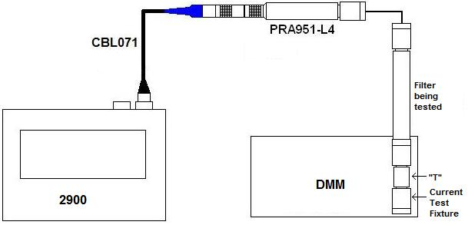
Figure 1

- Disconnect the Current Test Fixture and the Filter from the “T” on the DMM.

- Connect the BNC cable from the Current Source to one side of the “T” on the DMM (see figure 2).

- Using another BNC cable, connect the other side of the “T” on the DMM to the output of the Filter.

- Connect the ADP005 to the input of the PRM426.

- Connect the PRM426 to the input of the Filter.

- Using a BNC to BNC cable, connect the input of the ADP005 to the output of the 2209/2209.

- Connect the DMM to the Computer COM port using an RS232 cable.

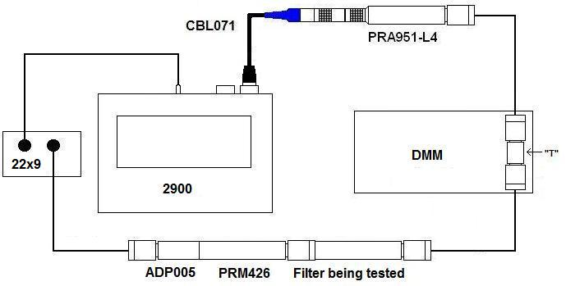
Figure 2

- Check the DMM to make sure the voltage is between 19 to 20.6 VDC.
If it is not, stop testing and troubleshoot and repair the preamp.

- Run the Lab.exe program and select “FIL001” or “426B02” from the Instrument box. Enter the serial number for Filter.

- Check the “Sweep Preamp” box and click “Start”. The test runs for 3 minutes.

- After the test has finished, disconnect the Filter and check the results. IF THE TEST FAILS, TROUBLESHOOT THE PROBLEM BEFORE CONTINUING.

- Test the PRM426 memory through the Filter (follow procedure D0001.8155).
- Connect the Filter to the PRM426.
- Connect the Filter to the TEDS cable.
- Make sure you can read the TEDS information from the PRM426.

If the filter is only being tested to go into inventory at the sub-assembly level, you are finished. The following steps are done when the preamp is being shipped.

  - Final Test and Prepare for Shipment

- Test the filter on the MetCal station following procedure D0001.8215 FIL001-426B02 Test.

- Print the certificate and data.

- Place the foam insert into the plastic box. Make sure it is straight.

- Put the preamplifier into the case.

- If the case is dirty or has fingerprints on it, clean it with glass cleaner.

- Create a calibration date sticker and place it on the top of the case in the upper right hand corner. (see picture below for examples of sticker placement)

- Create the appropriate model / serial number sticker and place it on the top of the case, just above the latch, centered side to side. (see picture below for examples of sticker placement)

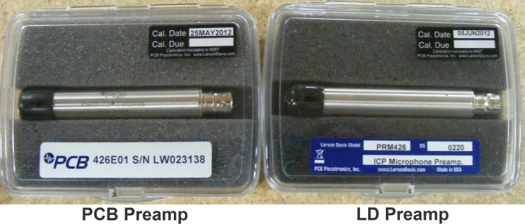

- Put the Certificate of Calibration and the test results in a bag.
- 426B02 certs go in a pink zip-lock bag. If these are going to be shipped to PCB on a transfer order, you can put all the certs in one bag.
- FIL001 certs go in the same sleeves that all LD product go in.

- Enter the preamps information into the database.

9.0 INSPECTION

No further inspection of the Filter is required.

- RECORDS

Test results are stored and maintained electronically.

11.0 DISTRIBUTION

Instruction is available in the online Document Control area or from the Document Control Clerk.

12.0 ATTACHMENTS

Not applicable to this procedure.

13.0 REVISION HISTORY

DCO # | REV | DATE | INITIALS | CHANGES MADE
767 | A | 4/19/04 | LH | Initial Release
1226 | B | 6/23/09 | JGG | Added pictures. Added 2239 to instrument list. Replaced “FIL001” with “Filter” and “PRA951” with “Current Source” in the instructions. Added instructions to use Loctite and the torque wrench when final assembling. A little clarification of the cable connections.
1401 | C | 8 Aug 2012 | JGG | Added steps for certification and packaging.
1949 | D | 24 Mar 2020 | JGG | Changed the final test to the MetCal system  Removed Loctite because this is done by Production now.

