2221 TEST INSTRUCTIONS

1.0 INTRODUCTION

The 2221 is a single channel power supply with A and C-weight filtering capabilities. It is used to provide power to a microphone / preamplifier combination.

2.0 DESCRIPTION

This instruction details the process for verifying the functionality of the 2221 and ensuring that the product meets specifications prior to being released for sale to a customer or being returned to a customer following repair or calibration.

3.0 LIMITATIONS

This instruction applies to the 2221 product only.

4.0 MATERIALS, TOOLS, & EQUIPMENT

Atmel AVR STK500 Programmer
2221 Test Cable
Lab Test Program
CBL097
HP 34401 DMM
2900/2209 test system (LD Calibration System)
BNC cables
Bench Power Supply with current meter
Test keyboard
Microphone with known sensitivity
CAL250
PRM902
Engineering Drawings for the Assembly and sub-Assembly S2221.01

5.0 PROCEDURE

With an A2221.01 Assembly and a test keyboard proceed as follows.

5.1 Power Supply Voltage Verification

- Apply 12 V External Power.
- Turn the Power switch to the on position.
- Look for about 60 mA of external power current.
- Check for 9.3 ±0.3 Volts at PwrIn test point.
- Check for 3.2 ±0.1 Volts at Vcc test point.
- Check for ±17.6 to 18.3 Volts at 18V and –18V test points.
- Check that the External Power LED is on.
- Check Eng on ‘Ldi’(Q:)\Firmware\2221 for the latest firmware version.
- Program the CPU with Atmel AVR Studio 4 as follows…
- Connect the AVR programmer board to your computers COM port. The program should automatically find the programmer no matter what COM port you have it on.
- Connect the AVR programmer board to the 2221 board with the six conductor ribbon cable.
- Apply 12 volts DC to both the AVR programmer and the 2221. Turn on the 2221 and programmer.
- Run the AVR studio program. If you do not have this installed on your computer, the installation file is located at \Engineering\Firmware\2221.
- If a window appears that looks like below, close it.

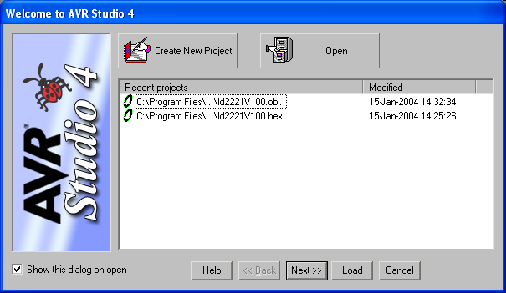

- Click on the button and the following window should open…

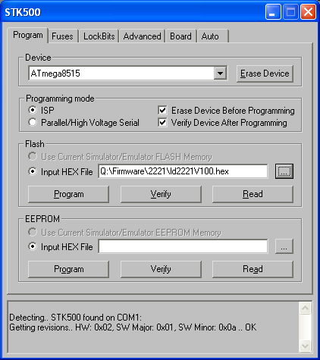

- Make sure it detected the programmer board by looking at the bottom of the window.

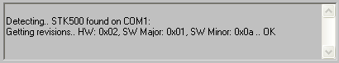

- Make sure it has selected, or select, ATmega8515 in the ‘Device’ window.
- Make sure it has selected, or select, the proper HEX file in the ‘Input HEX file’ window. The proper file is located in the Q:\Firmware\2221\ directory and should be the latest version of the firmware.
- In the ‘Programming mode’ section, make sure it has checked ‘ISP’, ‘Erase Device Before Programming’, and ‘Verify Device After Programming’.
- Click on the ‘Program’ button in the ‘Flash’ section of the window.
- Verify that it programmed ok by checking the bottom of the window.

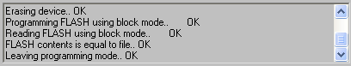

- Set the microphone bias to 200 V.
- Wait 40 seconds if the microphone bias was not already at 200 Volts
- Check for 200 Volts at the 200V test point.
- Adjust R93 for 200±0.2 Volts at the 200V test point. (if high change R88 to 249K)
- Build the S2221.01 level per assembly drawing

5.2 Gain Adjust, Signal LED and Overload LED Verification

- Set Gain to 0 dB and the weight to Z.
- Check that the signal LED is off.
- Set the Gain adjust pot fully counter clockwise.
- Input a 1 Volt, 1 kHz signal and check for 1 Volt signal at the Output.
- Check that the signal LED is on.
- Set the Gain adjust pot fully clockwise.
- Check that the Output signal is >3.16 Vrms.
- Set the Gain adjust pot fully counter clockwise.
- Change to C weight then A weight and check for about 1 Volt signal at Output.
- Set the Gain to 30 dB.
- Check that the Overload LED is blinking.
- Set the Gain to 20 dB.
- Check that the Overload LED is on steady.
- Push the Overload reset key.
- Check that the Overload LED goes out.
- Check BIAS LED’s
- Check GAIN LED’s.

5.3 Battery LED Function

- Turn the Power switch to the off position and remove external power.
- Apply 5.5 Volts DC to the battery compartment leads.
- Turn the Power switch to the on position.
- Check Battery LEDs for operation as follows...
  - 6 V LED works from 5.5 to 6.5 Volts.
  - 7 V LED works from 6.5 to 7.5 Volts.
  - 8 V LED works from 7.5 to 8.5 Volts.
  - 9 V LED works from 8.5 to 11.3 Volts.
Don’t go above 11.3 Volts.

5.4 Final Test

- Run the automated tests for the 2221 with the gain trim turned fully CCW.
- Attach a microphone and PRM902 to the input. Set the gain to 20 dB, Mic bias to 200 V and weighting to Z-wt. With a CAL250 on the Mic look for ~98 times the sensitivity of the Mic. Example: 98 x 48 mV/Pa = 4704 mV or 4.7 Volts. This checks that the 200 V Mic bias is getting to the Mic.

6.0 EVALUATION

This work instruction is an evaluation of the functionality of the product. The Technician ensures that the product meets the specifications prior to releasing the product for sale or return to the customer.

7.0 RECORDS

Electronic records of the automated tests are maintained for a minimum of two years.

8.0 REVISION HISTORY

DCO # | REV | DATE | INITIALS | CHANGES MADE
 | A | 3/7/03 | LH | Initial Release
538 | B | 5/12/03 | LH | Added Mic test of mic bias voltage.
654 | C | 10/6/03 | LH | Added instruction to check for firmware and reference to the final checklist (D0001.8234-1)
701 | D | 2/6/04 | JG | Added instructions for programming the board
750 | E | 3/5/04 | JG | Leroy changed a voltage and a step was added to section 5.2.
1374 | F | 03/26/12 | SC | Removed check list, added LED check and clarity changes

