CAL291 Certification

1.0 INTRODUCTION
This procedure contains the necessary detail to perform certification of the model CAL291.

2.0 DESCRIPTION
This procedure details how the functionality of the CAL291 is tested.

3.0 LIMITATIONS
This procedure is limited to the instrument model CAL291.

4.0 MATERIALS, TOOLS, & EQUIPMENT
Current measurement adapter (0.1 Ω resistor used)
DC power supply
BNC to mini phone cable
Mic extension cable
Oscilloscope or multimeter
2900 Probe
2900B, PRM900B, 2659 microphone, CAL250 (certified test equipment only)
Loading diagrams, schematic, documentation, for the A291.1 board and CAL291

Procedure (A) applies to older units, Procedure (B) applies to S/N >= 0200 (New Speaker)

5.0 PROCEDURE (A) Units with old speaker, before S/N 0200. Select “old speaker” tab in CAL291_TESTDATA file

5.1 Current Draw (Skip if doing re-certification)

5.1.1 Remove the bottom cover from the unit if it has been assembled previously.
5.1.2 Plug the current measurement adapter into the back of the unit.
5.1.3 Set the adjustable DC power supply to 12 volts and plug it into the current measurement adapter.
5.1.4 Turn the unit on. Use a multimeter to measure the voltage drop across the current measurement adapter. It should be approximately 0.002 volts. (20mA)

5.2 Filter Check (Skip if doing re-certification. Data for this step to be recorded in
R:\Provo\Data\CertData\Calibrators\CAL291\CAL291_TESTDATA).
5.2.1 Connect the signal generator output of a certified 2900B to the bnc input of the CAL291 using a bnc to mini phone cable.
5.2.2 Connect a 2900 probe to the channel 1 input of the 2900B. Connect the other end of the probe to either end of L1 on the A291.1 board.
5.2.3 Range to 130 and input pink noise into the CAL291. Units should be in dB μV. Keys: SYSTEM, UNITS[F], dB μV[I], SYSTEM, SIG.GEN[J], ON[A], PINK[J], LEVEL[E], .5000, EXIT, EXIT, EXIT, EXIT. Detector should be set at EXPONENTIAL 2 sec. Keys: DETECTR[H], EXP[C], AV.TIME[H], 2[H], EXIT. The 2900B display should be similar to that shown below:

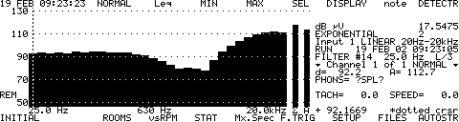

5.2.4 Use the arrow keys to move the cursor to the different frequencies. The following frequencies should be within the stated limits:
100 Hz 91.7 to 94.7
1 kHz 80.6 to 83.6
2.5 kHz 75.6 to 78.6
10 kHz 105.8 to 108.8

5.3 Check Sine wave Distortion (Record in
R:\Provo\Data\CertData\Calibrators\CAL291\CAL291_TESTDATA).

5.3.1 Use a PRM900B, 2659 microphone, Mic extension cable, and CAL250 to calibrate the 2900B. 2900B should be reading SPL. Keys: SYSTEM, UNITS[F], SPL[J], EXIT, EXIT. Change the detector to EXPONENTIAL 1/8 sec. Keys: DETECTR[H], EXP[C], AV.TIME[H], 1/8[D], EXIT. Turn on the CAL250, on the 2900B Keys: R/S, move the cursor to 250 Hz using the arrow keys, LEVEL[H], 114.00, EXIT, EXIT.
5.3.2 Using the 2900B signal generator input a 250 Hz sine wave at level 0.315. Keys: SYSTEM, SIG.GEN[J], ON[A], SINE[I], Fstart[A], 00250.000, EXIT, Lse[E], .3150, EXIT. The 2900B display should be similar to that shown below:

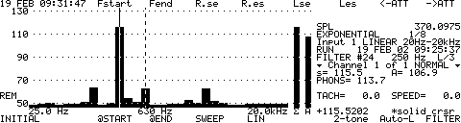

5.3.3 Levels should be within the following limits:
250 Hz ≥ 110 dB
≥ 500 Hz at least −30 dB down from 250 Hz
5.3.4 Input a 1 kHz sine wave at level 0.440. Keys: Fstart[A], 01000.000, EXIT, Lse[E], .4400, EXIT. The 2900B display should be similar to that shown below:

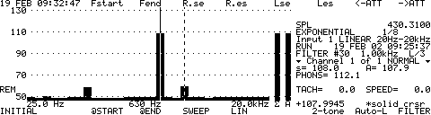

5.3.5 Levels should be within the following limits:
1 kHz ≥ 105 dB
≥ 2 kHz at least −30 dB down from 1 kHz
5.3.6 Input a 2.5 kHz sine wave at level 0.600. Keys: Fstart[A], 02500.000, EXIT, Lse[E], .6000, EXIT. The 2900B display should be similar to that shown below:

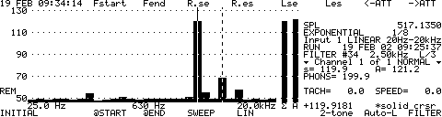

Levels should be within the following limits:
2.5 kHz ≥ 110 dB
≥ 5 kHz at least −30 dB down from 2.5 kHz
5.3.7 Input a 6.3 kHz sine wave at level 0.0946. Range to 120 on the 2900B. Keys: Fstart[A], 06300.000, EXIT, Lse[E], .0946, EXIT, EXIT, EXIT, EXIT. The 2900B display should be similar to that shown below:

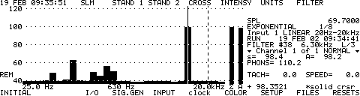

Levels should be within the following limits:
6.3 kHz ≥ 90 dB
≥ 12.5 kHz at least −30 dB down from 6.3 kHz

5.4 Check Pink Noise Levels (Record “pass” or “fail” in R:\Provo\Data\CertData\Calibrators\CAL291\
CAL291_TESTDATA).
5.4.1 Turn on the pink noise on the 2900B signal generator. Keys: DETECTR[H], LIN.S[A], AV.TIME[H], 000040.0000, EXIT, EXIT, SYSTEM, SIG.GEN[J], ON[A], PINK[J], LEVEL[E], .5000, EXIT, EXIT, EXIT ,EXIT. The 2900B display should be similar to that shown below:

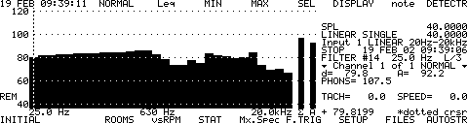

Levels should be within the following limits:
25 Hz to 6.3 kHz ≥ 70 dB

5.5 Final shipping preparation (Perform only applicable steps when re-certifying units)

5.5.1 Make sure the LED lights when the CAL291 is turned on.
5.5.2 Attach the bottom cover removed previously.
5.5.3 Use the “My Label” program to print a model/serial number label for the unit. Use the LD database to find the next serial number in sequence.
5.5.4 Print a calibration label using the “My Label” program and place both labels on the bottom of the unit.
5.5.5 Use the LD database to generate a Certificate of Calibration and Conformance to be shipped with the unit.
    - Enclose the unit and all accessories in the proper packaging.
5.5.7 Return completed units to proper area.

5.0 PROCEDURE (B) Units with new speaker, >= S/N 0200. Select “New speaker” tab in CAL291_TESTDATA file

5.1 Current Draw (Skip if doing re-certification)

5.1.1 Remove the bottom cover from the unit if it has been assembled previously.
5.1.2 Plug the current measurement adapter into the back of the unit.
5.1.3 Set the adjustable DC power supply to 12 volts and plug it into the current measurement adapter.
5.1.4 Turn the unit on. Use a multimeter to measure the voltage drop across the current measurement adapter. It should be approximately 0.002 volts. (20mA)

5.2 Filter Check (Skip if doing re-certification. Data for this step to be recorded in
R:\Provo\Data\CertData\Calibrators\CAL291\CAL291_TESTDATA).
5.2.1 Connect the signal generator output of a certified 2900B to the bnc input of the CAL291 using a bnc to mini phone cable.
5.2.2 Connect a 2900 probe to the channel 1 input of the 2900B. Connect the other end of the probe to either end of L1 on the A291.1 board.
5.2.3 Range to 130 and input pink noise into the CAL291. Units should be in dB μV. Keys: SYSTEM, UNITS[F], dB μV[I], SYSTEM, SIG.GEN[J], ON[A], PINK[J], LEVEL[E], .5000, EXIT, EXIT, EXIT, EXIT. Detector should be set at EXPONENTIAL 4 sec. Keys: DETECTR[H], EXP[C], AV.TIME[H], 4[I], EXIT. The 2900B display should be similar to that shown below:

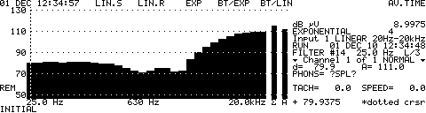

5.2.4 Use the arrow keys to move the cursor to the different frequencies. The following frequencies should be within the stated limits:
100 Hz 79.9 to 82.9
630 Hz 69.3 to 72.3
2.0 kHz 71.4 to 74.4
10 kHz 106.2 to 109.2

5.3 Check Sine wave Distortion (Record in
R:\Provo\Data\CertData\Calibrators\CAL291\CAL291_TESTDATA).

5.3.1 Use a PRM900B, 2659 microphone, Mic extension cable, and CAL250 to calibrate the 2900B. 2900B should be reading SPL. Keys: SYSTEM, UNITS[F], SPL[J], EXIT, EXIT. Change the detector to EXPONENTIAL 1/8 sec. Keys: DETECTR[H], EXP[C], AV.TIME[H], 1/8[D], EXIT. Turn on the CAL250, on the 2900B Keys: R/S, move the cursor to 250 Hz using the arrow keys, LEVEL[H], 114.00, EXIT, EXIT.
5.3.2 Using the 2900B signal generator input a 250 Hz sine wave at level 0.315. Keys: SYSTEM, SIG.GEN[J], ON[A], SINE[I], Fstart[A], 00250.000, EXIT, Lse[E], .3150, EXIT. The 2900B display should be similar to that shown below:

5.3.3 Levels should be within the following limits:
250 Hz ≥ 114 dB
≥ 500 Hz at least −30 dB down from 250 Hz
5.3.4 Input a 1 kHz sine wave at level 0.440. Keys: Fstart[A], 01000.000, EXIT, Lse[E], .4400, EXIT. The 2900B display should be similar to that shown below:

5.3.5 Levels should be within the following limits:
1 kHz ≥ 114 dB
≥ 2 kHz at least −30 dB down from 1 kHz
5.3.6 Input a 2.5 kHz sine wave at level 0.4000. Keys: Fstart[A], 02500.000, EXIT, Lse[E], .4000, EXIT. The 2900B display should be similar to that shown below:

Levels should be within the following limits:
2.5 kHz ≥ 118 dB
≥ 5 kHz at least −30 dB down from 2.5 kHz
5.3.7 Input a 6.3 kHz sine wave at level 0.1200. Range to 120 on the 2900B. Keys: Fstart[A], 06300.000, EXIT, Lse[E], .1200, EXIT, EXIT, EXIT, EXIT. The 2900B display should be similar to that shown below:

Levels should be within the following limits:
6.3 kHz ≥ 106 dB
≥ 12.5 kHz at least −30 dB down from 6.3 kHz

5.4 Check Pink Noise Levels (Record “pass” or “fail” in R:\Provo\Data\CertData\Calibrators\CAL291\
CAL291_TESTDATA).
5.4.1 Turn on the pink noise on the 2900B signal generator. Keys: DETECTR[H], LIN.S[A], AV.TIME[H], 000040.0000, EXIT, EXIT, SYSTEM, SIG.GEN[J], ON[A], PINK[J], LEVEL[E], .5000, EXIT, EXIT, EXIT ,EXIT. The 2900B display should be similar to that shown below:

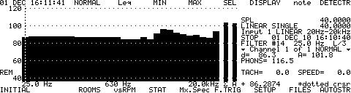

Levels should be within the following limits:
25 Hz to 6.3 kHz ≥ 75 dB

5.5 Final shipping preparation (Perform only applicable steps when re-certifying units)

5.5.1 Make sure the LED lights when the CAL291 is turned on.
5.5.2 Attach the bottom cover removed previously.
5.5.3 Use the “My Label” program to print a model/serial number label for the unit. Use the LD database to find the next serial number in sequence.
5.5.4 Print a calibration label using the “My Label” program and place both labels on the bottom of the unit.
5.5.5 Use the LD database to generate a Certificate of Calibration and Conformance to be shipped with the unit.
    - Enclose the unit and all accessories in the proper packaging.
5.5.7 Return completed units to proper area.

6.0 EVALUATION

7.0 RECORDS

8.0 REVISION HISTORY

DCO # | REV | DATE | INITIALS | CHANGES MADE
1100 | A | 6-12-08 | S.Mont. | RELEASE OF DOCUMENT
1230 | B | 7/1/09 | S.Mont. | Added reference to recertifying units and saving test data in excel file located on the M:Drive
1303 | C | 8/6/10 | SM | Changed references to M:\CertData to R:\Provo\Data\CertData.
1343 | D | 6/23/11 | SM | Added “B” part of procedure for new speaker

