AMC493 MASTOID TEST

1.0 INTRODUCTION

The purpose of this document is to provide the detail and instruction necessary to ensure the compliance of new and customer service mastoids. All instructions contained in this procedure pertain to all models of the AMC493.

2.0 DESCRIPTION

This test measures the sensitivity and impedance of the mastoid at several frequencies.

3.0 LIMITATIONS

The instructions apply to testing all models of the AMC493 Mastoid.

4.0 MATERIALS, TOOLS, & EQUIPMENT

Mastoid Test Stand
ESPEC Temperature\Humidity Cabinet
Temperature and humidity controlled room

5.0 PROCEDURE (Note: With AEC100 use reference 2575 microphone
With AEC101 use reference 2559 microphone
With AEC201 use reference 377A13 microphone with
modified ADP015 & attached cable in line with preamp to block 200V bias voltage.)

5.1 AMC493’s are assembled according to current assembly drawing. (Steps 5.1 through 5.3.6 are done on the S493 level. 5.4 through 5.4.6 are done on the AMC493 level. For service units and for new units that have already been tested but are now being sold with an artificial ear or new units that may need retesting, begin at step 5.2.2 by placing them in the temperature, humidity controlled room.)

5.2 Test Setup (When testing multiple units, steps 5.2.1 through 5.2.7 are performed only once.) Step 5.2.1 is skipped for customer service mastoids.

5.2.1 Place the assembled AMC493 mastoids in the ESPEC cabinet. Cycle the cabinet continuously on the default cycle (50 °C to -10 °C) for at least 24 hours. Refer to D0001.8189 Chamber Test for Calibrators.doc

5.2.2 Remove the AMC493 mastoids from the ESPEC cabinet and place them in the temperature, humidity controlled room. The artificial ear the mastoid is being tested with must also be placed in the room. New Mastoids must remain here for a period of at least 3 days before testing can begin. Conditioning time for Service Mastoids will be at Technicians discretion.

5.2.3 Tests are to be done in the temperature, humidity controlled room. (Temp = 23 °C, humidity = 50%)

5.2.4 Turn on all test equipment, i.e. 3200, amplifier, 2200C, computer, etc.

5.2.5 Pull the coupler off of the base. (It is preferred to use the customer's artificial ear for the calibration of the mastoid when available.)

5.2.6 Place the CAL250 over the microphone on the base and calibrate the 3200 to 114 dB SPL.

5.2.7 Replace the coupler over the microphone on its base.

5.2.8 Place the AMC493 over the microphone and use the centering template to center the mastoid on the fixture. (Remove the black conical ring if using the AEC101 or AEC201.)

5.2.9 Suspend the scale and shaker assembly over the mastoid and center it as close as possible. Set the scale to 552 grams and make sure it is level. Refer to diagram below:

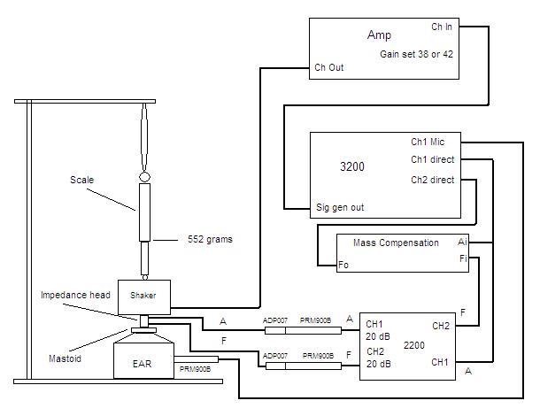

5.2.10 Make sure the amplifier gain is set at 38 or 42 on the channel being used.

5.3 TESTING

5.3.1 On the “Mastoid Test Stand” computer click on the “Mastoid Test” icon.

5.3.2 Create a new file, select correct models, and enter S/N’s for mastoid & artificial ear. (In test setup, “Black” or “Blue” refer to color of elastomer visible on top layer of mastoid.)

5.3.3 Run the “Sensitivity” and “Impedance” tests. The program will allow you at this time to make any final adjustments of centering and leveling the impedance head on the mastoid.

5.3.4 All units must pass the test limits. New units that don’t pass must be rebuilt. Service units that fail the test limits must be replaced and the customer informed.

5.3.5 Files are saved to R:\Provo\Data\CertData\Mastoid\Automated tests.

5.3.6 Use the Larson Davis Database to generate a record (new units only. This step completed after all mastoids have been tested.)

5.4 PAPERWORK (for service units, complete appropriate steps)

5.4.1 Print out the test data for “sensitivity” and “impedance” tests.

5.4.2 Generate the .csv file with the sensitivity data for the AMC493B using the export option under the “File” tab in the mastoid test program and burn to the Mastoid manual(IAMC493B.02). Write the S/N of the mastoid on the CD.

5.4.3 Use the Larson Davis Database to update the record and print out a “Certificate of Compliance” for the mastoid.

5.4.4 Place the AMC493 in a mastoid box.

5.4.5 Place a model, serial number label on the CCS043 mastoid case as well as a calibration sticker. The “My label” program is used to print these labels.
Customer service mastoids usually need only the calibration sticker.

5.4.6 Mastoid manual with .csv file containing sensitivity data is to be sent with all AMC493B’s.

5.4.7 The AMC493 is shipped with the Larson Davis certificate, Mastoid Sensitivity sheet, Mastoid Impedance sheet, an AMC493 manual, and the CCS043 Case. New units also receive the additional weight (MAE100.55). Service units receiving a new AMC493B as a replacement for older revision mastoids also receive document IAMC493A.02 located in the controlled documents area under \Work Instructions\Technician\AEC-AMC.

6.0 EVALUATION

This is a test process, no further evaluation required.

7.0 RECORDS

Test data and certificates of compliance are retained per the Quality Records Matrix D0001.1126-1.

8.0 REVISION HISTORY

DCO # | REV | DATE | INITIALS | CHANGES MADE
732 | A | 3/3/04 | SM | Initial Release
 | B | 6/10/08 | SM | Updates
1141 | C | 8/28/08 | LH | Added calibration with customers artificial ear  Added in comments for customer service mastoids
1248 | D | 8/03/09 | SM | Updated for test software & added diagram.
1306 | E | 8/6/10 | SM | Changed references to M:\CertData to R:\Provo\Data\CertData.
 | F | 3/11/11 | LH | Changed AMC493 and 493A to all models of AMC493. Conditioning to 3 days
ECO  4047 | G | 8/10/11 | LH | Added 5.4.2 sensitivity data put on to CD
1397 | H | 8/6/12 | SM | Minor clarifications and detail

