CAL150, CAL200 Re-certification SN ≥ 2000

1.0 INTRODUCTION

The purpose of this document is to provide the detail and instruction necessary to ensure the compliance of the specified product to established specifications

2.0 DESCRIPTION

This instruction explains the steps followed to re-certify the CAL150 and CAL200 calibrators.

3.0 LIMITATIONS

This instruction is limited to the recertification of the CAL150 and CAL200 products with serial numbers 2000 and greater.

4.0 MATERIALS, TOOLS, & EQUIPMENT

Calibrator Test Stand
½” Reference Microphone
Technician tool kit
D0001.8375 METCAL Procedure Instructions
D0001.8188 S200 Assembly Test
D0001.8189 Chamber Test For Calibrators
Current A200.1 loading diagram, schematic, and bill of materials

5.0 PROCEDURE
Wherever “mbar” is specified, test software now reads in k Pascals. Conversion from mbar to k Pascals is done by shifting decimal point one place to the left. In the event repair is necessary, refer to section 4.0 and send a quote as needed. (The order in which some steps are performed may be changed according to the technician’s preference.)

5.1 Preliminary Setup

5.1.1 Use the “Add Asset” window in MET/CAL to see if the calibrator being tested has been added to MET/CAL. If not, add the asset. Refer to D0001.8375 METCAL Procedure Instructions.

5.1.2 Double click on the icon labeled “Static Pressure Test” on the computer desktop of the “Calibrator Test System.”

5.1.3 Click on the appropriate shortcut to the needed service checklist on the computer desktop of the Calibrator Test Stand. Documents may also be retrieved from the controlled documents area on the network.

5.1.4 Arrange the “Static Pressure Test” screen and “Checklist” on the desktop as shown below: (The CAL250 Service Checklist is shown as an example)

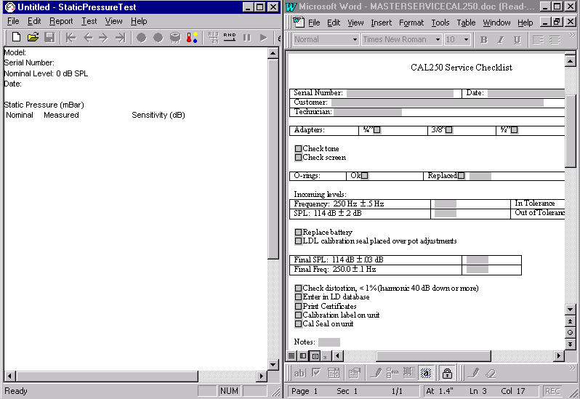

5.1.5 Fill out the top portion of the checklist. Customer information may be obtained from the service work order.

5.1.6 Perform a visual inspection of the calibrator for any physical damage or tampering. (Check the Larson Davis calibration seal)

5.1.7 Check off the type of adapter that came with the calibrator or check “None” if there wasn’t one.

5.1.8 Turn the calibrator on and check the tone. It should be clear and audible without distortion. Mark the checklist. (Occasionally a unit comes in with a dead battery. Replace battery at this time.)

5.1.9 Check the o-rings in the calibrator and adapter. Replace if necessary and note which o-ring was changed on the checklist.

5.2 Incoming levels

5.2.1 Insert the 915 preamp with the current ½ inch reference microphone from the “Calibrator Test System” into the base of the MTS1000.

5.2.2 Under “Files” in the “Static Pressure Test” screen click on the “New” option or click the “New File” icon. The screen below will appear:

Must not be selected! New
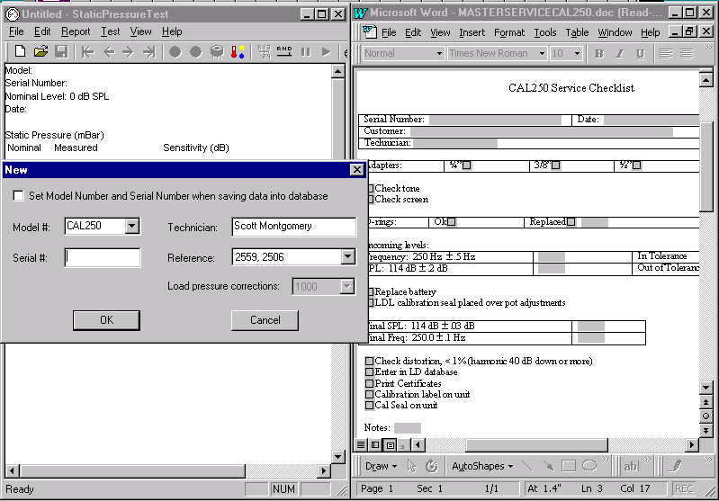

5.2.3 Enter the Model# and Serial# of the unit being re-certified. The screen above is for the CAL250. Select the correct model. Be sure the correct reference microphone is selected and your name is entered. When re-certifying a CAL150, or CAL200, the “Load pressure corrections” box in the window above must say “1000.” Click “OK.”

5.2.4 Remove the label from the back of the calibrator and connect the jumper wire from the base of the MTS1000 to the connection on the back of the calibrator. Place the calibrator over the microphone and preamp.

5.2.5 Place the bell over the calibrator and latch securely to the base of the MTS1000.

5.2.6 Use the ← → keys in the toolbar to toggle between the 114-dB certification screen and 94-dB certification screen. Technicians preference as to which level is run first. This can be done automatically or manually depending on the selection in the toolbar. The diagram below shows the automatic option. Unselect the “pause” button. The CAL250 is listed as a reference only.

Previous Next Start Stop Manual Auto Pause Continue
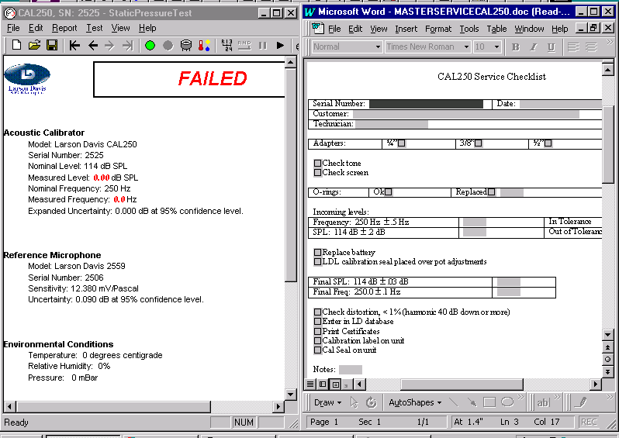

5.2.7 Click on the “Start” button shown above to begin the test. Toggle the rocker switch on the front of the MTS1000 on and off quickly to start the calibrator.

5.2.8 The “Test Completed” window appears at the end of test. Click “OK” to depressurize the bell, enter the resulting measured frequency and measured level in the proper data field in the checklist then unlatch and remove the bell. Make sure pressure has been released before unlatching the bell!

5.2.9 Switch the calibrator to the other level and repeat steps 5.2.5 through 5.2.8.

5.2.10 Don’t enter the measured frequency on the checklist after running the 94-dB level.

5.3 Pressure Test (PRM915 or PRM902 may be used.)

5.3.1 Flip the toggle switch on the calibrator to 114 dB. Flip the rocker switch on the base of the MTS1000 to “on” for continuous operation. (Switchbox should be set to 2900)

5.3.2 Place the bell over the calibrator and latch securely in place.

5.3.3 Use the ← → keys in the toolbar to toggle to the pressure test screen. This test may be done manually or automatically. The setup below is for the automatic option:

Save Previous Next Start Stop Auto Continue
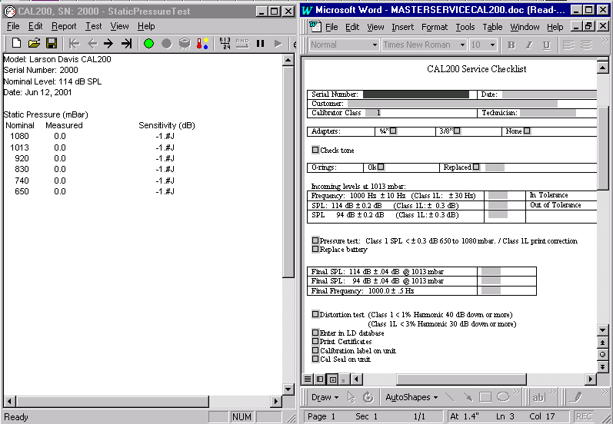

5.3.4 Click on the “Start” button to begin the test.

5.3.5 The test will run automatically until completed.

5.3.6 “Test Completed” window appears at the end of the test. Click “OK” to depressurize the bell.

5.3.7 Click on the “Save” icon in the toolbar.

5.4 Setting levels of CAL150/CAL200 if adjustment is necessary.
5.4.1 Use the ← → keys in the toolbar to toggle between the 114-dB certification screen and 94-dB certification screen. Run the 114-dB level first. Select the proper screen and then select “Auto” in the toolbar. Refer to the diagram below for button descriptions:

Previous Next Start Stop Manual Auto Pause Continue
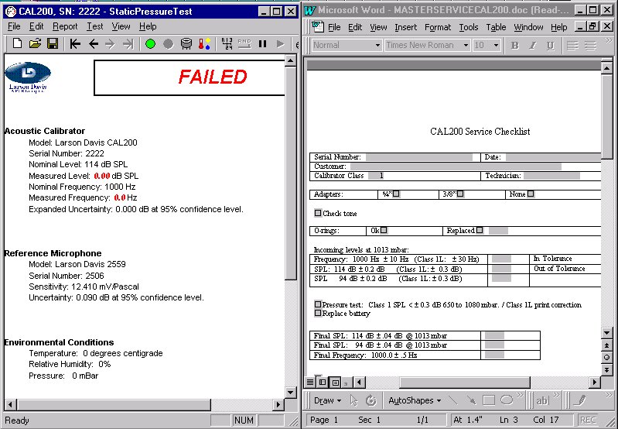

5.4.2 Click on the “Set Voltage” icon. “Set Voltage” may also be accessed under the “Test” option in the main menu. Make certain the 114-dB certification screen is displayed. See diagram below:
Set Voltage

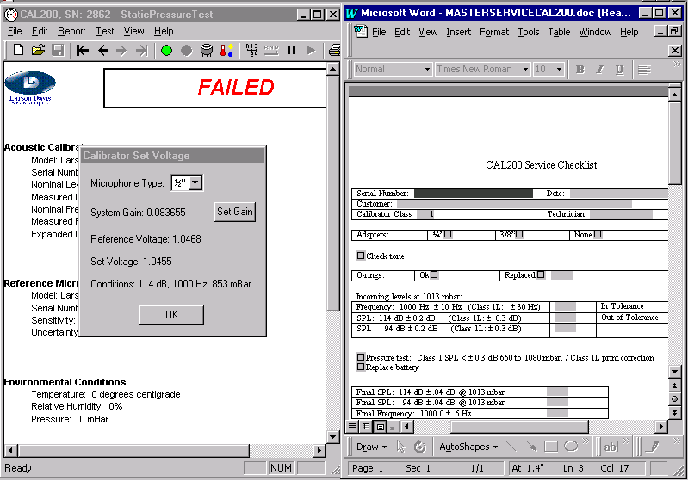

5.4.3 The “Set Voltage” shown above is the level specific to the model and serial number of the calibrator displayed in the upper left corner of the window. The decimal place is shifted 1 place to the left for the 94-dB “Set Voltage” level. (Make sure the Microphone Type is correct.)

5.4.4 Turn the unit on. Make any needed adjustments in this order: Frequency, 114-dB level, then 94-dB level. Set the 94 dB level ≈ .0005 V higher than the “Set Voltage” level for 94-dB. See the diagram below for potentiometer locations: Note: switchbox on Calibrator Test System should be set to 2900 before test begins.

Do not touch the Temperature Compensation! If it is changed the calibrator must be run through the chamber test again.
Frequency 114 dB level
Temperature Compensation

94 dB level Jumper for continuous operation, MTS1000 jumper connection

5.4.5 Click on the “OK” button in the “Calibrator Set Voltage” window to close if you haven’t already done so. Make sure calibrator is toggled to desired level. Place the bell over the calibrator and latch securely. Click on the “Start” button in the toolbar and flip the rocker switch on the base of the MTS1000 on and off quickly.

5.4.6 “Test Completed” window appears at the end of test. Click “OK” to depressurize the bell then enter the resulting Final SPL and Final frequency in the proper data field in the checklist (See checklist for final tolerances, enter the Final frequency for the 114-dB SPL only) Unlatch and remove the bell. Make sure pressure has been released before unlatching the bell!

5.4.7 Switch the calibrator to the 94-dB level, toggle to the 94-dB certification screen as in step 5.4.1, then repeat steps 5.4.5 through 5.4.6.

5.4.8 Click on the “Save” icon in the toolbar to save the test results.

5.5 Transfer data to METCAL system

5.5.1 From the “Open” dialog with the filter set to “Certificates”, select the correct tested date for the model and serial number of the calibrator and then click on the “Export” button.

5.5.2 A window will open for the SERIAL NUMBER of the calibrator to be entered, Enter the number & hit “Save”. Data writes to C:\EXPORTDATA.

5.5.3 Close the “Open” dialog box; from the MET/CAL Run Time window click “Calibrate” then “Run Procedures Executable…”

5.5.4 Run the procedure D0001.8386 (B) Acoustic Calibrator Import.

5.5.5 When the “MET/CAL Procedure – Import Calibrator” window opens click on “OK”.

5.5.6 “Select Asset” window will open. Enter the correct MODEL and SERIAL NUMBER then click the “Find” tab at the top of the screen.

5.5.7 Double click on the asset that appears in the bottom half of the screen.

5.5.8 When the “Open” window appears(C:\EXPORTDATA) double click on the SERIAL NUMBER to be exported to MET/CAL.

5.5.9 When the “Work Order” window appears, set “Initial Condition:” to appropriate condition then click “Save”.

5.5.10 The “Edit Work Order” will appear, verify that the model and serial number are correct.

5.5.11 Set the following fields: Status: Complete
QC Approved By: Technicians name
Cert Format: Cal_cert.rpt
ISOCert: checked
Due Date: As specified on order
Job Number: As listed on paperwork

5.5.12 Click on the “Save” tab in the menu at the top of screen.

5.5.13 After the save completes, click on the “Cert” button.

5.5.14 Once the PDF document opens, print the calibration certificate.

5.6 Labels for CAL150/CAL200

5.6.1 Place a Small Calibration Label with the date certified on the side of the calibrator with the power button and toggle switch. Place below the power button.
5.6.2 Print the serial number of the calibrator on the appropriate back label (L150.2 or L200.2 ) by selecting “File” then “Print labels” option from the Static Pressure Test program menu. Labels are printed on the Zebra printer. Place label on the back of calibrator. This label covers all of the access holes on the back of the unit.

5.6.3 Make sure a 3255.0014 (Warranty Calibration Seal) is on the side of the calibrator opposite the power button and toggle switch. See diagram below for label locations:

L200.2 (Calibrator Back Label) 3255.0014 (Warranty Calibration Seal)

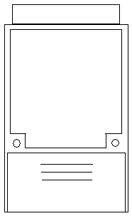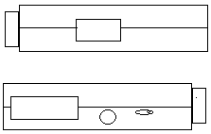
(Small Calibration Label)

5.7 Checklists and Database

5.7.1 Enter the information for the re-certified calibrator in the Larson Davis database. Create a Service Record with the re-certification date, and Before and After levels, along with any other service performed, listed in the “Tech Note.”

5.7.2 Make sure all items on the checklist have been completed and marked off. Save the completed checklist by serial number_DayMonthYear. Example: 2222_12Jun01. The completed checklists are to be saved in the following locations:
CAL150: R:\Provo\Data\CertData\Calibrators\Service CAL150
CAL200: R:\Provo\Data\CertData\Calibrators\Service CAL200

5.7.3 Return the completed calibrator to the Service Department with the service work order, Return to Customer form and Calibration Certificate Be sure that any adapters that came with the calibrator are returned with it.

6.0 EVALUATION

This instruction details the process of evaluating instruments returned to Larson Davis for recertification. No further evaluation is needed.

7.0 RECORDS

The certificates of compliance and test data are maintained per the Quality Records Matrix, D0001.1126-1.

8.0 REVISION HISTORY

DCO # | REV | DATE | INITIALS | CHANGES MADE
735 | A | 3/4/04 | SM | Initial Release
1098 | B | 6/10/08 | SM | Updates
1145 | C | 10/16/08 | SM | Minor changes and edits
1304 | D | 8/6/10 | SM | Changed references to M:\CertData to R:\Provo\Data\CertData.
1398 | E | 8/6/12 | SM | Minor changes and edits
1489 | F | 11/13/15 | SM/JWH | METCAL System
1895 | G | 6/10/19 | SM | 5.6.1 & 5.6.3 Removed specific ref to cal label to allow both sheets & rolls of labels to be used  5.6.2 Deleted reference to label rev & exception for label for CAL150B.

