CAL150, CAL200 Re-certification SN < 2000

**1.0 INTRODUCTION**

The purpose of this document is to provide the detail and instruction necessary to ensure the compliance of the specified product to established specifications

**2.0 DESCRIPTION**

This instruction explains the steps followed to re-certify the CAL200 calibrator. CAL150’s below S/N 2028 have 3/8” cavity and are no longer supported.

**3.0 LIMITATIONS**

The instruction is limited to the recertification of the CAL150 and CAL200 products with serial numbers below 2000.

**4.0 MATERIALS, TOOLS, & EQUIPMENT**

Calibrator Test Stand

¼” Reference Microphone

½” Reference Microphone

G.R.A.S. ¼” microphone – ½” preamplifier

¼” to 3/8” cal adaptor

Technician tool kit

**5.0 PROCEDURE**

***Wherever “mbar” is specified, test software now reads in k Pascals. Conversion from mbar to k Pascals is done by shifting decimal point one place to the left. Calibrators with S/N’s below 2000 are non-repairable. Customer will be given option to upgrade in the event a repair is necessary.***

**5.1 Preliminary Setup**

**5.1.1** Double click on the icon labeled “*Static Pressure Test*” on the computer desktop of the “Calibrator Test System.”

**5.1.2** Go to the controlled document folder to select the appropriate service checklist.

**5.1.3** Arrange the “Static Pressure Test” screen and “Checklist” on the desktop as shown below: *(The CAL250 Service Checklist is shown as an example)*

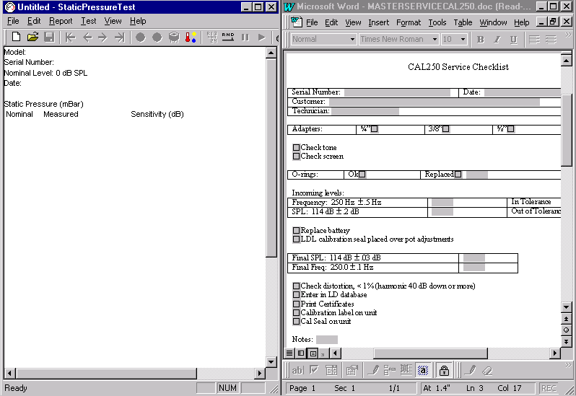

**5.1.4** Fill out the top portion of the checklist. Customer information may be obtained from the service work order.

**5.1.5** Perform a visual inspection of the calibrator for any physical damage or tampering. *(Check the Larson Davis calibration seal)*

**5.1.6** Check off the type of adapter that came with the calibrator or check “None” if there wasn’t one.

**5.1.7** Turn the calibrator on and check the tone. It should be clear and audible without distortion. Mark the checklist. *(Occasionally a unit comes in with a dead battery. Replace battery at this time.)*

**5.1.8** Check the o-rings in the calibrator and adapter. Replace if necessary and note which o-ring was changed on the checklist.

**5.2 Incoming levels**

**5.2.1** Insert the 915 preamp with the current **¼” reference microphone with G.R.A.S. ¼” microphone – ½” preamplifier adapter** for the CAL150 or **½” reference microphone** for the CAL200 into the base of the MTS1000.

**5.2.2** Under “*Files*” in the “Static Pressure Test” screen click on the “*New*” option or click the “*New File*” icon. The screen below will appear:

Must not be selected! New

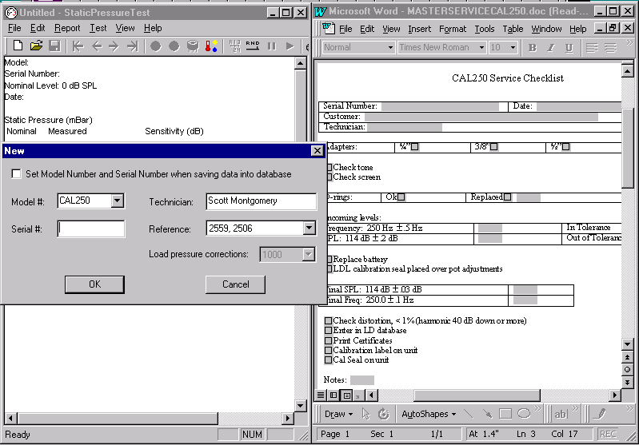

**5.2.3** Enter the **Model#** and **Serial#** of the unit being re-certified. *The screen above is for the CAL250.* **If certifying a CAL150 select CAL150 for Model. Select CAL200 if certifying a CAL200.** Be sure the correct reference microphone is selected and your name is entered. The “**Load pressure corrections**” box in the window above must say “**1000**.” Click “OK.”

**5.2.4** Place the calibrator over the microphone and preamp.

**5.2.**5 Use the **← →** keys in the toolbar to toggle between the 114-dB certification screen and 94-dB certification screen. Run the 114-dB level first. Select the proper screen and set the program to run in the auto mode. Refer to the diagram below and select “Auto” icon:

Previous Next Start Stop Manual Auto Pause Continue

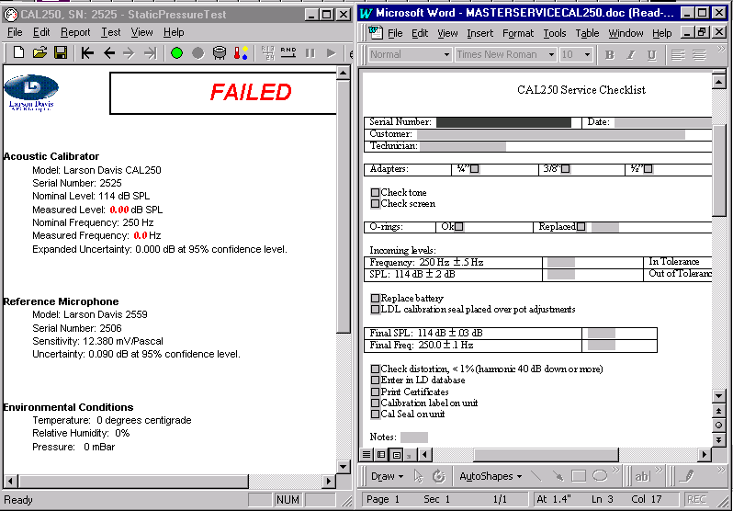

* + 1. Turn the calibrator on and **quickly** place the bell over the calibrator and latch securely to the base of the MTS1000.

**5.2.7** Quicklyclick on the “Start” button shown above to begin the test. (Switchbox must be set to 2900)

**5.2.8** “Test Completed” window appears at the end of test. Click “OK” to depressurize the bell, enter the resulting measured frequency and measured level in the proper data field in the checklist then unlatch and remove the bell. **Make sure the pressure has been released before unlatching the bell!**

**5.2.9** Switch the calibrator to the 94-dB level and repeat steps **5.2.5** through **5.2.8**.

**5.2.10** *Don’t enter the measured frequency on the checklist after running the 94 dB level. Determine if the incoming levels are “in tolerance” or “out of tolerance” and mark the proper box on the service checklist. Refer to the checklist for tolerances. If no adjustment is necessary, just run over pressure; make no adjustments.*

**5.3 Pressure Test (PRM915 or PRM902 may be used for pressure test.)**

**5.3.1** Place a rubber band around the calibrator to hold the power button down for continuous operation.

**5.3.2** Flip the toggle switch on the calibrator to 114.00 dB.

**5.3.3** Place the bell over the calibrator and latch securely in place.

**5.3.4** Use the **← →** keys in the toolbar to toggle to the pressure test screen. This test may be done manually or automatically. The setup below is for the automatic option:

Save Previous Next Start Stop Auto Continue

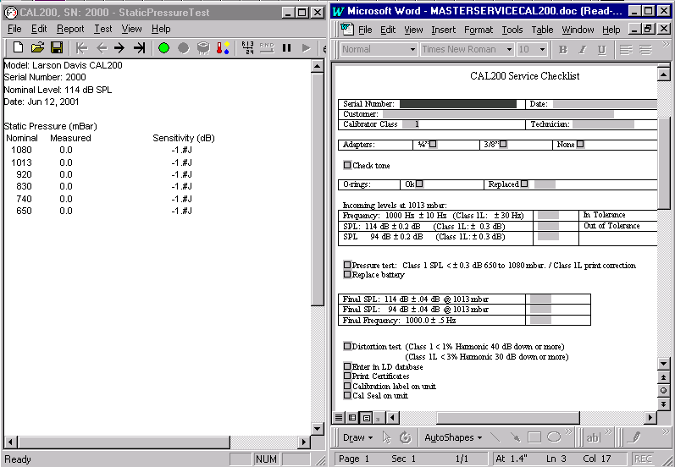

**5.3.5** Click on the “Start” button to begin the test .

**5.3.6** The test will run automatically until completed.

**5.3.7** “Test Completed” window appears at the end of the test. Click “OK” to depressurize the bell.

**5.3.8** Click on the “Save” icon in the toolbar.

**5.3.9** This newly generated correction must be printed for placement on the back of the calibrator at a later time. Use the L200.2 (Old Calibrator Back Label Silver)

**5.4 Re-certification of CAL150/CAL200 (PRM915 must be used for this step)**

***Note: Only necessary if levels were adjusted.***

**5.4.1** Remove the rubber band holding the power switch down.

**5.4.2** Use the **← →** keys in the toolbar to toggle between the 114-dB certification screen and 94-dB certification screen. Run the 114-dB level first. Select the proper screen and set the program to run in the auto mode as shown below:

Previous Next Start Stop Manual Auto Pause Continue

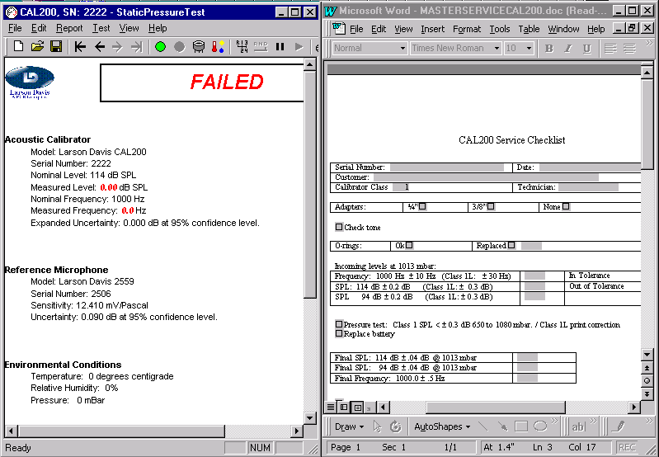

**5.4.3** Click on the “Set Voltage” icon. Make certain the 114-dB certification screen is displayed. See diagram below:

**Set Voltage**

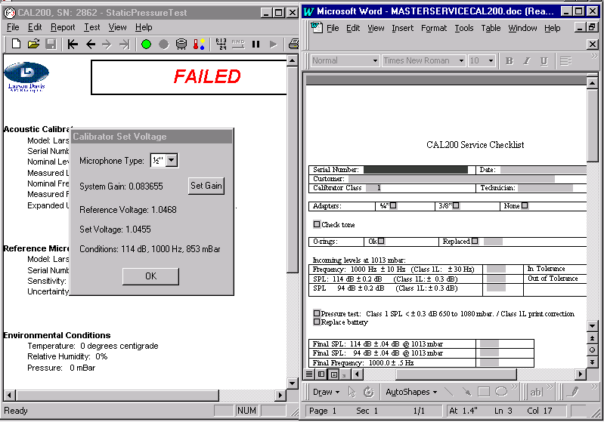

**5.4.4** The “**Set Voltage**” shown above is the level specific to the model and serial number of the calibrator displayed in the upper left corner of the window. The decimal place is shifted 1 place to the left for the 94-dB “Set Voltage” level. **(Make sure the *Microphone Type* is correct. CAL150’s require the ¼” reference microphone.)**

**5.4.5** Turn the unit on. *(Back label must be in place when certifying calibrator, peel back then stick back down after adjustments)* Make any needed adjustments in this order: Frequency, 114-dB level, then 94-dB level. Set the 94-dB level ≈ 0.4-dB below the “set voltage” level for 94-dB. Use the scope to monitor frequency, the HP 34401A to monitor levels. See the diagram below for potentiometer locations: ***Note: switchbox on Calibrator Test System should be set to 2900****.*

*Frequency* *114 dB level*

94 dB level *Jumper for continuous operation*

**5.4.6** Turn the calibrator on and **quickly** place the bell over the calibrator and latch securely to the base of the MTS1000.

**5.4.7**  Quicklyclick on the “Start” button to begin the test. (Switchbox must be set to 2900)

**5.4.8** “Test Completed” window appears at the end of test. Click “OK” to depressurize the bell, enter the resulting Final SPL and Final frequency in the proper field in the checklist (See checklist for final tolerances) then unlatch and remove the bell. **Make sure pressure has been released before unlatching the bell!**

**5.4.9** Switch the calibrator to the 94-dB level, toggle to the 94-dB certification screen as in step **5.4.2**, then repeat steps **5.4.6** through **5.4.10.** *Don’t enter the measured frequency on the checklist after running the 94-dB level*.

**5.4.10** Click on the “Save” icon in the toolbar to save the test results. The Certificate of Measured Output may also be printed at this time. Click on the “Print “ icon. See diagram below:

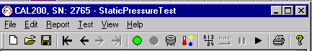

Save Print

**5.5 Paperwork**

**5.5.1** Enter the information for the re-certified calibrator in the Larson Davis database. Re-certification date, and Before and After levels should be listed in the Serial Record under “Service,” then “Tech Note.”

**5.5.2** Generate, print, and sign, a Certificate of Compliance for each unit re-certified. “Before” and “After” levels should be listed on the certificate. “**Refer to Certificate of Measured Output**” may be printed on the certificate instead of listing the levels. Example:

Before: 113.90 dB, 93.85 dB, 1000.1 Hz @ sea level.

After: Refer to Certificate of Measured Output.

**5.6 Labels for CAL150/CAL200**

**5.6.1** Place a Small Calibration Label with the date certified on the side of the calibrator with the power button and toggle switch. Place below the power button.

**5.6.2** Make sure a 3255.0014 (Warranty Calibration Seal) is on the side of the calibrator opposite the power button and toggle switch. See diagram below for label locations:

**L200.2 (Calibrator Back Label) 3255.0014 (Warranty Calibration Seal)**

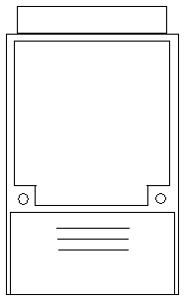 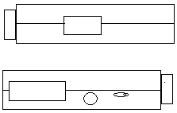

**(Small Calibration Label)**

**5.6.3** At this time replace the old back label with the new Calibrator Back Label generated in step 5.3.9.

**5.7 Records**

**5.7.1** Make sure all items on the checklist have been completed and marked off. Save the completed checklist by *serial number_DayMonthYear. Example: 2222_12Jun01.* The completed checklists are to be saved in the following locations:

CAL150: R:\Provo\Data\CertData\Calibrators\CAL150\Service CAL150

CAL200: R:\Provo\Data\CertData\Calibrators\CAL200\Service CAL200

**5.7.2** Return the completed calibrator to the Service Department with the service work order, Certificate of Compliance, and Certificate of Measured Output. Be sure that any adapters that came with the calibrator are returned with it.

**6.0 EVALUATION**

This instruction details the process for evaluating instruments returned to Larson Davis for recertification. No further evaluation is needed.

**7.0 RECORDS**

Certificates of Compliance and test data are maintained per the Quality Records Matrix, D0001.1126-1.

**8.0 REVISION HISTORY**

|  |  |  |  |  |
| --- | --- | --- | --- | --- |
| **DCO #** | **REV** | **DATE** | **INITIALS** | **CHANGES MADE** |
| 734 | A | 3/4/04 | SM | Initial Release |
| 1098 | B | 6/10/08 | SM | Updates |
| 1144 | C | 10/16/08 | SM | Minor changes |
| 1305 | D | 8/6/10 | SM | Changed references to M:\CertData to R:\Provo\Data\CertData. |
| 1896 | E | 6/10/19 | SM | Description now excludes CAL150.  5.1.2 changed location to controlled document folder.  5.3.9 deleted ref to “My Label” program  5.6.1 & 5.6.3 Removed specific ref to cal label to allow both sheets and rolls of labels to be used |
|  |  |  |  |  |
|  |  |  |  |  |
|  |  |  |  |  |