CAL250 RE-CERTIFICATION
Receive CAL250
Check tone, screen, and O-ring
Open CAL250 Service Checklist (D0001.8283)

Ok?
Determine problem
Correct Problem
Receive CAL250
Major
Minor
Replace battery
Check incoming level and record on Checklist. Reference CAL250 Final Certification (D0001.8192) section 4.2 to obtain levels.
Perform pressure test. Reference CAL250.F Assembly and Test section 4.5.

Needs adjustment?
Print out Certificate of Calibration
Refer to D0001.8192 CAL250 Final Certification Section 4.5
Enter service record in LD database
Generate necessary labels, Print Return to Customer Form
No
Yes
Adjust level
(See diagrams below)
Check levels again
Return equipment & paperwork to service desk
Yes
No
Passes?
Yes
No
Determine problem
Correct problem
Minor
Major
Send quote
Customer accepts
Yes
No
Return unrepaired equipment
Send quote

Older CAL250’s require disassembly to adjust the frequency. (Place the CAL250 over the microphone and preamp with the circuit board hanging outside the tube so the adjustment potentiometer may be accessed. Carefully connect a 9V battery to the battery clip, turn the unit on, monitor the frequency on the oscilloscope and adjust to specifications. Remove the CAL250 from the microphone and preamp and reassemble. See diagram below:)
End view of tube, rear battery door removed

Amplitude R20 Frequency R19 (Accessible on newer models)
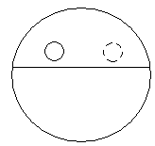

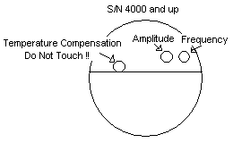

8.0 REVISION HISTORY

DCO # | REV | DATE | INITIALS | CHANGES MADE
736 | A | 3/4/04 | SM | Initial Release
1104 | B | 6/16/08 | SM | Updated
1489 | C | 11/13/15 | SM / JH | MET/CAL System

