PRM915 FINAL TEST

- PURPOSE AND SCOPE

The purpose of this document is to provide the detail and instruction necessary to ensure the compliance of the specified product to established specifications.

- AFFECTED DEPARTMENTS

Manufacturing

3.0 REFERENCE DOCUMENTS

Assembly drawings and schematics for the PRM915

4.0 RESPONSIBILITIES & AUTHORITY

The technician has the following responsibilities and authority:
- Verify compliance of the product under test to specification.
- Troubleshoot and correct product as required.
- Communicate concerns to Supervisor or Quality Assurance.
- Request management review of product concerns.
- Use proper ESD protective equipment.

5.0 DEFINITIONS

None

6.0 SAFETY PRECAUTIONS

- Safety Glasses are required when soldering, lead clipping, or testing power supplies.
- Follow general electrical precautions for working with energized, low voltage circuits

7.0 EQUIPMENT & MATERIALS

ADP040 (7pin Lemo with signal out)
- ADP041 (7pin Lemo with PRM915 signal input)
- BNC to BNC cable
- CBL071
- ADP005
- 2900 TEST STATION

- INSPECTION

- Examine the cosmetic appearance of the preamplifier
- Verify that the contacts and connectors are properly aligned on the part
- Questions about appearance or quality are to be brought to the attention of the supervisor, manager or QA

- INSTRUCTIONS

9.1 Trim

Refer to the PRM902 PRETEST AND TRIM procedure #D0001.8125.
NOTE: that if the current is wrong you will need to adjust the value of R7.
Also check that the small trace connecting a Via to the trace between L3 and Pin 7 of the Lemo connector is cut as shown below.
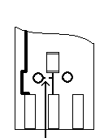

9.2 Test #1

Connect to 2900 test station as shown below.

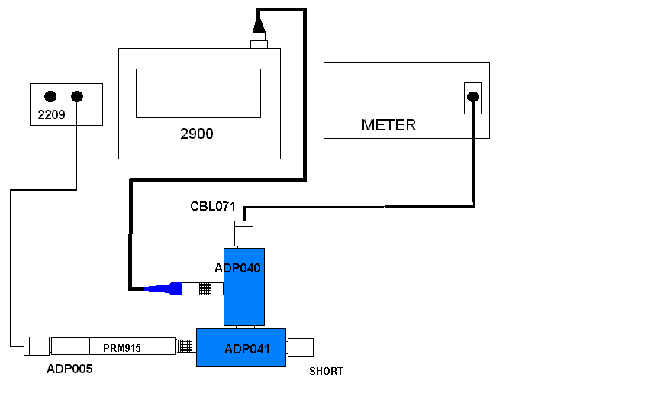

- Run the PreampTest program.
- Select your name in the Technician field.
- For Model: select 915.
- When it asks for the serial number, enter it and press OK.
- Click on the play button.
- When it asks for the serial number, enter it and press OK.

9.3 Test #2

- Connect to 2900 test station as shown below.

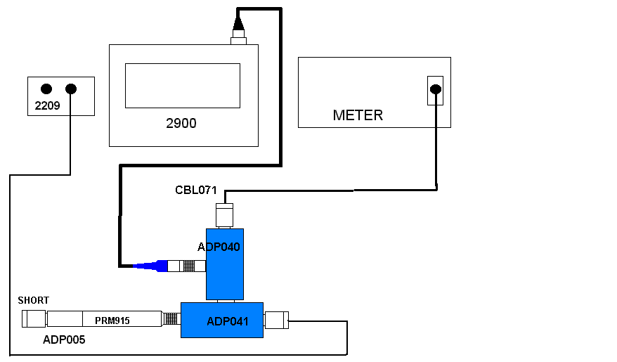

- Run the “PreampTest” program
- Select your name in the Technician field.
- For Model: 915 Inject.
- Click on the play button.
- When it asks for the serial number, enter it and press OK.
- Print both test results when finished

9.4 Test with mic.

- Connect the preamp to the test station as shown in the first diagram, but place a 2540 microphone on the preamp in place of the ADP005.
- Put a CAL250 over the microphone and activate the calibrator.
- The signal should be ≅ 120 mV AC.
(This level is dependent on the microphone used it is best to note this level and always use the same microphone for this test)

9.5 Cert.

- Create & Print Certificate of Conformance for PRM915 (without due date) in the LD database
- Sign cert and include above test results
- Print cal sticker and barcode sticker with s/n and place on outside of blue tube.

- RECORDS

Test data, certificates and other associated records are maintained per the Quality Records Matrix, D0001.1126-1.

11.0 DISTRIBUTION

Available online in work instruction area of Document Control.

12.0 ATTACHMENTS

None

13.0 REVISION HISTORY

DCO # | REV | DATE | INITIALS | CHANGES MADE
758 | A | 3/22/04 | JG | Initial Release
1154A | B | 11/11/08 | SC | Clarification of trim procedure
1867 | C | 1/16/19 | SRC | Added clarity so it was more production friendly

