PRM916 FINAL TEST

- PURPOSE AND SCOPE

The purpose of this document is to provide the detail and instruction necessary to ensure the compliance of the specified product to established specifications.

- AFFECTED DEPARTMENTS

Manufacturing

3.0 REFERENCE DOCUMENTS

Applicable assembly drawings and schematics for the PRM916

4.0 RESPONSIBILITIES & AUTHORITY

The technician has the following responsibilities and authority:
- Verify compliance of the product under test to specification.
- Troubleshoot and correct product as required.
- Communicate concerns to Supervisor or Quality Assurance.
- Request management review of product concerns.
- Use proper ESD protective equipment.

5.0 DEFINITIONS

None

6.0 SAFETY PRECAUTIONS

- Safety Glasses are required when soldering, lead clipping, or testing power supplies.
- Follow general electrical precautions for working with energized, low voltage circuits

7.0 EQUIPMENT & MATERIALS

ADP040 (7pin Lemo with signal out)
- ADP041 (7pin Lemo with PRM915 signal input)
- TWO BNC to BNC cable’s (one must be very short)
- CBL071
- PRM916 SHIELD (A shorted ADP005 with No Capacitor)
- ADP005
- 2900 Test station with the Preamp Test software installed.

- INSPECTION

- Examine the cosmetic appearance of the preamplifier
- Verify that the contacts and connectors are properly aligned on the part
- Questions about appearance or quality are to be brought to the attention of the supervisor, manager or QA

- INSTRUCTIONS

9.1 Trim

Refer to the PRM902 PRETEST AND TRIM procedure #D0001.8125.
NOTE: If the current is wrong you will need to adjust the value of R7.
Also check that the small trace connecting a Via to the trace between L3 and Pin 7 of the Lemo connector is cut as shown below.
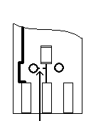

9.2 Test of frequency response of the preamp with the signal through ADP005.

- Connect the preamp to the 2900 test station as shown below.

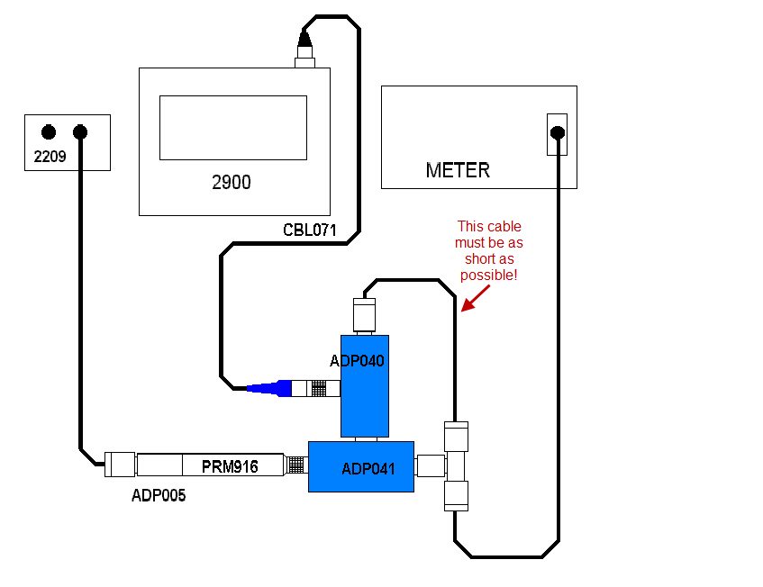

- Run the Larson Davis Preamp Test program.
- Select PRM916.
- Click on the START button.
- When it asks for the serial number, enter it and press OK.

9.3 Test of frequency response of preamp with the signal driving the internal capacitance bridge.

- Connect to 2900 test station as shown below.

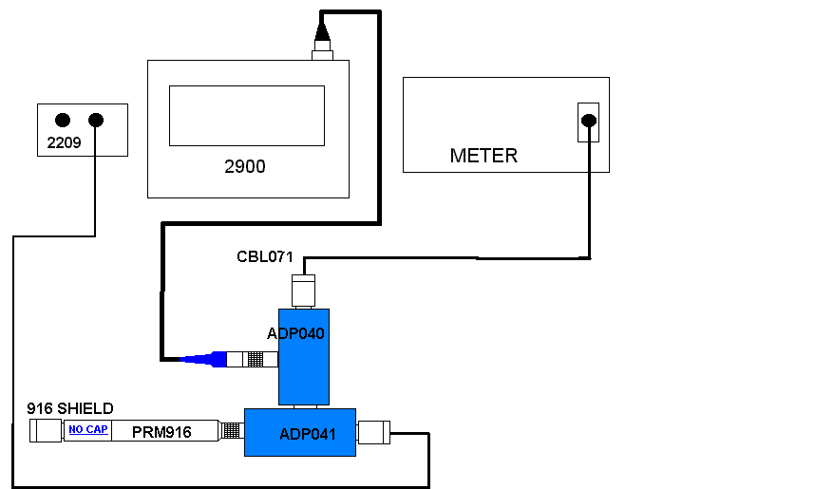

- Run the Larson Davis Preamp Test program.
- Select PRM916 Injected.
- Click on the START button.
- When it asks for the serial number, enter it and press OK.
- Print both test results when finished

9.4 Cert.

- Create & Print Certificate of Conformance for PRM916 (without due date) in the LD database
- Sign cert and include above test results
- Print cal sticker and barcode sticker with s/n and place on outside of blue tube.

- RECORDS

Records that are generated as a result of this instruction are maintained per the Quality Records Matrix, D0001.1126-1.

11.0 DISTRIBUTION

Instruction is available in the work instructions area of Document Control.

12.0 ATTACHMENTS

None

13.0 REVISION HISTORY

DCO # | REV | DATE | INITIALS | CHANGES MADE
757 | A | 3/22/04 | JG | Initial Release
1155A | B | 11/11/08 | SC | Clarification of trim procedure
1541 | C | 2/17/15 | JG | Changed picture in test 1 to shorten cable.  Changed from Lab to the Preamp Test software.  Changed heading of sections 9.2 and 9.3.
1867 | D | 1/16/19 | SRC | Added clarity so it was more production friendly

