**A770.2x TEST**

1. **PURPOSE AND SCOPE**

The purpose of this document is to provide the detail and instruction necessary to ensure the compliance of the specified product to established specifications. This instruction is applicable to both new product and to customer owned product that has been returned for repair and/or calibration.

**2.0 LIMITATIONS**

This instruction is limited to the testing of the A770.21, A770.21L, A770.22, A770.22B and A770.22L, A770.22C assemblies.

**3.0 AFFECTED DEPARTMENTS**

Manufacturing

**4.0 REFERENCE DOCUMENTS**

Applicable drawings and instructions for the A770.21 are needed.

**5.0 RESPONSIBILITIES & AUTHORITY**

The technician has the following responsibilities and authority:

* Verify compliance of the product under test to specification.
* Troubleshoot and correct product as required.
* Communicate concerns to Supervisor or Quality Assurance.
* Request management review of product concerns.
* Use proper ESD protective equipment.

**6.0 SAFETY PRECAUTIONS**

* Safety Glasses are required when soldering, lead clipping, or testing power supplies.
* Follow general electrical precautions for working with energized, low voltage circuits

**7.0 EQUIPMENT & MATERIALS**

# LxT Test Box

# EXC006

BNC to BNC cable

2900

Function Generator

Oscilloscope

BNC to test clips

**Multimeter**

**8.0 INSPECTION**

Perform a visual check of the board. Check for any shorts or mis-loaded parts.

**9.0 INSTRUCTIONS**

**9.1 Setup**

* Connect the EXC006 cable from the 2900 connector of the LxT Test Box to the 2900 Preamp 1 input**.**
* Connect the A770.2x board to be tested to the LxT preamp connector of the LxT Test Box.
* Using the BNC to BNC cable, connect from the LxT Test Box PS BNC to the Oscilloscope input.
* Turn on the 2900.

**9.2 Check preamp Power Supply current**

* Switch LxT Test Box to PS.
* Read the voltage of the Preamp PS on the Multimeter.
* The voltage should read between **(6.58 Volts to 7.03 Volts).**
  1. **Check the preamp current sink**
* Using the O-Scope Multimeter check the voltage from the test pad to ground.
* It should be between **(90 mV and 290 mV).**

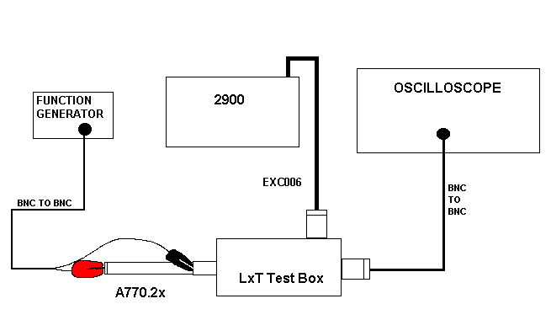

**9.4 Signal Check**

* Switch LxT Test Box to Signal
* Set the function generator to produce a 1 kHz sine wave. The amplitude is adjusted to a level depending on the specific model of the preamp.

See Table 1 Below

* On non LD Generators adjust to ½ this voltage. See table 1 below
* Hook the signal cable from the generator - ground lead to the preamp ground and the signal lead to the pogo on the Preamp.
* Check the sine wave on the O-Scope. See table 1 below

|  |  |  |  |  |  |  |  |  |  |  |  |  |  |  |  |  |  |  |  |  |  |  |  |  |  |  |  |  |  |  |  |  |  |  |  |
| --- | --- | --- | --- | --- | --- | --- | --- | --- | --- | --- | --- | --- | --- | --- | --- | --- | --- | --- | --- | --- | --- | --- | --- | --- | --- | --- | --- | --- | --- | --- | --- | --- | --- | --- | --- |
| |  |  |  |  |  | | --- | --- | --- | --- | --- | | **PREAMP** | **Board level** | **AC signal LD**  **Generators** | **Non LD Generator**  **(50 ohm output)** | **AC Out (Vrms)** | | **PRMLXT1** | **A770.21** | **5.25 Vrms** | **2.625 Vrms** | **.44 to .52 V** | | **PRMLXT1L** | **A770.21L** | **1.02 Vrms** | **.51 Vrms** | **.88 to 1.08 V** | | **PRMLXT2** | **A770.22** | **1.65 Vrms** | **.825 Vrms** | **.88 to 1.08 V** | | **PRMLXT2B** | **A770.22B** | **2.73 Vrms** | **1.385 Vrms** | **.44 to .52 V** | | **PRMLXT2L** | **A770.22L** | **1.02 Vrms** | **.51 Vrms** | **.88 to 1.08 V** | | **PRMLxT2C** | **A770.22C** | **5.25 Vrms** | **2.625 Vrms** | **.44 to .52 V** | |

**Table 1**

**9.5 Check DC Offset**

* Switch scope to read DC and verify that the signal is riding on a DC offset of

**(3.1 Volts to 3.7 Volts)**. If this voltage is too high, often Q3 will need to be changed.

* Turn off the 2900 and disconnect Preamp board.
* The Preamp boards are ready for final assembly.

1. **RECORDS**

No records are generated as part of this instruction.

**11.0 DISTRIBUTION**

Instruction is available online in the “Preamp” folder in the “Technician work instruction” folder in Document Control.

**12.0 REVISION HISTORY**

|  |  |  |  |  |
| --- | --- | --- | --- | --- |
| **DCO #** | **REV** | **DATE** | **INITIALS** | **CHANGES MADE** |
| ECO 3246 | A | 3/26/04 | LWH | Initial Release |
| DCO 1068 | B | 17 April 2008 | LWH | Added preamp sense section that was on S770.2x |
| DCO 1133 | C | 7 August 2008 | LWH | Corrected two preamp sense resistance ranges.  Non LD Generators adjust to ½ voltage. |
| ECO 4013 | D | 19 Aug 2011 | LWH | Added A770.22B. Moved “Test Preamp Sense” to S770.2x Test procedure |
| DCO  1353 | E | 14 Oct 2011 | LWH | In 9.4 changed 4.39 to 2.73 Volts for the A770.22B |
| DCO  1432 | F | 18 Jun 2013 | EO | Added a table for better view of voltage limits  And touched up some others. |
| DCO  1974 | G | 19 Aug  2020 | KH | Added PRMLxT2C to Signal Check table |
|  |  |  |  |  |