S770.2x TEST

- PURPOSE AND SCOPE

The purpose of this document is to provide the detail and instruction necessary to ensure the compliance of the specified product to established specifications. The instruction applies to both new and customer owned equipment that has been returned for repair and/or calibration.

2.0 LIMITATIONS

The use of this instruction is limited to testing the S770.21, S770.21L, S770.22, S770.22B and S770.22L also Customer returns of PRMLxT1, PRMLxT1L, PRMLxT2, PRMLxT2B and PRMLxT2L.

3.0 AFFECTED DEPARTMENTS

Manufacturing

4.0 REFERENCE DOCUMENTS

D0001.1126 Quality Records
Applicable revision drawings S770.21, and A770.21

5.0 RESPONSIBILITIES & AUTHORITY

The technician has the following responsibilities and authority:
- Verify compliance of the product under test to specification.
- Troubleshoot and correct product as required.
- Communicate concerns to Supervisor or Quality Assurance.
- Request management review of product concerns.
- Use proper ESD protective equipment.

6.0 SAFETY PRECAUTIONS

- Safety Glasses are required when soldering, lead clipping, or testing power supplies.
- Follow general electrical precautions for working with energized, low voltage circuits

7.0 EQUIPMENT & MATERIALS

LxT Test Box
EXC006
Two BNC to BNC cable’s
Function Generator
Oscilloscope
2900 TEST STATION
Torque Wrench
T831.52 Torque adapter tool
Input Adaptors ADP090 (12pF) for testing the PRMLxT1 and PRMLxT1L or
the ADP005 (18pF) for testing the PRMLxT2, PRMLxT2B and PRMLxT2L.
Larson Davis PreampTest program
PRMLxT Sense cable

- INSPECTION

- Examine the cosmetic appearance of the preamplifier
- Verify that the contacts and connectors are properly aligned on the part
- Questions about appearance or quality are to be brought to the attention of the supervisor, manager or QA

- INSTRUCTIONS

9.1 2900 Test Station Test setup

- Using one of the test stations in the technician area, connect the preamp as follows.
- Connect a BNC to BNC cable from the input of the multimeter to the LxT Test Box AC Out.
- Connect a 5-pin Switchcraft cable from the LxT Test Box 2900 BNC connector to channel one of the 2900.
- Connect the S770.2x (PRMLxT) to the LxT Test Box LxT Preamp connector.
- Screw an Input Adaptor onto the S770.2x (PRMLxT) to be tested.
- Connect the BNC to BNC cable coming from the output of the 2209 to the Input Adaptor.

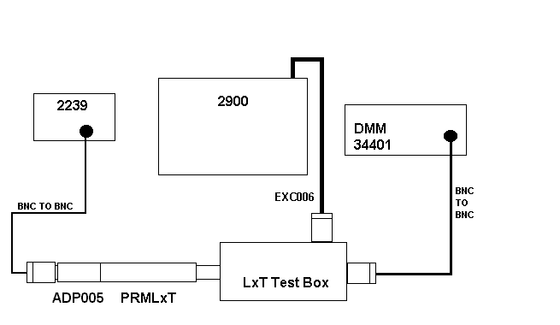
Test Setup shown with ADP005 (ADP090 used on some preamps in place of the ADP005)

9.2 Run Automated test

- Run the Larson Davis PreampTest program.
- Select your name in the Technician field if not selected already.
- Click on Model and select PRMLxT1, PRMLxT1L, PRMLxT2, PRMLxT2B or PRMLxT2L depending on the preamp being tested.
- Click on the begin button.
- When it asks for the serial number, enter it and press OK.

9.3 Test Preamp Sense
- Connect the PRMLxT Sense cable to the DMM set for reading Ohms.
- Plug an S770.2x into the cable and read the resistance.
- Check that each preamp passes the resistance for the specific model given in the following.
- S770.21 281 k Ohms to 293 k Ohms
- S770.21L 29 k Ohms to 31 k Ohms
- S770.22 98 k Ohms to 102 k Ohms
- S770.22L 9.8 k Ohms to 10.2 k Ohms
- S770.22B 2.38 k Ohms to 2.48 k Ohms

9.4 Finish Assembly
- If the Preamplifier passes, tighten the connector with the torque wrench to 17 inch pounds.
- Place the black vinyl protective cap on the microphone end of the preamplifier.
- Put the preamplifier into the case.

9.4 Close tested preamplifiers to technician area.

- RECORDS

- Test results are saved per the Quality Records Matrix, D0001.1126-1.
- Enter a new record in the LDL Database for each S/N tested.

11.0 DISTRIBUTION

This instruction is available online in the Technician work instruction folder under “Mic & Preamps”.

12.0 REVISION HISTORY

DCO # | REV | DATE | INITIALS | CHANGES MADE
ECO 3246 | A | 3/29/04 | LWH | Initial Release
DCO 1068 | B | 15 April 2008 | LH | Added torque wrench tightening and black vinyl protective cap. Removed test sections that are on the A770.2x test.
ECO 4013 | C | 18 Aug 2011 | LH | Added PRMLxT2B preamp and assemblies with PreampTest program

