PRM905 PRE-TEST AND TRIM

- PURPOSE AND SCOPE

The purpose of this document is to provide the detail and instruction necessary to ensure the compliance of the specified product to established specifications. This instruction is applicable to both new product and to customer owned product that has been returned for repair and/or calibration.

2.0 LIMITATIONS

This instruction is limited to the pre-testing and trimming of the PRM905.

3.0 AFFECTED DEPARTMENTS

Manufacturing

4.0 REFERENCE DOCUMENTS

Applicable drawings and instructions for the APRM905 and PRM905

5.0 RESPONSIBILITIES & AUTHORITY

The technician has the following responsibilities and authority:
- Verify compliance of the product under test to specification.
- Troubleshoot and correct product as required.
- Communicate concerns to Supervisor or Quality Assurance.
- Request management review of product concerns.
- Use proper ESD protective equipment.

6.0 SAFETY PRECAUTIONS

- Safety Glasses are required when soldering, lead clipping, or testing power supplies.
- Follow general electrical precautions for working with energized, low voltage circuits

7.0 EQUIPMENT & MATERIALS

ADP015
EXC001.5
BNC to BNC cable
CBL071
2200B
Function Generator
Oscilloscope
BNC to test clips

8.0 INSPECTION

Perform a visual check of the board. Check for any shorts or mis-loaded parts.

9.0 INSTRUCTIONS

9.1 Setup

- Configure test cables as shown below.

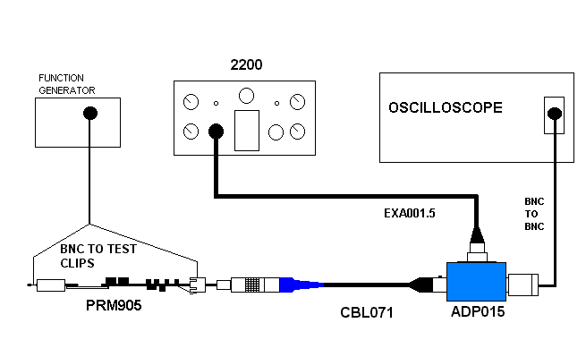
- Setup 2200B for a 0V BIAS and 0dB of GAIN.
- Connect the PRM905 board to be tested to the open end of the CBL071 cable.
(Lineup the ear on the PRM905 board connector with the red dot on the connector of the CBL071 cable)
- Turn on the 2200C.

9.2 Check preamp current

- Measure the voltage across R3 using the mutimeter leads of O-Scope.
- The voltage across R3 should read between 18 and 23 mV. If the voltage is not in range, adjust the value of R4 to correct the problem.

9.3 Signal Check

- Set the function generator to produce a 1 volt 1Khz sine wave.
- Hook the signal from the signal generator to the pogo in the top end if the Preamp, and ground it to the connector body.
- Check the sine wave on the O-Scope for about 0.96 Volts.

9.4 Check DC Offset

- Switch scope to read DC and verify that the signal is not riding on a DC offset of more then 2Vdc.
- Turn off the 2200B and disconnect Preamp board.
- Return Preamp board to production for final assembly.

- RECORDS

No records are generated as part of this instruction.

11.0 DISTRIBUTION

Instruction is available online in the “Preamp” folder in the “Technician work instruction” folder in Document Control.

12.0 REVISION HISTORY

DCO # | REV | DATE | INITIALS | CHANGES MADE
780 | A | 5/25/04 | LH | Initial Release

