S824 ASSEMBLY PROCEDURE

- PURPOSE AND SCOPE

- The purpose of this document is to provide detailed instructions necessary to ensure the compliance of the specified product to established specifications.

- AFFECTED DEPARTMENTS

- Manufacturing

3.0 REFERENCE DOCUMENTS

- Current S824 BOM
- Current assembly drawings for the A824.01 and A824.02
- Current case sub-assembly drawings

4.0 RESPONSIBILITIES & AUTHORITY

The technician has the following responsibilities and authority:

- Verify compliance of the product under test to specification.
- Troubleshoot and correct product as required.
- Communicate concerns to Supervisor or Quality Assurance.
- Request management review of product concerns.
- Use proper ESD protective equipment.

5.0 DEFINITIONS

- ECO - Engineering Change Order
- ESD - Electrostatic Discharge
- LDI - Larson Davis Division of PCB

6.0 SAFETY PRECAUTIONS

- Safety Glasses are required when soldering, lead clipping, or testing power supplies.
- Follow general electrical precautions for working with energized, low voltage circuits

7.0 EQUIPMENT & MATERIALS

- Variable power supply capable of delivering 12 Volts DC.
- ESD wrist strap properly grounded to your workstation.
- #1 Philips screw driver.
- #10 Torx screw driver.
- X-ACTO Knife
- Needle nose pliers

8.0 INSPECTION

- Visually check the 824 case for cosmetic defects.
- Carefully check the glass display that there are not any dust or white particles trapped inside.

9.0 INSTRUCTIONS

  - Cosmetic Inspection

- Look for any cosmetic scratches of paint defects in the top and bottom of the case.
- Check for dirt or specs under the glass of the display.
- Make sure the LD jewel and grips are well attached to the case.
- Look for any glue residue on the grips and back of the case.

  - A824.02 Board Preparation

- Place the shield on the table with the screw hole closest to you as shown in Fig. 1. Use an X-ACTO knife to cut a ¼” of the plastic below the hole in the screw tab of the 824 shield and remove the clear, plastic insulation around the screw hole.

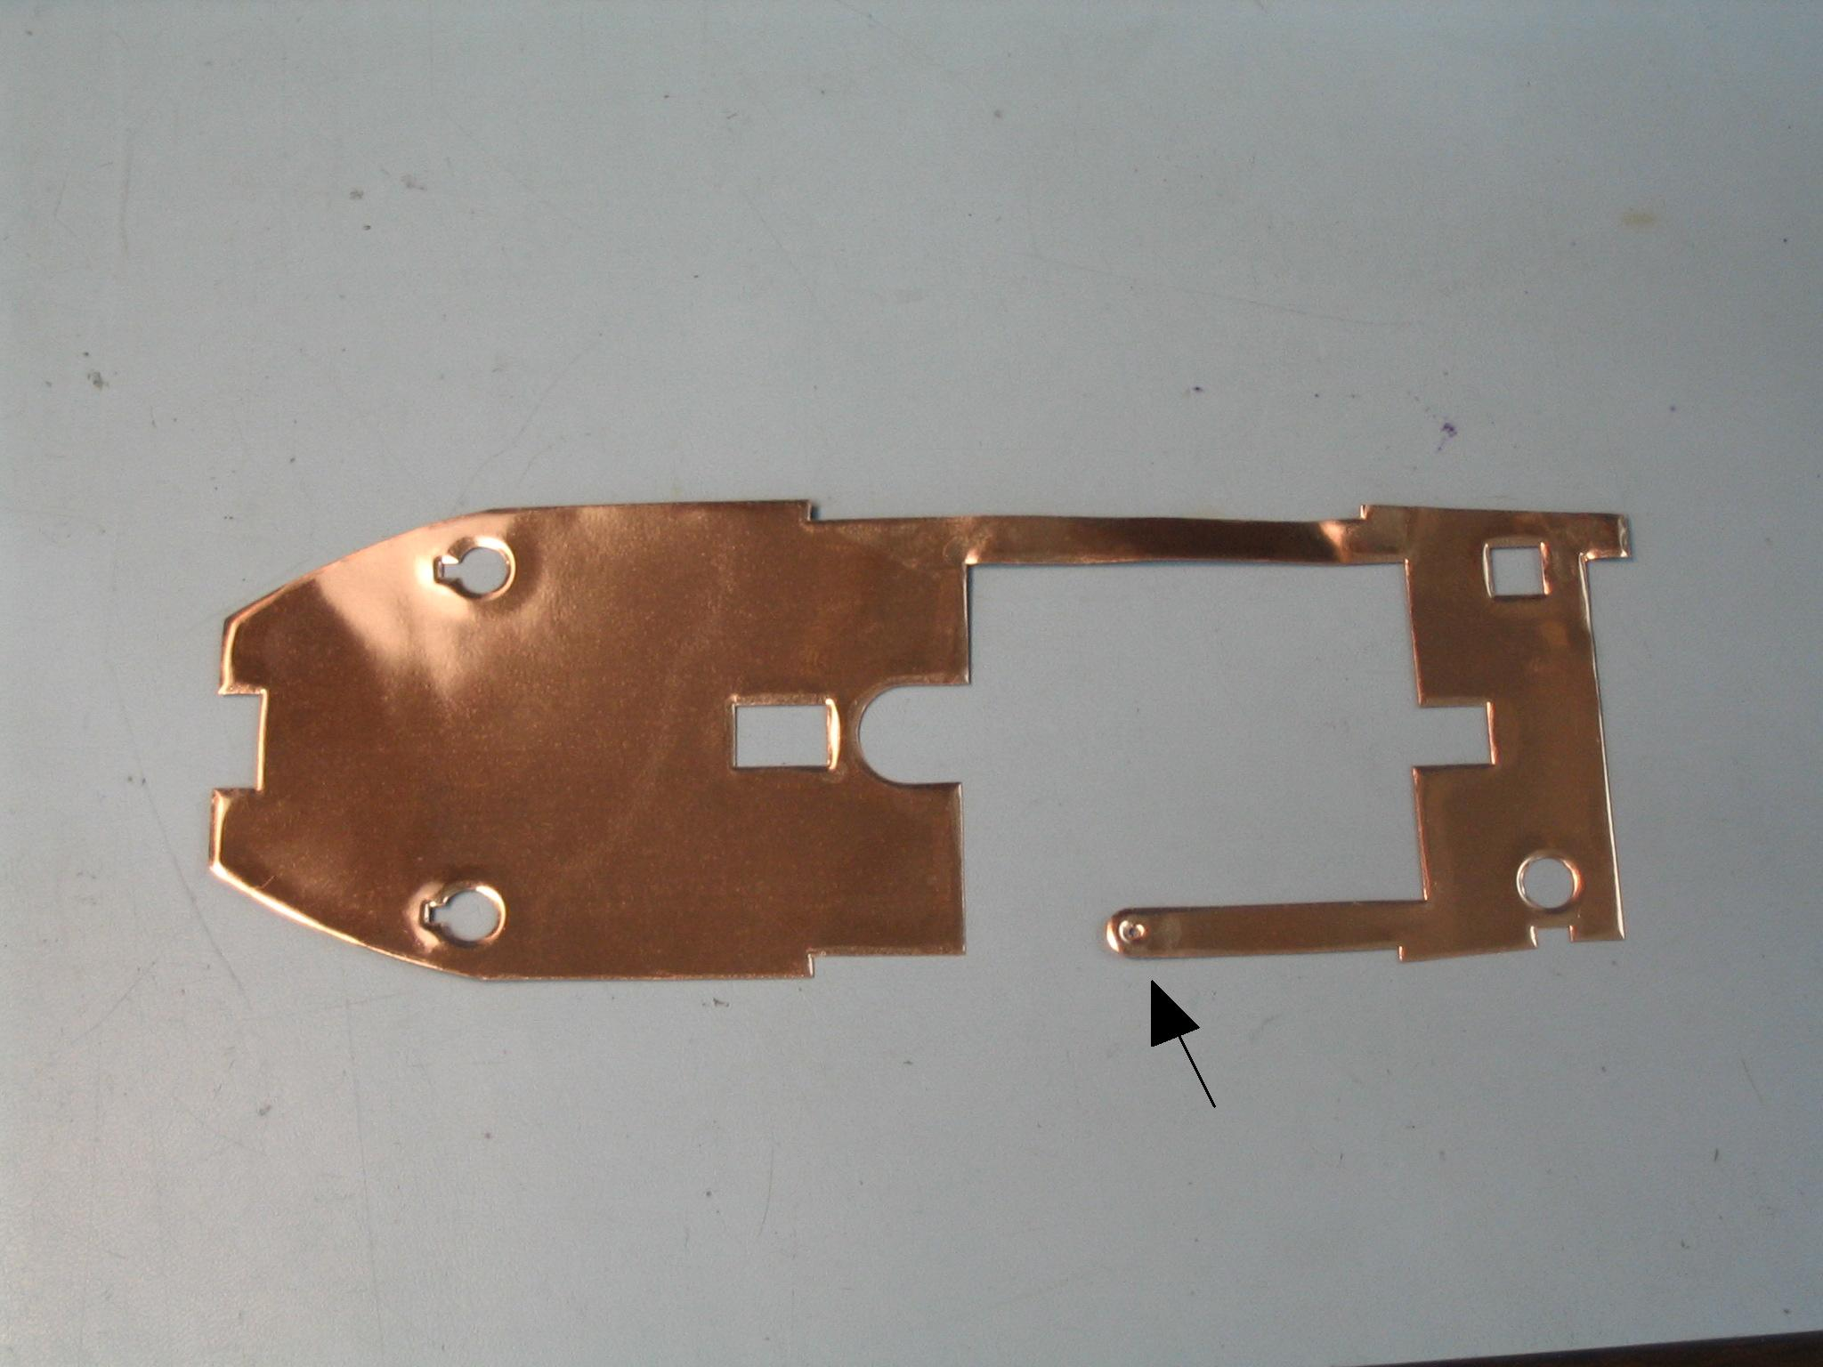
Fig. 1 Screw Tab

- Place the A824.02 board on bench with the DSP chip U205 and the preamp connector J2 on top.
- Turn the shield over and lay it on top of the A824.02 board so that all the connectors on the A824.02 board can still be seen. The bared part of the screw tab should touch the connection point just below P3 on the A824.02 board.
- Attach the shield to the A824.02 board with screw #5345.0009 and washer #7065.0004 at screw tab.
- Place a conductive o-ring, #M814.0006, over the barrel of preamp connector J2 as shown in Fig. 2.
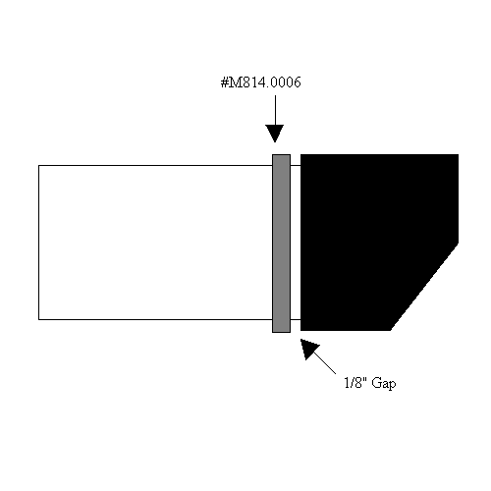
Fig. 2

  - Place 824 Board Set in Case

- Lay the A824.01 board in the top of the case with the LED’s towards the keypad.
- Carefully line up the pins on the A824.01 board with display connectors and press down on the A824.01 board starting near the display connector.
- Place the A824.02 board over the A824.01 board so that the shield is between them.
- Help guild the shield over the case standoffs.
- Carefully line up P3 of the A824.02 with P4 of the A824.01 and press them together. This is the connector next to the screw tab connection.
- Now, carefully line up P1 and P2 of the A824.02 board with P2 and P6 of the A824.01 board and press them together.
- Make sure to line up the o-ring on the preamp connector with its groove in the case.

  - Prepare for Back of Case

- Bend the tabs on the connector plate #M824.0004 in from a 90° to 45° angle as shown below.

M824.0004

- Set the connector plate #M824.0004 in the groove at the bottom of the 824, and cover the connectors with the silver tabs inside.

  - Install 824 Case Back

- Connect the battery wires on the back case to P202 of the 824.02 board. Connect the red wire to VBAT, the black wire to GND, and the yellow wire to the pin above VBAT.
- Place the 824 case back over the board set, lining up the connector place with the grove in the case and push the case together making sure they are properly aligned.
- Set one screw #5290.0079 in each of the six holes in the back of the case.
- Carefully tighten all screws with the Torx screw driver with the torque set to 60.

  - Testing

- Adjust the DC supply to 12 Volts DC and connect it to the 824.
- Press the POWER key to turn on.
- Watch the current draw on the DC supply. It should not exceed 150mA.
- Look to see if the display appears ok.
- Hold down the POWER key to turn off.

- Now refer to the 824 Test Procedure

- RECORDS

- No records are generated by this procedure.

11.0 DISTRIBUTION

- Engineering
- Manufacturing
- Service
- QA

12.0 ATTACHMENTS

- No attachments are applicable to this procedure.

13.0 REVISION HISTORY

DCO # | REV | DATE | INITIALS | CHANGES MADE
1124 | A | 7/11/08 | ACJ | Initial release
1126 | B | 7/22/08 | ACJ | Fixed errors found by Thomi Barker after the last change.

